

**CAPTURING READING PROFICIENCY GR1 TO GR7 ON SA-SAMS**

1. According to [LTA 2](http://www.fsdoe.fs.gov.za/EMISPortal/Resources/Circulars/LTA_2_2025.pdf) of 2025 and [LTA 3](http://www.fsdoe.fs.gov.za/EMISPortal/Resources/Circulars/LTA_3_2025.pdf) of 2025 Free State department of Education has implemented reporting on reading proficiency of learners.
2. This manual will assist on how to implement this on SA SAMS.
3. Download and install the program under Utilities on the EMIS Portal. Ther program is called**: Reading Proficiency report**.

<http://www.fsdoe.fs.gov.za/EMISPortal/Utilities.aspx>

1. The following shortcut will be created on the desktop after installing the program.

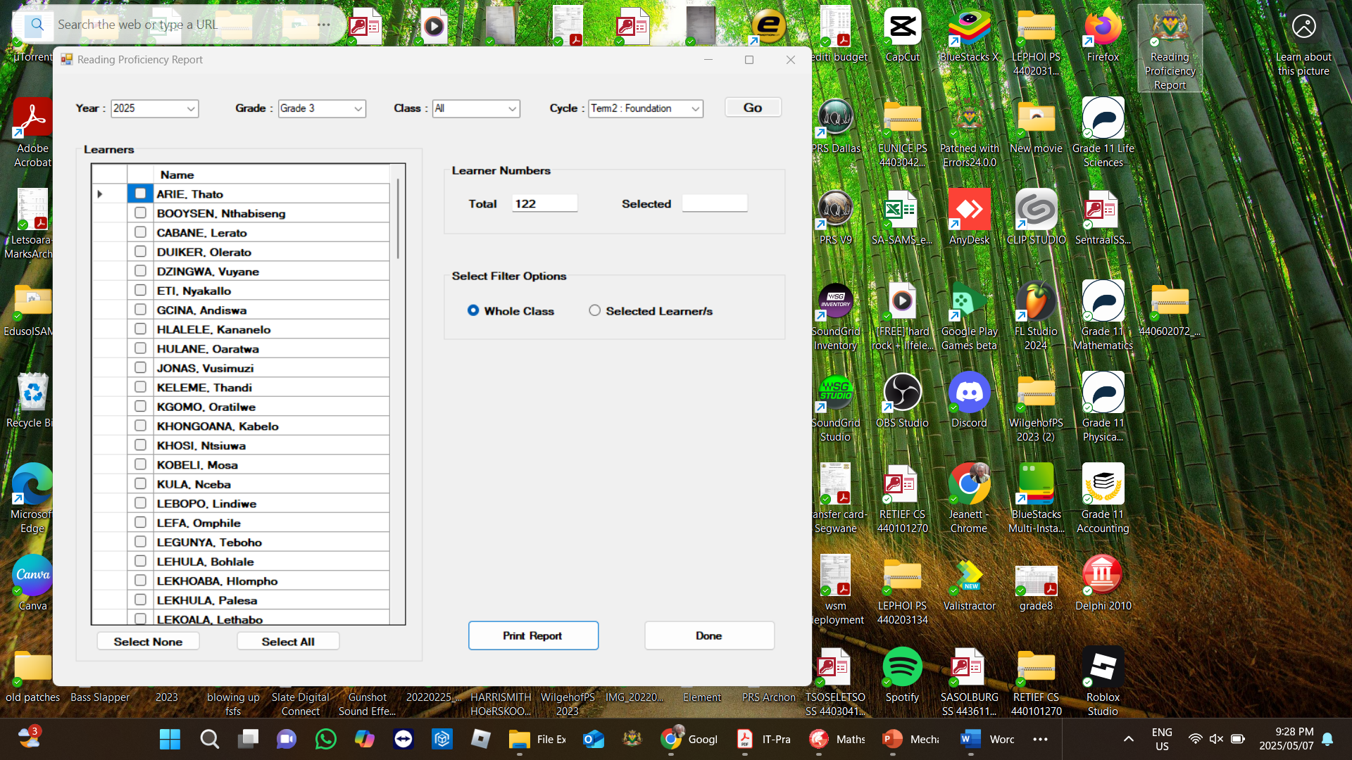

1. Open the installed program:

1. Make sure that the database is pointing to the correct SAMS database. Click on the Add Tasks button to add the tasks to your SAMS database.

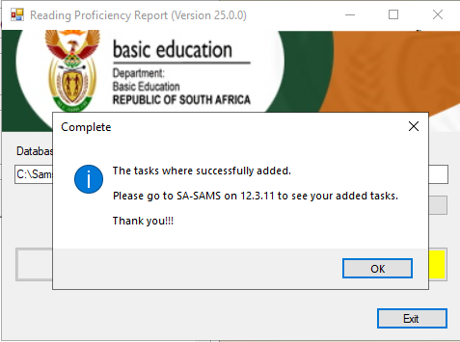

1. You can now exit the program and go to SA SAMS to make sure that the tasks were added.
2. After opening SA-SAMS, go to 12.3.11 to check the added tasks.
   1. In Gr 1 Early Grade Reading Assessment (EGRA) is only assessed for Home Language.
   2. In Gr 2 and 3 EGRA is assessed for Home Language and English First Additional Language.
   3. In Grades 1 – 3 two tasks were added: One in Term 2 and one in Term 4.

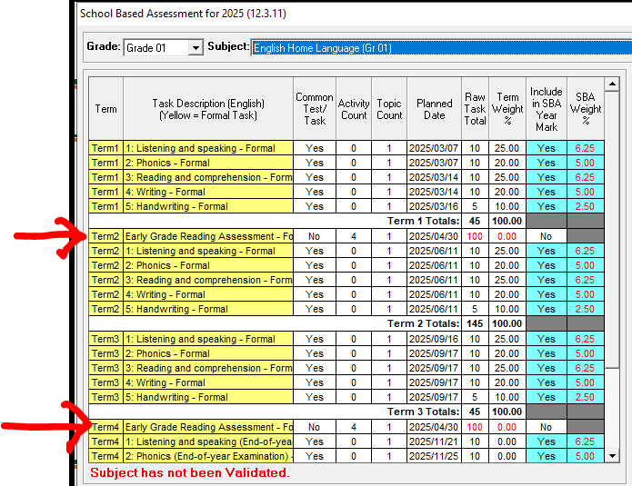

Both these tasks has 4 Activities.

* 1. In Grades 4 – 7 Reading Proficiency is assessed for Home Language and all First Additional Languages.
  2. In Grades 4-7 Only one task were added in Term4 , but an Additional activity was added to the Oral in Term 2. The task in Term 4 has 4 activities.

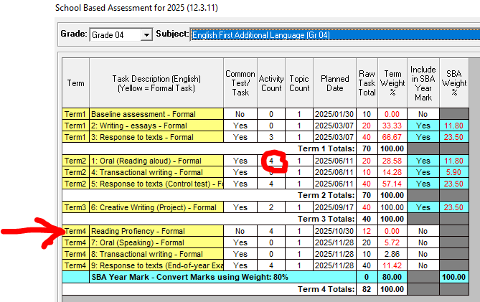

1. You can capture the learner marks the normal way in SA SAMS in 12.3.12.
2. For printing of learner reports: Open the installed Reading Proficiency program (in Point 5 of this document.)
3. Click on Print Learner Report.
4. Select the grade, class, cycle and the learners. Click on print report.

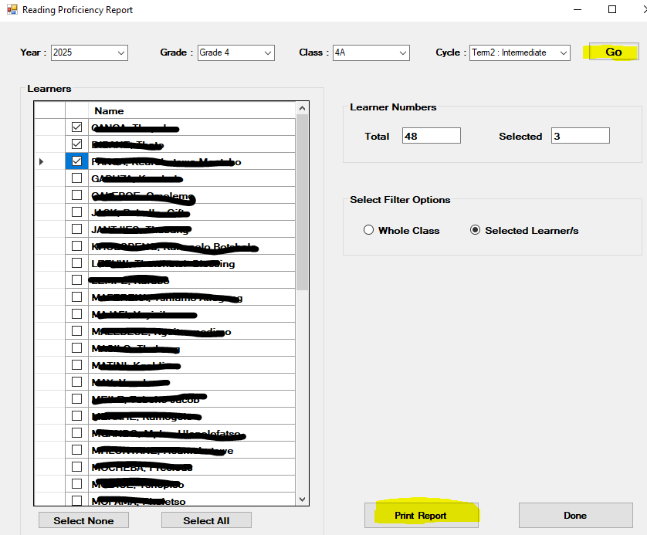

1. Print the displayed reports and click on the close button when finished printing.

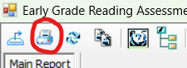

1. Click on Done to Exit the program.