Year End Learner Promotions

3. Learner and Parent Information

3.19 Process and Maintain Learner Promotions

Select **Year End to be processed** as the current year.

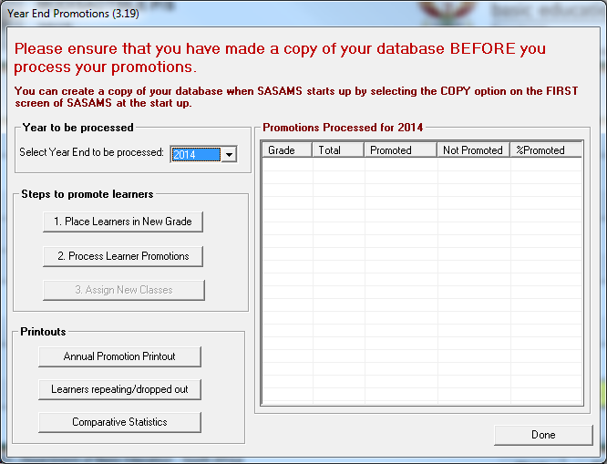

**Steps to promote Learners**

1. Click on the **Place Learners in New Grade** button. The following message will display to inform you that the **Promotion Decisions** have already been captured in **12.7.18**:

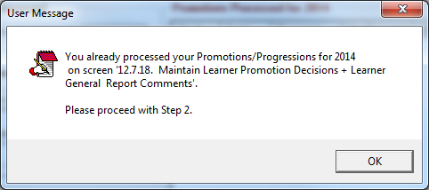

1. Click on the **Process Learner Promotions** button to process promotions. **Please make sure of the Statistics before you click on the Process Promotions button to process the learners.**

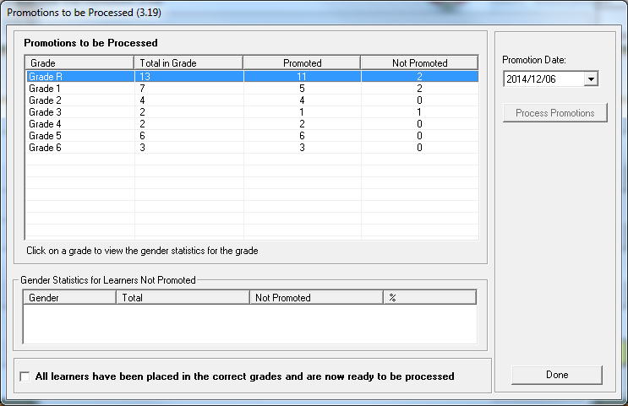

* 1. Once figures have been checked for accuracy, tick in the box at the bottom of the screen on -**All learners have been placed in the correct grades and are now ready to be processed.**

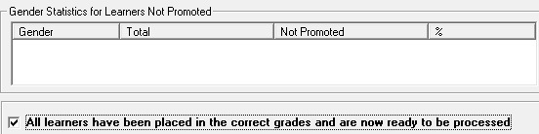

* 1. Select the **Promotion date** and click on the **Process Promotion** button.

**Note: You only do this process once because the more you click on the Process Promotion button the more learners are moved to the next grade.**

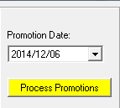 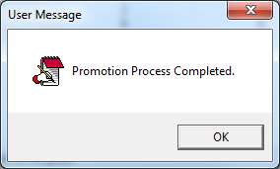

* 1. Promotions Processed.

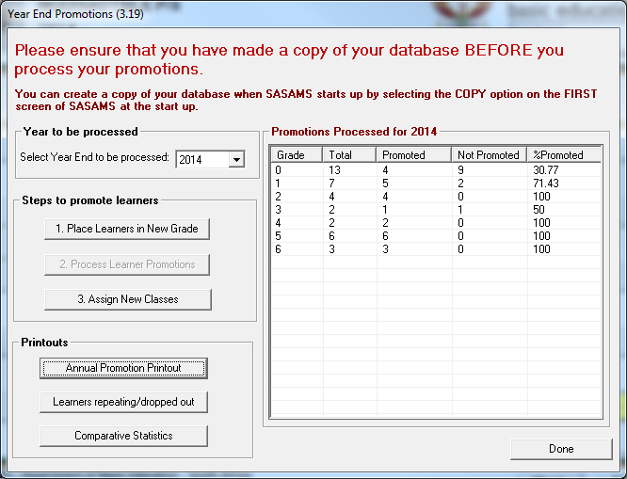

1. Click on the **Assign new classes** button. **(Optional- because a large school will not be able to assign classes to learners at this stage)**

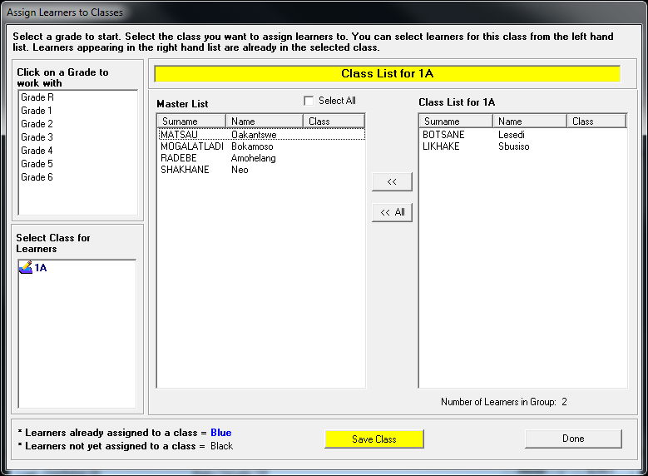

1. Click on the **Annual Promotion Printout** button to print the **Passrate Printout**.
   1. Select Year, click on the **Bar graph** and Click on the **Print** button.

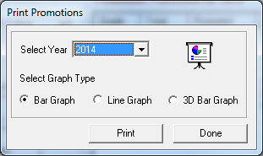

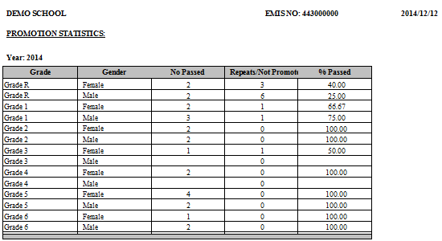

**Note: Some windows will display the graph and some not. Do not panic!**