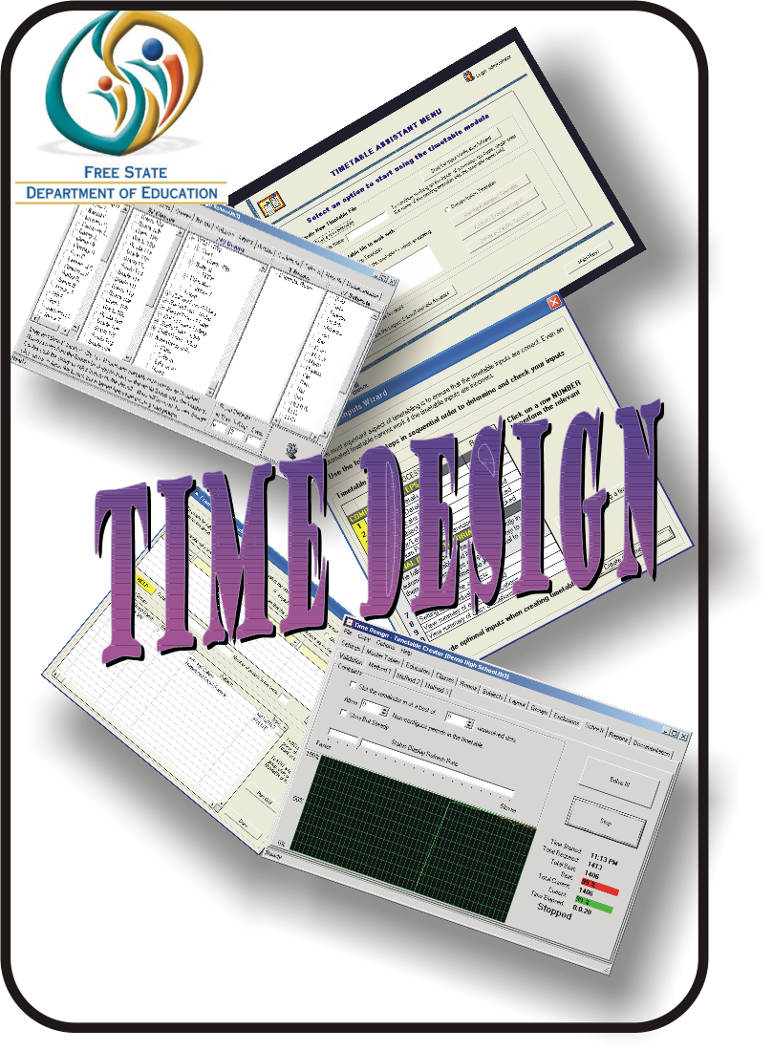

Please install Timetable Module
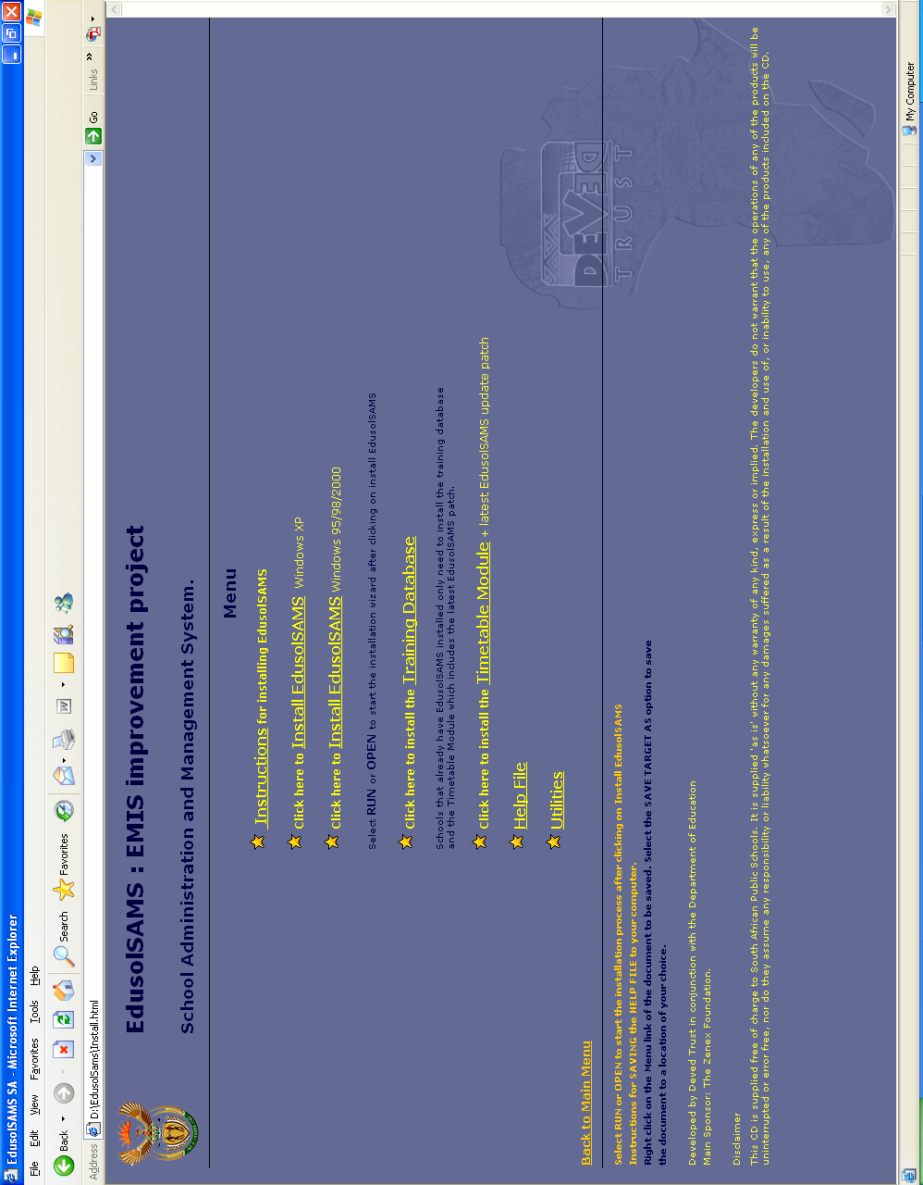
Click to install

TimeDesign - Striving to be the Ultimate Timetable Creator.

Concepts
Creating timetables for a training institution can be an extremely tedious task.
In a typical school, if you had five different grades, with about three classes per grade, with about 6 subjects per grade, and assuming that each period was 45 minutes long, based on a weekly cycle from 8:00am to 2:00pm (don't forget the breaks), you would have about 40 periods per cycle to fill per class.
This would work out to (5 grades) * (3 classes) * (6 subjects) * (40 periods) = 3600 slots that you need to fill per cycle. You also have to ensure that the teachers as well as the classes are not double booked.
This allows for 3600 factorial (3600 times 3599 times 3598 repeated all the way to 3 times 2 times 1) or about is 2.547 times 10 to the power of 11241 different combinations. Actually it is a bit more complex than that, once you take each day individually.
This program attempts to solve this problem in a logical manner while still attempting to ensure that no two days are similar thus providing the learners with varied days.
The program learns as it attempts to solve your problem and, taking this knowledge, it starts from scratch every now and then as a new approach so that it does not get stuck in an unsolvable loop.
This dynamic approach ensures that it will be extremely unlikely that the program will provide an identical solution on any successive run.

Features

A once off purchase with free upgrades - no more yearly license or update fees!
An unlimited number of periods per day.
An unlimited number of days within a cycle.
An unlimited number of educators.
An unlimited number of subjects.
An unlimited number of classes.
An unlimited number of rooms.
An unlimited number of educators, classes, rooms and subjects within a group.
An unlimited grouping combinations.
Multiple educators can teach the same subject.
Part-time educators and Heads - you can specify what periods are available for teaching.
Blocking of periods for subjects, groups, rooms - e.g. no mathematics first thing in the morning.
The program utilises a highly advanced solving engine based on Hierarchical Contention.
The ability to load the tables into Excel for personalisation.

LINK YOUR DATA TO SAMS

This section is created as a link between SAMS and Time Design

First click Start a new timetable
Type in your school’s name
Click on “Start the input Verification Wizard”

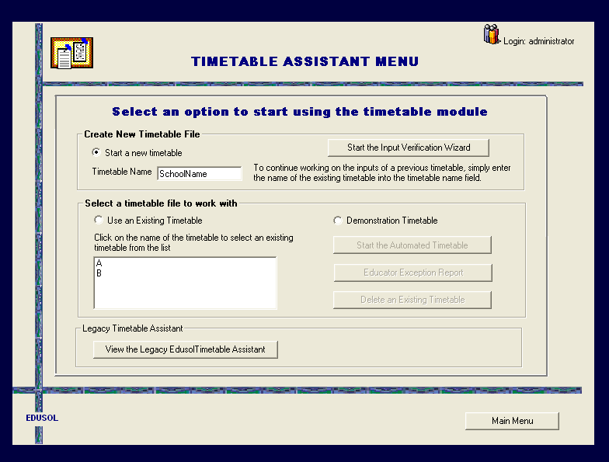

Many instructions are included in each window.
MAKE SURE TO READ ALL INSTRUCTIONS ON EACH WINDOW BEFORE MOVING TO THE NEXT WINDOW.

You will see that the “Result” column is empty.
Click on “ Check Cycle Details”

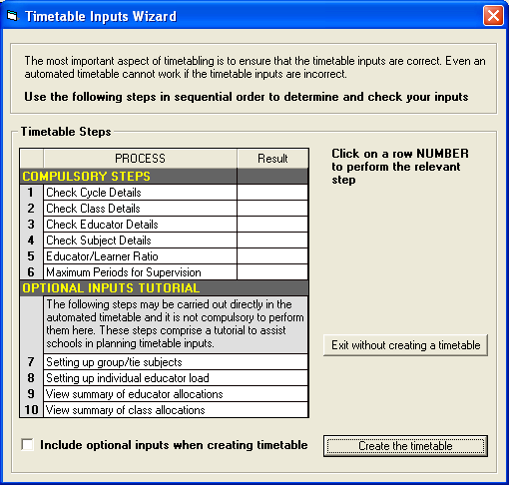

The data in SAMS will be displayed to you as in the next window.
Once the data is correct, click on the box “Cycle details checked and correct” and then click “Done”

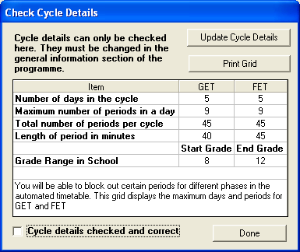

Do this until all results are “Checked” and “Done”
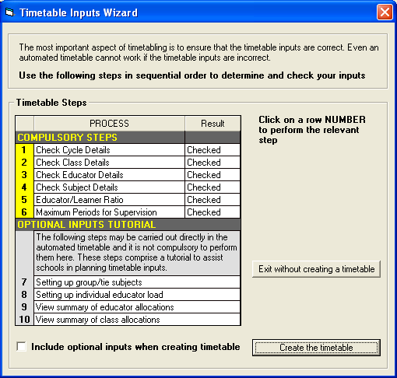

The next window explain how to create groups and ties for subjects
Use the dropdown lists to make selections
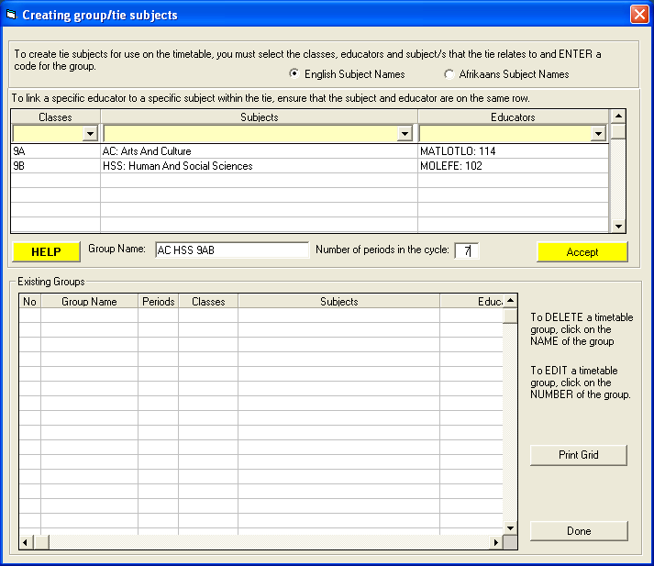

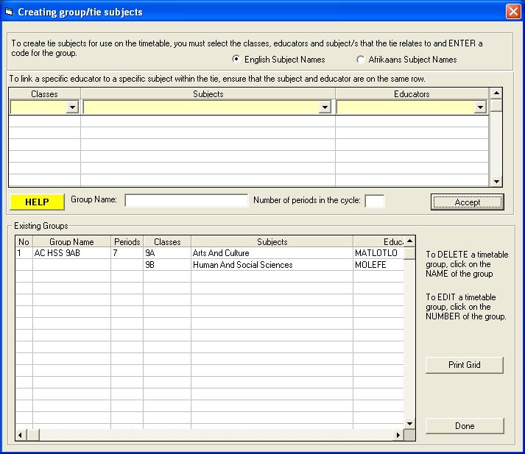

Select the subjects per educator as in the next window.
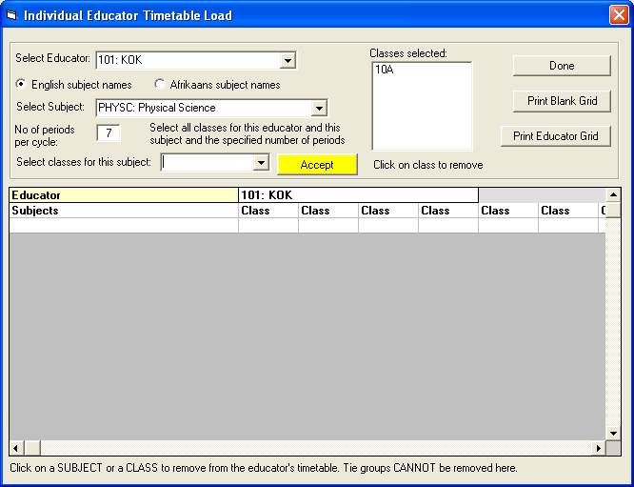

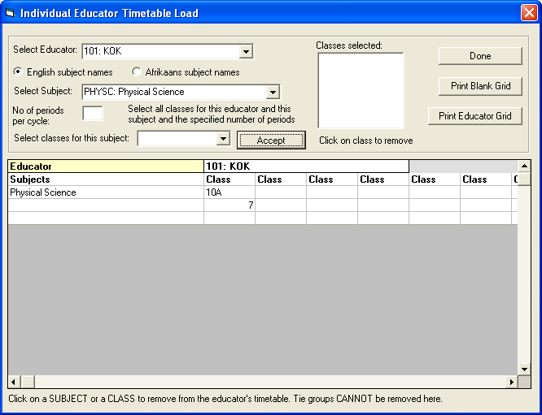

Check the Educator allocations when finished and determine over or under utilized educators.

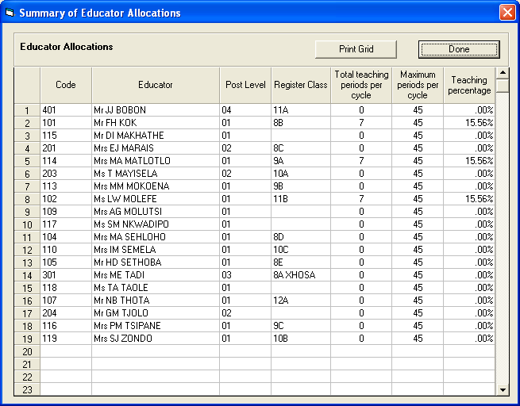
Quick Start

TimeDesign attempts to solve your program automatically. To achieve this, you follow the basic steps outlined below.
- Configure the days and periods.
- Add any miscellaneous periods.
- Set up your master timetables/templates.
- Enter your educators.
- Enter your classes.
- Enter your rooms.
- Enter your subjects.
- Combine educators, classes, rooms, and subjects to form logical groups.
- Edit the criteria for the newly created groups.
- Copy the master timetables/templates to the rest.
- Solve the timetable.
- Print the tables or transfer them to Excel.
That is all there is to it. On average, you should have a completed timetable within an afternoon.

File
New
Start a new timetable.
Open
Open an existing timetable.
Save
Save the timetable that you're working on.
Save as
Allow to to save the timetable with another name.
Import
Allow you to import version 2 timetables.
Exit
End the program.
Copy
These options allow you to copy from that level the template down to a lower level.
Help
Hints
Enable or disable the display of hints while you work.
Register
This one makes me smile.
About
This will display the version number and release date thus you can always check on the internet if you have the latest version.

Days and Periods.
Tutorial Link

Simply enter the names of the days and the periods as you want them displayed. The program will automatically increment the number of days or periods as required.
To edit a line, select that line either by using the arrow keys or clicking on it with the mouse cursor. You may either double click on the cell or press the 'F2' key to edit the existing information or you may simply start typing and the old information will be overridden.
You are not limited by the number of days or periods in the timetable.
Please Note:
The program assumes that all period lengths are the same when it tries to solve the timetables. You may however tag a period as a non-standard period if you assign it as a miscellaneous period.

Miscellaneous Periods

Simply enter the names of the miscellaneous periods as you want them displayed.
To edit a line, select that line either by using the arrow keys or clicking on it with the mouse cursor. You may either double click on the cell or press the 'F2' key to edit the existing information or you may simply start typing and the old information will be overridden.
You are not limited by the number miscellaneous periods in the timetable.
Please Note:
The program sees the miscellaneous period simply as a place holder within the timetable. In allocating multiple contiguous periods, the program will assume that its safe to span this period. i.e. English, Break,

Master Timetables Overview

This could actually be classed as templates. You would configure all the items that occur to the entire school/institution and then copy this to the lower levels.
You could have for example, the period 3 on day 2 of the educators master set for a staff meeting, and for the classes, this set as a study period. You would then copy the educator master to the educators and the class master to the classes.
You still the the ability to personalise individual timetables of educators, classes, rooms, subject, and groups.
Configuring these timetables is simply a matter of selecting the required period or periods(you may hold the left mouse button down to select a row or rectangular region), and right clicking the mouse for a pop-up menu of choices.
Once you have done this, you may then copy this down to the lower levels.
Please Note:
New educators, classes, rooms, subjects and groups begin with a blank timetable and do not inherit anything from the master tables. You have to explicitly copy the master to the lower levels.

Educators Overview

The educator page consists of two sections, the left side where you enter the educator names, and the right side where you either view the educator's details, or personalise the selected educator's timetable e.g. for 'mornings only' educators, or headmasters or headmistresses that might need certain periods for administrative purposes.
Entering or adding an educator is simply a matter of selecting and typing in the last blank row on the left. You have the ability of either sorting the educators( right click and choose sort), or dragging the educator to a new position(click the number in the left column, and while holding the mouse button down, drag the row to it's new position).
As the newly entered educator now has a blank timetable, I would suggest first entering all the educators, classes, subjects, rooms and groups, then copying the relevant master timetables, and then personalising the individual timetables.
Once again to personalise the individual timetable, simply select the period or periods, right-click the mouse, and choose from the pop-up menu.
The details button, will swap the timetable with information regarding the educator.
Please Note
Anything in yellow indicates a warning, e.g. missing information or groups where all the periods have not been slotted in yet. Anything in red, indicates potential problems, e.g. more periods needed by the educator/ class/ subject/ room/ group than what is available in the personalised timetable.

Classes Overview

The class page consists of two sections, the left side where you enter the class names and the number of learners in the class, and the right side where you either personalise the selected class' timetable e.g. for 'mornings only' classes.
Entering or adding an class is simply a matter of selecting and typing in the last blank row on the left. You have the ability of either sorting the classes( right click and choose sort), or dragging the class to a new position(click the number in the left column, and while holding the mouse button down, drag the row to it's new position).
As the newly entered class now has a blank timetable, I would suggest first entering all the educators, classes, subjects, rooms and groups, then copying the relevant master timetables, and then personalising the individual timetables.
Once again to personalise the individual timetable, simply select the period or periods, right-click the mouse, and choose from the pop-up menu.
The details button, will swap the timetable with information regarding the class.
Please Note
Anything in yellow indicates a warning, e.g. missing information or groups where all the periods have not been slotted in yet. Anything in red, indicates potential problems, e.g. more periods needed by the educator/ class/ subject/ room/ group than what is available in the personalised timetable.
Rooms Overview

The room page consists of two sections, the left side where you enter the room names and the class capacity, and the right side where you either personalise the selected room's timetable e.g. for 'mornings only' rooms.
Entering or adding an room is simply a matter of selecting and typing in the last blank row on the left. You have the ability of either sorting the rooms( right click and choose sort), or dragging the room to a new position(click the number in the left column, and while holding the mouse button down, drag the row to it's new position).
As the newly entered room now has a blank timetable, I would suggest first entering all the educators, classes, subjects, rooms and groups, then copying the relevant master timetables, and then personalising the individual timetables.
Once again to personalise the individual timetable, simply select the period or periods, right-click the mouse, and choose from the pop-up menu.
The details button, will swap the timetable with information regarding the room.
Please Note
Anything in yellow indicates a warning, e.g. missing information or groups where all the periods have not been slotted in yet. Anything in red, indicates potential problems, e.g. more periods needed by the educator/ class/ subject/ room/ group than what is available in the personalised timetable.

Layout Overview

This page allows you to create, edit and delete groups visually.
The groups pane will always have a 'New Group' option as the last item. To create a new group, simply drag the educators, classes, rooms, and subjects onto the 'New Group' item. You may double click the group name to bring up a window that will allow you to set the group's criteria.
To remove a group or an educator/ class/ room/ subject from the group, simply select it and drag it to the trash-can below.
The groups are as simple or as complex as what you want it to be. It can consist of a single educator with nothing else added, to a group consisting of x number of educators, y number of classes, z number of rooms, and w number of subjects where x,y,z,w can range from zero to about 32000. Once again, it is as simple or complex as you require. If you don't need to specify the rooms, leave it out, if you only need control of the computer center or laboratories, that's all you need to enter.
You now have the ability to lock the educator/class/subject and or room and set the default
Min/Day, Max/Day and Per Cycle values. This allows for the easy creation of simple group
combinations.
My definition of a group would be: a logical combination of educators, classes, rooms and subjects that all require x amount of periods at the same time.

Groups Overview

The group page consists of two sections, the left side where you enter the group names, and the right side where you either view the group's details, or personalise the selected group's timetable e.g. for 'mornings only' groups.
Entering or adding an group is simply a matter of selecting and typing in the last blank row on the left. You have the ability of either sorting the groups( right click and choose sort), or dragging the group to a new position(click the number in the left column, and while holding the mouse button down, drag the row to it's new position).
As the newly entered group now has a blank timetable, I would suggest first entering all the educators, classes, subjects, rooms and groups, then copying the relevant master timetables, and then personalising the individual timetables.
Once again to personalise the individual timetable, simply select the period or periods, right-click the mouse, and choose from the pop-up menu.
The details button, will swap the timetable with information regarding the group.
Please Note
Anything in yellow indicates a warning, e.g. missing information or groups where all the periods have not been slotted in yet. Anything in red, indicates potential problems, e.g. more periods needed by the educator/ class/ subject/ room/ group than what is available in the personalised timetable.

Exclusions Overview

This is where you can configure mutually exclusive groups for the same day.
For example, if you want to ensure that English and Maths for Grade 8a never happens on the same day, you could tag column a for both of these groups.
You are not limited to in any form, you could for example ensure that English does not happen on the same day for two classes as well as the above example. It would simply be setting column b for the two groups in question. ( if column a was not in use, you could have used that column).

Reports Overview

You have the ability to transfer the timetables and other pertinent information into an Excel spreadsheet where you can then personalise it further, i.e. add colours, create graphs, etc.
Simply select what you want in the spreadsheet and the program will transfer it into Excel..
I preferred to use Excel as firstly nearly everyone has it, and secondly you may modify the information to your requirements.
Note:
Unregistered programs will be able to print the first two timetables only.

Days and Periods.

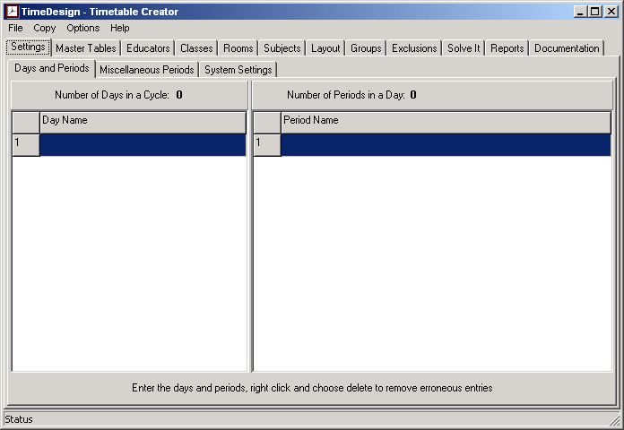
Upon start-up, you are presented with a screen like the one above. This is where you will enter the names that you want for your days and your periods. If your cycle consists of 5 days, you will most probably use Monday thru to Friday. For a two-week cycle, you could use 'W1- Monday' thru to 'W2 - Friday' for example.
The program will automatically increment the number of days and the number of periods as you start entering.
If you have accidentally entered too many days or periods, you may right click on either the days column or the periods column, where you will be given the option to delete the last day or period. Click anywhere else except on the pop-up menu to cancel this option.
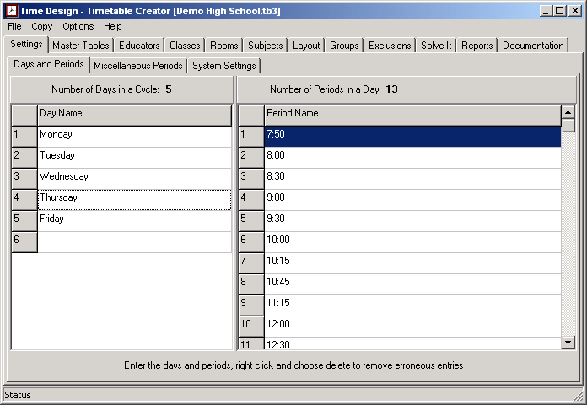
An example of days and periods added in.

Miscellaneous Periods

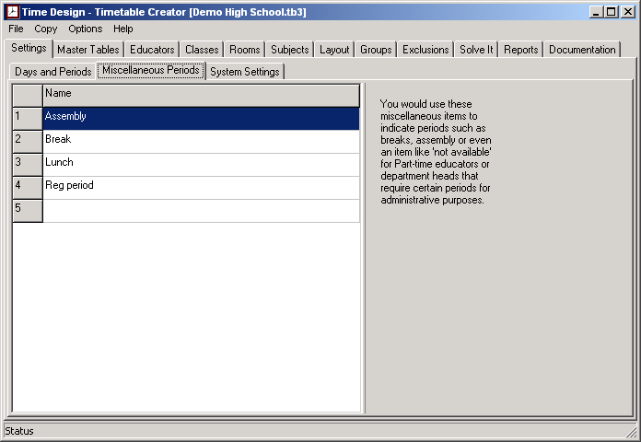
Enter any miscellaneous period descriptions that are not attached to any Educator or Subject i.e. Break, Assembly, Staff Meeting, etc.
The Master Timetables

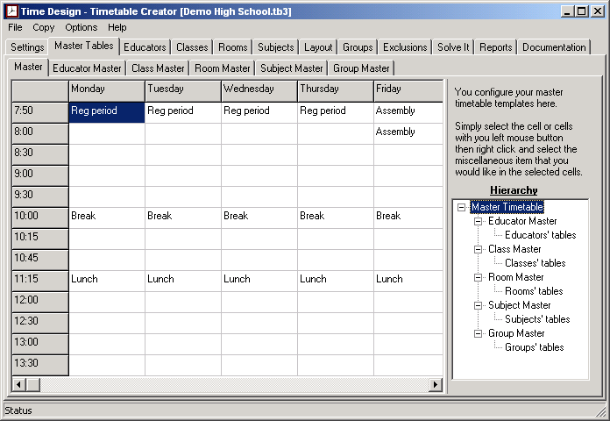
Select the periods in the grid by mouse, Right click for a pop-up Menu of your miscellaneous periods, and choose the one for the options. You may also 'block select' by dragging your mouse across the row or column before right clicking.
Once you are done, select 'Copy - Master Timetable to All' from the menu. This copies the Main timetable layout to all the others.
You can select the other master timetables from the tabs. Here you may add extra miscellaneous periods to the other timetables. If you do, don't forget to copy that master timetable to the individuals concerned.
You also have the ability to allocate miscellaneous periods to classes, educators, rooms, subjects and groups on an individual level, for example, if an educator can only give classes in the morning until 10 am, you can create a miscellaneous period called 'reserved' and allocate this to the periods after 10 am for that educator.

The Educators

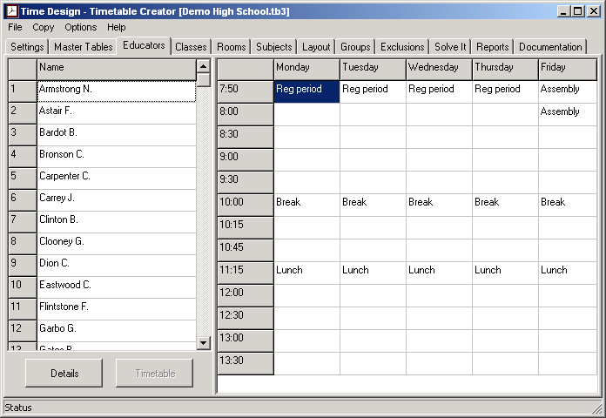
You would enter the Educator names in the column on the left side, as this is purely a timetable creator and not a database, I have not worried about first name, last name, telephone, etc.
Simply enter the names, as you would like to see them on the output. Ensure that each name is unique, as two Mr. E. Green's would be ambiguous as you enter more information.
The Educator information shows to which groups the educator belongs and cannot be changed from this screen. Don't forget to save. Pressing the 'F2' key or clicking on the selected row will allow you to edit the name. Any potential conflicts would highlight the information on the right in yellow and tag the problem with an asterisk.
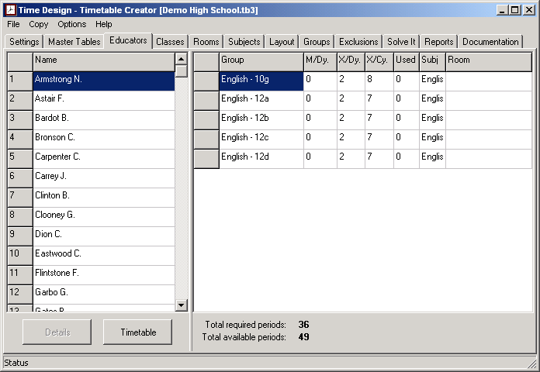

The Classes

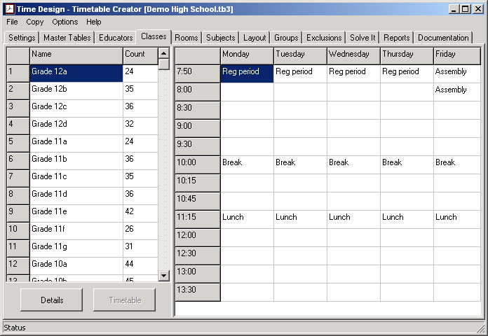
As can be seen, the Classes screen works the same as the Educator screen. We now capture the classes and the number of pupils in the class. Don't forget to save. Any potential conflicts would highlight the information on the right in yellow and tag the problem with an asterisk.
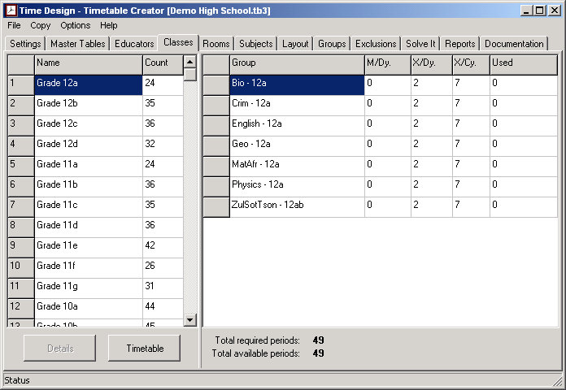
The Rooms

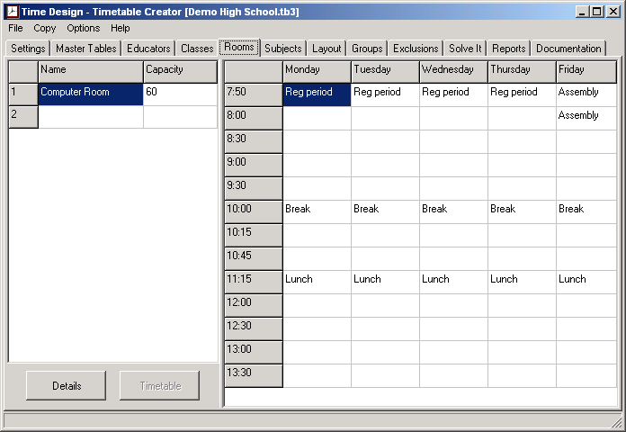
The Rooms screen also works the same as the Educators or Classes screen. We now capture the rooms and the capacity of the room. Don't forget to save. Any potential conflicts would highlight the information on the right in yellow and tag the problem with an asterisk.
You need only enter rooms that are shared by multiple educators. You could also use this to share other resources such as overhead projectors if need be.
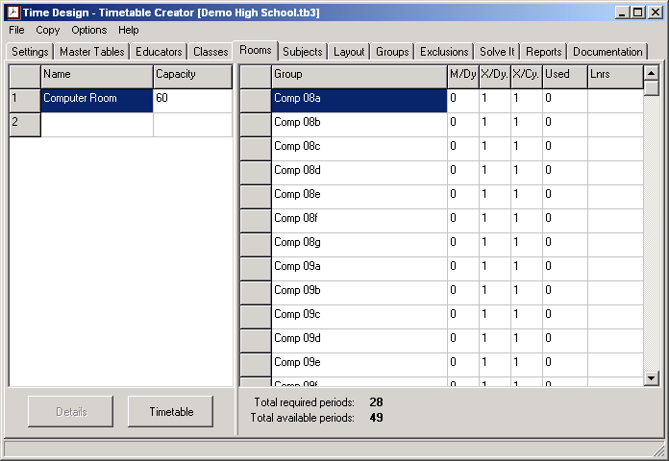

The Subjects

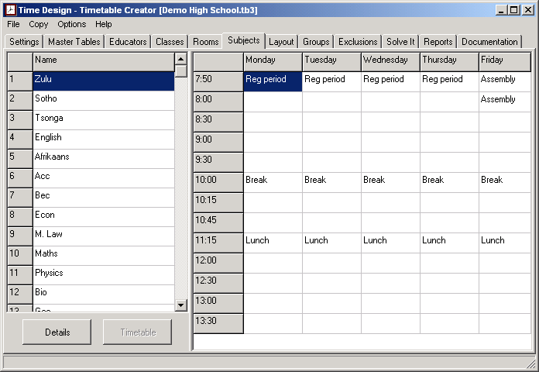
The Subjects screen also works the same as the previous screens. We now capture the subject names. Don't forget to save. Any potential conflicts would highlight the information on the right in yellow and tag the problem with an asterisk.
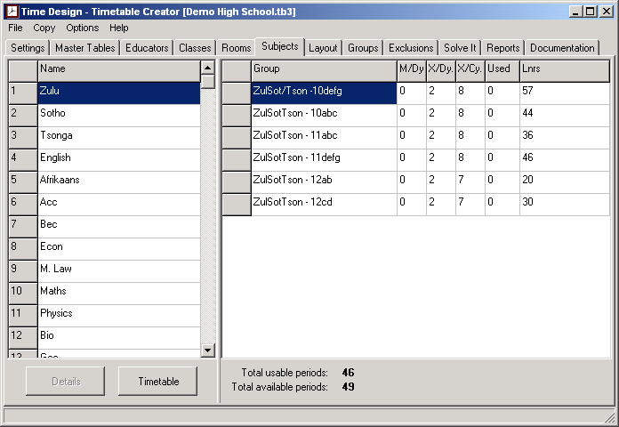
The total usable periods does not have to be less than the total available periods for the subjects. It simply gives an indication of the total number of periods used by the subject since multiple groups can be taught that subject simultaneously.

The Layout

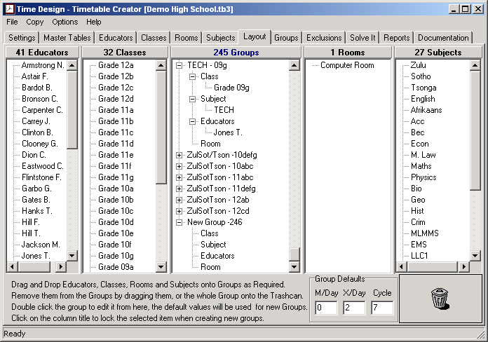
This screen is where you will most probably spend most of your time. As the concepts of grouping are quite in depth, I will not cover it here, but you can follow it via the following link Groups in more detail Here I want to concentrate more on the workings of the layout window.
The last group displayed, will always be the blank group where you will drag the educator, class, room and subject onto. This will append a new blank group on the end and the process is then repeated.
To speed things up, you can enter in the group defaults that will be used on the groups that are created. These defaults can be changed as required before the next batch is entered. You also have the 'Options - Quick Group Label' menu option which will provide a default label for the group based on the subject and class name.
To remove a group or an educator, or class, or room, or subject from a group, select it and drag it to the trashcan in the bottom right.
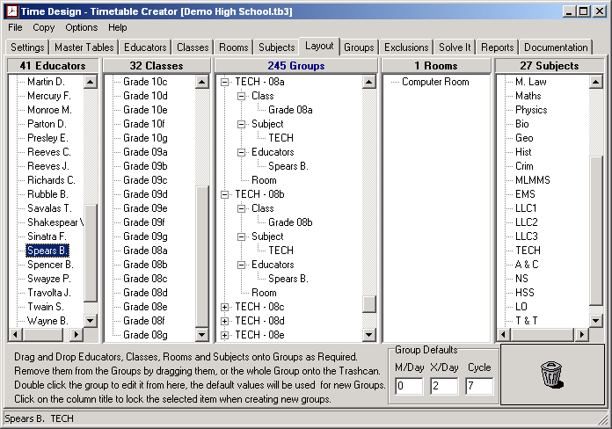
Looking at the above image, you will see that 'Spears B.' was selected, and then the column (where it says '41 Educators') was clicked. The same was done to the Subjects Column with the subject 'TECH' selected. This effectively locks these two columns as shown in the status bar at the bottom. By dragging 'Grade 8a' onto the 'New Group' label then 'Grade 8b' onto the next 'New Group' Label this effectively adds the educator and the subject at the same time, once again saving you a bit more time. To unlock the column, simply click on the column heading.
You are able to 'Lock' any of the columns except for the groups column.

The Groups

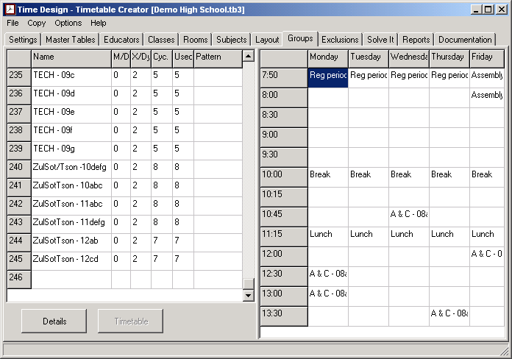
You could add groups here like the previous screens, and then populate it via the layout screen, but I think it's easier and quicker directly from the layouts screen. Instead, use this screen to verify the 'Minimum periods per day', the 'Maximum periods per day', and the 'Number of periods per cycle' values. The details section, will allow you to enter the Subject and room that the educator will use (select the educator, right click, and choose from the pop-up menu). You would also enter the number of learners taking each subject by selecting the subject and entering the value accordingly. Simplex groups will have the information filled in automatically.
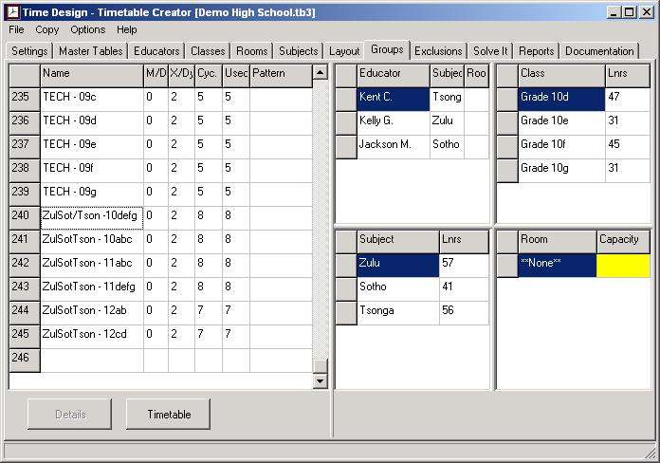

The Validation Screen

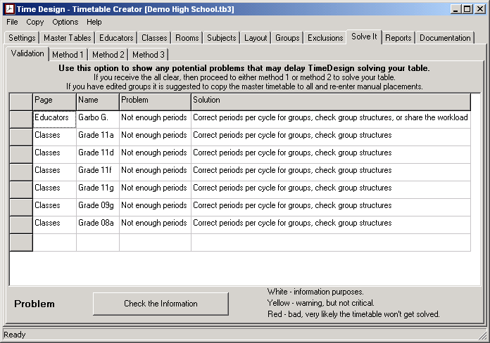
The validation screen will detect most of the basic errors and some of the more subtle errors. It will display the information and colour code it according to the severity. I would strongly recommend making use of this screen before attempting to solve your timetable.

The Solving Process

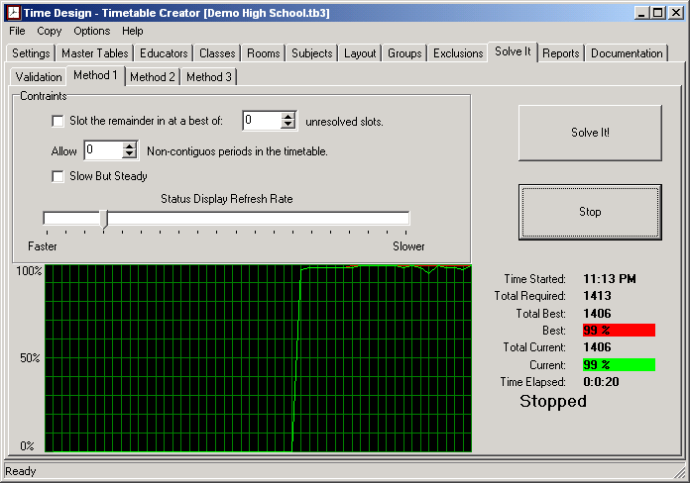
This is the heart of the program. Here the program attempts to solve the timetable. The graph displays the status of the solving process with the red line being the best solution so far and the green line, the current status.
The options available are:
Slot the remainder in at a best of x unresolved slots.
This will allow the solving engine to go one or two periods beyond the maximum for the day in an attempt to solve the timetable.
Allow x Non-contiguous periods in the timetable.
This will allow the solving engine to split the periods i.e. one in the morning and one in the afternoon, on the same day if it is unable to get two consecutive available slots.
Slow but Steady.
This will let the solving engine first attempt to slot as many multiple periods per day as allowed by the 'Maximum periods per day' setting for that group, as well as the catering for the 'Minimum periods per day' setting, before slotting in the remainder.
Status Display Refresh Rate.
This simply increases or decreases the display refresh rate. It has no impact on the speed that the program uses to attempt to solve the timetable.

The Reports

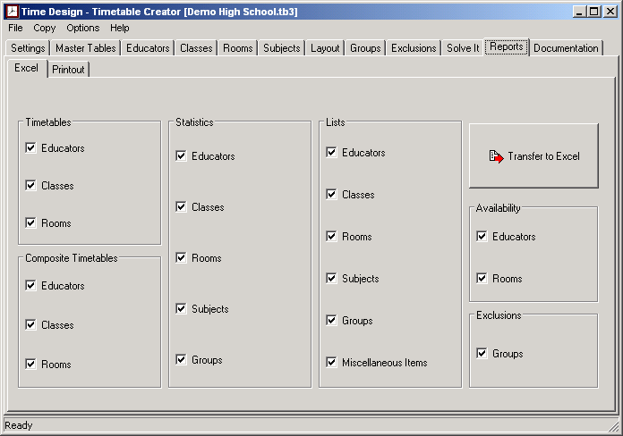
This allows you to transfer the information to Excel. In the near future, you will also be able to print the information directly from the program.
The reports available are broken into six groups namely:
The Timetables.
These are the standard timetables for the Educators, Classes, and Rooms.
The Composite Timetables.
These are the timetables that would be kept in the office. The information is grouped by day.
The Statistics.
This group lists the information along with the workload or utilisation of that resource. You would very likely use these reports to ensure that the workload is distributed fairly amongst your educators.
The Lists.
This will provide you with the basic information as entered into the system.
The Availability Lists.
These lists will help you allocate Educators to look after Classes where that Educator is absent.
The Exclusion List.
This will show you how you have configured any mutually exclusive groups.

Groups in more detail

Groups can be defined as a logical set containing educators, classes, rooms and subjects that have to be available at the same period of time for a certain number of times.
I have tried to leave it as flexible as possible without impeding on the functionality of the program. It is entirely up to you how complex or simple you would like them.
Most of the calls for support stem from the misunderstanding of the way the grouping is meant to take place in TimeDesign. I hope that this document will enlighten you and make your timetable planning easier.
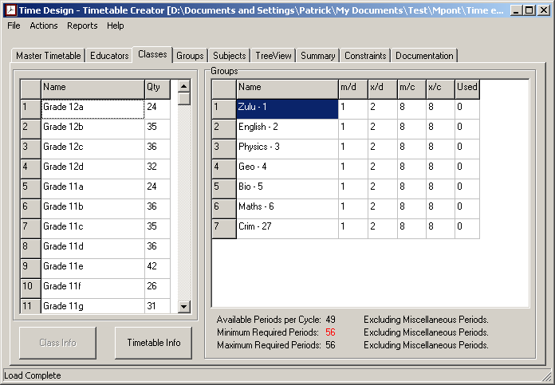
As can be seen from the information in the circle, the minimum number of periods required for this class is fifty six whereas the class only has forty nine available periods in the cycle (this is the available periods AFTER the Master timetable has been copied to the classes). This is an immediate indication that either the grouping has not been done properly or too many periods have been allocated to each group. In the above case it was actually the latter and by reducing the minimum periods per cycle to seven, we had a perfect allocation of periods to forty nine.
I define a group as the educator or educators and the class or classes involved that all need to have the same period or periods available for this group to reserve that period or periods for itself.
You are able to configure a variety of different types of groups and I will attempt to show you some different combinations.
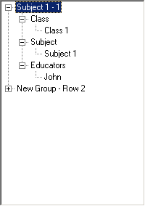 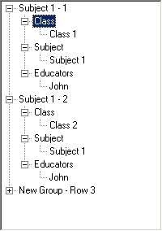
This kind of group is what the bulk of your groups will be made up of, a single class, with a single educator and subject. You can see, the picture on the right shows the same educator, the same subject and a different class. This is the correct way to do your basic groupings. Here just the educator and the class involved need blank periods in common for the program to slot the group into.
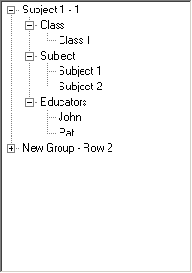
This group is a single class that gets split up, i.e. half the class goes to one subject and the other half goes to another. Here both educators and the class must have blank periods in common for the program to slot the group into.
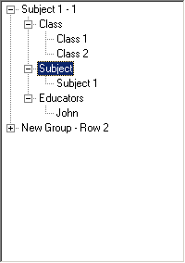
This group is two classes where both classes go to one subject with a single educator at the same time. Here the educator and both the classes must have blank periods in common for the program to slot the group into.
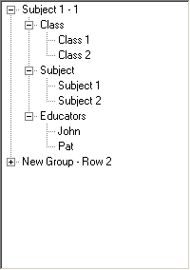
This group consists of two classes where half of each class goes to one subject and the other half goes to another. Here both educators and the classes must have blank periods in common for the program to slot the group into.
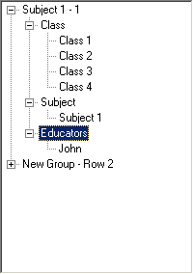
This is another extreme example where you can have four classes going to a single educator for a single subject.
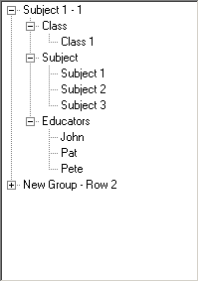
This time a single class is split into three smaller units each going to a different educator.
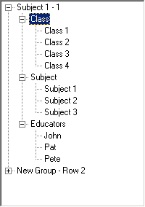
Here we have four classes being split up into three sub classes going to the relevant educator. Once again all three educators and all four classes need to have blank periods in common for this group to get slotted into.
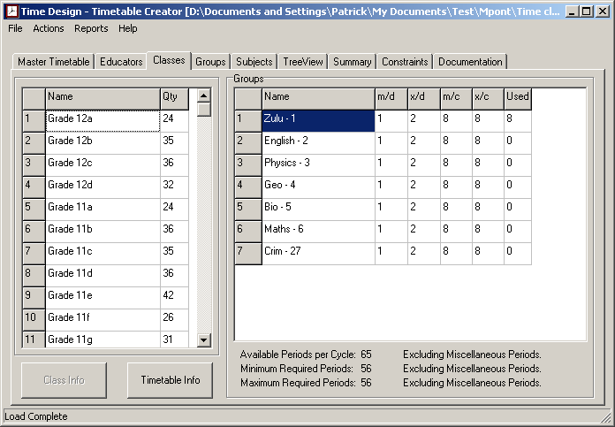
This last image shows that either the Master timetable with the breaks and assembly has not been copied to the classes and educators( Menu Actions - Master TT to All) or not all the groups have been created for the class or finally the minimum number of periods per cycle need to be adjusted to cater for the excess free periods of the class.
The bulk of your groups would consist of a single class, a single educator, the subject taught, and the room used, but as you can see, you decide what's going to suite your requirements best.

The Master Timetables

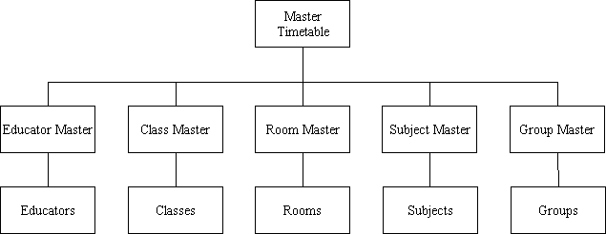
You would use the Master Timetable to create your initial timetable. If your educators had a staff meeting on Friday afternoons while the learners left early, you could modify the Educator Master and the Class Master accordingly before copying these to their respective destinations. You also have the ability to modify the lowest level of the timetables based on their requirements. i.e. the headmaster's timetable could be either blocked or a miscellaneous period assigned to the periods that he or she would not be available.

Re-using Old Timetables

Over time, your timetable information will need to be updated. If it is simply one educator being replaced by another, you could simply change the old educator's name in the Educator Screen and it will be updated throughout. Most times it would be more complex than that.
This is how I suggest you go about it:
- Remove all computer entries via the menu 'Copy - Clear Computer Entries'.
- Remove any manual group placements that may be affected.
- If you don't have many changes from the Master Timetable, it may be quicker to copy this to all.
- Delete, Rename or add affected educators, classes, subjects and rooms.
- In the Layout Screen, remove or modify any affected groups.
- In the case of additions, you will have to copy the associated master timetable to that sublevel.
- You have the option not to overwrite existing Blocks, Misc. periods or Manual periods.
- Confirm the personalised timetables.
- Validate your information, this would also remove any 'orphaned groups' (groups where info has been removed).
- It may help to transfer the information into Excel for easier scrutiny.
- Finally Solve, transfer to Excel and produce the reports.

Period Control

You have the ability to control all the periods at the sub-levels. You could for example, ensure that technology is never the first or the last period of the day for all grades:
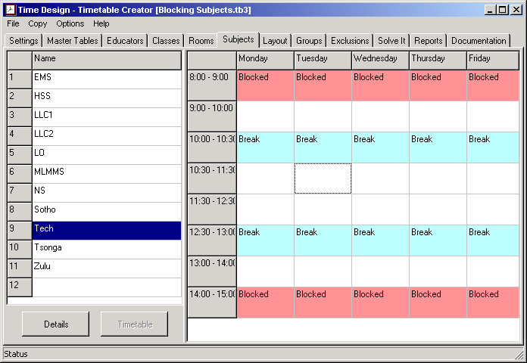
You can cater for part-time educators or Principals:
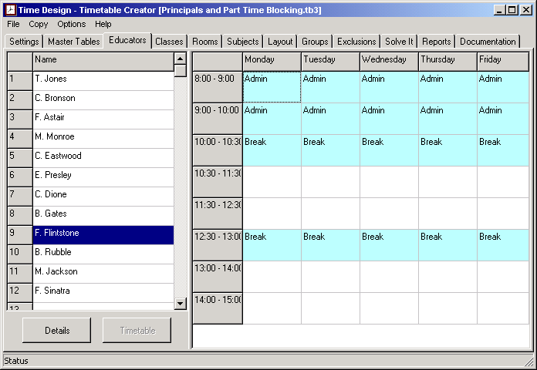
Possible other uses include blocking a room at certain times or forcing P.E. Classes to take place the period before breaks and home-time to allow the learners to shower.

Exclusions

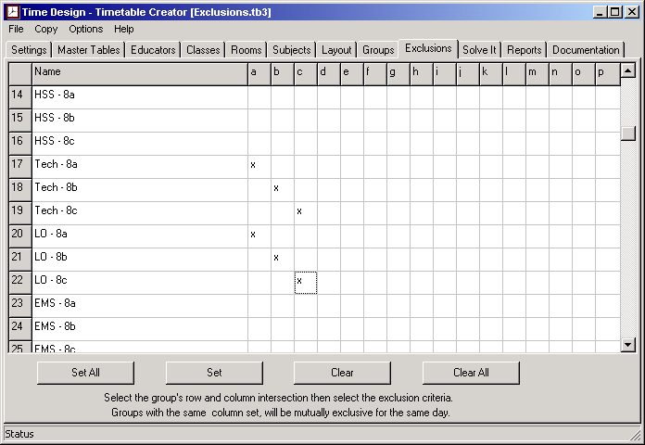
This screen allows you to configure mutually exclusive groups.
In the above example, 'Tech - 8a' and 'LO - 8a' cannot take place on the same day, however, on the day that 'Tech - 8a' is taught, any of the other groups could occur.
The same goes for 'Tech - 8b' & 'LO -8b' and 'Tech - 8c' & 'LO -8c'.
Below, you can see one of the possible outcomes.
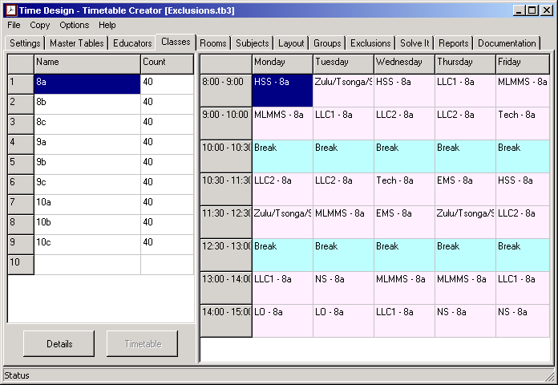
The Solving Engine

After two years of experimenting with various methods and algorithms, from brute force methodologies, through models of evolving life algorithms, to genetic algorithms with dynamic DNA structures, I could not get a method that worked well and consistently. Most of these methods worked well for simpler two dimensional type schedules, e.g. night shift, sport roster or bus timetables, but seemed to fall over when working with the multi dimensional concepts of the school timetables.
I eventually chucked all of these ideas out, sat down and devised a straightforward logical method, also based on nature, what I like to call Hierarchical Contention, or in simpler terms, the pecking order, be it a pride of lions, a troop of monkeys, or even the set of groups used in timetables. The engine emulates Mother Nature so closely that if you could see the battles that take place within the program, I would have to rate TimeDesign PG13 for violence.
Using this method, solving times have reduced dramatically, where the average South African high school timetables can usually be solved within seconds on today's entry level computers. Having played around with similar programs, I can quite confidently say that the solving engine is one of the best and fastest available.

System Settings

NOT AVAILABLE IN THE FIRST VERSION OF FSDoE
Imagine a pride of lions all sitting under a large tree. The Leader usually takes the best spot with the rest fitting in according to their hierarchy in the pride.
TimeDesign tries to simulate this environment with the groups each given an initial level of strength based on the number of classes, educators, and rooms in the group. This initial strength level, then allows the program to do a first pass in slotting in the groups. On the next run, the groups that have not been slotted in get an increase in strength, then attempt to force out any groups that are now weaker. To ensure that a really strong group does not get stuck indefinitely in a period slot that might cause the table to be unsolvable, the program lets these groups die from old age, which basically means the group has to start again fighting it's way to the top.
The ideal solving environment is when you are able to keep the current line on the graph moving in a saw tooth fashion. Before each loop, the groups are resorted based on their strength, with the strongest getting first options.
The Parameters.
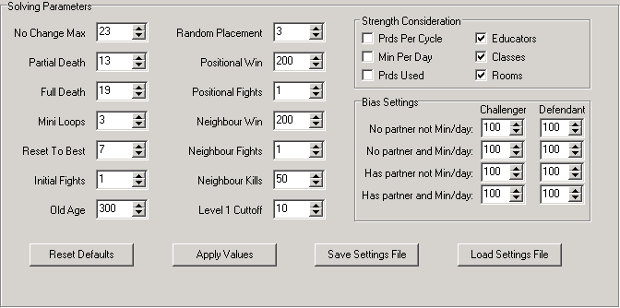
No Change Max.
If after x number of major loops with no improvement, all group strengths are set to their base level.
Partial Death.
The weaker half of the pride is removed. Strengths are kept the same.
Full Death.
The whole pride is removed. Strengths are kept the same.
Mini Loops.
How many loops take place before a major loop takes place.
Reset to best.
TimeDesign tries to allow potential new solutions to develop, if after x number of loops with no improvement, the best solution is used to continue with. Strengths are not reset.
Initial Fights.
How many times per mini loop the groups will strengthen and attempt to oust another group.
Old Age.
The age a group must reach before it dies a 'natural death' and restarts.
Random Placement.
If at least x blank periods are available on a day, the group to be randomly placed on one of them otherwise TimeDesign takes the first available blank period.
Positional Win.
Any group is only allowed to fight with another group if it is within x number of steps within the hierarchy i.e. the low ranking groups have to fight their way up the ladder.
Positional Fights.
This is similar to Initial Fights, the tenacity of the fighting group.
Neighbour Win and Neighbour Fights.
These are the same as the two above except that they come into action if the group already has at least one period slotted in a day, and is now attempting to get the prior or following period as well.
Neighbour Kills.
Sometimes, where the group already has on period slotted, it is unable to get the second period to make a double period. This allows the slotted period to get killed, thus allowing it to find a new spot where possibly it is able to get the double easier.
Level One Cut off.
This is used with the 'slow but steady' option to decide when the multiple periods and min/day periods have been placed then the rest are allowed to be placed.
Strength Consideration.
The checked options are taken into account when the group needs to be strengthened, if none are ticked, a basic strength increment is added to the group.
Bias Settings.
This is expressed as a percentage here. It indicates how strongly the program must take into account various scenarios.
You have the option to load and save different settings according to the style of timetable that you're working with. If you load new settings, it will only come into effect when you apply them. this allows you to preview different settings first. To cancel these loaded settings, switch to one of the other screens (not one within the settings tab) then switch back again.
Feel free to change these values as the values given are the result of months of testing and timing with a spread of different styles of timetables, it is possible to find values that are even better for your style of timetable.
You have the ability to reset the values to the defaults, so there is no chance of messing things up beyond repair.

