

SA-SAMS

Guidelines for using the Standard Letter and Forms module

September 2009

Education Management Systems (EMS)
Department of Education
Private Bag X895
0001 PRETORIA
CONTENTS

1. INTRODUCTION 3
2. GETTING STARTED 3
3. STRUCTURE OF STANDARD LETTER AND FORMS 4
3.1 Standardised Mail Merge Letter 5
3.2 Print Completed Application Forms 6
3.3 Parent Data Forms 6
3.4 Learner Data Forms 6
3.5 Printing Data For One Parent Or Learner 7
3.6 Learner Parent Export 7

- INTRODUCTION

Standard Letters & Forms incorporates the correspondence between all stakeholders and creates a record of all correspondence.

- GETTING STARTED

Select the Standard letter and forms button from the main menu to open.

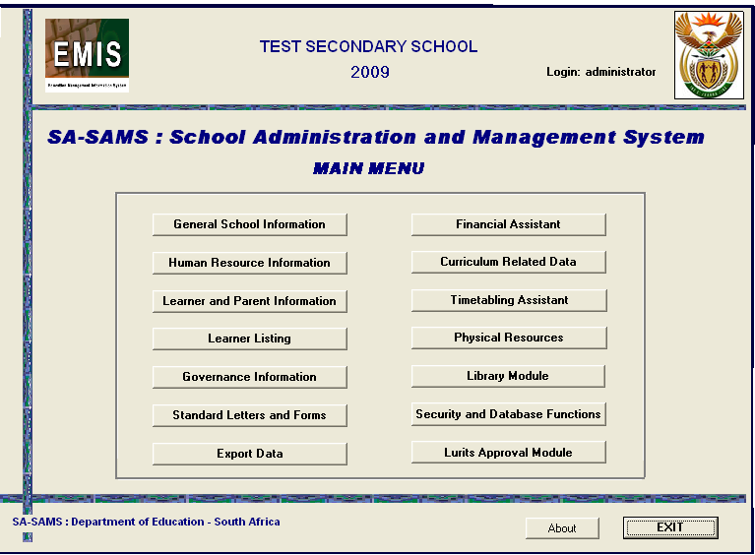
Figure 1: SA-SAMS Main Menu

- STRUCTURE OF STANDARD LETTER AND FORMS

To start the Standard Letters and Forms module on the SA Main Menu, click on Standard Letters and Forms button. The Select Letter or Form to Print menu below will open (Figure 2 below).

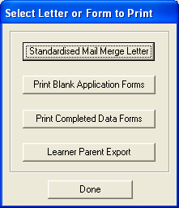
Figure 2: Select Letter or Form to Print

- In this section communication with all stakeholders can be maintained through the Standardized Mail Merge Letter option.
- Proactive measures for future registrations at schools can be implemented by making use of the Blank Application Form option.

  - Standardised Mail Merge Letter

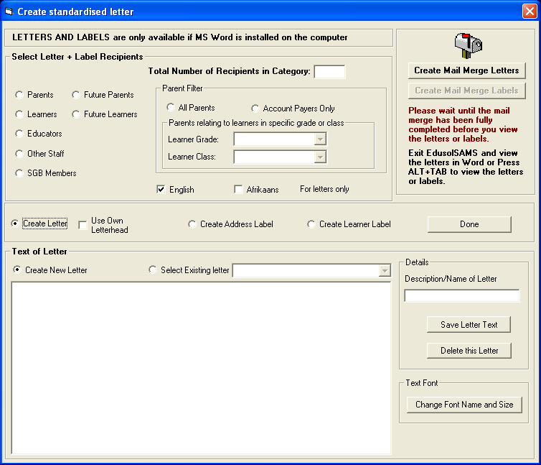
Figure 3: Create standardised letter

- Letters can be sent to a specific target audience by making the pertinent selection
- Parents and learners receiving letters have the filter option to narrow done the number of recipients
- There is a selection option to Create New Letter or to Select an Existing Letter
- For a new letter, type the heading of the letter in the Description/Name of Letter box
- Then begin typing the content of the letter in the space provided. Save letter text
- Once the letter has been typed select the recipients in the Filter section
- The number of recipients will be displayed in the box above
- Click on the button Create Mail Merge Letters, word document will open.
- Letters will show with the name of the recipient , the date and the salutation
- Select pages to be printed
- Existing letters can be used by updating information in the letter before selecting Mail Merge

  - Print Completed Application Forms

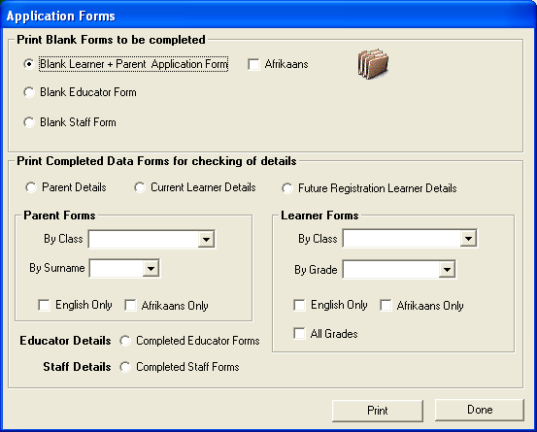
Figure 4: Application Form

- Click on Print Blank Application Forms button
- This option enables the user to print Blank Application or Registration Forms for use by the school
- Blank forms for learner and parent, educators and other staff can be printed and distributed to the relevant parties for completion so that when data capturing begins or if information needs updating it can be gathered in this way
- Alternatively, the user can also print learner and parent data already captured on the system.
- These printouts can then be given to the learners and parents to verify the accuracy of their data.

  - Parent Data Forms

- Parent data forms are printed by selecting the first letter of the parents’ surname (i.e. alphabetical printing)

  - Learner Data Forms

- Learner data forms are printed per grade.

  - Printing Data For One Parent Or Learner

- In order to print a data form for a specific parent or learner, select the relevant filter category and click on the Print button.
- The Printer Setup window will open. Select your printer options and click on the Ok button.
- The Print Preview Window will now open displaying the data for all the learners or parents in the selected category.
- Use the arrow keys to scroll through the data until the page containing the required data is located or use the search icon to locate the desired data. Print only this page.

  - Learner Parent Export

- Learner and parent export menu is used to view or export learner and parent information.

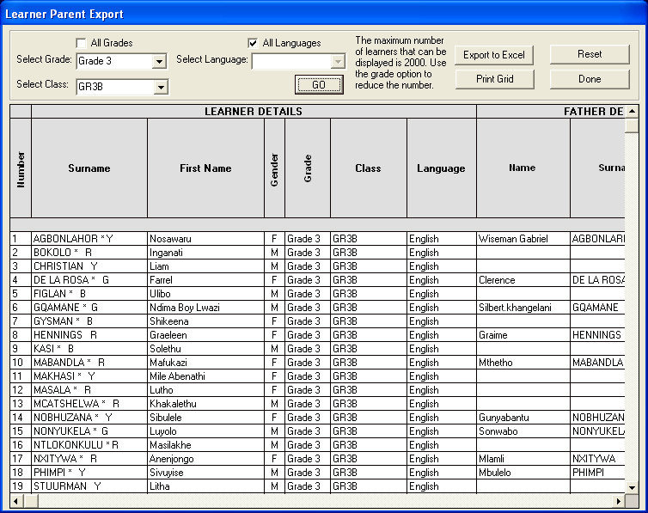
Figure 5: Learner Parent Export

- To create an export selects the relevant grade, class and language the click on the yellow Go button.
- To print the grid click on the Print Grid button
- To clear information on the grid click on the Reset button
- To create an export click on the Export to Excel Button and the following screen will appear

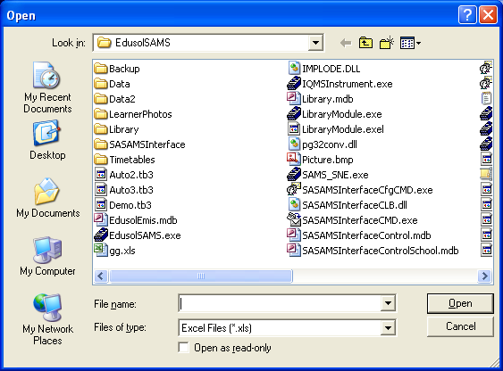
Figure 6: Create Export

- Type in the file name on the File Name text box and the following message will popup.

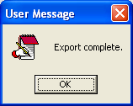

- The file you have created can be located on this path: C:\Program Files\EdusolSAMS

