Screening, Identification, Assessment and Support (SIAS) Manual

A. Assign disabilities to SNE learners

1. Click on Learner Listing button from the Main Menu.
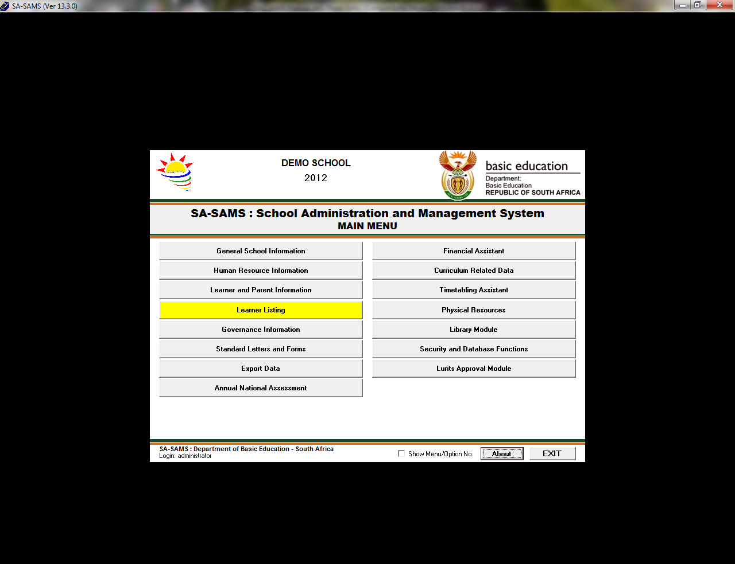

2. Select the SNE learner and click on View/Update Learner, the following screen will display.
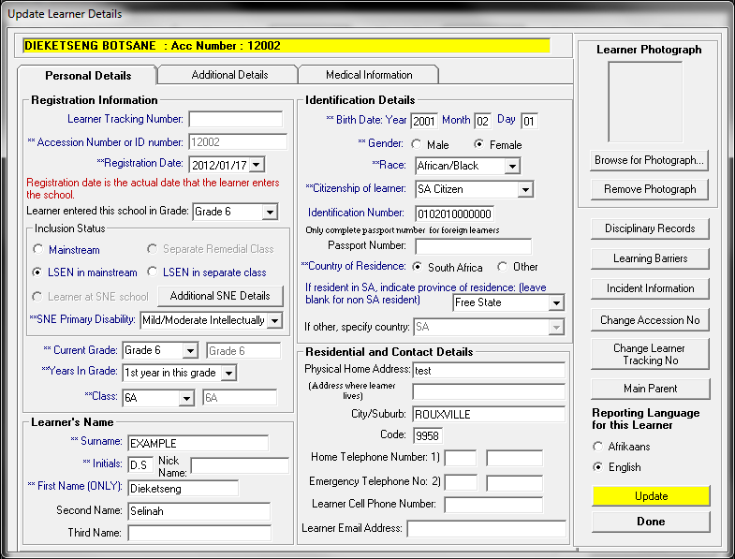
- Click on LSEN in Mainstream or LSEN in Seperate Class. NB: If a learner is in seperate class the learner's class will be LSEN not a normal class.
- Select the SNE Primary Disability . NB: If there are multiple disabilities, click on Additional SNE Details button in order to select them.
- Click on Update button.

B. SIAS for SNE learners

1. Click on Learner and Parent Information-->Learner Data Files Menu-->SIAS for SNE learners.
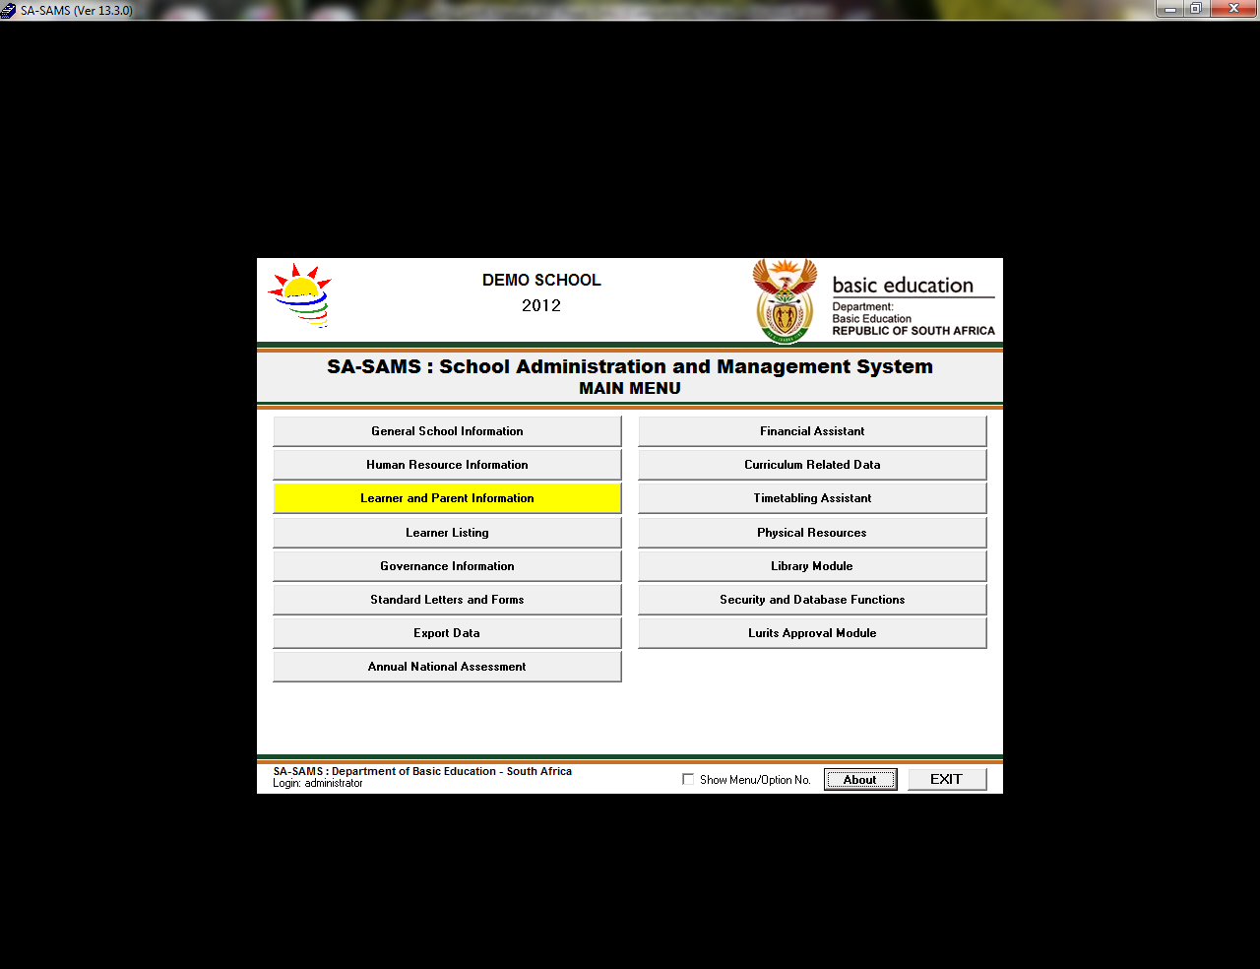

2. When clicking on SIAS of SNE learners button,this screen will display. The selected year is the current year and click on the Continue button.
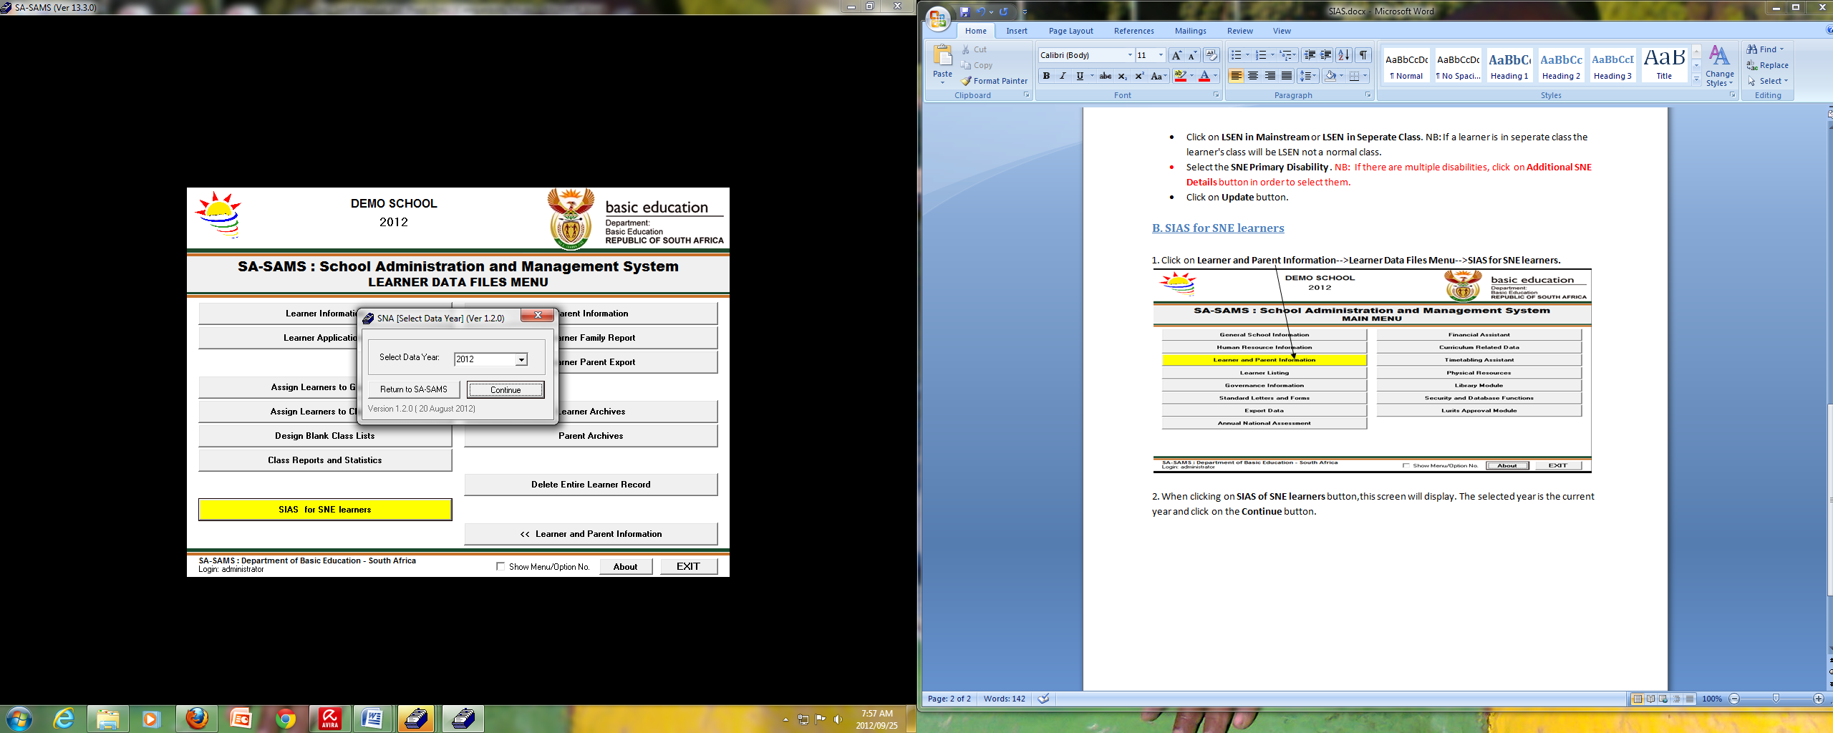

3. Select the learner you want to assess and click on the Support Needs Assessment button. NB: If a learner is not listed on the list box refer to how to assign disabilities to SNE learners.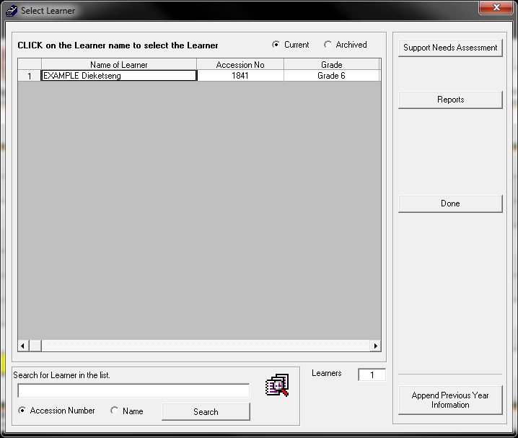

- If the learner 's information on SIAS was captured the previous year, Click on Append Previous Year Information button. The following screen will display:
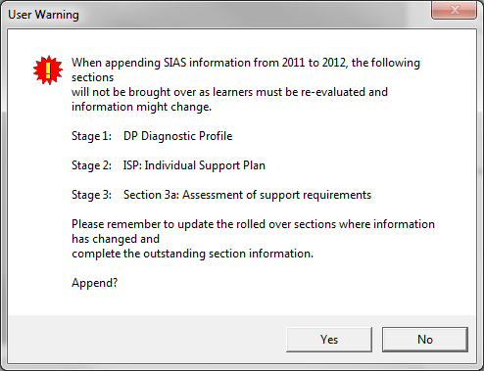

- If you click on Yes button, the following screen will display. It will tell tell you how many rows were added.
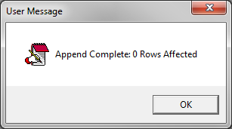

4. The following screen will appear. All four stages needs to be completed to capture the evaluation of the learner.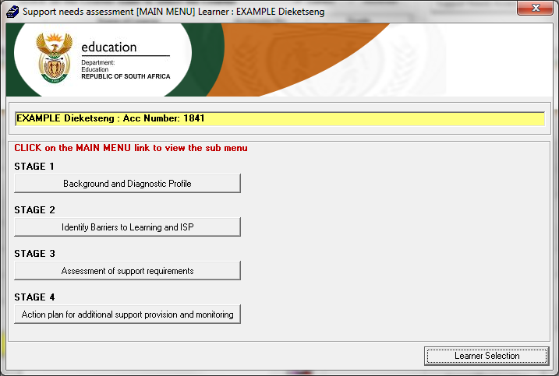

Stage 1: Background and Diagnostic Profile
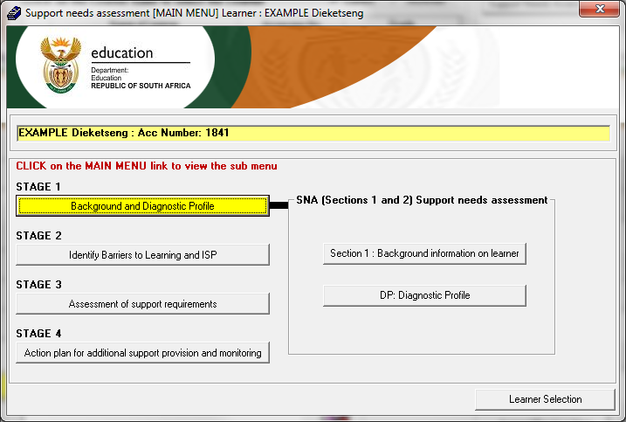
1. Click on Background information on learner button, the following screen will display. Enter required details in the various fields then click Save button.
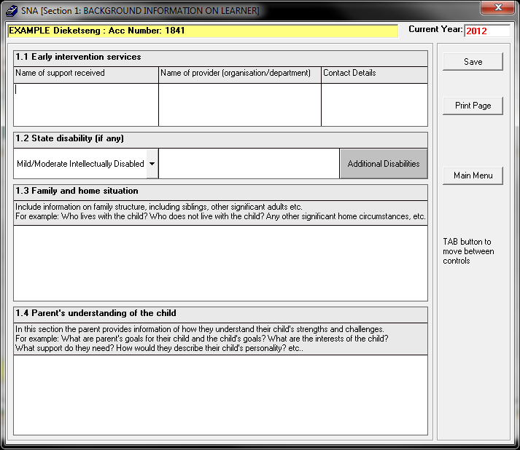
2. Click on Diagnostic Profile button, the following screen will display.
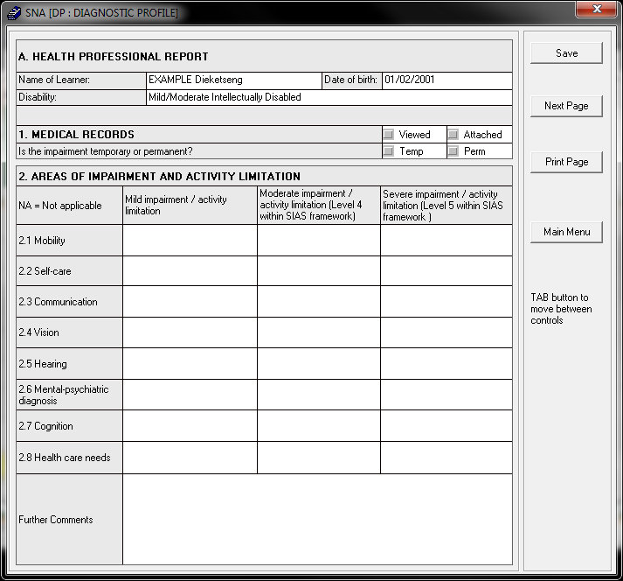
- Select the required medical records field.
- The screen is Read-Only therefore you cannot capture anything. This screen is a summary of the following pages in this section. Click on the Next Page button to move to the next page.
- The following screen will appear. Capture the a score according to the Activity limitations. Click on Save button.
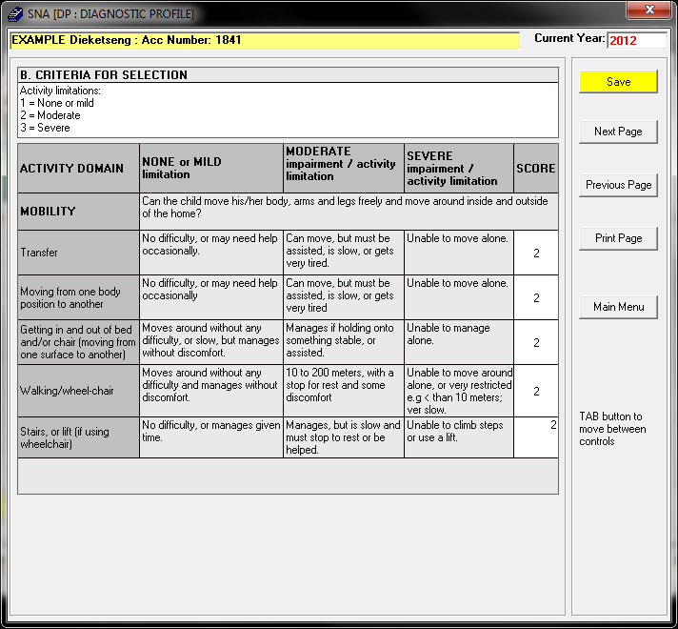
- Click the Next Page button, capture the scores and save information until there is no Next Page button displayed. Click Previous Page button to return to the first page of Diagnostic Profile. The summary of activity limitations will display as follows.
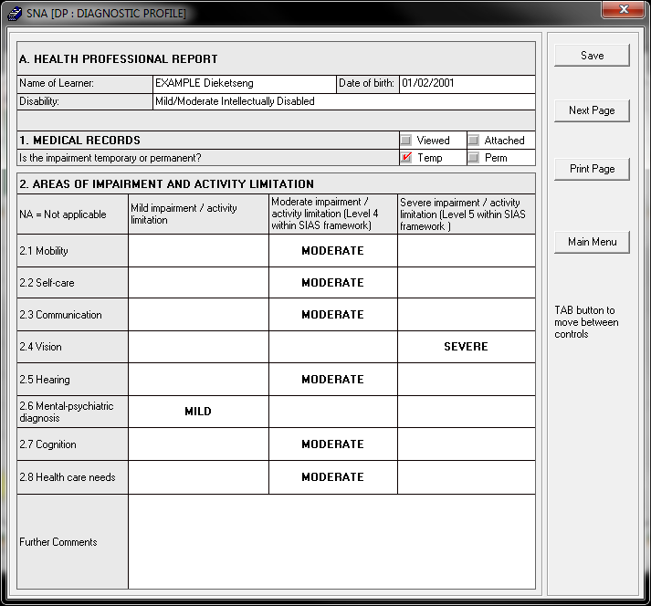

- Click the Main Menu button to return to the Stages.

Stage 2: Identify Barriers to Learning and ISP

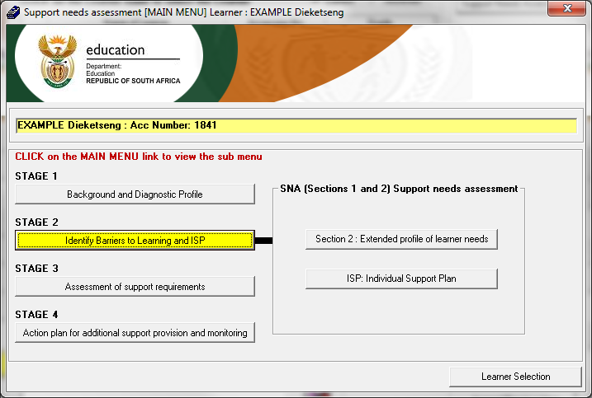
1. Click on Extended profile of learner needs button to display the following screen.
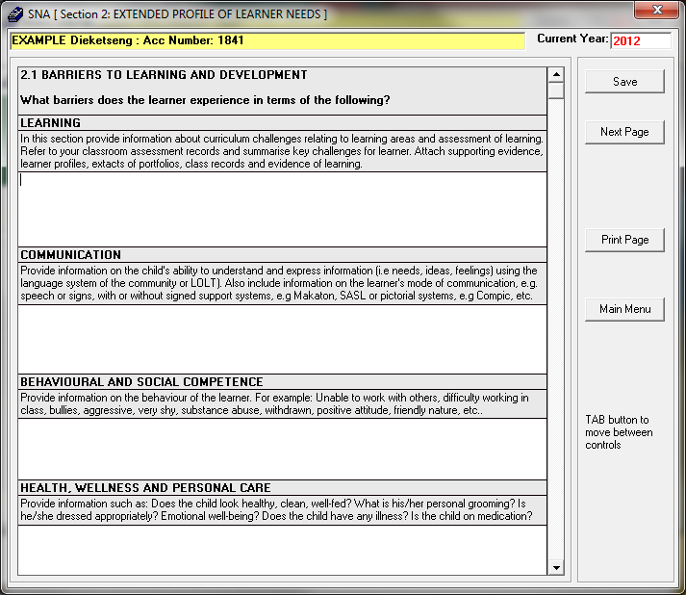
- Explain the barriers that the learner experience in terms of Learning, Communication, Behavioural and Social competence, and Health, Wellness and Personal care.
- Click Save and then click the Next Page button.
- The following screen will display:
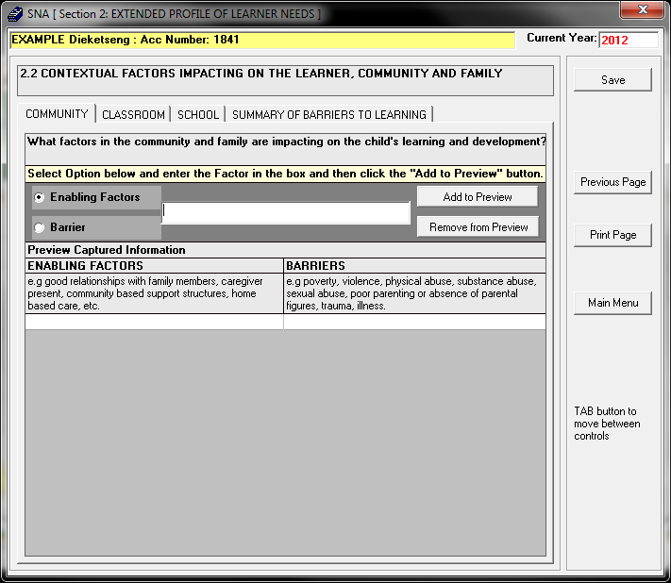
- Click on the Community button and then select the Enabling factor option.
- Type the Enabling factor of a learner in the text box and then click Add to Preview button.
- Click on the Barrier option and type in the learner’s barrier and then click Add to preview.
- Repeat the above steps for the Classroom and School buttons.
- Click Save button to view the Summary of Barriers to Learning button and the following screen will display.
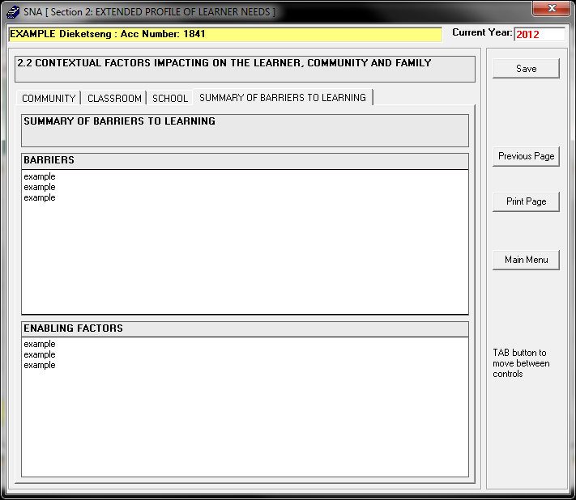

- Click on Main Menu to return to the Stages.
2. Click on Individual Support Plan button and the following screen will display.
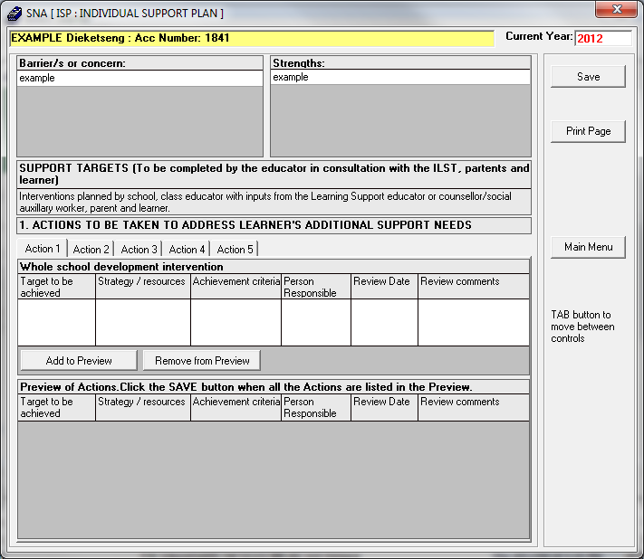
- Click on the action1 button and enter the required detail according to the individual support plan for the learner.
- Click on the add to preview button to add the information you have provided for the learner.
- Repeat the above steps for action2, action3, action4 and action5 menus.
- To remove the Preview:
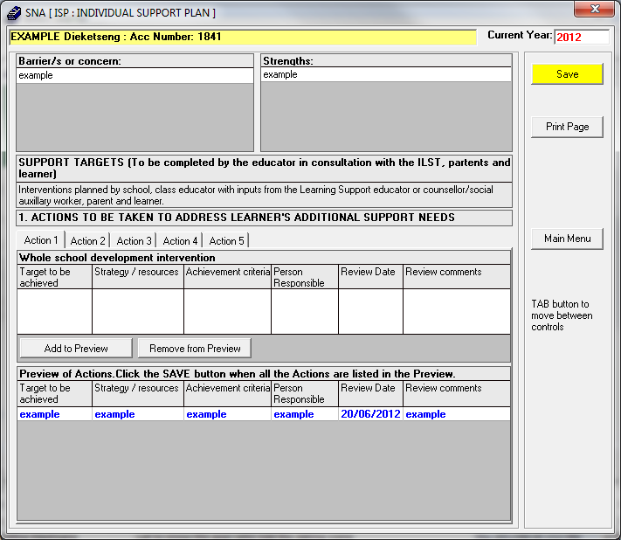
- Click on action 1, action2, action3, action4, action5 button, to view the support plan of the learner on the action list.
- Click on the support plan you wish to remove, the learner support plan colour will turn blue.
- Click on the remove from preview button and click on save button.

Stage 3: Assessment of support requirements

1. Click on Assessment of support requirements button, the following screen will display.
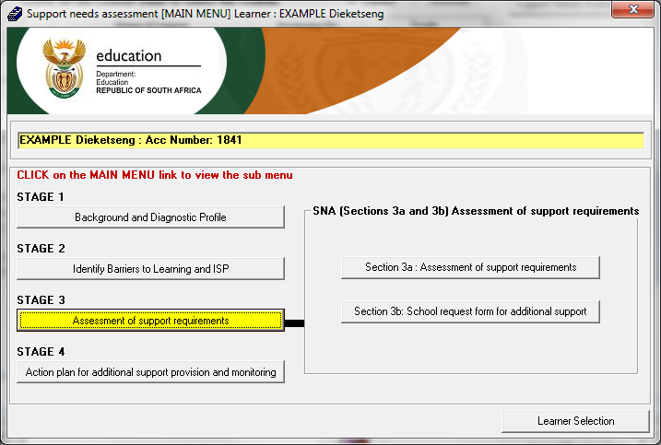
2. Click on Assessment of support requirements button, the following screen will display.
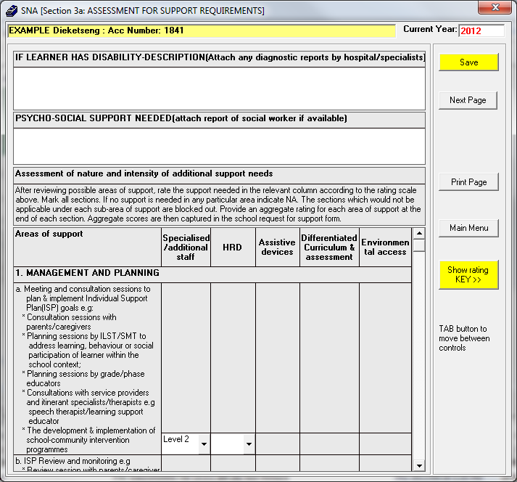
- To view the rating click on the show rating key button, the following screen displays. This are the definitions of each level. To hide the Show rating Key details, click on Hide rating KEY

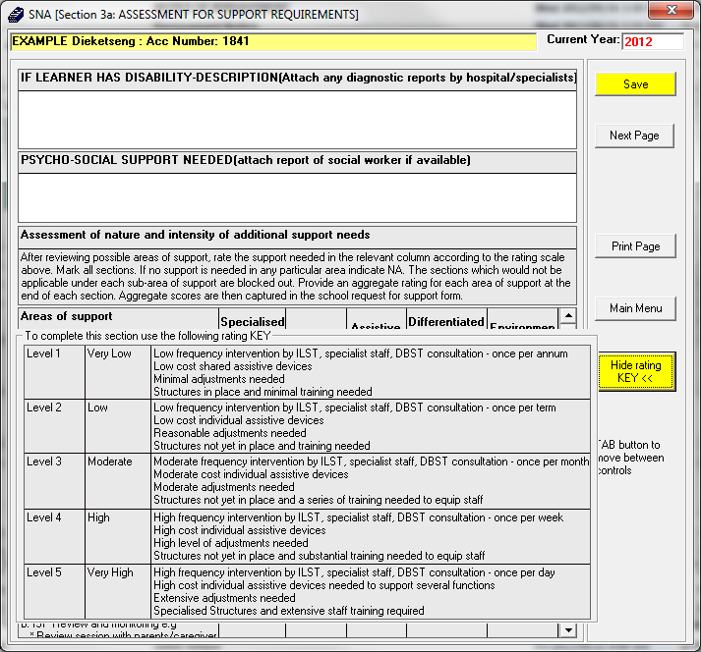
- Enter the required details for the learner’s report.
- Select the rating as per learner’s requirements.
- After you have captured the rating for the learner click on the Save button and then click on the next page button to move to the next page.
- The following screen will display:
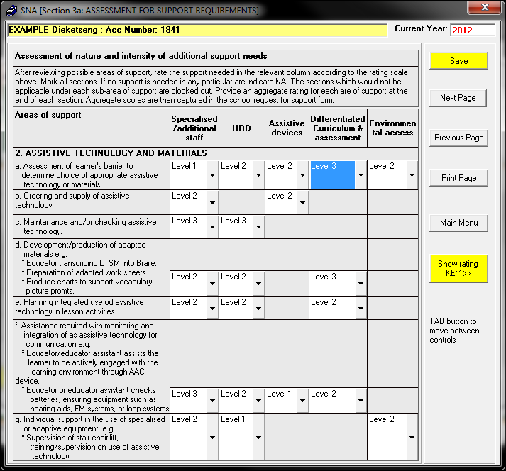
- Enter the required details for the learner’s report.
- Select the rating as per learner’s requirements.
- After you have captured the rating for the learner click on the Save button and then click on the next page button to move to the next page.
- Repeat this for the following pages until there is no Next Page button. Note: It will show you the overall rating of all the pages in each column. Return to the Main Menu.
3. Click on School request form for additional support button, the following screen will display.

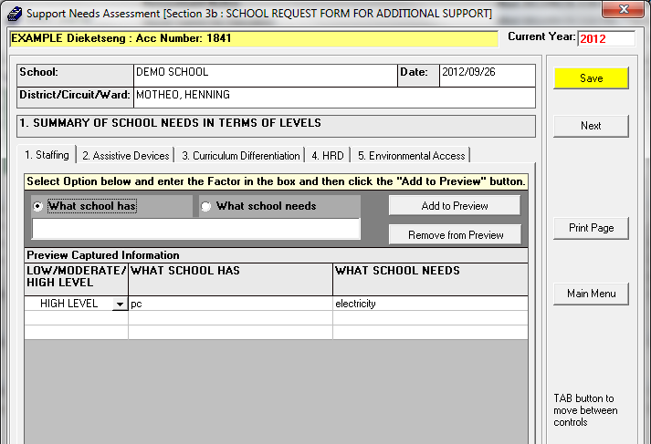
- Click on the staffing button then select what school has option.
- Type-in the text box what support school have in terms of staffing.
- Click the add to preview button to add to the list of what you have in your school.
- Select what school needs option.
- Type-in the text box what support school needs in terms of staffing.
- Click on the add to preview button then click the save button.
- Repeat the above steps for the assistive devices, curriculum differentiation, HRD, and environment access menus.
- Click on the Next button and the following screen will display:
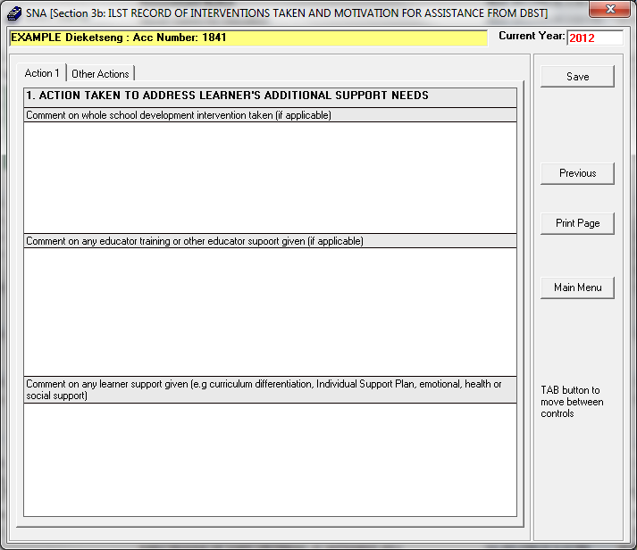

- Click on the action 1 button and elaborate what action was taken to address the additional support needs for a learner.
- Enter the required details of the learner in the various columns according to the additional needs of a learner.
- Click on the other action menu and the following screen will display:
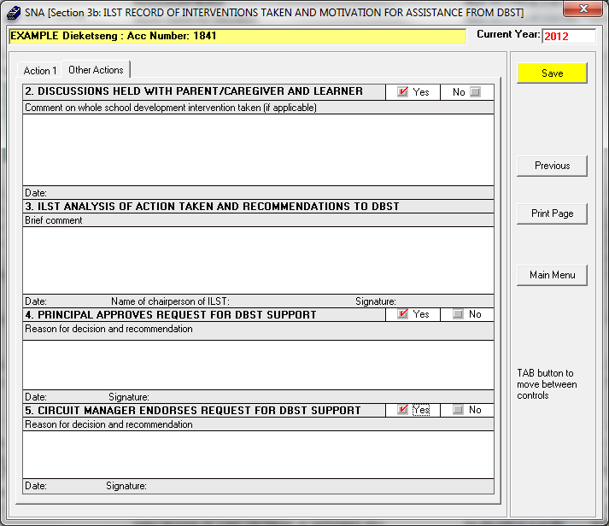

- Enter the required details in the various fields.
- Click on the print page button to print the form.
- Click save and then click on the main menu button to return to the main menu .
4. Click Action plan for additional support provision and monitoring button, the following screen will display:
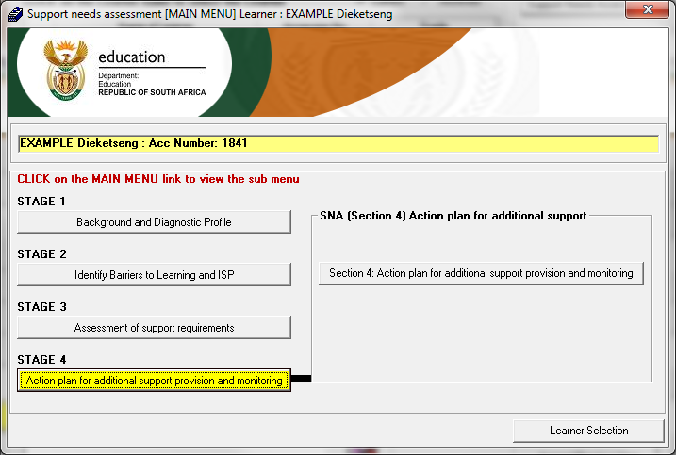
5. Click Action plan for additional support provision and monitoring button, the following screen will display:
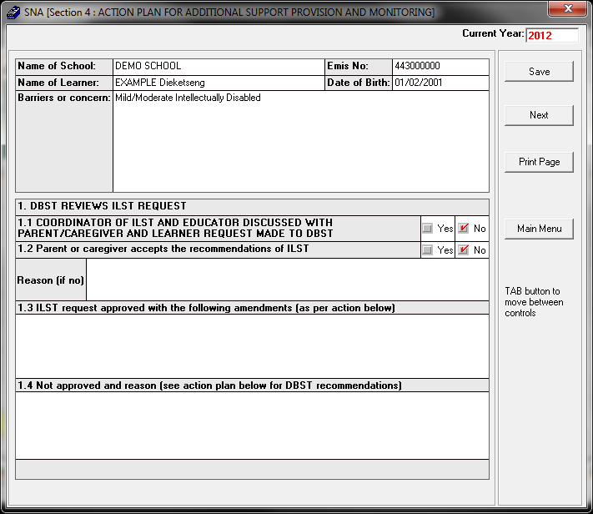
- This form must be filled in by using the guidelines for planners. The district-based support team reviews the motives for additional support which must be outlined on this form.
- Enter the required details in the various fields. After you have captured all the required field click save, then click on the next button.
- The following screen will display:
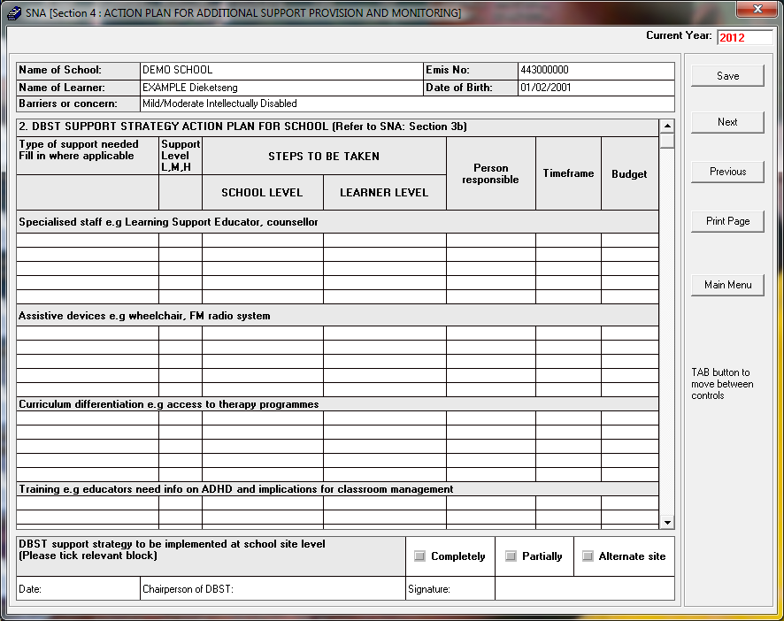
- It takes the number of steps to verify whether the assessment which has been conducted by the BDST in consultation with the school is valid, enter the required details in the various fields
- Once done click on the save button then click on the next button.
- The following screen will display:
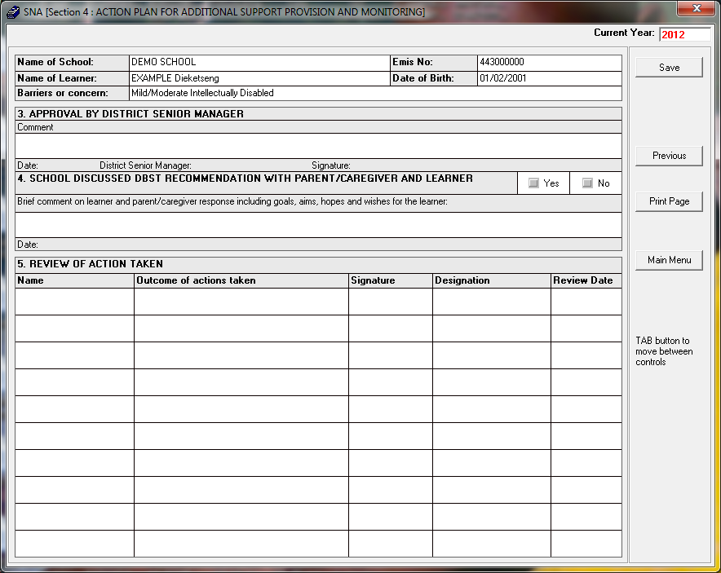
- The decision-making process about levels of support-packages will involve the ILST, parent/ care-giver and member of the support team (DBST). The lead professional will be a member of the DBST appointed to coordinate, meetings with significant partners, including a member of the ILST and the parent/care-giver.
- Enter the required details in the various fields.
- Once done click on the save button then click on the main menu button.

C. To view Learner Score summary
1. Click on Reports button in SIAS module.
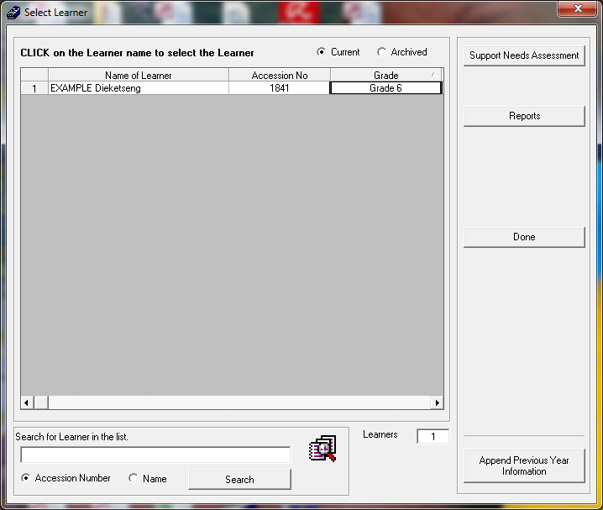
2. Click on Learner Score Summary-->Selected Year(Current Year)-->Select Learner/Grade/All-->Click on Print.
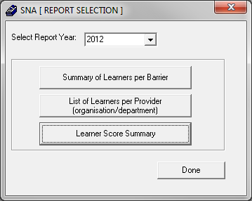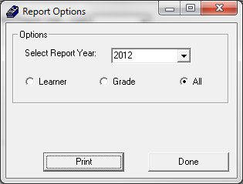
3. The following screen displays:
