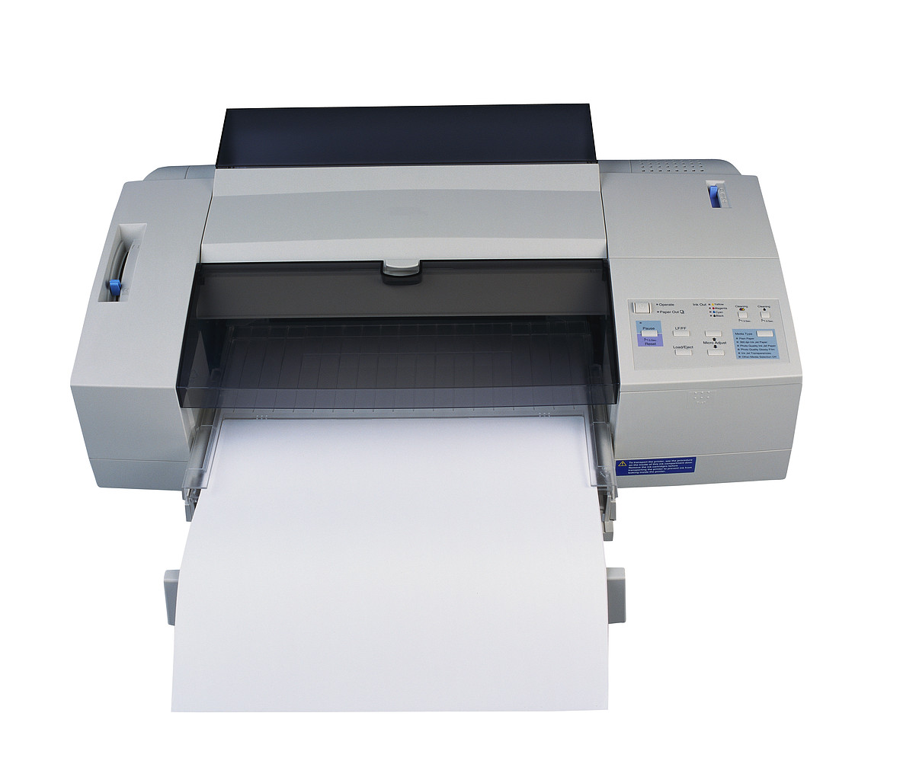
SA-SAMS printouts

All printouts in SA-SAMS, except for those in Financial Assistant, Timetabling, Physical Resources, Library Module and Lurits Approval Module, are listed below.

Explanation of Column contents

 | PRINTOUT | MENU | SUBMENU
1 | The printout is listed in the column | The main SA- SAMS menu is indicated in this column. Under Curriculum the main Submenu is also listed in this column | The submenu and further steps are indicated in this column

 | PRINTOUT | MENU | SUBMENU
1 | School Subjects |  | School Subjects – School Subjects printout
2 | Teaching days per term |  | Report Comment setup School days – GO - print
3 | Bus Routes |  | Bus routes – Print Bus Routes
4 | Demerit/Merit Codes |  | Demerit/Merit Codes - Printout
5 | Feeder Schools |  | Feeder Schools – Print feeder Schools
6 | Year Planner |  | Year Planner – Print Planner
7 | Individual Educator Leave register |  | Educator Information – Select educator – Leave and absences - Print
8 | Register classes |  | Educator Information – Print register classes
9 | Educator Contact List |  | Educator Information – Print Educator Contact List
10 | Individual Non-Educator Leave register |  | Staff Information – Select staff member– Leave and absences – Print
11 | Non-Educator Contact List |  | Staff information – Print Staff Contact List
12 | Blank Attendance register: educators |  | Print Blank Attendance Register
13 | Absentee Dates: Educator |  | View Individual Staff Absences - Select educator – Selected Staff Member
14 | Absentee Dates: All Educator |  | View Individual Staff Absences - All Staff Members
15 | Attendance Statistics |  | View Attendance Statistics – Print All/Print weeks – Print
16 | Educators who left school |  | Educator Attrition register
17 | Non-Educators who left school |  | Staff Attrition register
18 | Appointment register |  | EMIS HR Reports - Appointment register
19 | Educator details |  | EMIS HR Reports - Educator details
20 | Educator Subject Specialisation |  | EMIS HR Reports - Educator Subject Specialisation
21 | Staff Training Received |  | EMIS HR Reports - Staff Training
22 | Staff Training Funded |  | EMIS HR Reports - Staff Training Funded
23 | Aggregated Educator details |  | EMIS HR Reports - Aggregated Educator details
24 | Employment and Remuneration |  | EMIS HR Reports - Employment and Remuneration
25 | Home Language and Race |  | EMIS HR Reports - Home Language and Race
26 | Educator Instruction Language |  | EMIS HR Reports - Educator Instruction Language
27 | Educator Leave Summary |  | Staff Leave Summary Printout – Educators – Select dates
28 | Non-Educator Leave Summary |  | Staff Leave Summary Printout – Educators – Select dates
29 | Learner Disciplinary Record |  | Learner Information – Select learner – Disciplinary record - Print
30 | Learner Incident Record |  | Learner Information – Select learner – Incident record - Print
31 | Learner Learning Barrier Record |  | Learner Information – Select learner – Learning barriers- Print
32 | Learner Marks Report previous year/exam |  | Learner Information – Select learner – Marks Archive – select - Print
33 | List of Learner Application |  | Learner Applications – Application Printouts
34 | Blank Class List (design own) |  | Learner Grades and Classes – Design blank Class List – Select – Print class list
35 | Class Statistics |  | Learner Grades and Classes – Class Statistics - Print
36 | SNE Learners report |  | SIAS for SNE learners – Select year – Report - select - Print
37 | Support Needs for Individual Learner |  | SIAS for SNE learners – Select year – select learner – Support Needs Assessment – select – Print page
38 | Parents per Family |  | Parent Information – Parent per family Printouts
39 | Parent List |  | Parent Information – Parent Listing per Parent - Print
40 | Parent(s) with Learner(s) |  | Parent Information – Parent/s with Learner – select - Print
41 | Learner Family Report |  | Learner Family Report – select – select - Print
42 | Learner Parent List |  | Learner Parent Export – select – select - Print
43 | Previous Learner - Detail |  | Learner Archive – select learner – Learner details - print
44 | Previous Learner – absentee record |  | Learner Archive – select learner – Absentee History
45 | Previous Learner – Marks report |  | Learner Archive – select learner – Marks Archive
46 | Previous Learner – Transfer card |  | Learner Archive – select Print Learner Transfer Cards - select learner – select Date of Issue - Print
47  48  49  50 | Archive Printouts  - Learner Details  - Absentee History  - Marks (report previous year/s)  - Transfer Card |  | Archive Printouts  - Learner Archive – select learner - Learner details – Print  - Learner Archive – select learner – Absentee History – Print  - Learner Archive – select learner –Marks Archive – select – Print  - Learner Archive – select Print Learner Transfer Card - select learner – Print
51 | Blank Daily Attendance Register |  | Print Blank Daily Attendance Register – select required - Print
52 | Print Learner Daily Absentees |  | Maintain Learner Weekly Attendance – Print Learner Absentees (Daily) – select the necessary - Print
53 | Print Daily Absentees |  | Print daily absentees - select the necessary - Print
54 | Absences for Individual Learner |  | View Individual Learner Absences – select the required - Print selected Learner
55 | Absences for All Learners |  | View Individual Learner Absences – select the required – Print All learners
56 | Learner Attendance printouts |  | Learner Attendance Printouts –Daily Attendance Details per Learner – select - Print
57 | Total Days Absent per Learner |  | Learner Attendance Printouts - Total Days Absent per Learner – select - Print
58 | Weekly/Monthly Attendance Summary per Class |  | Weekly/Monthly Attendance Summary per Class – select - Print
59 | Weekly Attendance Statistics |  | Weekly Attendance Statistics – select - Print
60 | (a) Quarterly Attendance Statistics |  | Quarterly Attendance Statistics – select - Print
61 | (b) Quarterly Attendance Statistics (Pink form) |  | Quarterly Attendance Statistics – Ptint Return – verify - Print
62 | Enrolment Printouts – School alphabetical |  | Enrolment Printouts and Class List – select - Print
63 | Enrolment Printouts – Grade alphabetical |  | Enrolment Printouts and Class List – select - Print
64 | Enrolment Printouts – School by Accession Number |  | Enrolment Printouts and Class List – select - Print
65 | Learner Age and House Groups |  | Learner Age and House Groups – select - Print
66 | Detail of SNE learners |  | Detail of SNE learners – select - Print
67  68  69  70  71  72  73  74  75  76  77  78 | Learner Detail Data Printouts (various)  - Learner Distribution  - Hostel Boarders  - Learner Population Group  - PSNP Table  - Language Data Table  - LSEN in mainstream  - LSEN in mainstream according to barriers  - Learner Pregnancy in Previous Year  - Number of transfers into the school  - Grade 1 Pre-Primary Programmes  - Learners with deceased parents  - Learners registered for Social Grants |  | Learner Detail Data Printouts – select required - Print
79  80  81  82  83  84  85  86  87  88  89  90  91  92  93  94  95  96 | Learner Aggregate Data Printouts  - Learners According to Grade, Population Group and Gender  - SNE according to disability, Population Group and Gender  - Learners according to Age, Grade and Gender  - Learners according to Home Language and Grade  - SNE according to Home Language and Disability  - Learners according to Language of Teaching and Learning  - SNE according to Language of Teaching and Learning  - Learners according to Preferred Language and Grade  - Preferred Language for SNE Learners  - Grade 1 Enrolments  - Transfers into the School  - Mortality Statistics (previous year)  - Current Mortality Statistics  - FET subjects per population group  - SNE learner in Mainstream Classes  - Number of Learners registered for Social Grant  - Number of Learners with Deceased Parents  - Mode of Transport |  | Learner Aggregate Data Printouts –  - Learners According to Grade, Population Group and Gender – Print  - SNE according to disability, Population Group and Gender  - Learners according to Age, Grade and Gender  - Learners according to Home Language and Grade  - SNE according to Home Language and Disability  - Learners according to Language of Teaching and Learning  - SNE according to Language of Teaching and Learning  - Learners according to Preferred Language and Grade  - Preferred Language for SNE Learners  - Grade 1 Enrolments  - Transfers into the School  - Annual Survey Mortality Statistics (previous year)  - Current Mortality Statistics  - FET subjects Gr 10 to 12 per population group  - SNE learner in Mainstream Classes  - Number of Learners registered for Social Grant  - Number of Learners with Deceased Parents  - Mode of Transport
97 | Demerit/Merit Scores |  | Demerits/Merit Module – Manage Learners Demerit/Merit – select – Print
98 | Detention Notification |  | Demerits/Merit Module – Manage Learners Demerit/Merit – select - Print
99 | Demerit/Merit Score List |  | Demerits/Merit Module - Demerit/Merit Score List – select - Print
100 | Learner Bus Routes |  | Learner Bus Routes – select – Print (various)
101 | Mentor for Learner |  | Assign Mentor to Learner – select – assign – Print (various)
102 | Reporting Language |  | Reporting Language – select – assign - Print
103  104  105 | Promotion Printouts  - Annual Promotion Printout (end of year)  - Learner repeating / dropped out  - Comparative Statistics |  | Proces and Maintain Learner Promotion – follow promoting steps – select - Print
106 | SGB Members |  | SGB Composition Register – maintain - Print
107 | SGB functions |  | Maintain current SGB Functions – complete pages - Print
108 | Governance Records |  | Maintain Governance Records – Add new records - Print
109  110  111  112 | SGB Printouts  - Composition Register  - Register of Governance Records  - Current SGB Functions  - SGB Training |  | SGB Printouts  - SGB Composition Register – Print  - Register of Governance Records  - Current SGB Functions  - SGB Training – select – select – Print
111 | Harassment Incidents |  | Print Harassment Incidents – Print
112 | Mail Merge Letter |  | Standardised Mail Merge Letter select – write – merge - Print
113 | Blank Application Form |  | Print Blank Application Form – select – Print
114 | Completed Data Form (can also be used for transfer letter) |  | Print Completed data Form – select – Print
115 | Parent List (Both parent detail) |  | Learner Parent Export – select - Print
116 | School Subject Printout (= # 1) | Submenu | Maintain Subjects/Learning Areas - Print
117 | Learning Outcomes per Subject/Learning Area |  | Maintain LO’s - select - Print
118 | Report Language |  | Maintain Learner Report Languages – select - Print
119 | Educator Subject Group |  | Create Educator Subject Groups – Print Options – select - Print
120 | Mark sheets |  | Print Educator Mark Assessment Sheets - select - Print
121 | Learner Subjects |  | View/Print Learner Subject Allocation – select - Print
122 | CASS Assessment Program – Calendar View | Submenu | Select – Add – Calendar View - Print
123 | CASS Assessment Program – Grid |  | Select – Add – Print Task Grid - Print
124 | Mark Entry form |  | Select – Add – Print a Mark Entry Form or Enter Marks for Subject
125 | Assessment Programme (=# 123) |  | View Programme of Assessment Tasks – select - Print
126 | Calendar View of Assessment Tasks (= # 122) |  | Calendar View of Assessment Tasks
127 | Print Record Sheet of CASS results (grid / with marks) |  | Print Record Sheet of CASS results – grid for mark entry / print with marks - Print
128 | Report Cycle List | Submenu | Maintain Progress Report Cycles – Add – Print Cycle List – Print
129 | Report Comments |  | Maintain Report Comments – Add – Print Grid - Print
130 | Report Subject Order |  | Maintain Report Subject Order – select – Add – Print Grid - Print
131 | Marks List |  | Enter Learner Report Cycle Results – select – select - Print Grid
132 | Progress Report |  | Print Learner Progress Reports – select – select – Print (various options for Progress reports under Progress Report – Select desired)
133 | Blank GET Mark Schedule | Submenu | Blank GET Mark Schedule – select – Print - Print
134 | Mark Schedule - Grade |  | Internal Cycle Mark Schedule per Grade – select – Print Grid - Print
135 | Mark Schedule - Subject |  | Internal Cycle Mark Schedule per Subject – select – Print Grid - Print
136 | Marks Total Schedule - Grade |  | Internal Total Mark Schedule per Grade – select – Print Grid - Print
137 | Department Mark Schedules - per Grade (Year end) |  | Department Mark Schedules per Grade – select – select - Print - Print
138 | Arts and Culture Participation |  | Arts and Culture Participation – select – Print - Print
139 | Not Promoted and Repeat numbers |  | Not Promoted and Repeat numbers - Print
140 | Repeat/Drop out - Learner detail |  | Learner Detail: Repeats and Dropouts – select – select – Print Grid - Print
141 | Languages as Subjects |  | Enrolment: Languages as Subjects - Print

