Quality Managemnt systeMS (QMS) For school based educators Tool Guidelines

Step by Step Guidelines

**INTRODUCTION**

What is QMS? QMS is an Quality management system that consists of performance measurement for school-based educators. The QMS was approved by all parties at ELRC in November 2014. The agreement was finalised by the ELRC on 03 September 2019 and an addendum to the agreement outlining the timeframes for training, capacity building and implementation was signed by all parties on 10 September 2020.The QMS module has to be integrated into SA-SAMS to reduce administrative burden related to the paper based system. IQMS module has a friendly user interface specifically adapted to cater for non-computer literate users. A button interface and user prompting mechanism is used as opposed to more complicated menu structures.

**GENERAL SUGGESTIONS FOR USING QMS**

* Use the Save button to save information you have captured.
* Use the Print Page button to print a grid on the form.
* Use the Export(Excel) button to export a grid on the form.
* Use the Main Menu button to return to the Educator’s selection form.
* Use the Next Page button to proceed to the next form.
* Use the Educator List to return to the educator list form

**QMS ROAD MAP**

QMS Module

|  |  |
| --- | --- |
| Browse database | Browse SA-SAMS school database , it is auto detected there afet |
| Login | Login with different user rights |
| Performance Measurement | Assign Educator Appraiser |
|  | Assign Educator Resource person |
|  | QMS Descriptor choice |
|  | QMS Workplan |
|  | QMS Self Appraisal |
|  | QMS Supervisor Appraisal |
|  | QMS Composite score sheet |
|  | QMS Checklist |
|  | QMS Identified Development Needs |
|  | QMS Summative score sheet |
|  | Print Educator list |

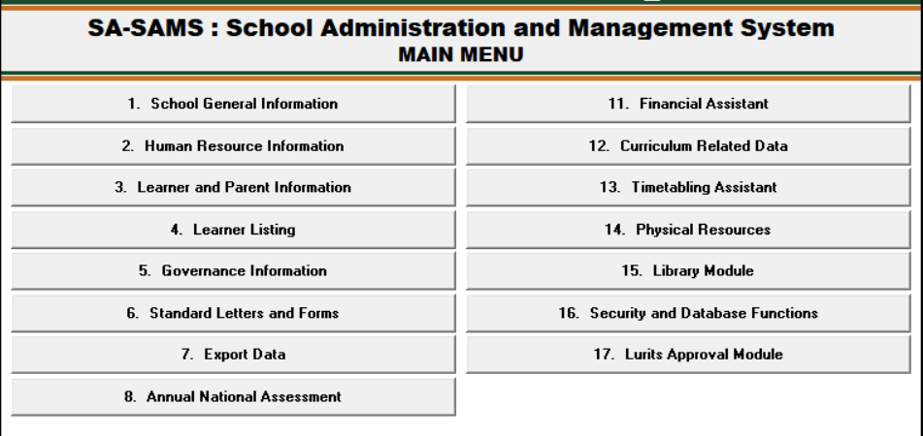

Figure 1: SA-SAMS: Human Resource Information

Insert SA-SAMS Main Menu here. Page 5

• Click on the Human Resource Menu on SA-SAMS and the screen below will appear:

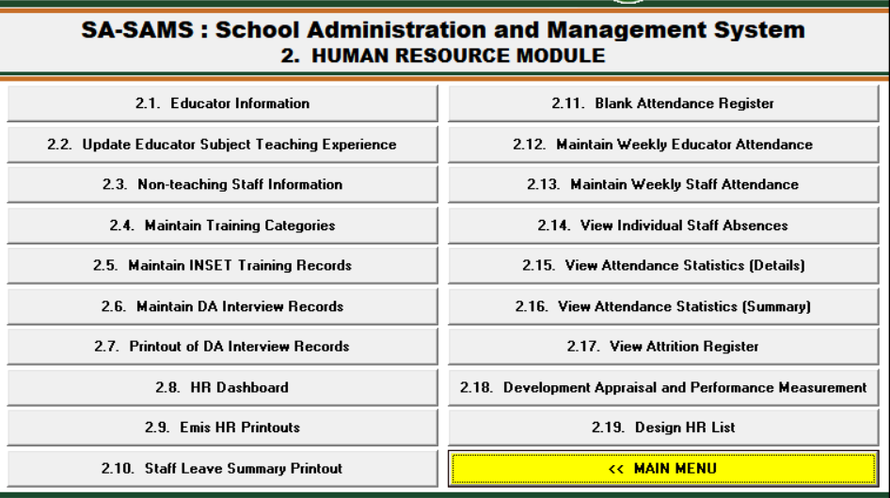

Figure 2: Human Resource menu page

• Click on the Development Appraisal and Performance Measurement menu. The menu below appears;

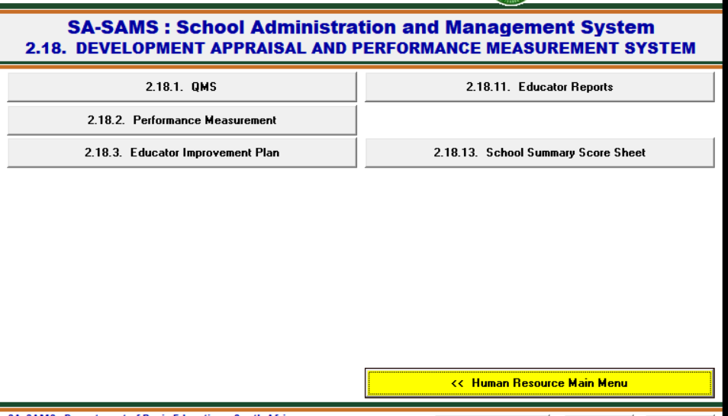

Figure 3: Development Appraisal and Performance Measurement menu page

• Click on the QMS menu and The database browse menu below appears;

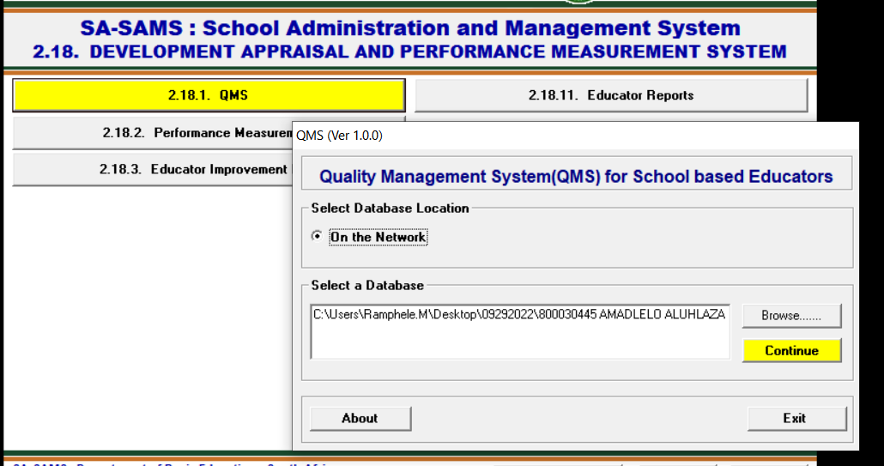

Figure 4: Development Appraisal and Performance Measurement menu page

• Click on browse and select SASAMS Database and the user log-in menu below appears;

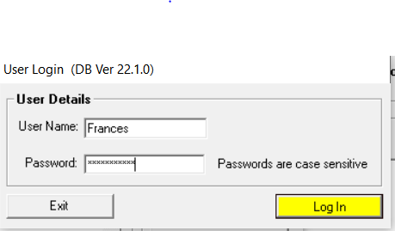

Figure 5: Login menu page

Enter the user name and the password to log in to the QMS module, Login with the educator Credential, If a resource person from outside the school the details should first be captured under staff information as personnel category resource person and also circuit manager then user must be added on menu no 16.12 first to have the credentials to log onto QMS,

* Click on the login button after punching in the credentials. The QMS Main Menu screen will now be loaded (Note that the – password can be changed at any time. Refer to the System Security section on how to change the passwords and user name.)

1. **QMS APPRAISAL INSTRUMENT FOR EDUCATORS ON POST LEVEL 1**

**Educator List**

Educator list, This is the main menu form that contains the list of educators which can be used for assessing purposes, to start working with the this form you need to select an educator and click on any menu item to begin the appraisal process.

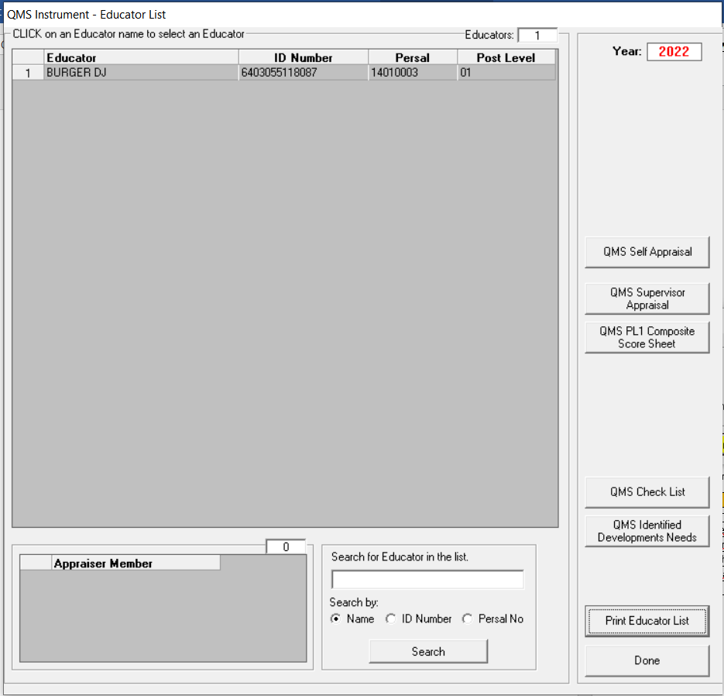

Figure 1.1: QMS Instrument – Educator List menu page

* Rights will be different Base on different Post level.
  + Post level 1 won’t be able to:
    - See work plan as work plan
    - To do anything on the QMS supervisor appraiser
    - Capture their own QMS Identified Development Needs
    - See summative score sheets
    - Assign an appraiser and an educator
    - Assign a resource person to an educator
    - Select descriptor choices

|  |  |  |  |  |  |
| --- | --- | --- | --- | --- | --- |
| **APPRAISAL INSTRUMENT (Post Level 1) Educators** | | | | | |
| **1** | **INTRODUCTION** | | | | |
| 1.1 | The performance appraisal of an educator (Post Level 1) must be conducted twice during the year, using the approved instrument provided in this section. | | | | |
| 1.2 | The two appraisals are conducted as follows:  ○ Mid-year, and ○ Annual | | | | |
| **2** | **THE INSTRUMENT** | | | | |
| 2.1 | The QMS instrument **(Annexure A 1)** must be completed for each educator on post level 1. | | | | |
| 2.2 | The instrument should also be used for purposes of self-appraisal, the mid-year appraisal and final appraisal. | | | | |
| 2.3 | The instrument consists of 5 Performance Standards | | | | |
| 2.4 | The Performance Standards in the instrument form the core elements of the job description for educators. | | | | |
| 2.5 | The criteria form the key deliverables for each Performance Standard. | | | | |
| 2.6 | The desired outcome/key objective of each criteria has been pegged with a maximum rating of 4. | | | | |
| 2.7 | When completing the instrument, the appraiser/supervisor must use the rating guide which provides the elements for the key descriptors for ratings that range from 1 – 4. | | | | |
| 2.8 | 2.8 A rating that is less than the desired outcome will be influenced by the following factors: | | | | |
|  | * There is no or insufficient evidence of a particular desired activity | | | | |
|  | * The desired activity is infrequent | | | | |
|  | * The desired activity is frequent but of poorer quality than desired; | | | | |
|  | * The desired activity is infrequent and of poor quality; and | | | | |
|  | * The desired activity may be frequent and of reasonable quality but is impacted by a negative attitude | | | | |
|  |  | | | | |
| **3** | **PERFORMANCE STANDARDS** | | | | |
| **Table 1** below shows the Performance Standards, the criteria and the desired outcomes for PL 1 educators | | | | | |
| **TABLE 1: PERFORMANCE STANDARDS AND CRITERIA FOR PL 1 EDUCATORS** | | | | | |
| **No.** | **Performance Standard** | **Criteria** | **The desired outcome** | | |
| **1** | Creation of a positive learning environment | Learning and teaching environment | The use of learning and teaching environment enables all learners to be productively engaged in individual and cooperative learning. | | |
| Classroom Management | Time and available resources are managed to promote optimal learning and teaching for all learners. Activities are efficiently supervised. Learners work together with the educator towards the achievement of relevant learning outcomes. | | |
| **2** | Curriculum knowledge, lesson planning and presentation | Knowledge of subject | Uses expert knowledge, in addition to Outcomes and Assessment Standards, to promote learner interest and research in the specific Learning Area/Subject. | | |
| Planning and presentation | Effective use of planning instruments leads towards a higher form of learning/ understanding. | | |
| Management of work schedule | Excellent management of content and context within the timeframes stipulated in the Work Schedule accompanied by relevant intervention strategies. | | |
| Record keeping | Records are meticulously maintained and analysed to diagnose learner needs and teaching effectiveness. Records are used to adjust teaching strategies and improve learner achievement | | |
| **3** | Learner assessment and achievement | Feedback to learners | Provides feedback using a variety of strategies. Uses remedial and enrichment measures that instill confidence in learners to achieve intended learning outcomes. | | |
| Knowledge and application of forms of assessment | Knows and uses a range of forms of assessment techniques to continuously maximise learner achievement. Methods of assessment are used to raise the standards of teaching and learning. | | |
| Learner progress and achievement | Learners optimally achieve the relevant Learning Area/ Subject outcomes. Assessment results show outstanding levels of competence and achievement. | | |
| **4** | Professional Development | Participation in Continuous professional development | Participates fully and takes a leading role in initiating and delivering professional development activities. | | |
| Educator professionalism | Educator is exemplary and truly displays the purpose and intent of the educators’ code of professional ethics. | | |
| **5** | Extra-mural and co-curricular participation | Participation in extra-mural and co-curricular activities | Networks with relevant stakeholders and encourages development of extra-mural or co-curricular activities. | | |
| **4. Rating Scale, Descriptor, scores and percentages:** | | | | | |
| **4.1 Post Level 1 Educators** | | | | | |
| •A 4 point rating scale is used when completing the instrument. | | | | | |
| **Rating** | **Descriptor** | | | **Score (Maximum Score = 152)** | **Percentage** |
| 1 | **Unacceptable:** The level of performance does not meet minimum expectations and requires urgent intervention and support | | | ***0-75*** | ***0%-49%*** |
| 2 | **Acceptable:** Satisfies minimum expectations. The level of performance is acceptable and is in line with the minimum expectations, but development and support are still required | | | ***76-105*** | ***50%-69%*** |
| 3 | **Good:** Performance meets expectations, but some areas are still in need of development and support | | | ***106-128*** | ***70%-84%*** |
| 4 | **Outstanding:** Performance exceeds expectations. Although performance is outstanding, continuous self-development and improvement are advised. | | | ***129-152*** | ***85%-100%*** |

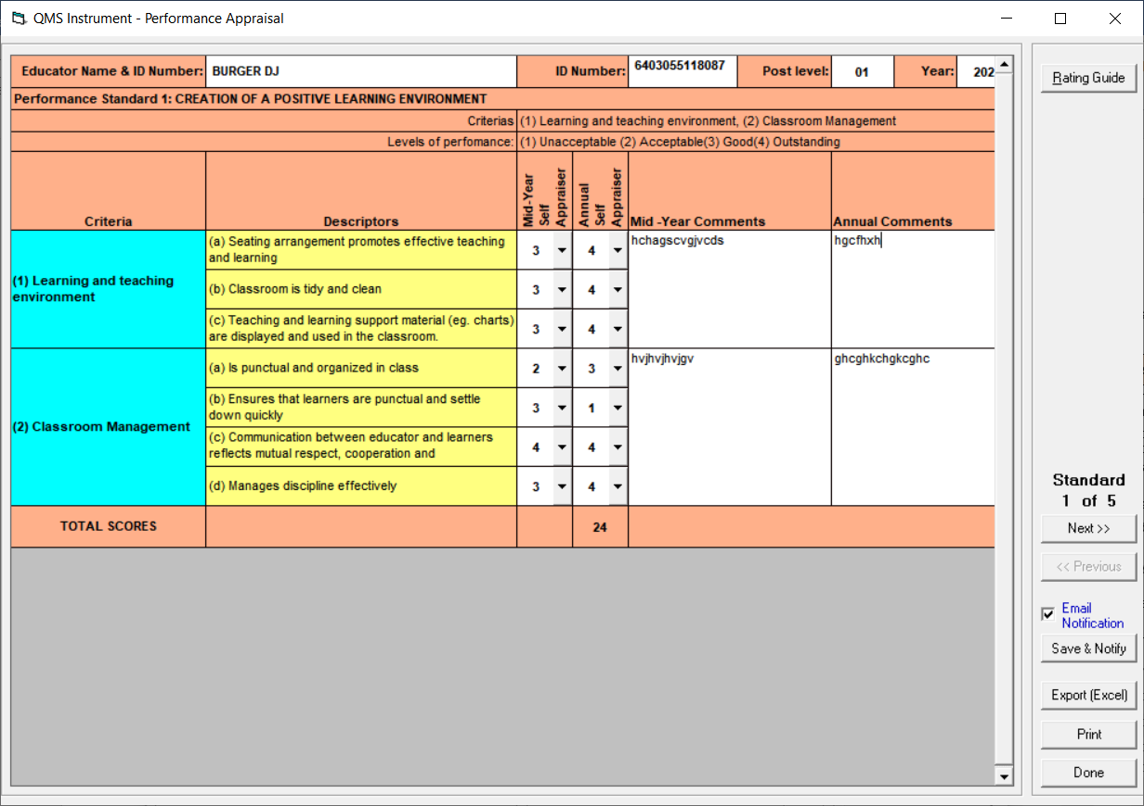

Figure 1.2: QMS Instrument – Performance Appraisal (Self Evaluation)

* Select the relevent rating from the dropdown of a 4 point scale and capture the comments Midyear total should not calculate but the Annual total should.
* Post Level one has 5 persformance standard.
* To move to the next starndard click on next>> Button.
* To move back click on <<Previous Button
* Click on save and notify to to save
* Click on on Export( Excel) to export to excel
* Click on print to print
* Click on Done to exit the menu

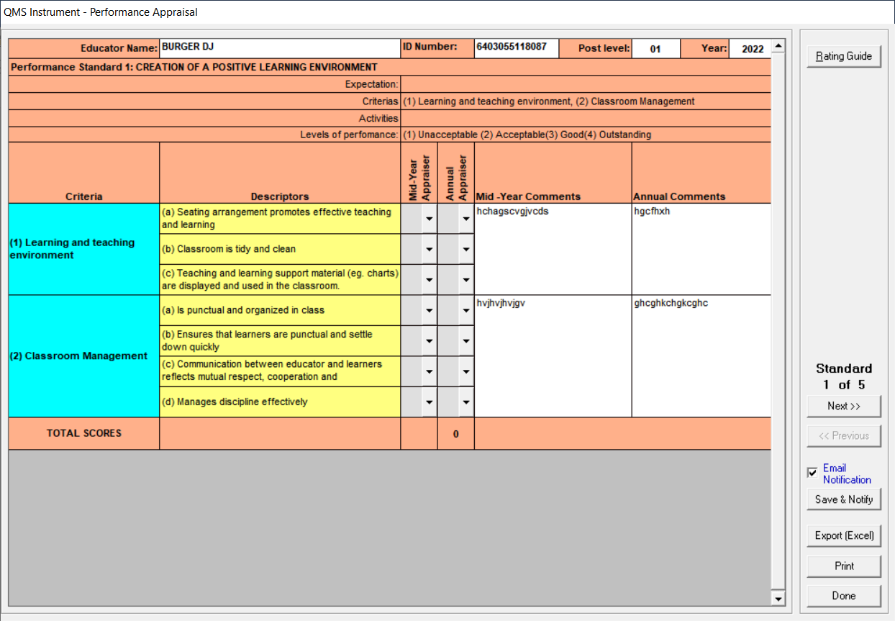

Figure 1.3: QMS Instrument – Performance Appraisal (Supervisor Evaluation)

* You can only change the comments on this menu and the menu will load comments from self appraisal.
* Post Level one has 5 persformance standard.
* To move to the next starndard click on next>> Button.
* To move back click on <<Previous Button
* Click on save and notify to to save
* Click on on Export( Excel) to export to excel
* Click on print to print
* Click on Done to exit the menu

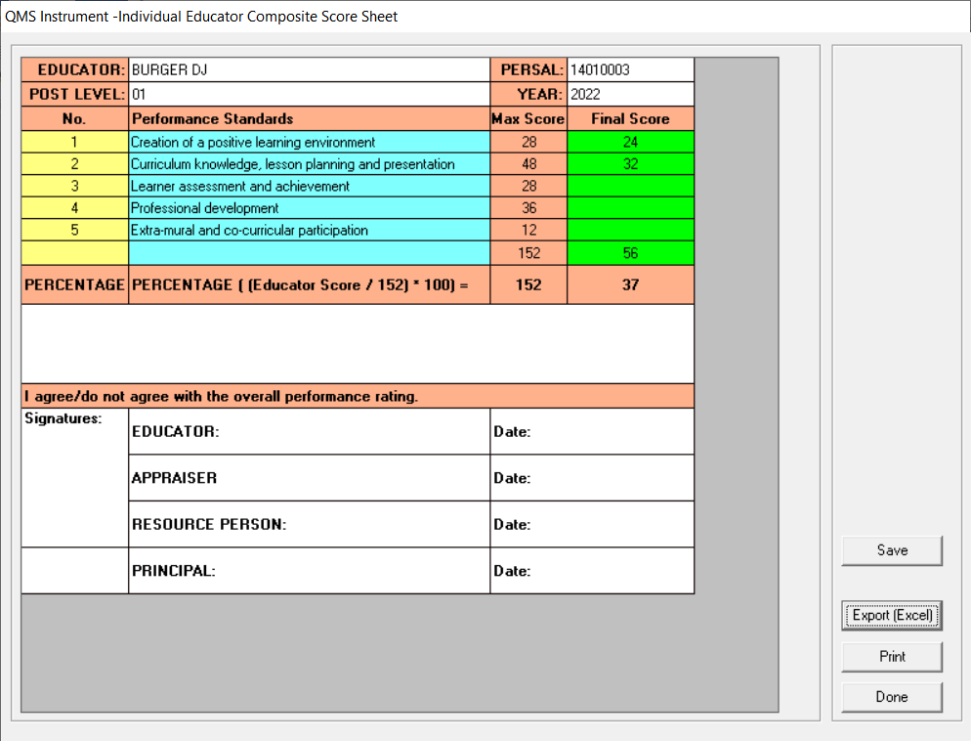

Figure 1.4: QMS Instrument – Composite score sheet

* Save your score on this menu.
* Click on save to to save the scores
* Click on on Export( Excel) to export to excel
* Click on print to print
* Click on Done to exit the menu

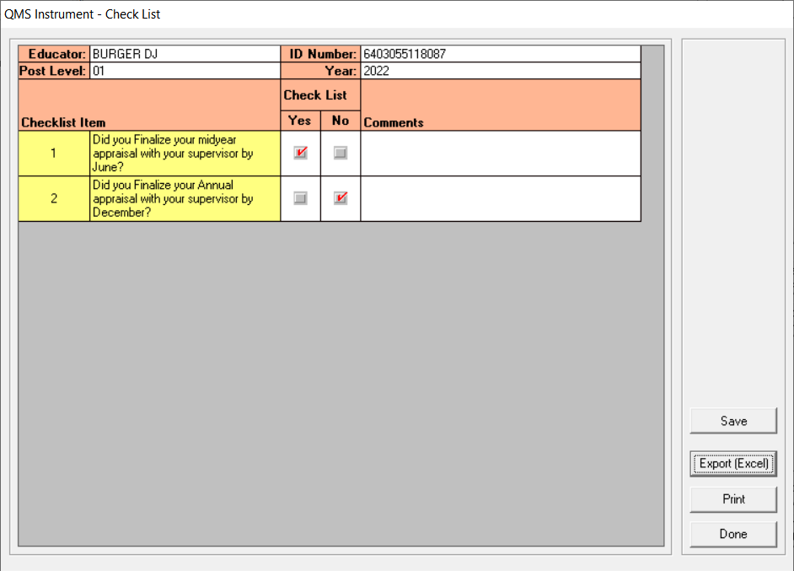

Figure 1.5: QMS Instrument – Check list

* Capture and Save your score on this menu.
* Click on save to save the check list
* Click on print to print
* Click on Done to exit the menu

**2. QMS APPRAISAL INSTRUMENT FOR EDUCATORS ON POST LEVEL 2**

**Educator List**

Educator list, This is the main menu form that contains the list of educators which can be used for assessing purposes, to start working with the this form you need to select an educator and click on any menu item to begin the appraisal process.

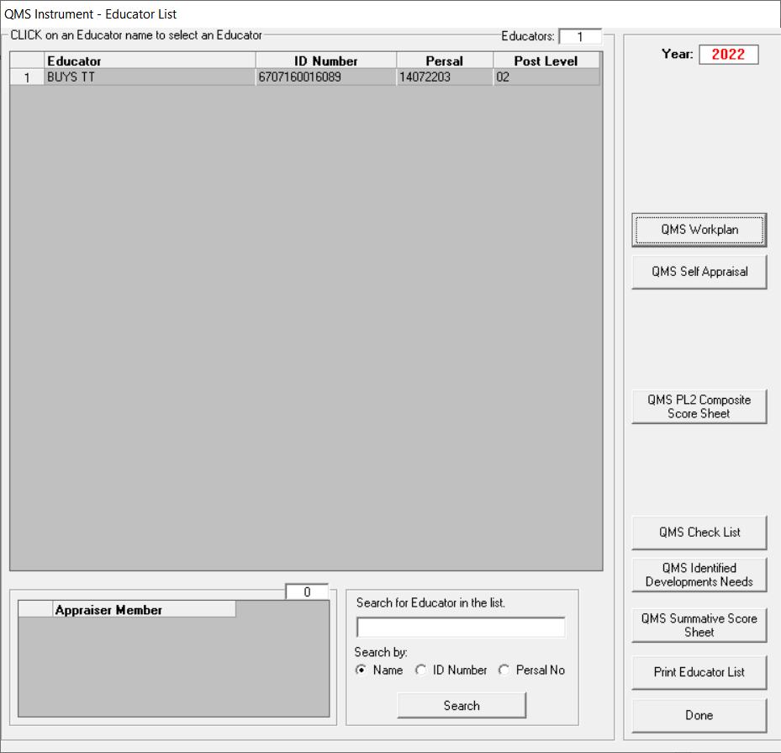  
Figure 2.1: QMS Instrument – Educator List menu page (Post Level 2)

* Rights will be different Base on different Post level.
  + Post level 2 won’t be able to:
    - To do anything on the QMS supervisor appraiser
    - Capture their own QMS Identified Development Needs
    - Assign an appraiser and an educator
    - Assign a resource person to an educator
    - Select descriptor choices

|  |  |  |  |  |  |  |  |  |
| --- | --- | --- | --- | --- | --- | --- | --- | --- |
| **QMS APPRAISAL INSTRUMENT FOR EDUCATORS ON POST LEVEL 2** | | | | | | | | |
| **DEPARTMENTAL HEAD** | | | | | | | | |
|  |  |  |  |  |  |  |  |  |
| **1** | **Introduction** | | | | | | | |
| 1.1 | The appraisal of Departmental Heads (Post Level 2) must be conducted twice during the year, using the approved instrument provided in this section. | | | | | | | |
| 1.2 | 1.2 The two appraisals are conducted as follows: ○ Mid-Year, and ○ Annual | | | | | | | |
| **2** | **QMS Workplan and instrument** | | | | | | | |
| 2.1 | The QMS work plan (Annexure B 1) and QMS instrument (Annexure B 2) must be completed for each Departmental Head. | | | | | | | |
| 2.2 | The QMS work plan and instrument should also be used for purposes of self- appraisal, the mid-year appraisal and annual appraisal. | | | | | | | |
| 2.3 | All Departmental Heads are required to complete a work plan at the beginning of each evaluation cycle. | | | | | | | |
| 2.4 | A Departmental Head is evaluated on 6 Performance Standards; | | | | | | | |
| 2.5 | The Performance Standards in the instrument form the core elements of the job description for Departmental Head. | | | | | | | |
| 2.6 | The criteria form the key deliverables for each Performance Standard. | | | | | | | |
| 2.7 | The desired outcome/key objective of each criteria has been pegged with a maximum rating of 4. | | | | | | | |
| 2.8 | A rating that is less than the desired outcome will be influenced by the following factors: | | | | | | | |
|  | * There is no or insufficient evidence of a particular desired activity | | | | | | | |
|  | * The desired activity is infrequent | | | | | | | |
|  | * The desired activity is frequent but of poorer quality than desired; | | | | | | | |
|  | * The desired activity is infrequent and of poor quality; and | | | | | | | |
|  | * The desired activity may be frequent and of reasonable quality but is impacted by a negative attitude | | | | | | | |
| **3** | **PERFORMANCE STANDARDS** | | | | | | | |
| **Table 1** below shows the 6 Performance Standards, the criteria and the desired outcome for PL 2 educators. | | | | | | | | |
| **TABLE 2: PERFORMANCE STANDARDS, CRITERIA AND DESIRED OUTCOMES FOR PL 2 EDUCATORS (HODs)** | | | | | | | | |
| **No.** | **Performance Standard** | **Criteria** | | **The desired outcome** | | | | |
| 1 | Creation of a positive learning environment | Learning and teaching environment | | The use of learning and teaching environment enables all learners to be productively engaged in individual and cooperative learning. | | | | |
| Classroom Management | | Time and available resources are managed to promote optimal learning and teaching for all learners. Activities are efficiently supervised. Learners work together with the educator towards the achievement of relevant learning outcomes. | | | | |
| 2 | Curriculum knowledge, lesson planning and presentation | Knowledge of subject | | Uses expert knowledge, in addition to Outcomes and Assessment Standards, to promote learner interest and research in the specific Learning Area/Subject. | | | | |
| Planning and presentation | | Effective use of planning instruments leads towards a higher form of learning/ understanding. | | | | |
| Management of work schedule | | Excellent management of content and context within the timeframes stipulated in the Work Schedule accompanied by relevant intervention strategies. | | | | |
| Record keeping | | Records are meticulously maintained and analyzed to diagnose learner needs and teaching effectiveness. Records are used to adjust teaching strategies and improve learner achievement | | | | |
| 3 | Learner assessment and achievement | Feedback to learners | | Provides feedback using a variety of strategies. Uses remedial and enrichment measures that instill confidence in learners to achieve intended learning outcomes. | | | | |
| Knowledge and application of forms of assessment | | Knows and uses a range of forms of assessment techniques to continuously maximise learner achievement. Methods of assessment are used to raise the standards of teaching and learning. | | | | |
| Learner Progress and achievement | | Learners optimally achieve the relevant Learning Area/ Subject outcomes. Assessment results show outstanding levels of competence and achievement. | | | | |
| 4 | Professional development | Participation in  Continuous professional development | | Participates fully and takes a leading role in initiating and delivering professional development activities. | | | | |
| Educator professionalism | | Educator is exemplary and truly displays the purpose and intent of the educators’ code of professional ethics. | | | | |
| 5 | Extra-mural and co-curricular participation | Participation in extra-mural and co-curricular activities | | Networks with relevant stakeholders and encourages development of extra-mural or co-curricular activities. | | | | |
| 6 | Management of curriculum | Providing leadership, mentoring, support and development | | Regular classroom visits provide clear, valuable, guidance, support and constructive feedback to educators. | | | | |
| Administration of resources and records | | Efficient utilization and updating of resources, furniture and equipment are in good condition and well-maintained. Policy for furniture and equipment is implemented. Register for assets are well maintained. | | | | |
| Decision-making and accountability | | Consults, accepts total responsibility for all decisions even if they are proved to be wrong. Decisions are often proactive rather than reactive. Arrives at decisions creatively. | | | | |
| Policy development and implementation | | Policies are developed through wide consultation and according to the needs of the school. Implementation of both internal and external school policies is consistent and supports teaching and learning. Full compliance with policies at all levels | | | | |
| **4. Rating Scale, Descriptor, scores and percentages:** | | | | | | | | |
| **4.1 Post Level 2 Educators** | | | | | | | | |
| •A 4 point rating scale is used when completing the instrument. | | | | | | | | |
| **RATING** | **DESCRIPTOR** | | | | **DEPUTY** | | ***PERCENTAGE*** | |
| **1** | **Unacceptable**: The level of performance does not meet minimum expectations and requires urgent intervention and support | | | | **0 – 113** | | **0% - 49%** | |
| **2** | **Acceptable**: Satisfies minimum expectations. The level of performance is acceptable and is in line with the minimum expectations, but development and support are still required | | | | **114 – 159** | | **50% - 69%** | |
| **3** | **Good**: Performance meets expectations, but some areas are still in need of development and support | | | | **160 – 193** | | **70% - 84%** | |
| **4** | **Outstanding:** Performance exceeds expectations. Although performance is outstanding, continuous self-development and improvement are advised. | | | | **194 – 228** | | **85% - 100%** | |
|  |  |  |  |  |  |  |  |  |

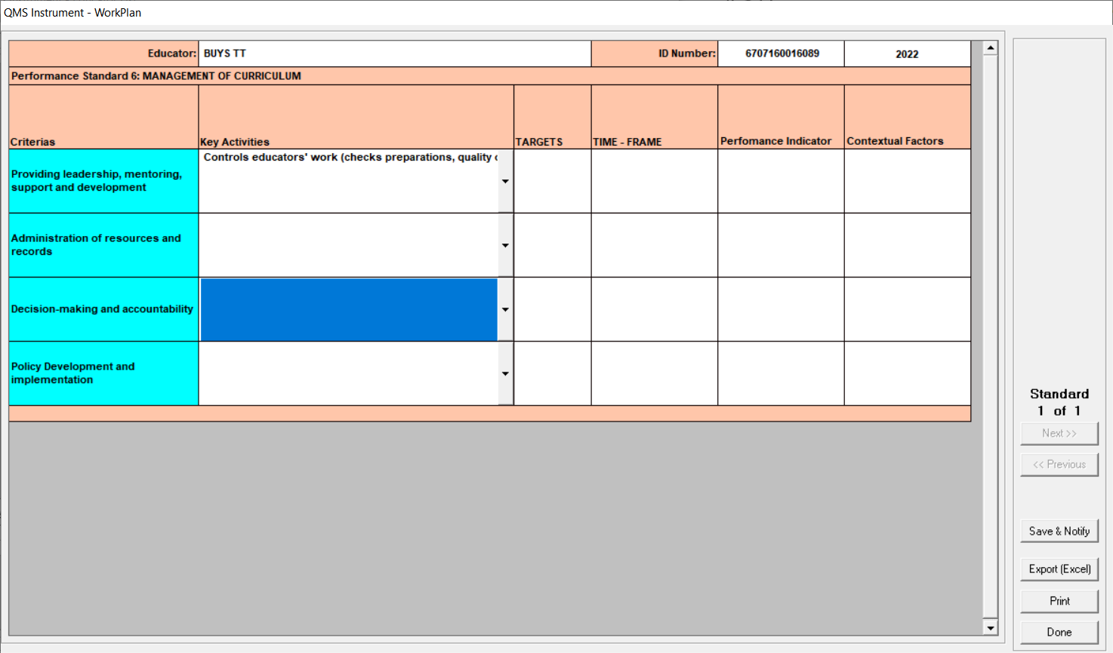

Figure 2.2: QMS Instrument – WorkPlan

* Select the relevent Descriptor frm the dropdown.
* Workplan is only done on Performance stardard 6.
* Click on save and notify to to save
* Click on on Export( Excel) to export to excel
* Click on print to print
* Click on Done to exit the menu
* You wont be able to do apprasal if the workplan is not done.

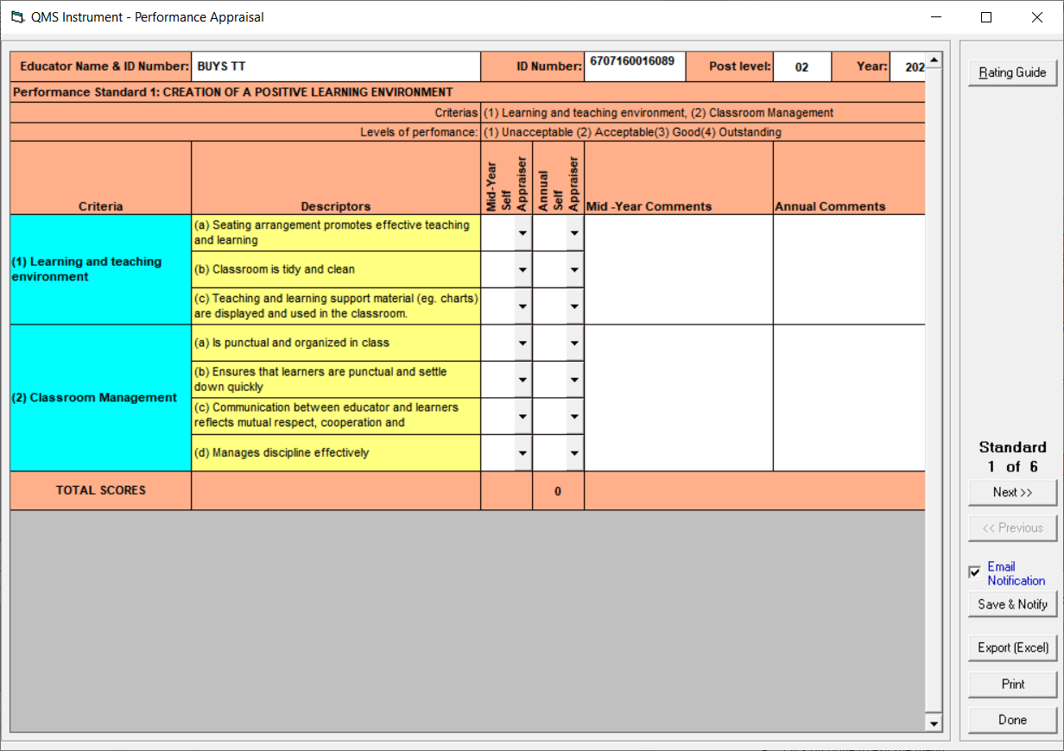

Figure 2.3: QMS Instrument – Performance Appraisal (Self Evaluation)

* Select the relevent rating from the dropdown of a 4 point scale and capture the comments Midyear total should not calculate but the Annual total should.
* Post Level two has 6 persformance standard.
* To move to the next starndard click on next>> Button.
* To move back click on <<Previous Button
* Click on save and notify to to save
* Click on on Export( Excel) to export to excel
* Click on print to print
* Click on Done to exit the menu



Figure 2.4: QMS Instrument – Performance Appraisal (Supervisor Evaluation)

* You can only change the comments on this menu and the menu will load comments from self appraisal.
* Post Level two has 6 persformance standard.
* To move to the next starndard click on next>> Button.
* To move back click on <<Previous Button
* Click on save and notify to to save
* Click on on Export( Excel) to export to excel
* Click on print to print
* Click on Done to exit the menu

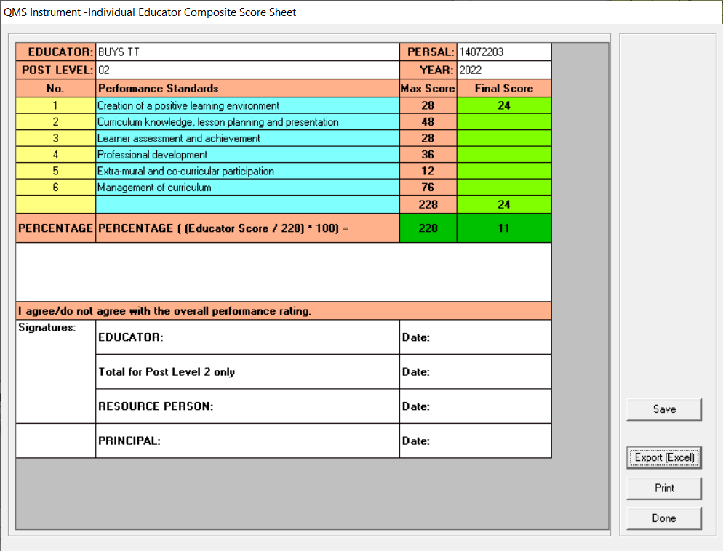

Figure 2.5: QMS Instrument – Composite score sheet

* Save your score on this menu.
* Click on save to to save the scores
* Click on on Export( Excel) to export to excel
* Click on print to print
* Click on Done to exit the menu

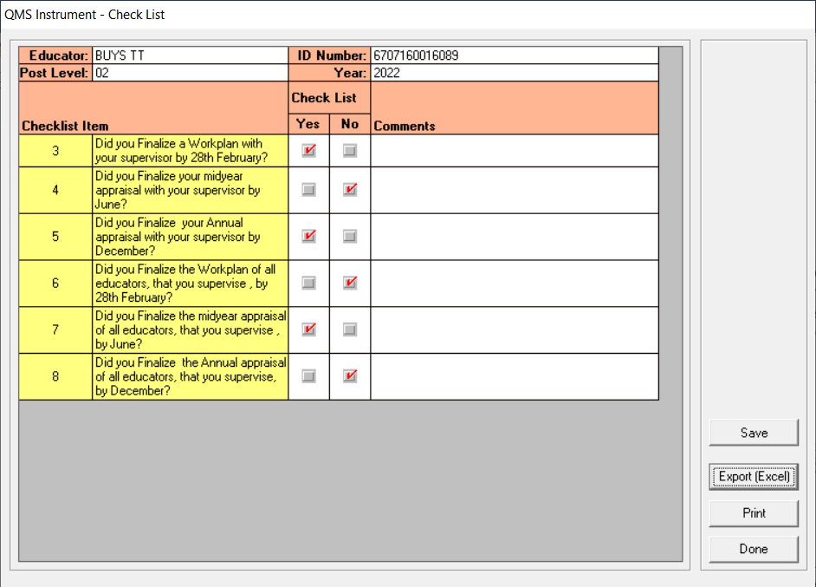

Figure 2.6: QMS Instrument – Check list

* Capture and Save your score on this menu.
* Click on save to save the check list
* Click on print to print
* Click on Done to exit the menu

1. **QMS APPRAISAL INSTRUMENT FOR EDUCATORS ON POST LEVEL 3**

**Educator List**

Educator list, This is the main menu form that contains the list of educators which can be used for assessing purposes, to start working with the this form you need to select an educator and click on any menu item to begin the appraisal process.

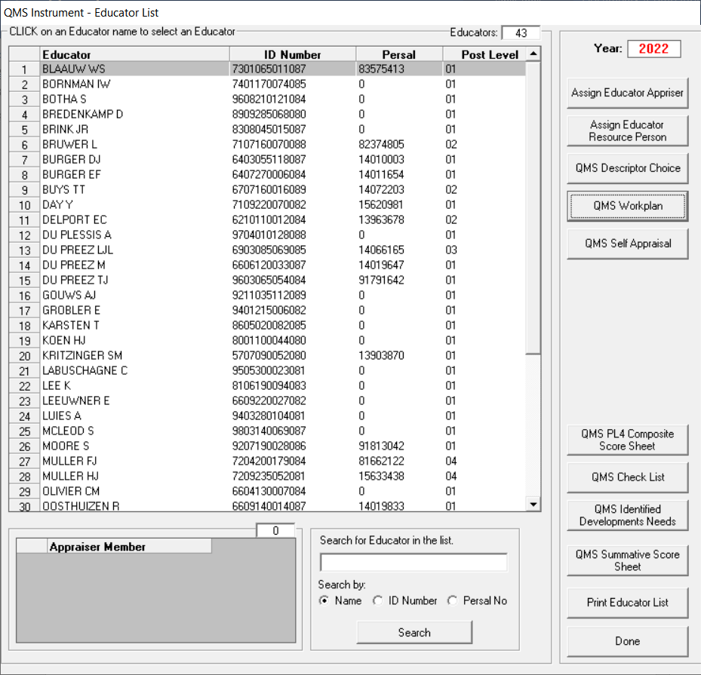

Figure 3.1: QMS Instrument – Educator List menu page (Post Level 3)

* Rights will be different Base on different Post level.
  + Post level 3 is able to:
    - Capture QMS Identified Development Needs for their appraise
    - See summative score sheets
    - Assign an appraiser and an educator
    - Assign a resource person to an educator
    - Select descriptor choices
    - Do a work plan, won’t do appraisal if work plan not done
  + Post level 3 won’t be able to:
    - To do anything on the QMS supervisor appraiser
    - Wont capture their own Development Needs for their appraise
    - Appraise themselves
  + Appraise if not assigned as supervisor to an educator

|  |  |  |  |  |  |  |  |  |  |  |  |
| --- | --- | --- | --- | --- | --- | --- | --- | --- | --- | --- | --- |
| **QMS APPRAISAL INSTRUMENT FOR EDUCATORS ON POST LEVEL 3** | | | | | | | | | | | |
| **DEPUTY PRINCIPALS** | | | | | | | | | | | |
|  | |  | |  |  |  |  |  |  |  |  |
| **1** | | **Introduction** | | | | | | | | | |
| 1.1 | | The performance appraisal of a deputy principal must be conducted twice during the year, using the approved instrument provided in this section. | | | | | | | | | |
| 1.2 | | Deputy Principals have a choice in selecting the number of descriptors within the 7 performance standards in the appraisal instrument. | | | | | | | | | |
| **2** | | **QMS WORK PLAN AND INSTRUMENT** | | | | | | | | | |
| 2.1 | | Deputy Principals (PL 3) are required to complete a work plan **(Annexure C 1)** at the beginning of each evaluation cycle. | | | | | | | | | |
| 2.2 | | The QMS instrument **(Annexure C2)** should be used for the appraisal of Deputy Principals. | | | | | | | | | |
| 2.3 | | The work plan and instrument should also be used for purposes of self-appraisal, the mid-year appraisal and final appraisal. | | | | | | | | | |
| 2.4 | | The Performance Standards in the instrument form the core elements of the job description for deputy principals and principals. | | | | | | | | | |
| 2.5 | | The criteria form the key deliverables for each of the 7 Performance Standards. | | | | | | | | | |
| 2.6 | | The desired outcome/key objective of each criteria has been pegged with a maximum rating of 4. | | | | | | | | | |
| 2.7 | | A rating that is less than the desired outcome will be influenced by the following factors: | | | | | | | | | |
|  | | * There is no or insufficient evidence of a particular desired activity; | | | | | | | | | |
|  | | * The desired activity is infrequent; | | | | | | | | | |
|  | | * The desired activity is frequent but of poorer quality than desired; | | | | | | | | | |
|  | | * The desired activity is infrequent and of poor quality, and | | | | | | | | | |
|  | | * The desired activity may be frequent and of reasonable quality but is impacted by a negative attitude | | | | | | | | | |
| **3** | | **APPRAISAL OF DEPUTY PRINCIPALS** | | | | | | | | | |
| 3.1 | | During the signing of a work plan, the Deputy Principal must also select and agree with the supervisor (principal) on the descriptors in the QMS instrument (Annexure C 2) that will be applicable for his/her self-appraisal, mid-year appraisal and annual appraisal. | | | | | | | | | |
| 3.2 | | The following descriptors are compulsory:  •All 35 descriptors in Performance Standards 1, 3 and 4. | | | | | | | | | |
| 3.3 | | In addition, a total of 24 descriptors from Performance Standards 2, 5, 6 and 7 should be selected as follows: | | | | | | | | | |
| Performance Standard | | | Number of items/descriptors to be agreed upon for appraisal | | | | | | | | |
| 1 | | | All descriptors are compulsory | | | | | | | | |
| 2 | | | ***10 descriptors*** | | | | | | | | |
| 3 | | | All descriptors are compulsory | | | | | | | | |
| 4 | | | All descriptors are compulsory | | | | | | | | |
| 5 | | | ***10 descriptors*** | | | | | | | | |
| 6 | | | ***2 descriptors*** | | | | | | | | |
| 7 | | | ***2 descriptors*** | | | | | | | | |
| 3.4 | | The Deputy Principal should be appraised on a total of 59 descriptors (35 compulsory descriptors and 24 selected descriptors) in the 7 Performance Standards. | | | | | | | | | |
|  | |  | |  |  |  |  |  |  |  |  |
| **4** | | **PERFORMANCE STANDARDS** | | | | | | | | | |
|  | |  | |  |  |  |  |  |  |  |  |
| **Table 3** below shows the 7 Performance Standards, the criteria and the desired outcomes for PL 3 educators. | | | | | | | | | | | |
| **TABLE 3: PERFORMANCE STANDARDS AND CRITERIA FOR PL 3 EDUCATORS (Deputy Principals)** | | | | | | | | | | | |
| **RATING** | | **Performance Standard** | | **Criteria** | | **The desired outcome** | | | | | |
| 1 | | Leading the learning school | | (1)    Classroom teaching | | Effective use is made of all resources to ensure that learners are motivated to perform optimally. | | | | | |
| (2)    Support for the learning school | | The support of all stakeholders has been secured and there is evidence that a quality teaching and learning environment is established / being improved | | | | | |
| 2 | | Shaping the direction and development of the school | | 1) Planning | | Effective use is made of all planning resources and techniques (data, budgets, consultations, policies etc). | | | | | |
| 2) School governing body and the broader school community | | SGB is established and functioning. SGB is supported in the performance of its functions in terms of SASA. Partnerships are set up to support the development of the school | | | | | |
| 3 | | Managing quality and securing accountability | | 1) Securing accountability | | The use of LTSM is monitored. A textbook retrieval system is in place and implemented effectively. The work of the SMT is monitored regularly. Systems are in place to a) monitor educator and learner attendance, and b) address improper conduct and dress code of educators and learners | | | | | |
| 2) Managing the quality of teaching and learning | | Departmental policies with regard to assessment administration are followed. Marking and moderation of learner assessments are monitored regularly. Learner assessment outcomes are analysed, intervention strategies developed and implemented | | | | | |
| 4 | | Developing and empowering self and others | | 1) Staff | | Staff development initiatives are functioning. Regular classroom visits provide constructive feedback, guidance and support. Teacher appraisal systems comply with policy and the results are valid, reliable and fair. | | | | | |
| 2) Self | | Regular participation in activities aimed at enhancing personal and professional growth. Conduct is exemplary. | | | | | |
| 5 | | Managing the school as an organisation | | 1) Financial management | | School’s finances are managed by applying the necessary controls to optimise use of fund. Protocols are followed in developing the school budget, including approvals by the SGB and parent community. All prescription is SASA and departmental directives are adhered to. | | | | | |
| 2) General institutional management and administration | | Log book contains a record of important events in the school. The school has effective and efficient systems in place to manage correspondence and other forms of communication, the systems are properly maintained and provide easy access for authorised persons. School provides accurate statistics to the district office. | | | | | |
| 3) Management of infrastructure | | School has a safe and secure environment with clear access controls. Existing resources and physical infrastructure are used effectively. Use and safekeeping of all movable and immovable assets are monitored regularly. School buildings, ablution facilities and grounds are well maintained. | | | | | |
| 6 | | Managing human resources (staff) in the school | | (1) Managing human resources in the school | | Departmental HR policies are understood, explained to staff and implemented correctly. Delays in addressing staff queries, grievances, disciplinary issues are avoided. | | | | | |
| 7 | | Management and advocacy of extra-mural activities | | (1) Management of extra-mural activities | | Networks with relevant stakeholders and encourages development of extra-mural or co-curricular activities. | | | | | |
|  | |  |  | | --- | --- | | **4.1** | **Post Level 3 Educators** | |  | •A 4 point rating scale is used when completing the instrument. | |  |  |  |  | |  |  |  |  | |  |  | |  |  |  |  | |  |  |  |  | |  |  | | **RATING** | **DESCRIPTOR** | **DEPUTY PRINCIPAL SCORE** | | ***PERCENTAGE*** | | | | | |  | **Maximum score** | **236** | | **%** | | | | | | **1** | **Unacceptable**: The level of performance does not meet minimum expectations and requires urgent intervention and support | **0 - 117** | | **0% - 49%** | | | | | | **2** | **Acceptable**: Satisfies minimum expectations. The level of performance is acceptable and is in line with the minimum expectations, but development and support are still required | **118 – 164** | | **50% - 69%** | | | | | | **3** | **Good**: Performance meets expectations, but some areas are still in need of development and support | **165 – 199** | | **70% - 84%** | | | | | | **4** | **Outstanding**: Performance exceeds expectations. Although performance is outstanding, continuous self-development and improvement are advised. | **200 - 236** | | **85% - 100%** | | | | |   Educator data, This is the main menu form that contains the list of educators that can be selected as Supervisors/ appraisers, to start working with the this form you need to select an educator and click on any menu item to begin the appraisal process.    Figure 3.1: QMS Instrument – Educator data   * The following applies to different post level.   + For Educators Deparmental Head ,principal and Deputy will appear under available   + For Deparmental Head principal and Deputy will appear under available   + For principal nothing will appear under available   + Deputy principal Principal only will appear under available * How to select a Suppervisor/ Appraiser member:   + To select an Suppervisor/ Appraiser member, select an educator from the available Suppervisor/ Appraiser members list, and click on the Forward arrow. The selected educator should now appear in the selected Suppervisor/ Appraiser Members list box.   • How to remove a Suppervisor/ Appraiser member   * + To remove an Suppervisor/ Appraiser member, select an educator from the selected Suppervisor/ Appraiser member list and click on the back arrow. The selected educator should now appear in the available Suppervisor/ Appraiser member list box. * Click on save to to save the Suppervisor * Click on on Export( Excel) to export to excel * Click on print to print * Click on Done to exit the menu     Figure 3.2: QMS Instrument – Resource Person   * How to select a Resource Person and circuit manager:   + To select Resource Person member, select an educator from the available Resource Person members list, and click on the Forward arrow. The selected educator should now appear in the selected Resource Person list box.   • How to remove a Suppervisor/ Appraiser member   * + To remove Resource Person member, select an educator from the selected Resource Person member list and click on the back arrow. The selected educator should now appear in the available Resource Person Appraiser member list box. * Click on save to to save the Resource Person * Click on on Export( Excel) to export to excel * Click on print to print * Click on Done to exit the menu     Figure 3.3: QMS Instrument – Descriptor choice   * By default all the descriptor is yes select No to remove the descriptors from the workplan and apprisal form, refere to the collective agrement. * Click on save and notify to save * Click on on Export( Excel) to export to excel * Click on print to print * Click on Done to exit the menu     Figure 3.4: QMS Instrument – WorkPlan   * Select the relevent Descriptor fro m the dropdown. * Workplan is only done on Performance stardard 6. * Click on save and notify to to save * Click on on Export( Excel) to export to excel * Click on print to print * Click on Done to exit the menu * You wont be able to do apprasal if the workplan is not done.     Figure 3.5: QMS Instrument – Performance Appraisal (Self Evaluation)   * Select the relevent rating from the dropdown of a 4 point scale and capture the comments Midyear total should not calculate but the Annual total should. * Post Level three has 7 persformance standard. * To move to the next starndard click on next>> Button. * To move back click on <<Previous Button * Click on save and notify to to save * Click on on Export( Excel) to export to excel * Click on print to print * Click on Done to exit the menu     Figure 3.6: QMS Instrument – Composite score sheet   * Save your score on this menu. * Click on save to to save the scores * Click on on Export( Excel) to export to excel * Click on print to print * Click on Done to exit the menu     Figure 3.7: QMS Instrument – Check list   * Capture and Save your score on this menu. * Click on save to save the check list * Click on print to print * Click on Done to exit the menu     Figure 3.8: QMS Instrument – Identified development Needs   * Capture and Save your Development Needs on this menu. * Click on save to save the Development Needs * Click on print to print * Click on Done to exit the menu     Figure 3.9: QMS Instrument – Summative Score sheet   * Summury of all educators sorted in decending order by post level and all their Identified Development needs. * Click on on Export( Excel) to export to excel * Click on save to save the Development Needs * Click on print to print * Click on Done to exit the menu | | | | | | | | | | |

**4. QMS APPRAISAL INSTRUMENT FOR EDUCATORS ON POST LEVEL 4**



Figure 4.1: QMS Instrument – Educator List menu page (Post Level 4)

* Rights will be different Base on different Post level.
  + Post level 4 is able to:
    - Capture QMS Identified Development Needs for their appraise
    - See summative score sheets
    - Assign an appraiser and an educator
    - Assign a resource person to an educator
    - Select descriptor choices
    - Do a work plan, won’t do appraisal if work plan not done.
  + Post level 4 won’t be able to:
    - To do anything on the QMS supervisor appraiser
    - Wont capture their own Development Needs for their appraise
    - Appraise themselves
  + Appraise if not assigned as supervisor to an educator

|  |  |  |  |  |  |  |  |  |
| --- | --- | --- | --- | --- | --- | --- | --- | --- |
| **QMS APPRAISAL INSTRUMENT FOR EDUCATORS ON POST LEVEL 4** | | | | | | | | |
| **PRINCIPALS** | | | | | | | | |
|  |  |  |  |  |  |  |  |  |
| **1** | **INTRODUCTION** | | | | | | | |
| 1.1 | The performance appraisal of a principal must be conducted twice during the year, using the approved instrument provided in this section. | | | | | | | |
| 1.2 | Different weighting scales are applicable to the final appraisal scores of Principals who teach 30% or more of the scheduled teaching time and those who teach less than 30% of the scheduled teaching time. | | | | | | | |
| **2** | **QMS WORK PLAN AND INSTRUMENT** | | | | | | | |
| 2.1 | Principals (PL 4) are required to complete a work plan (**Annexure D1**) at the beginning of each evaluation cycle. | | | | | | | |
| 2.2 | The QMS instrument (**Annexure D2**) should be used for the appraisal of principals. | | | | | | | |
| 2.3 | The work plan and instrument should also be used for purposes of self-appraisal, the mid-year appraisal and final appraisal. | | | | | | | |
| 2.4 | The Performance Standards in the instrument form the core elements of the job description for deputy principals and principals. | | | | | | | |
| 2.5 | The criteria form the key deliverables for each of the 7 Performance Standards. | | | | | | | |
| 2.6 | The desired outcome/key objective of each criteria has been pegged with a maximum rating of 4. | | | | | | | |
| 2.7 | A rating that is less than the desired outcome will be influenced by the following factors: | | | | | | | |
|  | There is no or insufficient evidence of a particular desired activity; | | | | | | | |
|  | The desired activity is infrequent; | | | | | | | |
|  | The desired activity is frequent but of poorer quality than desired; | | | | | | | |
|  | The desired activity is infrequent and of poor quality, and | | | | | | | |
|  | The desired activity may be frequent and of reasonable quality but is impacted by a negative attitude | | | | | | | |
| **3** | **APPRAISAL OF PRINCIPALS** | | | | | | | |
|  |  |  |  |  |  |  |  |  |
| 3.1 | During the signing of a work plan, the Principal and the his/her supervisor (Circuit Manager) must also discuss the appraisal instrument (Annexure D 2) that will be applicable for his/her self-appraisal, mid-year appraisal and annual appraisal. | | | | | | | |
| 3.2 | Principals have a choice in selecting 4 out of 5 descriptors in Performance Standard 7. | | | | | | | |
|  |  |  |  |  |  |  |  |  |
| 3.3 | All other descriptors in Performance Standards 1 – 6 are compulsory. | | | | | | | |
|  |  |  |  |  |  |  |  |  |
| 3.4 | Two different weighting scales are applicable to the final appraisal scores of Principals who teach 30% or more of the scheduled teaching time and those who teach less than 30% of the scheduled teaching time. | | | | | | | |
|  | The scale is applied as follows: | | | | | | | |
|  |  |  |  |  |  |  |  |  |
|  | **Principal (P 1A)** | Principals who teach 30% or more of the scheduled teaching time. Principals who teach less than 30% of the scheduled teaching time. | | | | | | |
|  | **Principal (P 1B)** | Principals who teach less than 30% of the scheduled teaching time. | | | | | | |
|  |  |  |  |  |  |  |  |  |
|  | The weighting of the scores allocated for the above 2 categories of principals are as follows: | | | | | | | |
|  |  |  |  |  |  |  |  |  |
|  |  | **Classroom Teaching (Performance Standard 1)** | | | **Management and Leadership (Performance Standards 2 – 7)** | | |  |
|  | **Principal (P 1A)** | 40% | | | 60% | | |  |
|  | **Principal (P 1B)** | 20% | | | 80% | | |  |
|  |  |  |  |  |  |  |  |  |
| 3.5 | An example of establishing 30% of scheduled teaching time is shown in the table below: | | | | | | | |
|  |  |  |  |  |  |  |  |  |
|  | **Weekly teaching (instructional) time allocation as per school time-table** | | | **30% of teaching time** | | | |  |
|  | **27,5 hours** | | | **8.25 hours** | | | |  |
|  | **25 hours** | | | **7,5 hours** | | | |  |
|  |  |  |  |  |  |  |  |  |
| **4** | **PERFORMANCE STANDARDS** | | | | | | | |
| **Table 4** below shows the 7 Performance Standards, the criteria and the desired outcomes for PL 4 educators (Principals): | | | | | | | | |
| **TABLE 4: PERFORMANCE STANDARDS AND CRITERIA FOR PRINCIPALS** | | | | | | | | |
|  | **Performance Standard** | **Criteria** | | **The desired outcome** | | | | |
| 1 | Leading the learning school | (1)    Classroom teaching | | Effective use is made of all resources to ensure that learners are motivated to perform optimally. | | | | |
| (2)    Support for the learning school | | The support of all stakeholders has been secured and there is evidence that a quality teaching and learning environment is established / being improved | | | | |
| 2 | Shaping the direction and development of the school | 1) Planning | | Effective use is made of all planning resources and techniques (data, budgets, consultations, policies etc). | | | | |
| 2) School governing body and the broader school community | | SGB is established and functioning. SGB is supported in the performance of its functions in terms of SASA. Partnerships are set up to support the development of the school | | | | |
| 3 | Managing quality and securing accountability | 1) Securing accountability | | The use of LTSM is monitored. A textbook retrieval system is in place and implemented effectively. The work of the SMT is monitored regularly. Systems are in place to a) monitor educator and learner attendance, and b) address improper conduct and dress code of educators and learners | | | | |
| 2) Managing the quality of teaching and learning | | Departmental policies with regard to assessment administration are followed. Marking and moderation of learner assessments are monitored regularly. Learner assessment outcomes are analysed, intervention strategies developed and implemented | | | | |
| 4 | Developing and empowering self and others | 1) Staff | | Staff development initiatives are functioning. Regular classroom visits provide constructive feedback, guidance and support. Teacher appraisal systems comply with policy and the results are valid, reliable and fair. | | | | |
| 2) Self | | Regular participation in activities aimed at enhancing personal and professional growth. Conduct is exemplary. | | | | |
| 5 | Managing the school as an organisation | 1) Financial management | | School’s finances are managed by applying the necessary controls to optimise use of fund. Protocols are followed in developing the school budget, including approvals by the SGB and parent community. All prescription is SASA and departmental directives are adhered to. | | | | |
| 2) General institutional management and administration | | Log book contains a record of important events in the school. The school has effective and efficient systems in place to manage correspondence and other forms of communication, the systems are properly maintained and provide easy access for authorised persons. School provides accurate statistics to the district office. | | | | |
| 3) Management of infrastructure | | School has a safe and secure environment with clear access controls. Existing resources and physical infrastructure are used effectively. Use and safekeeping of all movable and immovable assets are monitored regularly. School buildings, ablution facilities and grounds are well maintained. | | | | |
| 6 | Managing human resources (staff) in the school | (1) Managing human resources in the school | | Departmental HR policies are understood, explained to staff and implemented correctly. Delays in addressing staff queries, grievances, disciplinary issues are avoided. | | | | |
| 7 | Management and advocacy of extra-mural activities | (1) Management of extra-mural activities | | Networks with relevant stakeholders and encourages development of extra-mural or co-curricular activities. | | | | |
|  |  |  |  |  |  |  |  |  |
| 4 | **Rating Scale, Descriptor, scores and percentages:** | | | | | | | |
| 4.1 | **Post Level 4 Educators (Principals)** | | | | | | | |
|  | • A 4-point rating scale is used when completing the instrument. | | | | | | | |
|  |  |  |  |  |  |  |  |  |
|  | **RATING** | **DESCRIPTOR** | | | **PRINCIPAL SCORE** | | | ***PERCENTAGE*** |
|  | **1** | **Unacceptable:** The level of performance does not meet minimum expectations and requires urgent intervention and support | | | **0 - 141** | | | **0% - 49%** |
|  | **2** | **Acceptable:** Satisfies minimum expectations. The level of performance is acceptable and is in line with the minimum expectations, but development and support are still required | | | **142 - 198** | | | **50% - 69%** |
|  | **3** | **Good:** Performance meets expectations, but some areas are still in need of development and support | | | **199 - 240** | | | **70% - 84%** |
|  | **4** | **Outstanding:** Performance exceeds expectations. Although performance is outstanding, continuous self-development and improvement are advised. | | | **241 - 284** | | | **85% - 100%** |
| **Maximum score: 284** | | | | | | | | |
|  |  |  |  |  |  |  |  |  |

|  |  |  |  |  |  |  |  |  |  |  |  |  |  |  |  |  |  |  |  |  |  |  |  |  |  |  |  |  |  |  |  |  |  |  |  |  |  |  |  |  |  |  |  |  |  |  |  |  |  |  |  |  |  |  |  |  |  |  |  |  |  |  |  |  |  |  |  |  |  |  |  |  |  |  |  |  |  |  |  |  |  |  |  |
| --- | --- | --- | --- | --- | --- | --- | --- | --- | --- | --- | --- | --- | --- | --- | --- | --- | --- | --- | --- | --- | --- | --- | --- | --- | --- | --- | --- | --- | --- | --- | --- | --- | --- | --- | --- | --- | --- | --- | --- | --- | --- | --- | --- | --- | --- | --- | --- | --- | --- | --- | --- | --- | --- | --- | --- | --- | --- | --- | --- | --- | --- | --- | --- | --- | --- | --- | --- | --- | --- | --- | --- | --- | --- | --- | --- | --- | --- | --- | --- | --- | --- | --- | --- |
|  | |  |  | | --- | --- | | **4.1** | **Post Level 3 Educators** | |  | •A 4 point rating scale is used when completing the instrument. | |  |  |  |  | |  |  |  |  | |  |  | |  |  |  |  | |  |  |  |  | |  |  | | **RATING** | **DESCRIPTOR** | **DEPUTY PRINCIPAL SCORE** | | ***PERCENTAGE*** | | | | | |  | **Maximum score** | **236** | | **%** | | | | | | **1** | **Unacceptable**: The level of performance does not meet minimum expectations and requires urgent intervention and support | **0 - 117** | | **0% - 49%** | | | | | | **2** | **Acceptable**: Satisfies minimum expectations. The level of performance is acceptable and is in line with the minimum expectations, but development and support are still required | **118 – 164** | | **50% - 69%** | | | | | | **3** | **Good**: Performance meets expectations, but some areas are still in need of development and support | **165 – 199** | | **70% - 84%** | | | | | | **4** | **Outstanding**: Performance exceeds expectations. Although performance is outstanding, continuous self-development and improvement are advised. | **200 - 236** | | **85% - 100%** | | | | |   Educator data, This is the main menu form that contains the list of educators that can be selected as Supervisors/ appraisers, to start working with the this form you need to select an educator and click on any menu item to begin the appraisal process.    Figure 3.1: QMS Instrument – Educator data   * The following applies to different post level.   + For Educators Deparmental Head ,principal and Deputy will appear under available   + For Deparmental Head principal and Deputy will appear under available   + For principal nothing will appear under available   + Deputy principal Principal only will appear under available * How to select a Suppervisor/ Appraiser member:   + To select an Suppervisor/ Appraiser member, select an educator from the available Suppervisor/ Appraiser members list, and click on the Forward arrow. The selected educator should now appear in the selected Suppervisor/ Appraiser Members list box.   • How to remove a Suppervisor/ Appraiser member   * + To remove an Suppervisor/ Appraiser member, select an educator from the selected Suppervisor/ Appraiser member list and click on the back arrow. The selected educator should now appear in the available Suppervisor/ Appraiser member list box. * Click on save to to save the Suppervisor * Click on on Export( Excel) to export to excel * Click on print to print * Click on Done to exit the menu     Figure 3.2: QMS Instrument – Resource Person   * How to select a Resource Person and circuit manager:   + To select Resource Person member, select an educator from the available Resource Person members list, and click on the Forward arrow. The selected educator should now appear in the selected Resource Person list box.   • How to remove a Suppervisor/ Appraiser member   * + To remove Resource Person member, select an educator from the selected Resource Person member list and click on the back arrow. The selected educator should now appear in the available Resource Person Appraiser member list box. * Click on save to to save the Resource Person * Click on on Export( Excel) to export to excel * Click on print to print * Click on Done to exit the menu     Figure 3.3: QMS Instrument – Descriptor choice   * By default all the descriptor is yes select No to remove the descriptors from the workplan and apprisal form OnPerformance Standard 7 only, refere to the collective agrement. * Click on save and notify to save * Click on on Export( Excel) to export to excel * Click on print to print * Click on Done to exit the menu     Figure 3.4: QMS Instrument – WorkPlan   * Select the relevent Descriptor fro m the dropdown. * Workplan is only done on Performance stardard 6. * Click on save and notify to to save * Click on on Export( Excel) to export to excel * Click on print to print * Click on Done to exit the menu * You wont be able to do apprasal if the workplan is not done.     Figure 3.5: QMS Instrument – Performance Appraisal (Self Evaluation)   * Select the relevent rating from the dropdown of a 4 point scale and capture the comments Midyear total should not calculate but the Annual total should. * Post Level three has 7 persformance standard. * To move to the next starndard click on next>> Button. * To move back click on <<Previous Button * Click on save and notify to to save * Click on on Export( Excel) to export to excel * Click on print to print * Click on Done to exit the menu     Figure 3.6: QMS Instrument – Composite score sheet   * Save your score on this menu. * Click on save to to save the scores * Click on on Export( Excel) to export to excel * Click on print to print * Click on Done to exit the menu     Figure 3.7: QMS Instrument – Check list   * Capture and Save your score on this menu. * Click on save to save the check list * Click on print to print * Click on Done to exit the menu     Figure 3.8: QMS Instrument – Identified development Needs   * Capture and Save your Development Needs on this menu. * Click on save to save the Development Needs * Click on print to print * Click on Done to exit the menu     Figure 3.9: QMS Instrument – Summative Score sheet   * Summury of all educators sorted in decending order by post level and all their Identified Development needs. * Click on on Export( Excel) to export to excel * Click on save to save the Development Needs * Click on print to print * Click on Done to exit the menu |