

SA-SAMS

Library Module

September 2009

Education Management Systems (EMS)
Department of Education
Private Bag X895
0001 PRETORIA

CONTENT

1. INTRODUCTION 3
2. LIBRARY MODULE MAIN MENU 4
2.1 Library Module Road Map 5
3. GENERAL SETTINGS 6
4. MAINTAIN LIBRARY ITEMS 7
4.1 Search for Library Items 7
4.2 Maintain Library Items. 10
5. MAINTAIN LANGUAGES FUNCTION 11
6. MAINTAIN AUTHORS 12
7. MAINTAIN PUBLISHERS 12
8. MAINTAIN SERIES 13
9. MAINTAIN SUBJECT CODES 14
10. MAINTAIN CATEGORIES 15
11. ISSUE SYSTEM 16
11.1 User and Item Validation 17
11.2 Return Item 18
11.3 Fine Accumulation. 18
12. FINE TRANSACTIONS 19
12.1 Process Payment 20
12.2 Cancel Fine 21
13. RESERVATIONS 22
13.1 Process Reservations 23
13.2 View 25
14. QUICK FIND 25
15. LIBRARY USERS 26
15.1 Library Learner Users 26
15.2 Library Educator Users 27
15.3 Library Staff Users 28
16. LIBRARY REPORTS 30

1. INTRODUCTION

The library module in SA-SAMS was developed to ensure that all schools can administer the day to day running of a school library facility. This document serves to assist SA-SAMS users on how to use the library module. In more detail the document will explain how to:
  - create and manage a school item catalogue
  - manage library users
  - issue, return and renew library items
  - manage fines
  - manage reservations
  - manage history records for library users
  - search items and view reports

2. LIBRARY MODULE MAIN MENU

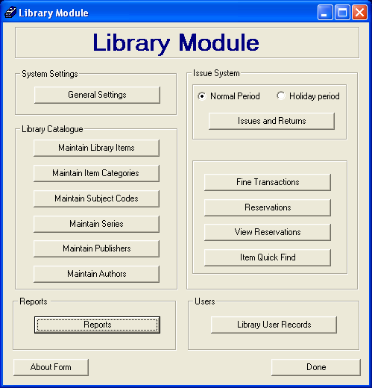
Figure 1: library module main menu page

2.1 Library Module Road Map

SA-SAMS Library
General Settings
Library Catalogue
Issue System
Fine Transactions
Reservations
View all Reservations

Reports

Library User Records
Item Quick Find
Loan Periods
Number of Loan Items
Fine Amount
Fine Intervals
Issue Restrictions
Library Items
Item Category
Subject Codes
Item series
Publishers
Issue Item
Return Item
Renewals
Validation Item/User
Pay Fine
Cancel Fine
View Fine
Make a Reservation
Cancel Reservations
View a Reservation
Issued Item Report
Outstanding Item Report
Reserved Item Report
View User Record
Search for Item
Authors
Languages

3. GENERAL SETTINGS
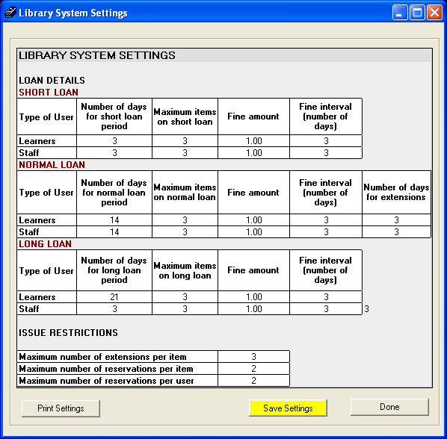
Figure 2: Library System Settings page

This section provides an interface to capture general loan details for learners and staff (both educators and general staff members). The library administrator must set-up the number of loan days, maximum loan items, fine amount and fine interval on the general settings page to get started with the Library module.
- Short Loans: Shortest periods an item can be loaned out to Library users (short loan periods are determined by the school library loan policies).
- Normal Loans: Schools must determine an average number of days a user can loan an item out. The period must then be captured as normal loans on the library system.
- Number of days for extensions: Maximum days allowed for a loan extension.
- Long Loans: Extended period (of normal loans) for item loans. It is normally during school holidays that long loans apply.
- Fine Amount: The amount of money which a user will be entitled to pay in case of exceeding the number of days allocated for a loan.
- Fine Interval: A number of days after which a fine will be repeated if an item which is due for return remains unreturned.
- Issue Restrictions: Captures all restrictions attached to the issue of an item. An item will not be issued if all restriction values are not met. There are 3 restrictions for issuing an item on this library system:
  - Number of extensions per item : Number of times a loan can be extended for an item
  - Number of reservations per item: Number of times an item can be reserved, e.g. one book can be reserved by 2 learners at a time.
  - Number of reservations per user: Number of items a user can reserve, e.g. one user can reserve 2 items at one time.
- When all values have been captured, click save settings button and then done button to return to the main menu.
Note: If above settings are not captured then fine amounts, return dates, user and item restrictions will not apply.
- To print settings, click on print settings button.

4. MAINTAIN LIBRARY ITEMS

4.1 Search for Library Items
1. To maintain the library items, click on maintain library items button

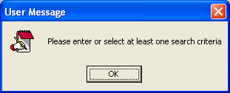
Figure 3: Search Criteria

- To search for an item on the catalogue a user must at least enter one criteria

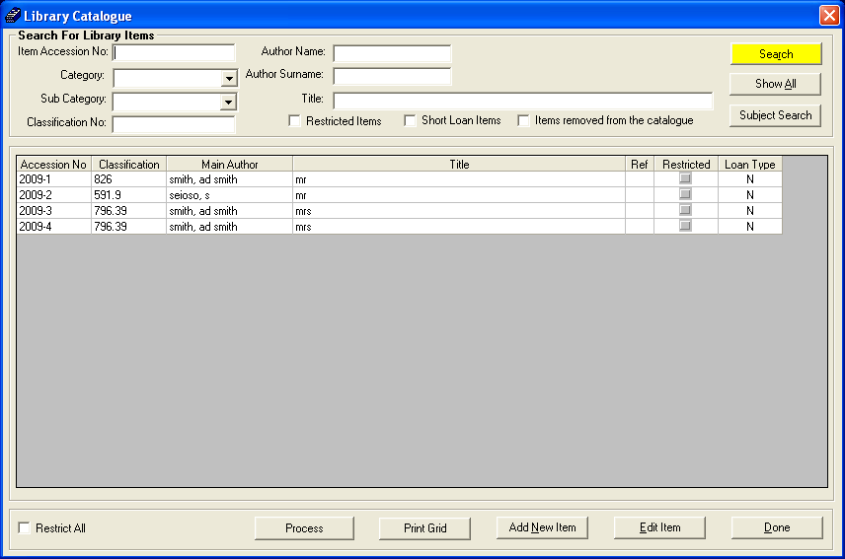
Figure 4: Search and Maintain Item page
- User can search for an item by a using combination of the following search criterions :
  - Accession number: A unique number that is allocated to an item when it is added to the catalogue. The number consists of the year of capture stroke (-) a number that is incremented per new item. e.g. 2009-1 for the first item that was captured in the year 2009. Accession numbers are automatically allocated by the system.
  - Category: An item category can be a magazine, book, etc
  - Sub category: A sub category can represent a sports, family, woman, etc.magazine within a magazine category
  - Classification no: Subjects are classified according to their area of study. A classifications number is allocated to all subjects of study. The system will automatically allocate a classification number to each item when it is added to the catalogue.
  - Author name: The author’s first name.
  - Author surname: the author’s last name
  - Title: the item name.
  - Restricted items, Short loan items and Items removed
  - Subject search : user can search by subject (i.e. Bonds)
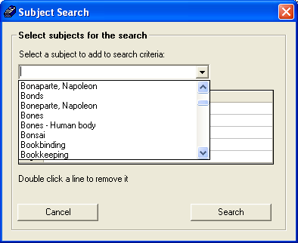
Figure 5: Subject Search
- Click Show All button to view all the available items in the catalogue.

4.2 Maintain Library Items.

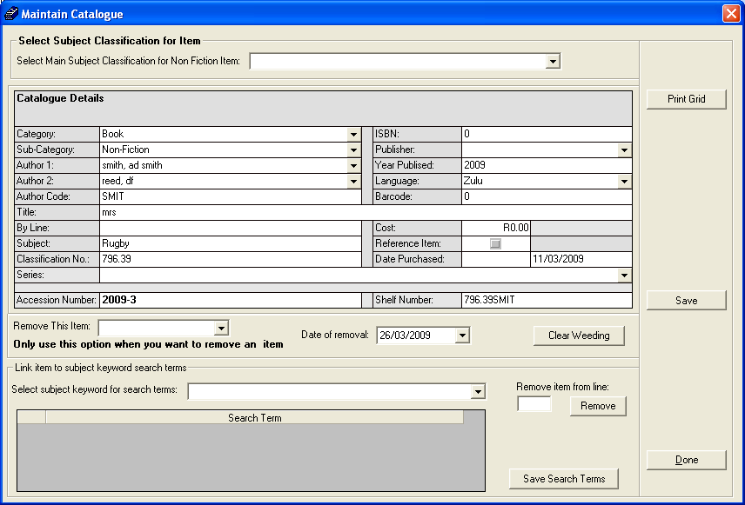
Figure 6: Maintain library Item
  - As illustrated on figure 4: to maintain an item, select an Item and click on edit item.
  - Figure 6 (above) will appear showing more details of the item.
  - Capture all necessary fields and click on save.
  - Click on done to exit the library item maintenance page.

5. MAINTAIN LANGUAGES FUNCTION

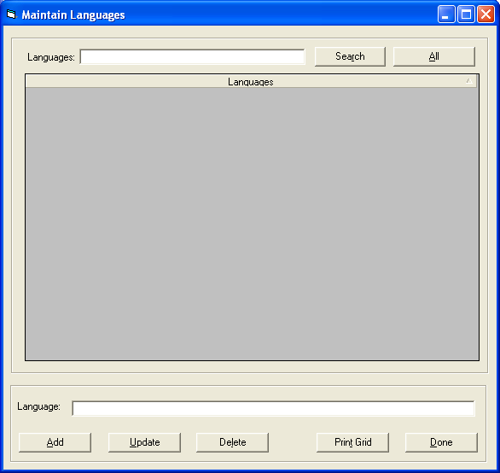
Figure 7: Maintain languages page

- In maintain languages section, user can add, update or delete a language.
- Type the language you wish to maintain on the textbox provided and select the functions to be performed (add, update or delete).
- User can search for available languages by using the search function provided. To search for available languages, type a phrase of the language on the top textbox and click on search.
- Use print grid button to print the list of available languages.
- Click all button to list all the available languages.
- Click done button to exit the language window.

6. MAINTAIN AUTHORS
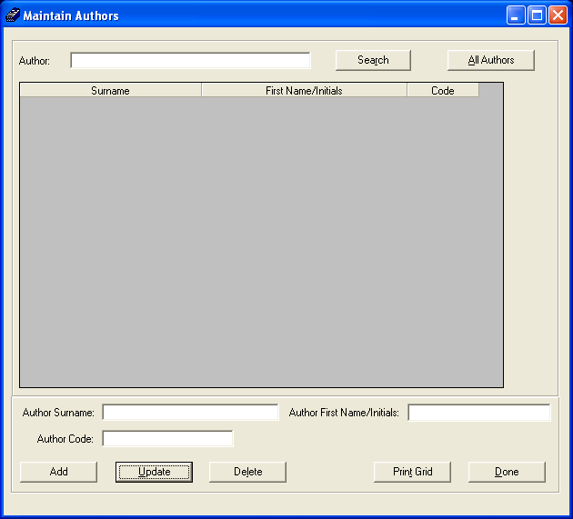
Figure 8: maintain authors page
- In maintain authors section, user can add, update or delete authors.
- Type the author surname and/or author first name/initials and/or author code you wish to maintain on the textboxes provided and select the function to be performed(i.e. add, update or delete)
- User can search for available authors by using the search function provided. To search for an author, type a phrase of the author’s name and click on search button.
- Click all authors button to list all the available authors on the catalogue.
- Use print grid button to print the list of available authors.
- Click done button to exit the maintain author page.

7. MAINTAIN PUBLISHERS
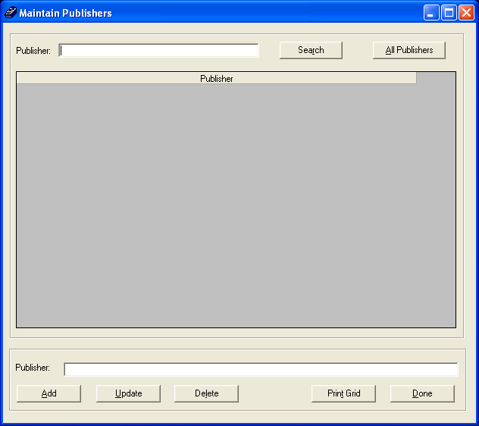
Figure 9: Maintain publisher page

- In maintain publishers section, user can add, update or delete a publisher.
- Type the publisher you wish to maintain on the textbox provided and select the functions to be performed (add, update or delete).
- User can search for available publishers by using the search function provided. To search for available publisher, type a phrase of the publisher’s name and click on search button.
- Click all publishers to list all the available publishers.
- Use print grid button to print the list of available publishers.
- Click done to exit maintain publisher page.

8. MAINTAIN SERIES
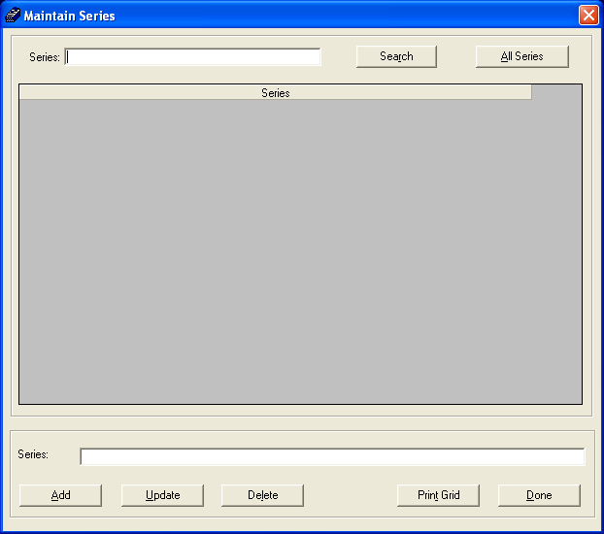
Figure 10: Maintain series page

- In maintain series section, user can add, update or delete a series.
- Type the series you wish to maintain on the textbox provided and select the function to be performed. (add, update or delete)
- User can search for available series by using the search function provided.
- To search for a series, type a phrase of the series and click on search button.
- Click all series to list all the available series.
- Use print grid button to print the list of available series.
- Click done to exit the maintain series page.

9. MAINTAIN SUBJECT CODES

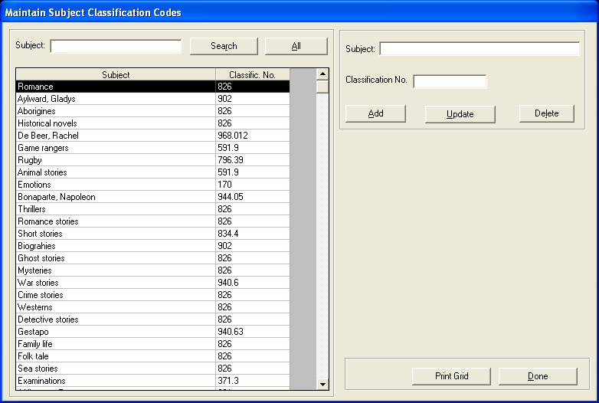
Figure 11: Maintain subject classification codes

- In maintain subject codes section, user can add, update or delete a subject code.
- Type or select the subject and classification number for the subject you wish to maintain on the textbox provided and select the function to be performed (add update or delete).
- User can search for available subject code by using the search function provided. To search for available subject codes, type a phrase of the subject code and click on search button.
- Click all subject code to list all the available subject code.
- Use print grid button to print the list of available subject code.
- Click done button to exit the maintain subject classification codes page.

10. MAINTAIN CATEGORIES

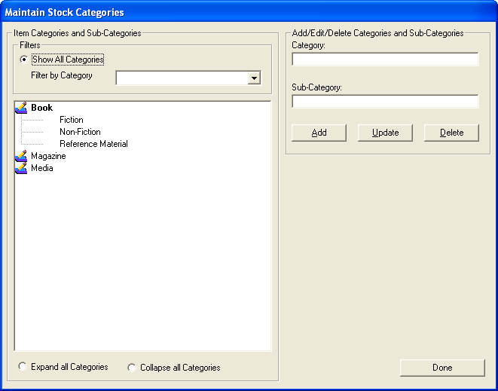
Figure 12: Maintain stock categories page

- In maintain subject categories, user can add, update or delete categories and sub-categories.
- Type or select the category or/and subcategory and for the category or/and subcategory you wish to maintain on the textbox provided and select the function to be performed (add update or delete).
- Select show all categories to view a full list of available categories.
- Use filter by drop list to select a specific category of items.
- Use expand all categories to view sub-categories
- Use collapse all categories to view only main categories
- Click on done to exit maintain stock category page.

11. ISSUE SYSTEM
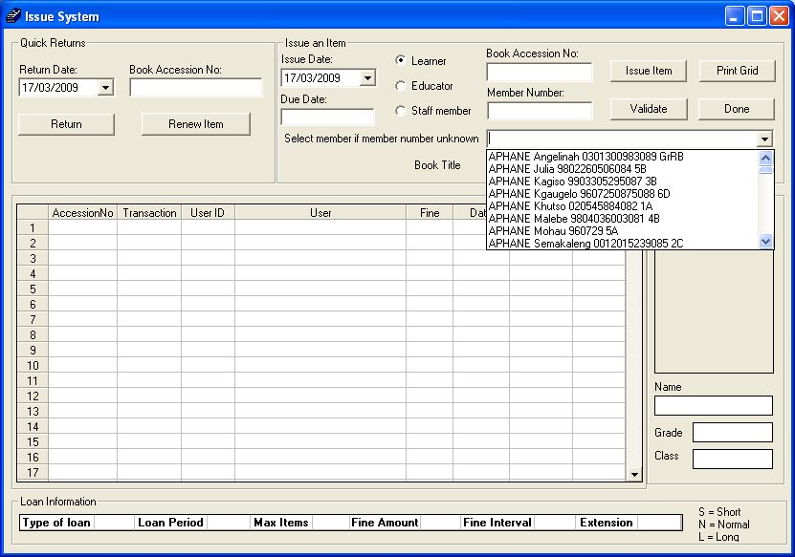
Figure 13: Issue system page

- To issue an item to a learner, click on the learner radio button and select the learner from select member if member numbers unknown drop down list. Type the learner number on member number text box if you know the number.
- Type book accession number on the space provided.
Note : The return due date is calculated according to short loan, long loan and normal loan settings as they appear under general settings.
If validation (see 11.1) is successful, click issue item to loan the item out to user.

11.1 User and Item Validation

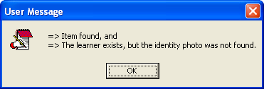
Figure13.1: Validation

The validation button is used to checks for:
  - Leaner existence
  - The grade and class of the learner.
  - Availability of Item accession number requested in the catalogue
  - Learner Identity Photograph
Note: Validation does not apply for educator and staff users and the validate button will not be active in that case. Issue date is automatically extracted from the system date but it can also be manually captured.

11.2 Return Item

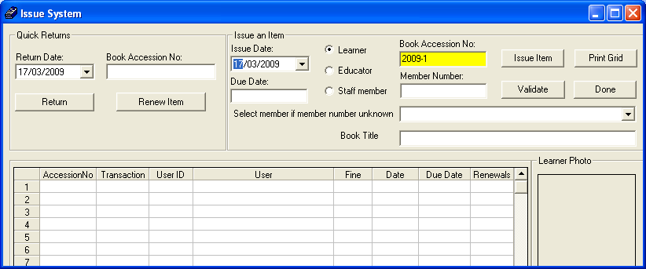
Figure 14: Issue System Page

- To return Items, type the book accession number on allocated text box under quick returns and click on return button.

11.3 Fine Accumulation.

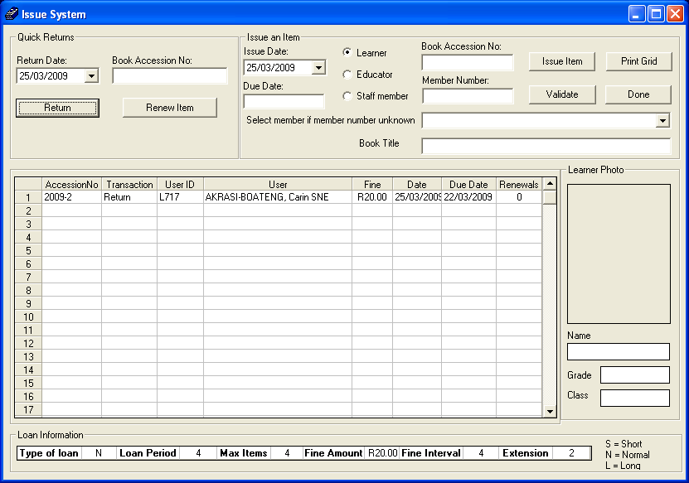
Figure 15: Calculate Fine

  - Fine amount is calculated and charged to user when maximum loan days are exceeded.
  - When an item is returned, the system checks the recorded return due date for the item. If due date has expired, then a fine is calculated according to the loan period, fine amount and fine interval that were captured on the general settings section.

12. FINE TRANSACTIONS

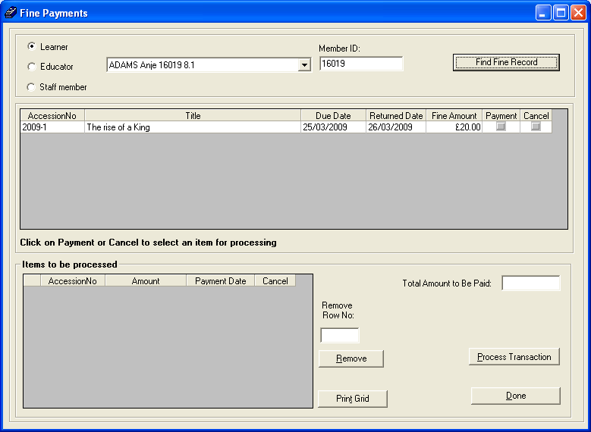
Figure 16: Fine Transaction Page

- To view current fines for learners, educators or staff members, select a member from the drop down list or type member id on text box provided and click on find fine record button.
- To pay fine click on payment. The fine will move to items to be processed (see figure 17)

12.1 Process Payment

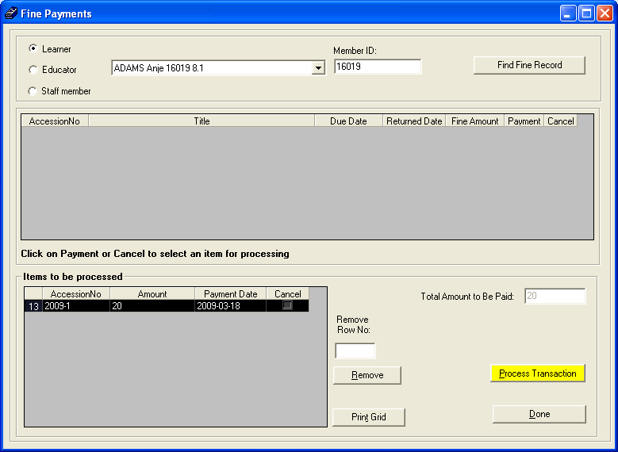
Figure 17: Process Payment Page

- Total fine amount will show on total amount to be paid text box
- To complete the payment, click on process transactions button.
- To remove the fine from items to be processed, click on the fine to select it and click remove button. The fine will move back to the fine list.

12.2 Cancel Fine

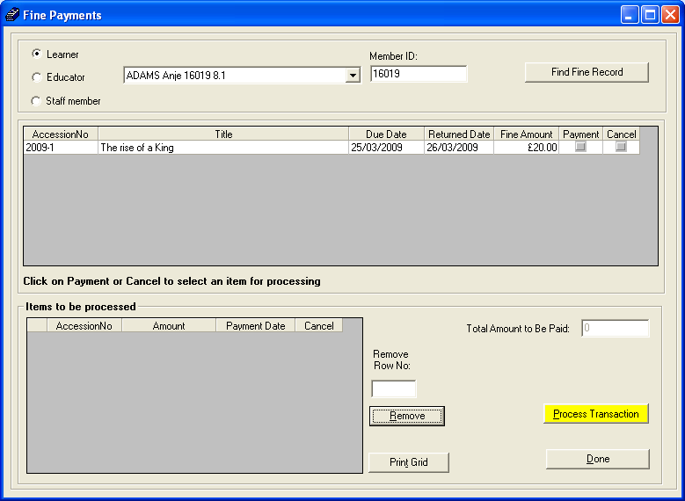
Figure 18: Cancel Fine Page

- To cancel the fine, click on cancel. The fine will move to items to be processed.
- Click on process transaction to cancel the fine
- To remove the fine from items to be processed, select a fine and click on remove button. The fine will move back to the fine list.
- Click done button to exit the cancel fine page.

13. RESERVATIONS

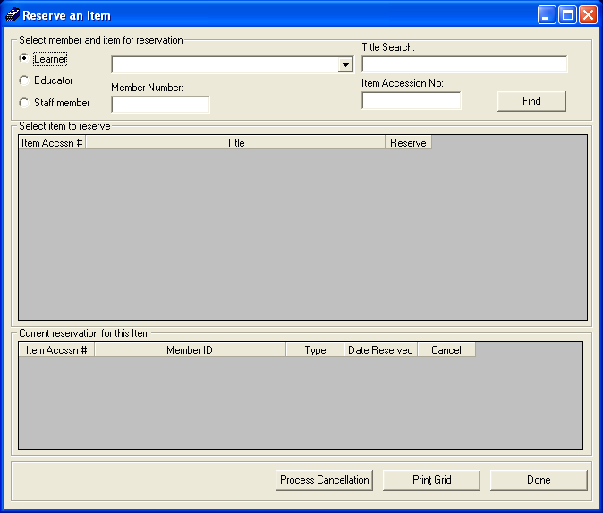
Figure 19: Reserve an Item Page

- To reserve items for learners, educators or staff members, select a member from drop down list or type member id on text box provided.
- Type the title or item accession number and click on find button to locate the item to be reserved.

13.1 Process Reservations

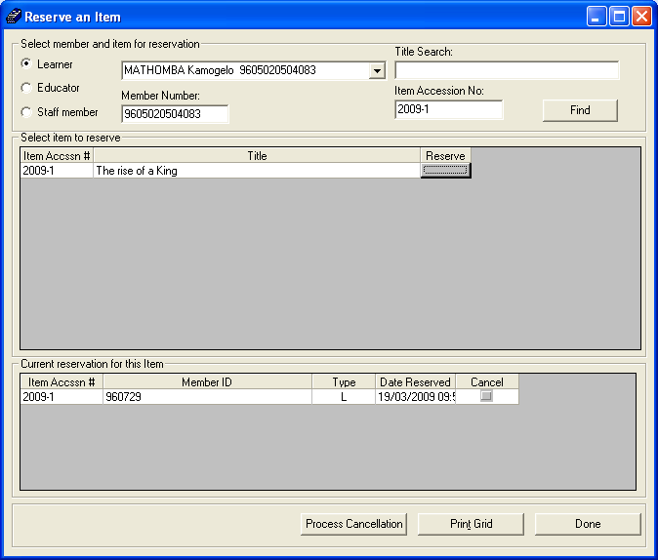
Figure 20: Item Reservation Page

- When item is found on the catalogue, it will be displayed under select item to reserve.
- To reserve the item for user , click on the reserve button
Note: If item has already been booked, a list of current reservations will appear under current reservations for this item. Item cannot be reserved if it is available on the shelf.

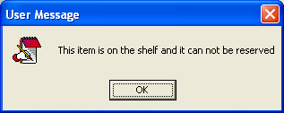
Figure 21: (Can’t reserve: Available on shelve)

- To cancel a reservation, click on cancel check box next to the reservation you wish to cancel and click on process cancellation.
- Click print grid button to print reservations.
- Click done to exit the reservations page.

13.2 View

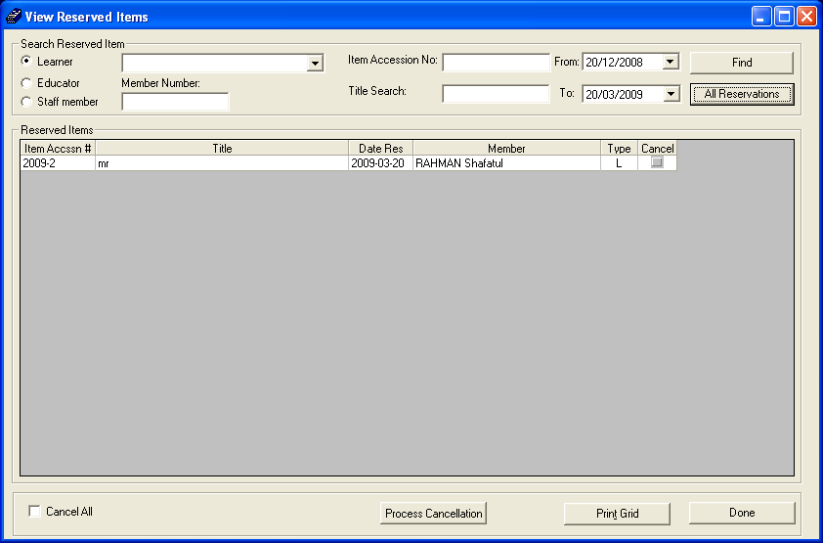
Figure 21: View Reserved Item Page

- To view all reservations, click on all reservations button.
- To view reserved items for learners, educators or staff members, select a member from drop down list or type member id on text box provided.
- To view reservations for a specific item, type accession no on the text box provided and click on find button.
- To search for a specific item, type title on title search and click on find button.
- To search for reservations made within a specific period, select a date from and date to and click on find.
- To cancel a reservation, click on cancel button next to the reservation on the list and click on process cancellation.
- To cancel all reservations, check cancel all check box and click on process cancellation
- To print reservations list, click on print grid button.
- To exit, click on done to exit the reservations page.

14. QUICK FIND

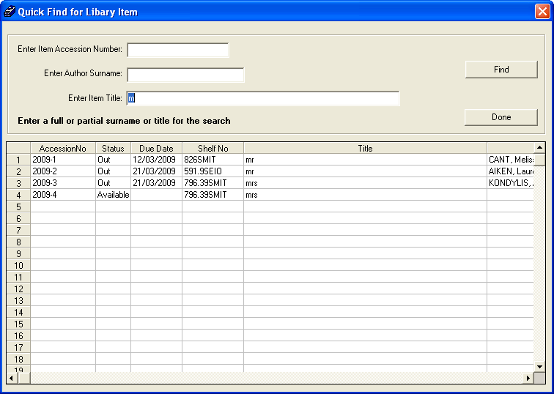
Figure 22: Quick Find Page

- Users can search for items using the quick find for library item function.
- Users can search by entering item accession number and/or author surname and/or item title and then clicking on find.
- A phrase of the item’s name can be used to search for items e.g. user may enter letter “m” and click on find to list all the items starting with letter “m” as on figure 22 above.

15. LIBRARY USERS

15.1 Library Learner Users

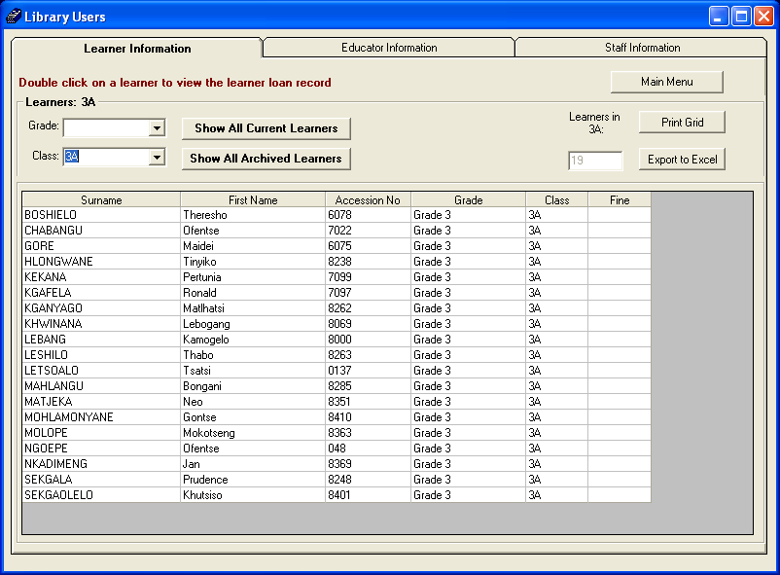
Figure 23: Learner Library Users Page

- To view a list of library users, select library users from library main menu.
- Select learner information tab to view information for learner users.
- Click show all current learners to view a complete list of current learner library users.
- Click show all archived learners to view a complete list of archived learner library users.
- Use drop list for grade and class to filter down the learner list.
- Use export to excel to create an excel file of the list of users showing on the grid.
- Use print grid to print the user list.

15.2 Library Educator Users

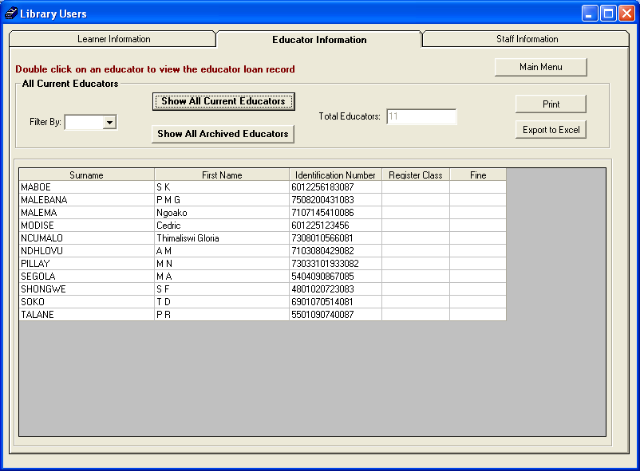
Figure 24: Educator library Users Page

- Select educator information to view information for educator users.
- Click show all current educators to view a complete list of current educator library users.
- Click show all archived educators to view a complete list of archived educator library users.
- Use filter by drop list of a – z to filter down the educator’s surnames.
- Use export to excel to create an excel file of the list of users showing on the grid.
- Use print grid to print the user list.

15.3 Library Staff Users

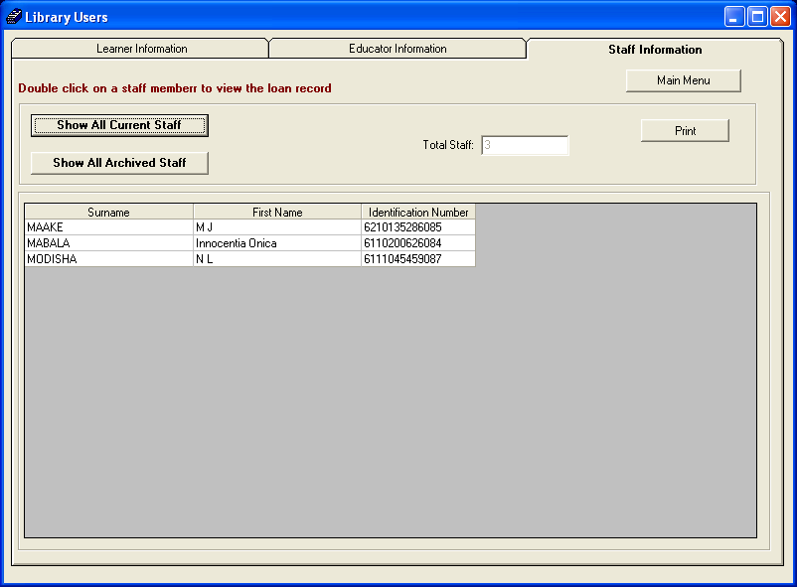
Figure 25: Staff Library Users Page

- To view a list of library users, select library users from library main menu.
- Select staff information to view information for staff users.
- Click show all current staff to view a complete list of current staff library users.
- Click show all archived staff to view a complete list of archived staff member library users.
- Use print grid to print the user list.

16. LIBRARY REPORTS

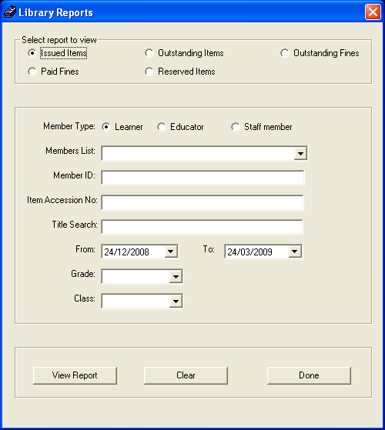
Figure 26: Library Reports Page

- To extract reports from the library module, select reports from main menu.
- User can request a report for issued items, outstanding items, outstanding fines, paid fines and reserved items.
- To search for a report:
- Select member type : learner, educator or staff member
- Select member list Drop down list. Type the member ID number on text box provided if it is known.
- Type item accession no on the provided text box if it is known.
- Type the title on title search text box if you know the name of the item you are searching for.
- Select the start date and end date on from drop down list and to dropdown list.
- Select the grade on which u you like to conduct the search.
- Select the class on which u you like to conduct the search.
Note: Grade and class search do not apply for educators and staff.

