LURITS Online Submissions

1. Click on the **Lurits Approval Module** button.

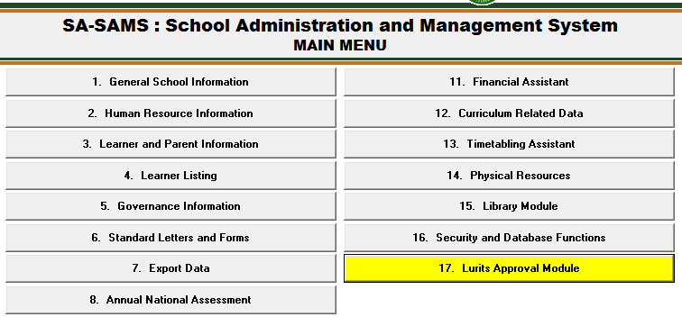

1. Click on the School Information tab.
   1. If the Lurits Status is “1” then tick in a box on **“I certify that the information provided on this form is to the best of my knowledge and belief correct and complete”** and click on the **Approve** button. The status will change to “2”.
2. Click on the **Learner Information tab**.
   1. Click on the **Show All Current Learners** button. Do step 2.1 to approve.

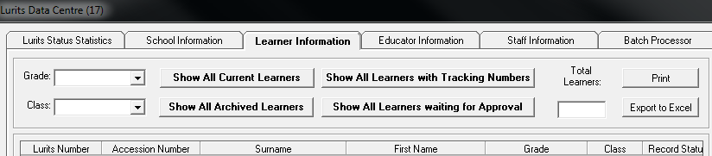

3.2 Click on the **Show All Archived Learners** button. Do step 2.1 to approve.

1. Click on the **Educator Information tab**. Click each circled button and do step2 to approve.

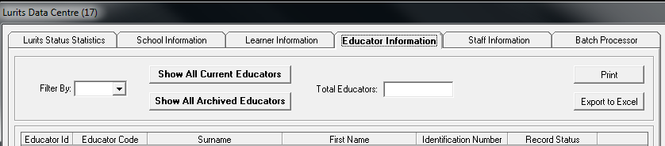

1. Click on the **Staff Information tab**. Click each circled button and do step2 to approve 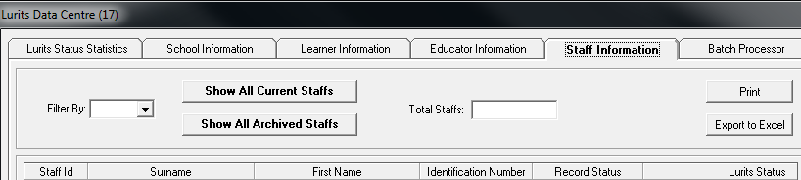
2. Return to **Lurits Status Statistics tab** to display the deployment report. Scroll down to check if there is any information waiting to be approved.

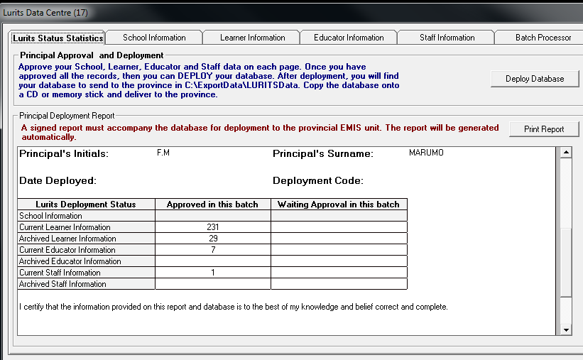

* 1. If not, click on the **Deploy database** button.

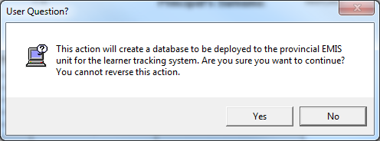

* 1. Click on the **Yes** button and **Print**.

1. Right click on **Start** and click on **Open Windows Explorer**.

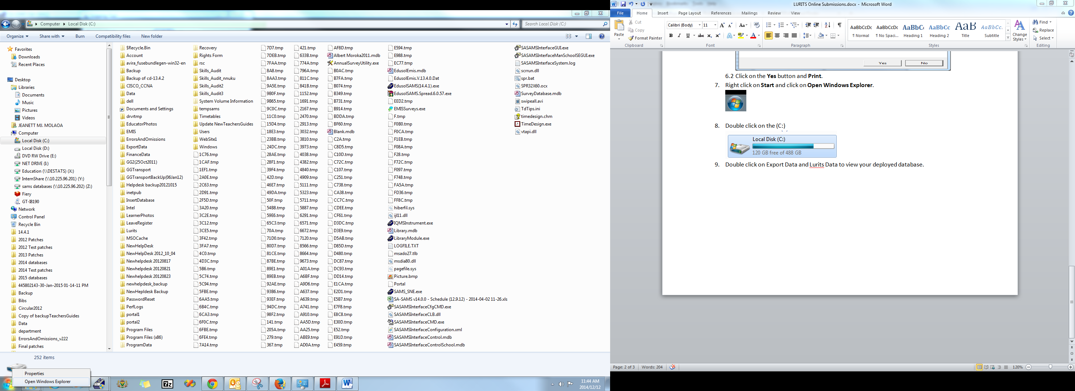

1. Click on the (C:)

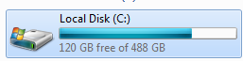

1. Double click on **Export Data** and then **Lurits Data** to view your deployed database.
2. This is what a deployed database looks like:

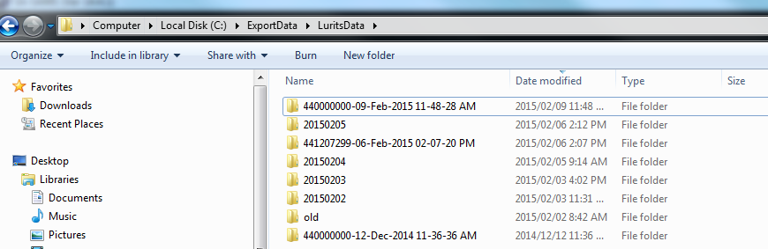

**Note: Please make sure that the selected deployed database has the latest date and time.**

1. Right-click on the folder with the **latest date and time.** Click on **Send** **to**. Click on **Compressed(zipped folder)**.

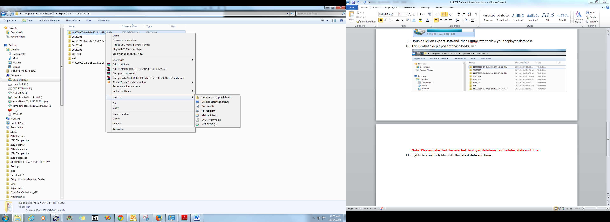

1. It will create a **zipped file** that is the same name as your deployed folder.

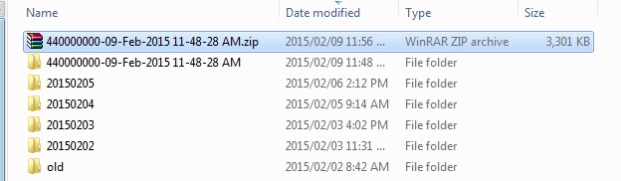

**How to upload the Lurits Deployment report as an image?**

1. Before **scanning** or **taking a photo** of your deployment report, the principal must sign the deployment report.
2. This is how the **image** will look like: **Note: Only image files(jpg, bmp, gif, png) and pdf files will be accepted.**

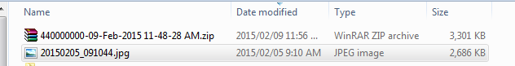

**Login in EMIS Portal**



1. Enter your **EMIS number** and **Password** and click on Login.
2. Click on **SAMS Submission**, the following will display:



1. You will notice that the default **Year** is current year, but if not then select the correct year and select the data **month**.

**Browsing files on your computer**

1. **Browsing for zipped Database**
   1. Ensure that you LURITS database is zipped and you know where it is saved. Then click the **Browse** button to locate and select your database.
   2. When you have found your zipped database then click **Open** to prepare it for uploading.
2. **Browsing for Lurits Deployment Report**
   1. Click the Browse button to locate where you saved the image/pdf file.
   2. When you have found your Lurits Deployment report then click **Open** to prepare it for uploading.
3. Click on the **SUBMIT** button.