

---------------------------------------------------------------------------------------------------

LURITS Feedback Process Manual

LURITS FEEDBACK PROCESS

After your data has been uploaded to the National Department of Education by the Provincial Lurits Administrator, the National Department of Education will send the Provincial Lurits Administrator Feedback Files. These Feedback files will be copied onto a CD and in turn be sent to each school for loading them back onto their own computer.

Once you have received your Feed Back CD you need to insert it into your main SA-SAMS computer.

NB: Ensure that you Run/Install the latest SASAMS Patch before proceeding with the feedback process and ensure that Microsoft.Net Framework 2.0 for SP1 is installed.

- Click on the ‘Start Button’ (Start Menu), located on the bottom left corner of your screen
3
- Click on ‘My Computer’ (the screen below will be displayed).
- Double Click on ‘CD-R Feedback Files (D)’/ CD-R to open the CD.

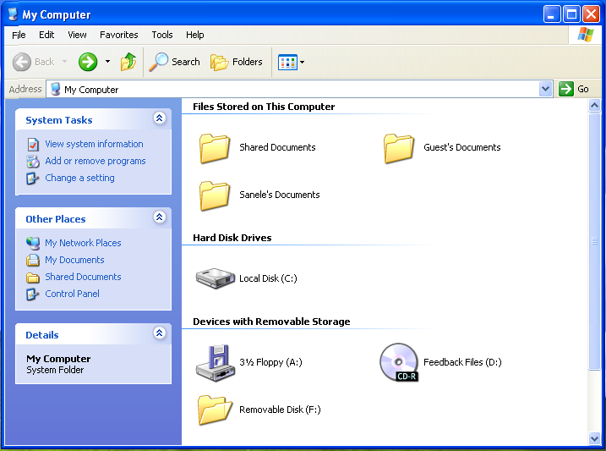

Fig 1: My Computer.
4. Copy the ‘School Name folder’ or the folder with the ‘School’s Emis Nr’ and place it on the Desktop.

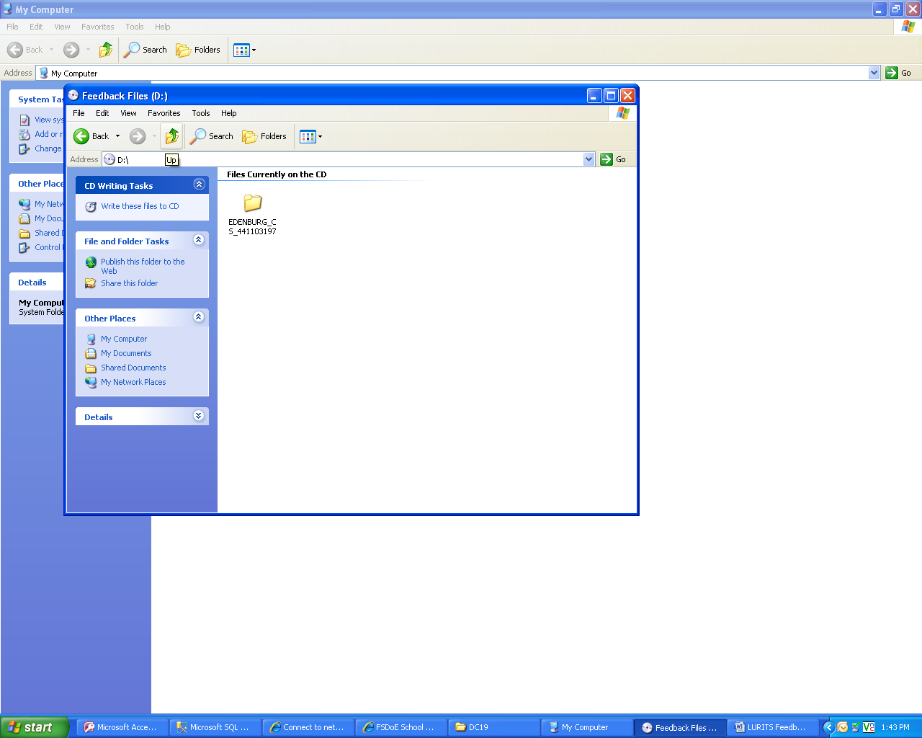
4

Fig 2: CD Drive.

5. Click on the SA-SAMS icon on the Desktop to launch the SA-SAMS Main Menu (Fig: 3) below

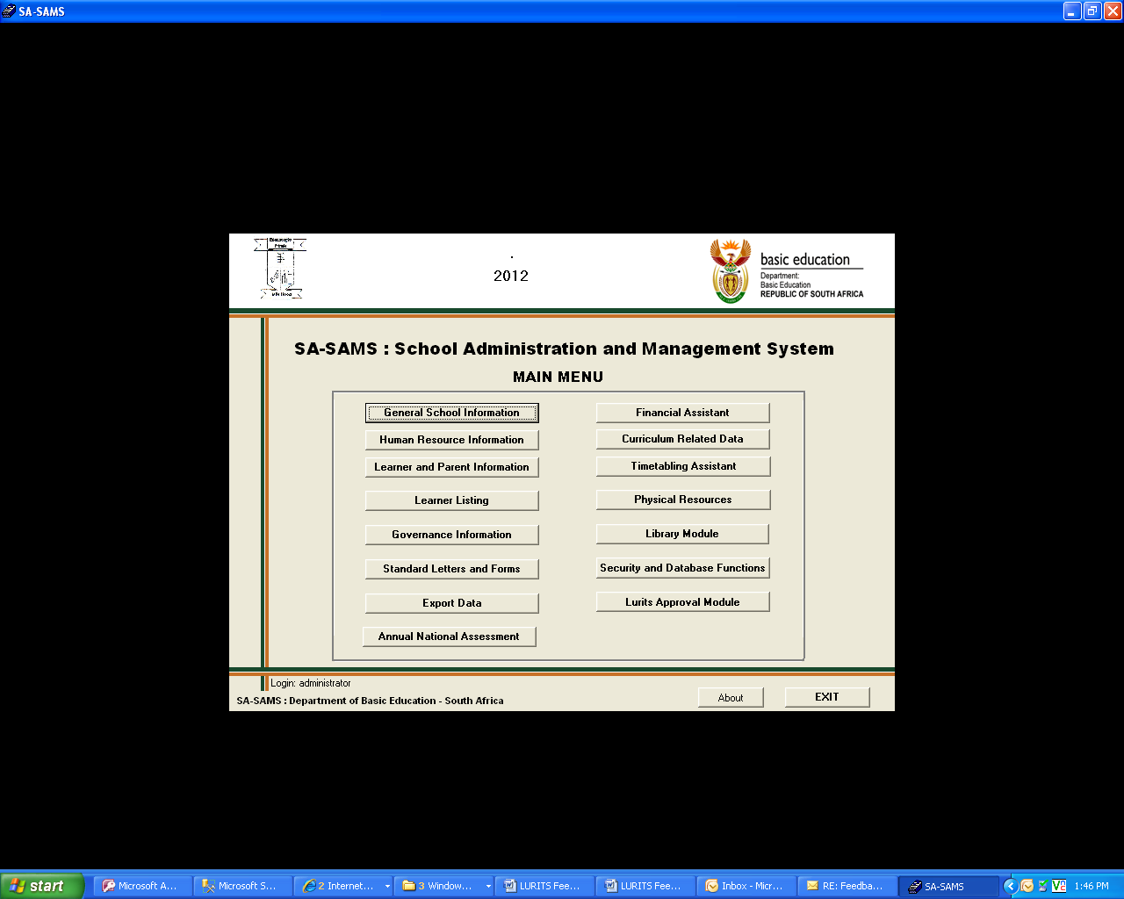
6
Fig 3: SA-SAMS Main Menu.
- Click on Lurits Approval Module (Fig: 3) to launch the Lurits Data Centre screen.
The Lurits Data Centre Screen will be displayed.

7. Click on ‘Batch Processor’
8. Ensure that the ‘Lurits Batch Processor is turned on’ (has been ticked).
9. Then click ‘Create Directory Structure’

NB: If you have imported your Feedback Files before the ‘Create Directory Structure’ button will be INACTIVE/DISABLED, then in this case you should skip step 9 and proceed to step 10.

For those schools importing their Feedback Files for the first time and the ‘Create Directory Structure’ button is INACTIVE/DISABLED then they must install MICROSOFT.NET FRAMEWORK 2.0 for SP1 available in any of the latest SASAMS CD patches under Utilities (only for WINDOWS XP and prior versions of WINDOWS)

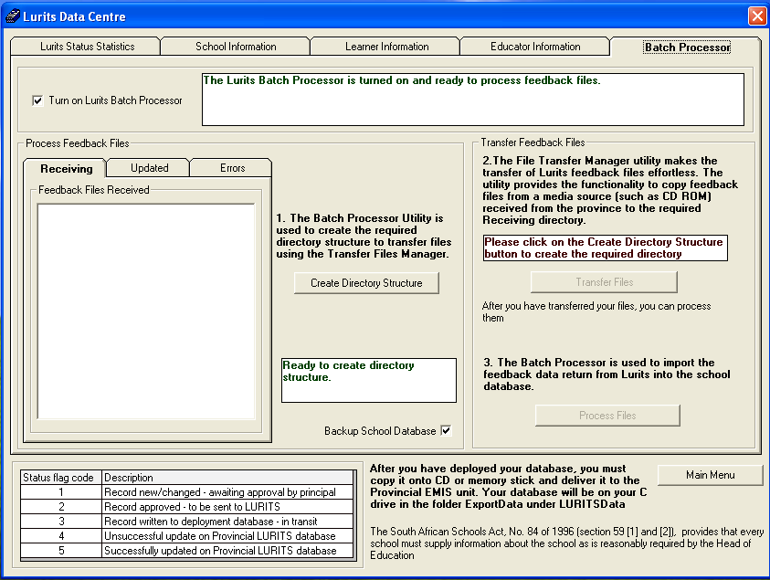
7
8
9
10
Fig 4: Lurits Data Centre.

10. Click on ‘Transfer Files’, to launch ‘Lurits/SA-SAMS Import Interface’.
11. Click on, ‘ImportInterfaceFile(s)’

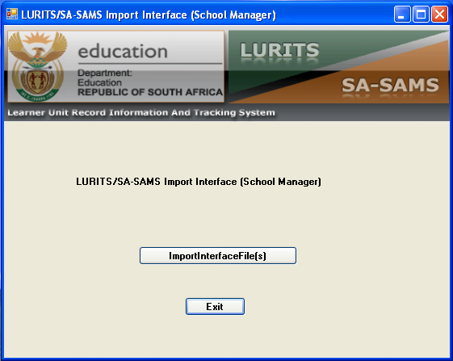
11

Fig 5: Lurits/SA-SAMS Import Interface.

After clicking on ‘ImportInterfaceFile(s)’ you will now select the location of the Feedback Files i.e. the School Name Folder you placed on the Desktop.

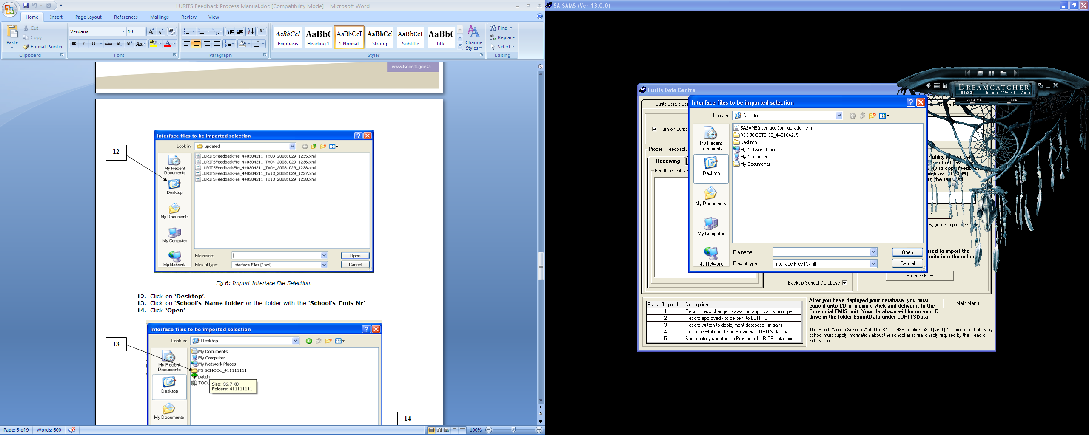
12

Fig 6: Import Interface File Selection.

12. Click on ‘Desktop’.
13. Click on ‘School’s Name folder or/and the folder with the ‘School’s Emis Nr’
14. Click ‘Open’

13
14

Fig 7: My Desktop.

15. Select the ’Receiving folder’
NOTE: if the ‘receiving folder’ is not there; exit SASAMS and look at you latest Errors and Omissions report for any errors in your database, correct them, approve both your School information, Learner and Educator information then deploy your database and submit it.
16. Click ’Open’
15
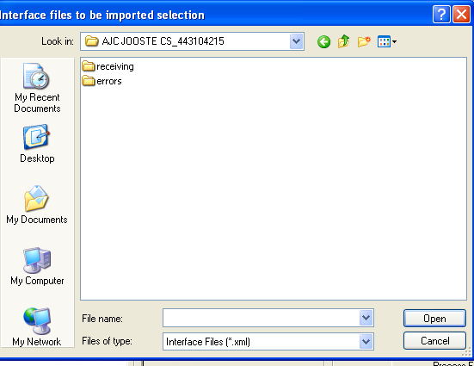
16

Fig 8: Feedback Files Folder

You will now have the Feedback Files in front of you.
17. ’Select all of them’
18. Click ’Open’
17

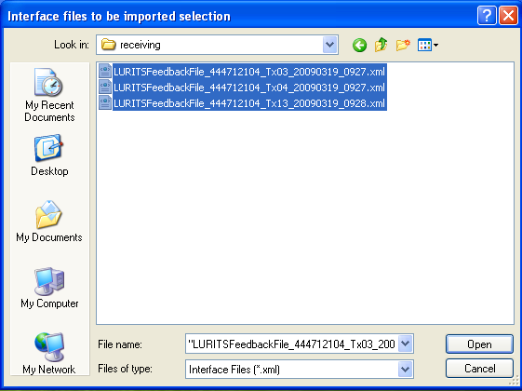
18

Fig 9: Feedback Files (receiving folder)

The next screen will indicate that the ’import has been successfully completed’.

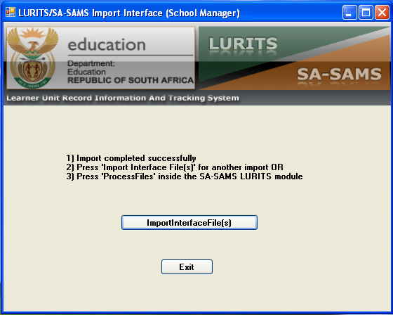
19

Fig 10: Import completed successfully.

- Click on’ Exit’, and you will notice that the selected Feedback Files from the CD, have been placed in the ‘Receiving’ tab

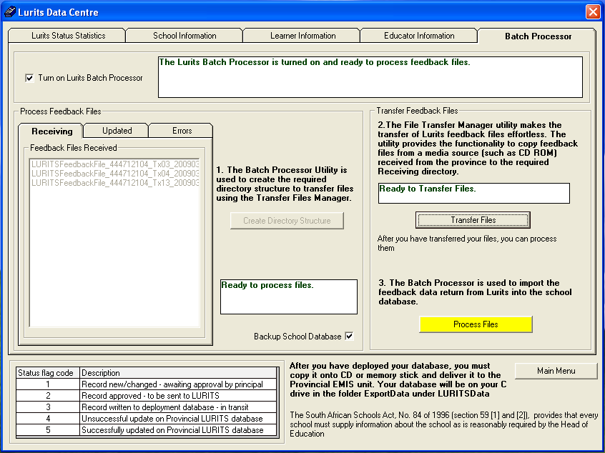
20
Fig 11: Feedback Files in the Receiving tab

- To conclude this process you need to click on ’Process Files’, then on the
21
User Message screen click ‘OK’ to backup your database.

To view your learners with their Lurits tracking numbers, Click on ‘Learner Information’, then Click on ’ Show All Learners with tracking numbers’ (21)

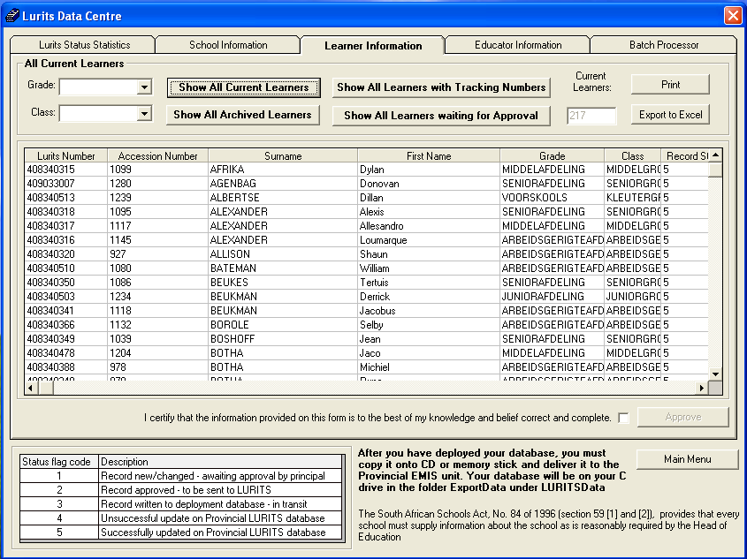
Fig 12: Learners with Tracking Numbers.

