

SA-SAMS

Guideline for using IQMS Module

September 2009

Education Management Systems (EMS)
Department of Education
Private Bag X895
0001 PRETORIA

CONTENT

1. INTRODUCTION 3
2. GENERAL SUGGESTIONS FOR USING IQMS MODULE 3
3. IQMS ROAD MAP 4
4. DEVELOPMENT APPRAISAL AND PERFORMANCE MEASUREMENT SYSTEM 8
4.1 Educator General Details ….. ………9
4.2 Development Appraisal 11
4.3 Performance Measurement 12
4.4 Personal Growth Plan (PGP) 13
4.5 PM Check List 14
4.6 Score Sheet 15
4.7 Print Educator List 16
5. EDUCATOR IMPROVEMENT PLAN 17
6. EXPORT IQMS DATA 18
7. REPORTS 20
7.1 Summary of Score (Individual Educator) 20
7.2 School Summary Score Sheet 23
8. SYSTEM SECURITY 24
9. LOG ON AS DIFFERENT USER 26

- INTRODUCTION

What is IQMS?

IQMS is an integrated quality management system that consists of development appraisal, performance measurement and whole school evaluation programmes which are aimed at enhancing and monitoring performance of the education system.
The IQMS module had to be integrated into SA-SAMS to reduce administrative burden related to the paper based system. IQMS module has a friendly user interface specifically adapted to cater for non computer literate users. A button interface and user prompting mechanism is used as opposed to more complicated menu structures.

- GENERAL SUGGESTIONS FOR USING IQMS MODULE

  - Use Save button to save information you have captured on the form
  - Use Print Page button to print a grid on the form
  - Use Main Menu button to return to the Educator’s selection form
  - Use Next Page button to proceed to the next form
  - Use Educator List to return to the educator list form

- IQMS ROAD MAP

IQMS Module
Performance Measurement
Educator Improvement Plan
Export IQMS Data
Reports
System Security
Logon as Different User
Educator General Details
Change login Password
Development Appraisal
Performance Measurement
Personal Growth Plan
PM check list
Score Sheet
Print Educator list
Summary of Score (Individual Educator)
School Summary Score sheet

To access the IQMS module, please follow the instruction below.

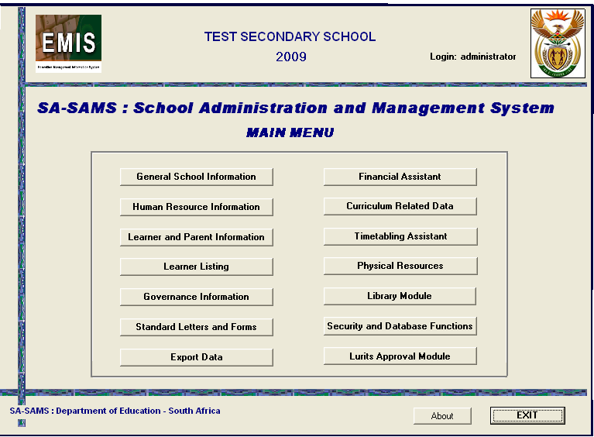
Figure 1: Human Resources Information menu page

- Click on the Human Resource Information menu on SA-SAMS main menu, the following screen will appear;
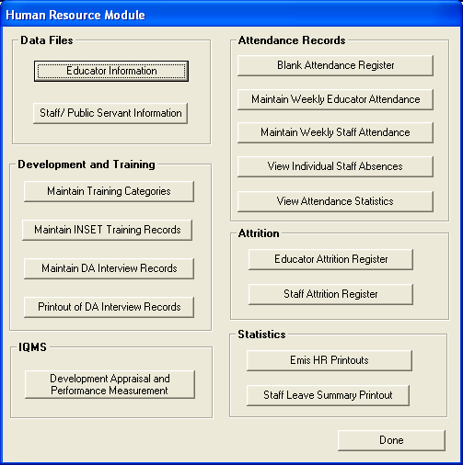
Figure 2: Human Resource menu page

- Click on the Development Appraisal and Performance Measurement menu; the following screen will appear;

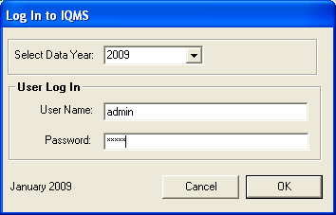
Figure 3: User log-in menu page

- Enter the user name and the password to log in to the IQMS module, the default login username and password are :
- User Name: admin
- Password: admin
- Click on the Ok button;
The IQMS Main Menu screen will now be loaded (Note that the password can be changed at anytime. Please refer to the System Security section on how to change the passwords and username.)

- DEVELOPMENT APPRAISAL AND PERFORMANCE MEASUREMENT SYSTEM

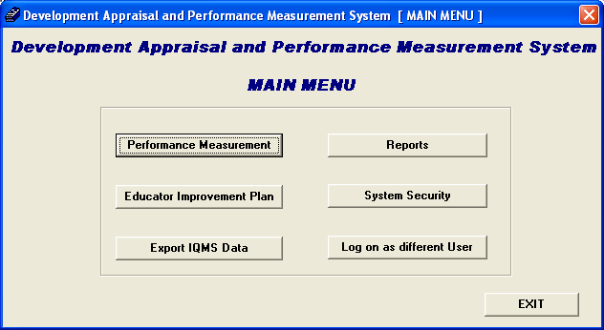
Figure 4: Development appraisal main menu page
  - Performance Measurement menu is used to capture and manage the appraisal process.
  - Educator Improvement Plan menu is used to draft a plan for improving the teaching standards of educators. This section must be completed by the school principal.
  - Export IQMS Data menu is used to create an XML file with performance appraisal and performance scores of individual educators.
  - Reports menu is used to generate individual educator reports
  - System Security menu is used to manage and control access into the system.
  - Log on as Different User menu can be used to renew the active connection session.

  - Educator General Details

This is the main menu form that contains the list of educators which can be used for assessing purposes, to start working with this form you need to select an educator and click on any menu item to begin the appraisal process.

.

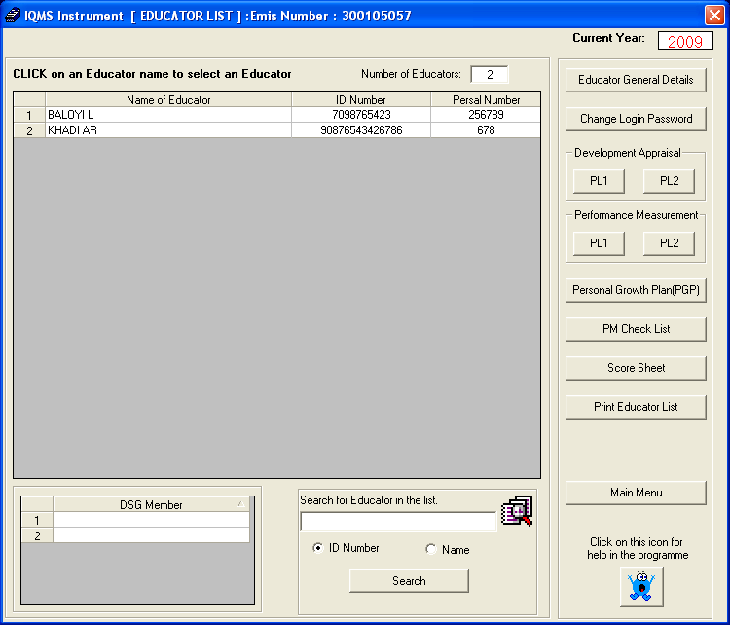
Figure 5: IQMS instrument educator list menu page

- To view the educator’s personal and educational details;
  - Click on the Educator General Details menu. The following screen will appear:

This form will be used to view personal and educational details of the selected educator. The DSG members for an educator can also be selected from this section. To return to the main menu click on the Educator List menu.

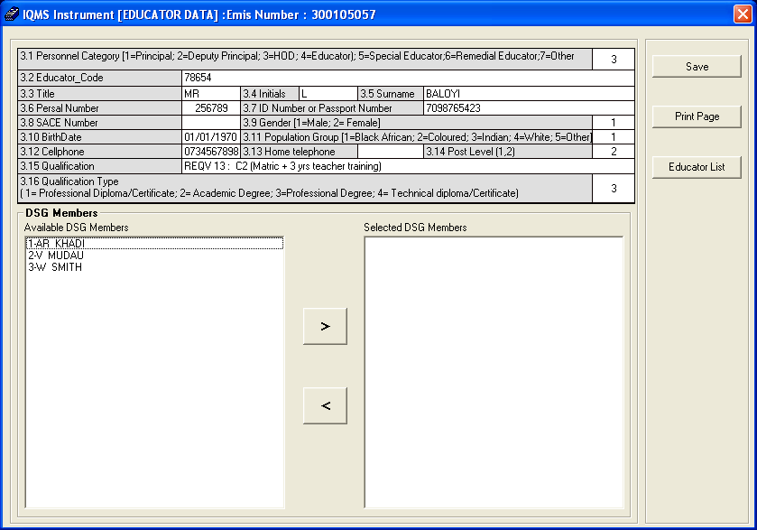
Figure 6: IQMS instrument (educator Data) menu page

- How to select a DSG member

  - To select an SGB member, select an educator from the available DSG members list and click on the Forward arrow. The selected educator should now appear in the selected DSG Members list box.

- How to remove a DSG Member

  - To remove an SGB member, select an educator from the selected DSG member list and click on the back arrow. The selected educator should now appear in the available DSG member list box

  - Development Appraisal

The purpose of the development appraisal is to appraise individual educator in a transparent manner with a view to determine areas of strength and weakness, and to draw up programmes for individual development.

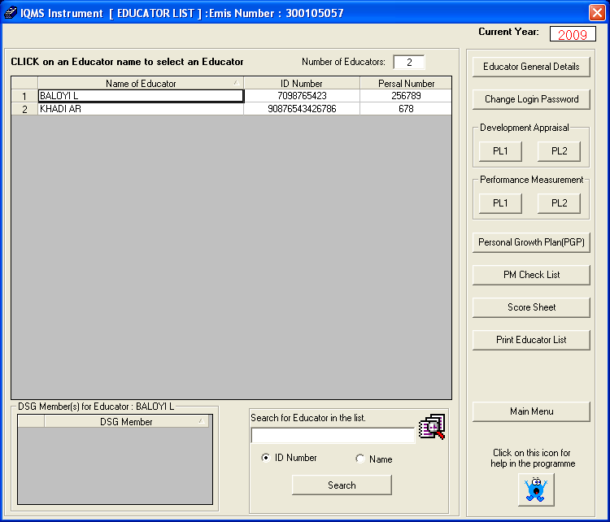
Figure 7: IQMS instrument [educator list] menu page

- To start with the development appraisal for the educator;
  - Select the educator you wish to make assessment for;
  - Click on the PL1 menu and the following screen will appear;

This form is used to evaluate how the educator interacts with learner, if he/she create a positive learning environment and if his/her teaching methods is understandable by learners.

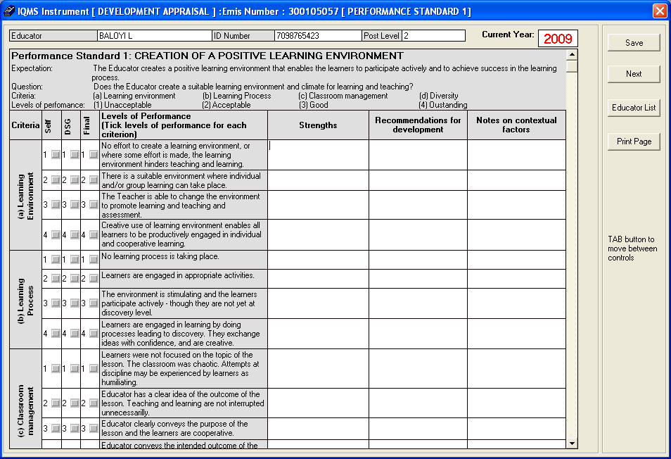
Figure 8: IQMS instrument [development appraisal] menu page

Note that if you log in to the system as the user you can only be able to do the Self assessment appraisal; where else if you log in as the administrator you can only be able to complete the FINAL and DSG appraisal, After you have completed the appraisal on the above form click on the Next button to continue, note that from form 2 to form 10 the appraisal process is completed the same way as you did on the above form.

  - Performance Measurement

The purpose of performance measurement is to evaluate individual teachers for salary progression, grade progression, affirmation of appointments and rewards and incentives.

- To start with the assessment of the educator click on the Performance Measurement menu;

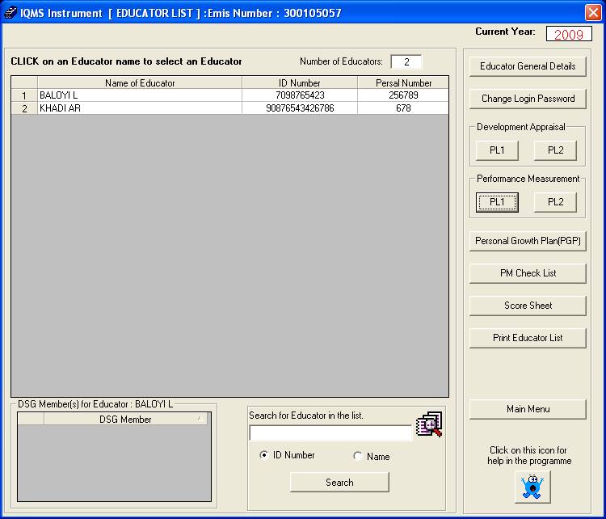
Figure 9: Educator list menu page
Note that the Performance Measurement appraisal process can be completed the same way as the Development Appraisal process.

  - Personal Growth Plan (PGP)

Each time the educator is appraised he/she should review his/her own Personal Growth Plan, the aim of this plan is to ensure that the appraisal is developmental, when drawing the PGP the educator needs to actively participate so that he/she will grow as a professional educator.

To start using the Personal Growth Plan Menu:

- Click on the Personal Growth Plan (PGP) button;
- The following screen will appear;

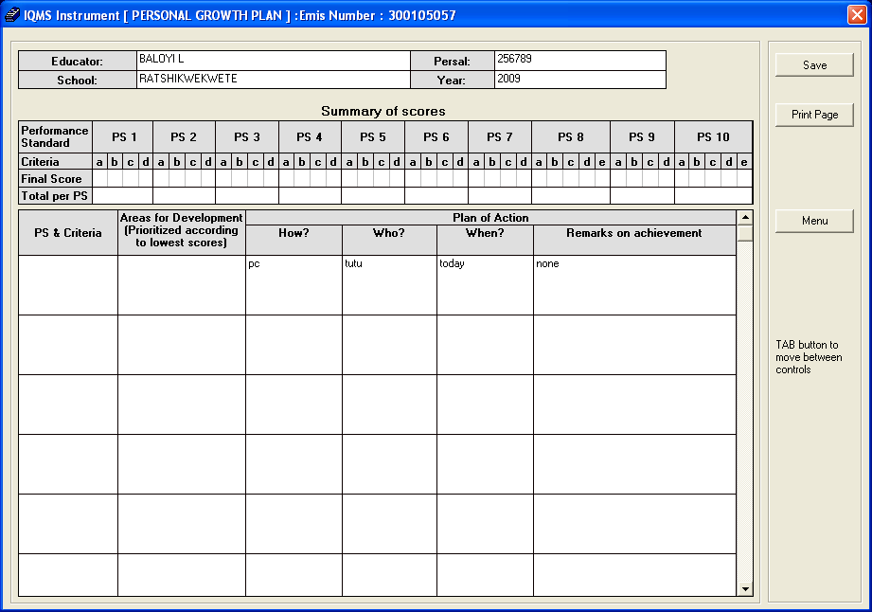
Figure 10: Personal Growth Plan menu page

- Enter the required details in the various fields;
- Once done click on the Save button then click on the Print Page button;
- Alternatively click on the Menu button to return to the educator list menu.

  - PM Check List

This form is used as a check list to evaluate if the educator has been apprised, if the Personal growth plan has been approved, if there are areas which still needs development and how the educator contribute in the extra-circular activities in the school.

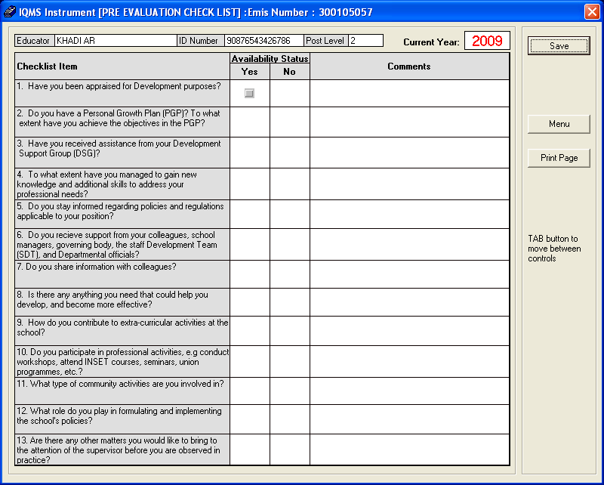
Figure 11: Pre-evaluation check list menu page

- Enter the required details in the various fields;
- Once done click on the Save button then click on the Print Page button;
- Alternatively click on the Menu button to return to the main menu.

  - Score Sheet

After the appraisal process has been completed by the school principal, he/she can use this form to rate the educator’s performance standards, the rating must be based on the results from the appraisal, this form can be used to determine if there are areas which still needs development.

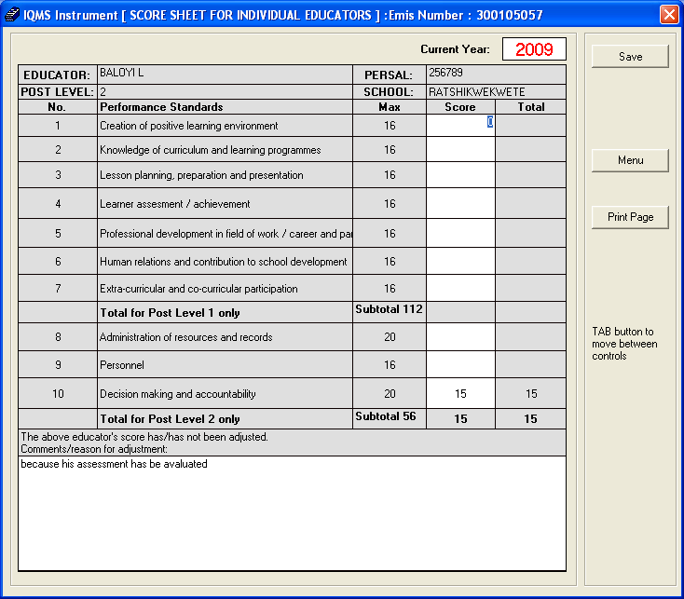
Figure 12: Score Sheet menu page

- Enter the required details in the various fields;
- Once done click on the Save button then click on the Print Page button;
- Alternatively click on the Menu button to return to the educator list menu.

  - Print Educator List

This form is used to print the list of educators which are currently on your school.

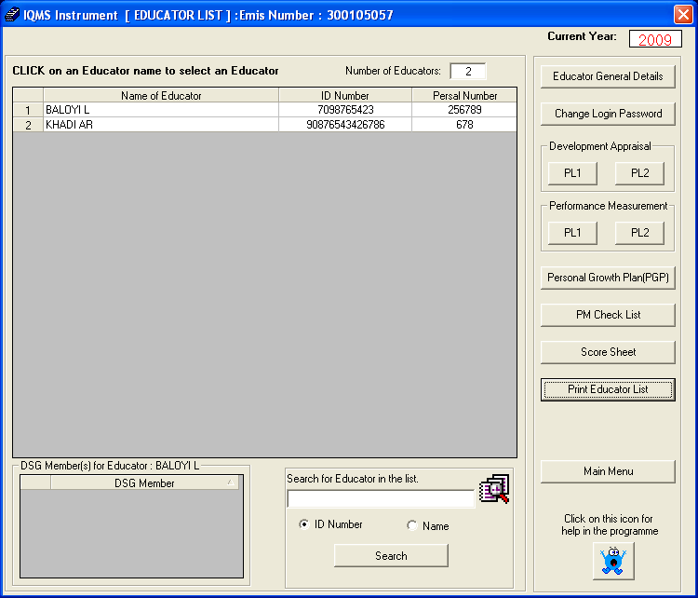
Figure 13: Educator list menu page

- Click on the Print Educator List button and;
- Click on the Print Button to print educator’s list.

- EDUCATOR IMPROVEMENT PLAN

The educator improvement plan is used to show the performance standards where educator got low scores which show where he/she need help, what strategies will be used to provide the help, who will give help and person responsible on the SDT and any other remarks. This plan is completed by the SDT in consultation with the school principal.

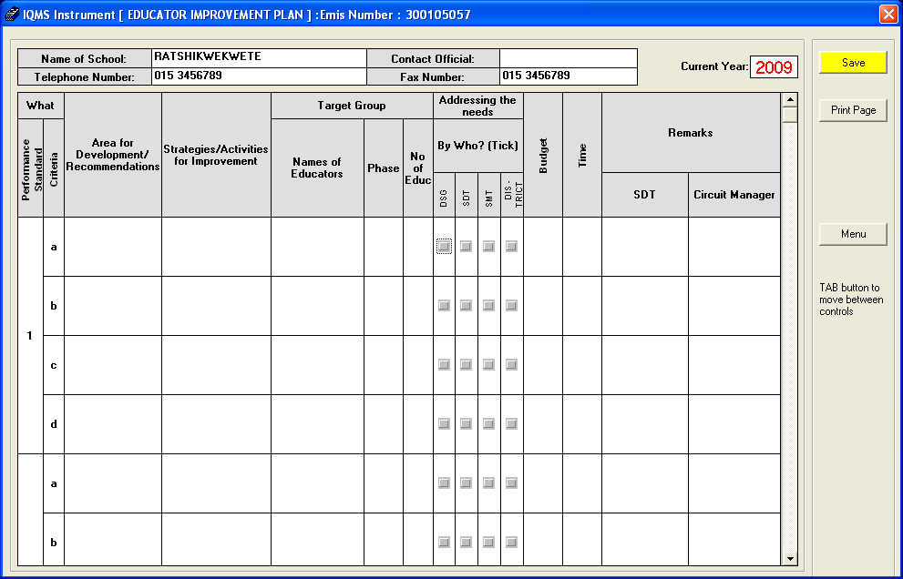
Figure 14: Educator Improvement plan menu page

- Enter the required details in the various fields;
- Once done click on the Save button then click on the Print page button;
- Alternatively click on the Menu button to return to the educator’s list menu.

- EXPORT IQMS DATA

This menu is used to create various educators’ details; however this report generates the XML file, to access this file.

Figure 15: Educator Improvement plan menu page

- Click on the Export IQMS Data menu
- The following user message screen will appear;

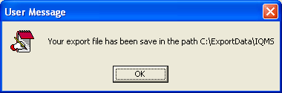
Figure 16: IQMS XML file path menu page

- The above image shows the path where the XML file is stored and created
- Locate the My Computer icon and double click on it
- Click on the Local Disk (c :) icon
- Locate the ExportData folder and open in
- Double click on the XML file to open it

- REPORTS

  - Summary of Score (Individual Educator)

This form is used after the appraisal process has been completed, it is used to view the report of the educator, to begin using this form click on the Reports menu from the IQMS main menu and the following screen will appear.

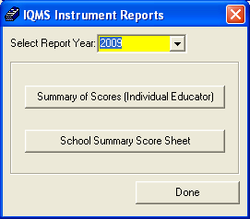
Figure 17: IQMS instrument Report menu page

- Select the year to make the report for from the Select Report Year dropdown.
- Click on the Summary of Score (individual Educator) menu.
The following screen will appear;

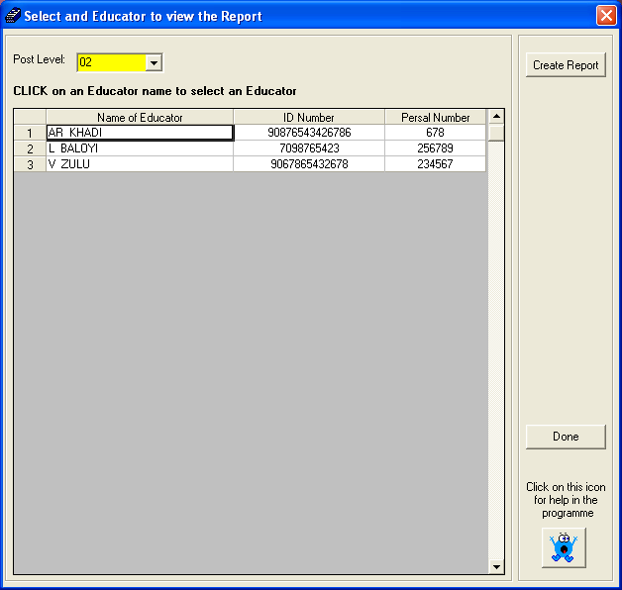
Figure 18: Educator view report menu page

- Select the educator’s post level from the Post Level drop down menu.
- Select the educator you wish to view report for.
- Click on the Create Report menu
The following screen will appear;

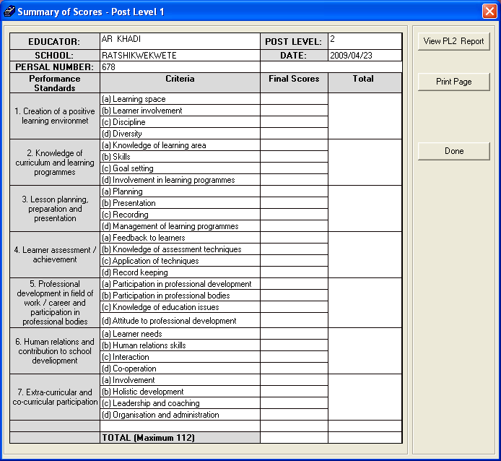
Figure 19: Summary of score report menu page

- Enter the required details in the various fields;
- Alternatively click on the Done button to return to the previous page.
- Click on the View PL2 Report button to move to the next page the View PL2 Report button provide you with the next part of the report,
The following screen will appear;
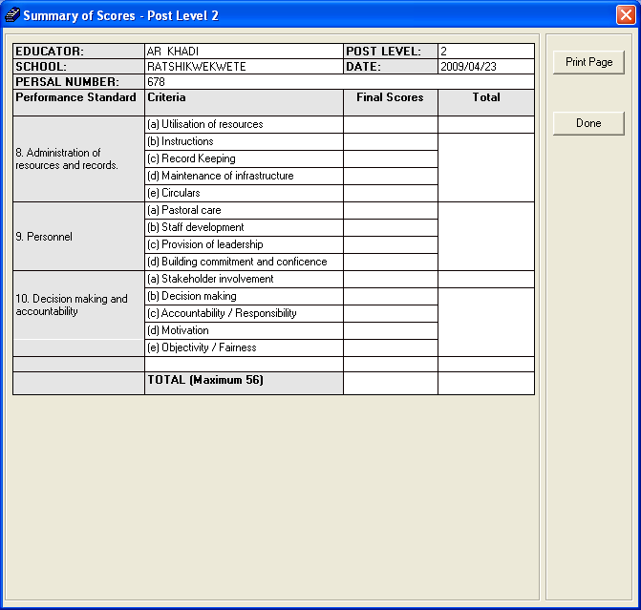
Figure 20: Summary of score report menu page

- Click on the Print Page button to print the educator.
- Click on the Done button to go back to the previous page.

  - School Summary Score Sheet

This menu is used to print the score sheet report form, to access this form click on the school summary score sheet menu and the following screen will appear;

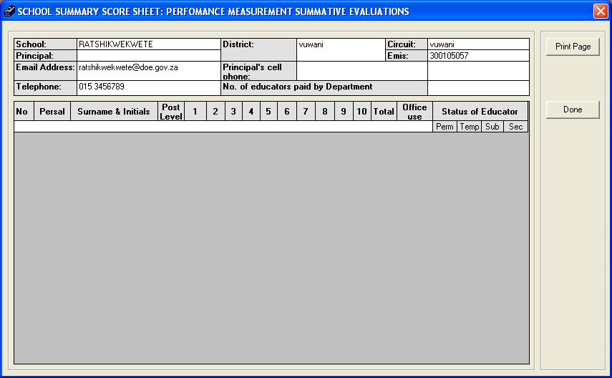
Figure 21: Summary score sheet report menu page

- Click on the Print Page menu to print the form or
- Click on the Done button to return to the IQMS instrument report page.

- SYSTEM SECURITY

This form is used to add new user name on the system, to access this form click on the System Security menu form the IQMS main menu and the following screen will appear;

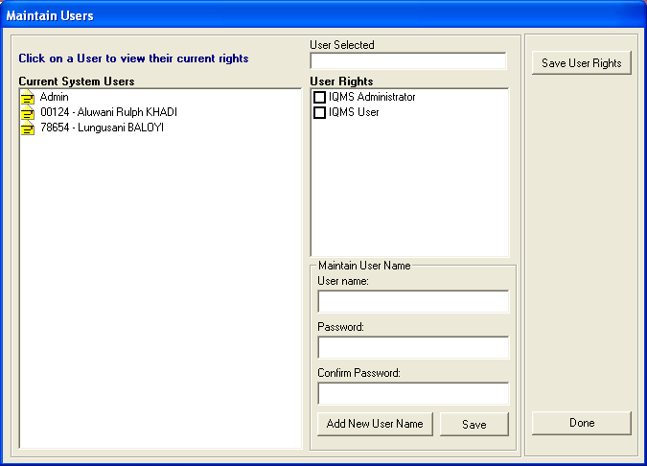
Figure 22: Maintain user menu page

- Select the user under Current system User list box
  - To add current system user click on the Human Resources Information menu from SA-SAMS main menu
  - Go to Educator Information menu then click on the Add New Educator menu to add an educator
- Depending on the rights you wish to have on the system select either IQMS Administrator or IQMS user then click on the Save User Rights button.
  - The IQMS Administrator option gives you rights to complete the FINAL and DSG appraisal
  - The IQMS User option gives you limited rights on the system, as IQMS user you can only be able to do the self-assessment appraisal.
- To add new user name on the system click on the Add New User name button
- The new password must be used when you log in to the IQMS menu.

- LOG ON AS DIFFERENT USER

This form is used when you want to log in as different user with limited or unlimited rights, to access this form click on the Log on as different user menu and the following screen will appear;

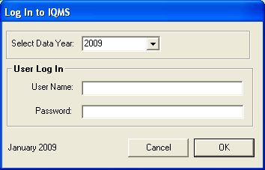
Figure 23: Log on to IQMS menu page

- Enter the user name and the password on the correct field.
- Click on the OK button to log on.

