

SA-SAMS

Guideline for using Human Resource Information module

September 2009

Education Management Systems (EMS)
Department of Education
Private Bag X895
0001 PRETORIA

CONTENT
1. INTRODUCTION 3
2. HUMAN RESOURCE INFORMATION 4
3. SECTION A: DATA FILES 5
3.1 Maintain Educator Information 5
3.1.1 Adding an Educator 5
3.1.2 Editing an Educator Details 7
3.1.3 Removing/Archiving an Educator 8
3.1.4 Restoring an Archived Educator/Staff Member 9
3.1.5 Subject Specialisations for Educators 10
3.1.6 Leave and Absences 11
3.1.7 Educator Teaching Load 12
3.1.7.1 Maintain Teaching Load Pre R – 6 12
3.1.7.2 Maintain Teaching Load 7 – SNE 14
3.1.8 Assigning Educators To Register Classes 15
3.1.9 Educator Contact List 16
3.2 Staff/Public Servant Information 17
3.2.1 Removing a Staff Member 20
3.2.2 Staff Member Contact List 20
4. SECTION B: DEVELOPMENT AND TRAINING DATA 21
4.1 Maintain Training Categories 21
4.1.1 Adding a New Category 22
4.1.2 Editing/Deleting Existing Categories 22
4.2 Maintain INSET Training Records 22
4.2.1 Training Attended 24
4.3 Maintain Development Appraisal Interview Records 25
4.3.1 Add Appraisal Interview Records 26
4.3.2 Printout of DA Interview Records 27
5. SECTION C: MAINTAINING STAFF ATTENDANCE RECORDS 28
5.1 Maintain Weekly Educator Attendance 31
5.2 Maintain Weekly Educator Attendance 31
5.3 Add Leave Records 32
5.4 Maintain Weekly Staff Attendance 33
5.5 Staff Attendance 35
5.6 View Individual Staff Absences 37
5.7 Staff Absentee Records 38
5.8 Staff Leave Summary Printout 38
5.9 Attrition Register: Educator and Other Staff 40
5.10 Statistics 41
5.11 Staff Leave Summary Printout 41

- INTRODUCTION

The Human Resource Information module was developed and incorporated into SA-SAMS as a tool to assist schools in administering the educators and staff/public servant’s information. This includes the processing and administering of leave, absenteeism, training, appraisals and all human resource related data and processes.

This manual serves to guide and assist SA-SAMS users on how to use the module in order to gain full benefits of running the SA-SAMS HR module within a school.

- HUMAN RESOURCE INFORMATION

- Select the Human Resources Information button from the Main Menu to open the module.

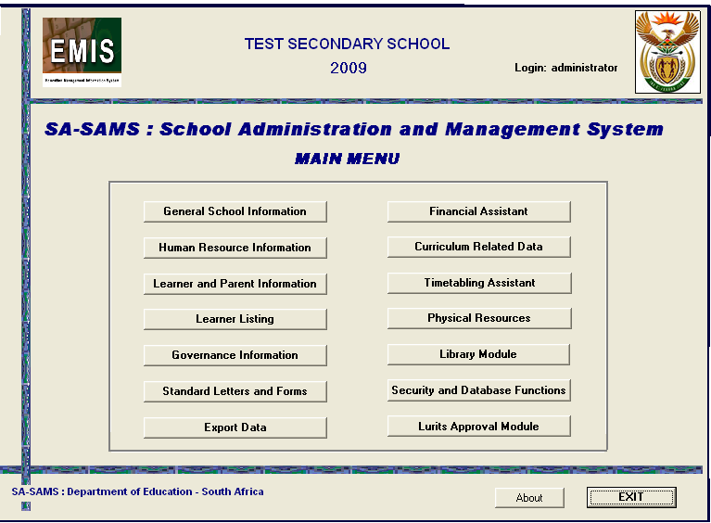
Figure 1: SA-SAMS Menu

- The Human Resource Module is where all employees information is captured and maintained.
- This includes educators, non-teaching staff and all public servants employed at the school.
- Educator information is captured separately from other staff.

- SECTION A: DATA FILES

  - Maintain Educator Information

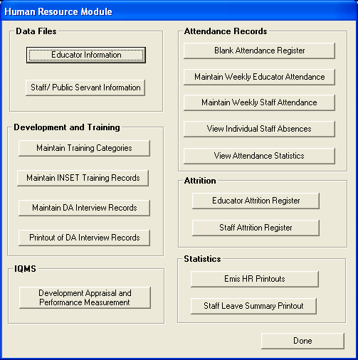
Figure 2: HR Module

- To start capturing educator information, click on the Educator Information button and the screen picture below will open (See figure 3)

    - Adding an Educator
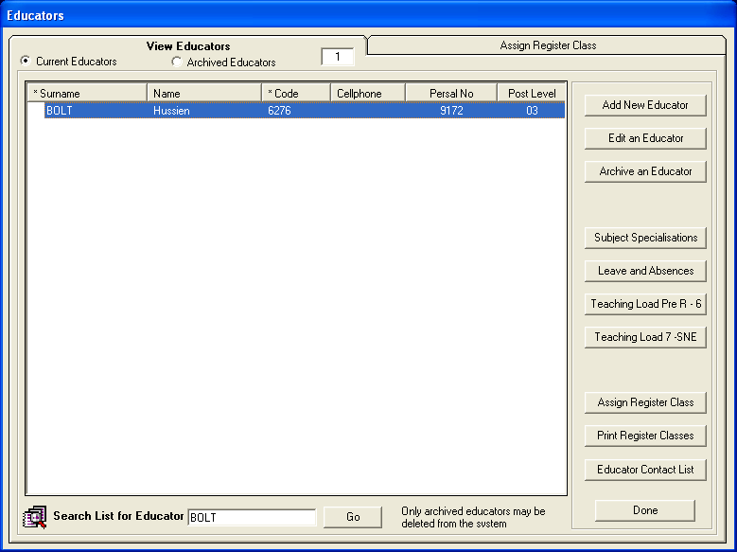
Figure 3: Add Educators

- Click the Add New Educator button to open the educator data capture window (See )
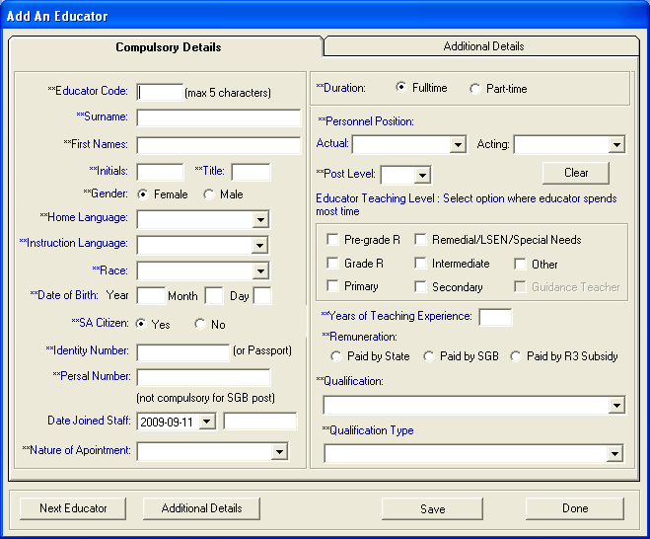
Figure 4: Add an Educator
- Complete all the educator details in the relevant fields and Save your data;
- Remember, there are two pages(Compulsory Details and Additional details tab) of data to capture; and
- All fields marked in blue are compulsory fields and must be completed before you can Save the data.
- When all the compulsory information is captured, click on Save. Click on Next Educator to capture more educators or click on Done to finish.

    - Editing an Educator Details

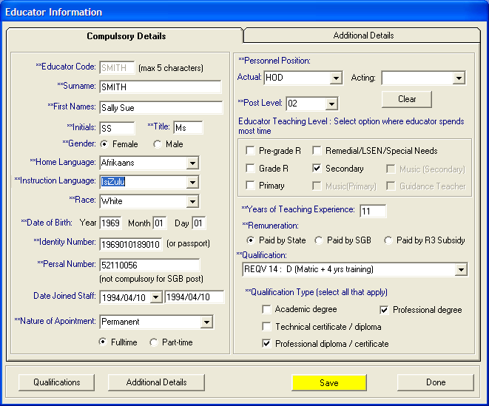
Figure 5: Educators Information

- From the Educator List, click on the name of the educator that you wish to update or view.
- Once you have highlighted the name of the relevant educator, select the Edit an Educator button to view or edit the educator’s details; and
- Remember to Save your new data if you add to or change any of the educator’s details.

- Click on Qualifications from the Educator Information Window to edit educator qualification.

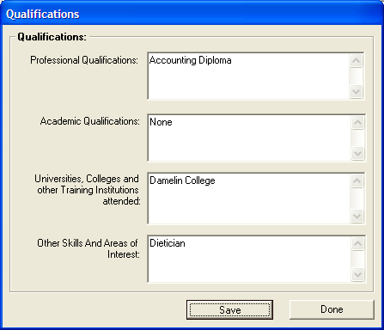
Figure 6: Qualification Information
- Type in information
    - Professional Qualification
    - Academic Qualification
    - Universities, Colleges and other Training Institutions attended
    - Other Skills and Areas of Interest
- Click on Save and Done button

    - Removing/Archiving an Educator

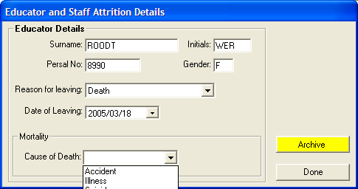
Figure 7: Educators and staff Attrition Information

- In order to remove an educator from the current staff of a school, you have to archive the educator. Educators cannot be deleted from the system without first being archived;
- An educator archive is maintained for record keeping purposes;
- From the Educator, click on the name of the educator that you wish to archive;
- Once you have highlighted the name of the relevant educator, click on the Archive an Educator button;
- You will now be required to give a reason for the educator leaving the school;
- If death is the reason for archiving, the cause of death must be selected from the dropdown menu; and
- Click on the Archive button to archive the educator.

    - Restoring an Archived Educator/Staff Member
- This function has been included to save the recapturing of an educator’s information should the archived educator return to the school
- On the screen where all Educators are listed Figure 2, (also on Other Staff screen, Figure 13) there are two option buttons:
  - Current Educators (Current Staff Members);
  - Archived Educators (Archived Staff members);
- Select the option Archived Educators.
- The screen with all archived educators will open.

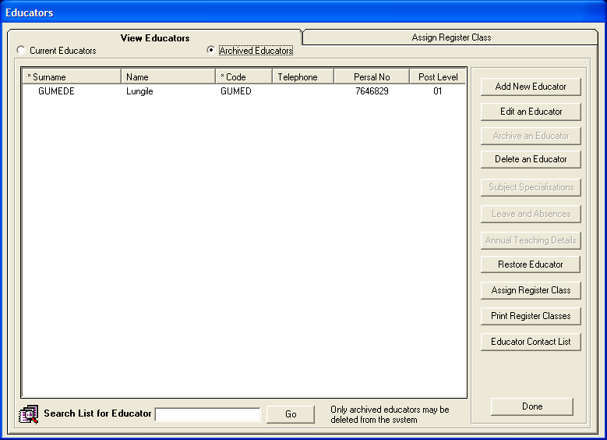
Figure 8: Archived Educators

- The Restore Educator button is listed on the right
- Click on the Name Of The Educator you wish to restore
- Click on the Restore Educator button
- Return to the Current Educators screen and the selected educator can once again be viewed on this list

    - Subject Specialisations for Educators

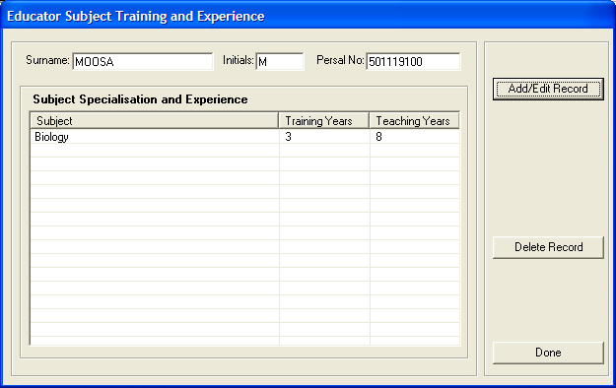
Figure 8: Educator Subject training and experience

- This section allows you to add the subject specializations for each educator
- Click on an educator in the list and select the Subject Specializations button
- The screen in Fig 9 will open;
- To add a subject specialization click on Add/Edit Record

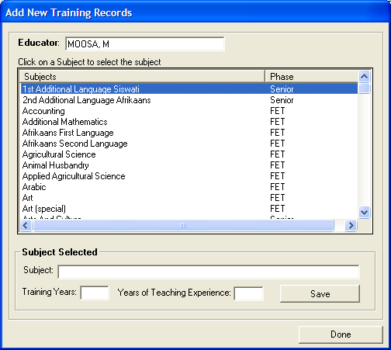
Figure 9: Add New Subject Specialization

- Click on Add/Edit record to enter/edit training records.
- Select the subject that the educator is trained or specialized in from the subject list
- Enter the number of years of training and experience in the subject and Save.

    - Leave and Absences
- Click Leave of absence from the HR main Menu to Edit, Delete or Print Leave of Absence data
- On this section users cannot add Leave of absence information; Leave of Absence information can only be captured in the Attendance Records section which is subsequently explained in page 34 through to page 36 of this manual.
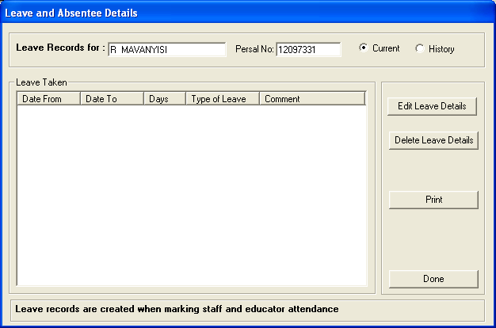
Figure 10: Leave and Absentee Details

- Select Leave of Absence from Leave Taken section and click on Edit Leave Details or Delete Leave Details button to edit or delete Leave of absence details for the selected educator.
- To print Leave details, click on Print button

    - Educator Teaching Load

      - Maintain Teaching Load Pre R – 6
- Click on Teaching Load Pre R – 6 button to open the Teaching Load Pre R – 6 window (See Figure 10)
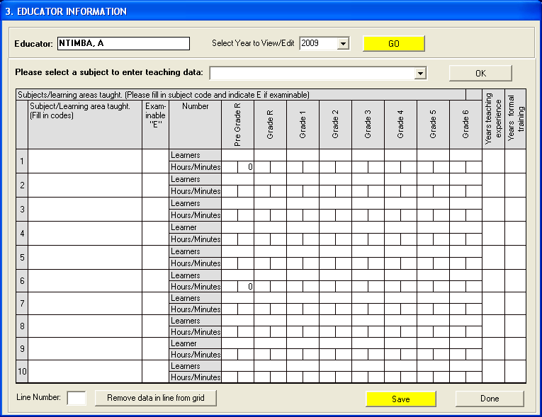
Figure 10: Educator Teaching Load

- This gives a complete record of each educators workload for the current year
- At a glance one can see the number of learners per grade, per subject that an educator is teaching
- On the View Educators page click on the name of the educator
- Click on the Teaching Load Pre R - 6 button or the Teaching Load Grade 7 to SNE for the relevant grade
- Select year and click Go button
- Select subject and click Ok button
- The subject appears in the Subject/Learning Area taught column
- Type in ‘E’ if its examinable
- Type in the number of learners per grade
- Type the number of years teaching the subject
- Type in the number of years formal training
- Type in the number of years teaching experience
- To remove a line from the grid, enter the line number and click on Remove data in line from grid
- Click on Save button

      - Maintain Teaching Load 7 – SNE

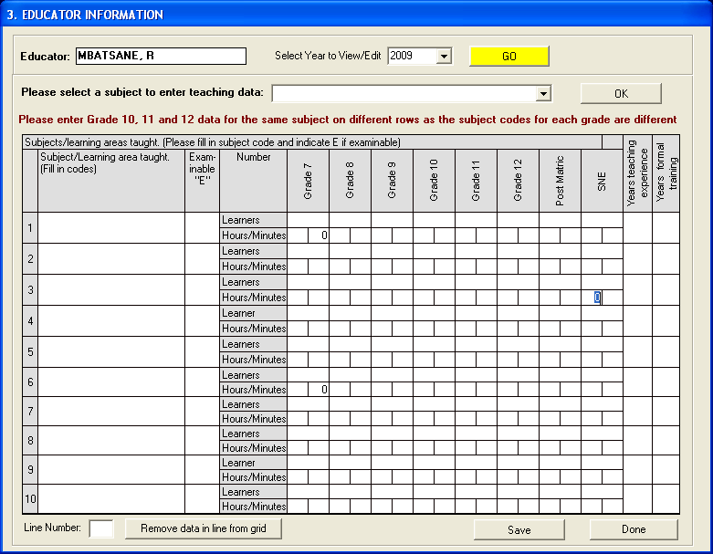
Figure 11: Educator Teaching Load

- This gives a complete record of each educators workload for the current year
- At a glance one can see the number of learners per grade, per subject that an educator is teaching
- On the View Educators page click on the name of the educator
- Click on the Teaching Load 7 - SNE button or the Teaching Load Grade 7 to SNE for the relevant grade
- Select year and click Go button
- Select subject and click Ok button
- The subject appears in the Subject/Learning Area taught column
- Type in ‘E’ if its examinable
- Type in the number of learners per grade
- Type the number of years teaching the subject
- Type in the number of years formal training
- Type in the number of years teaching experience
- To remove a line from the grid, enter the line number and click on Remove data in line from grid
- Click on Save button

    - Assigning Educators To Register Classes

- In order to assign educators to register classes, either select the button or click on the TAB heading

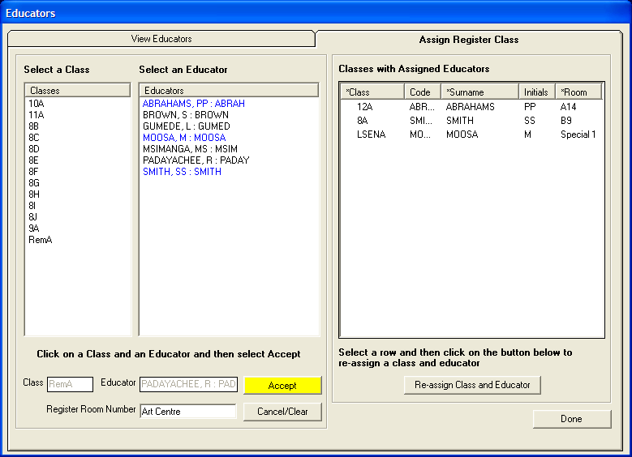
Figure 12: Educators

- Click on the class and then click on the educator
- Both appear at the bottom of the screen
- Type in register room number and then click on Accept button
- To remove a class from an educator, click on the class name in the right hand column then click on Re-assign Class and Educator

- To print Educator classes Registers, click on Printing Classes Register button.

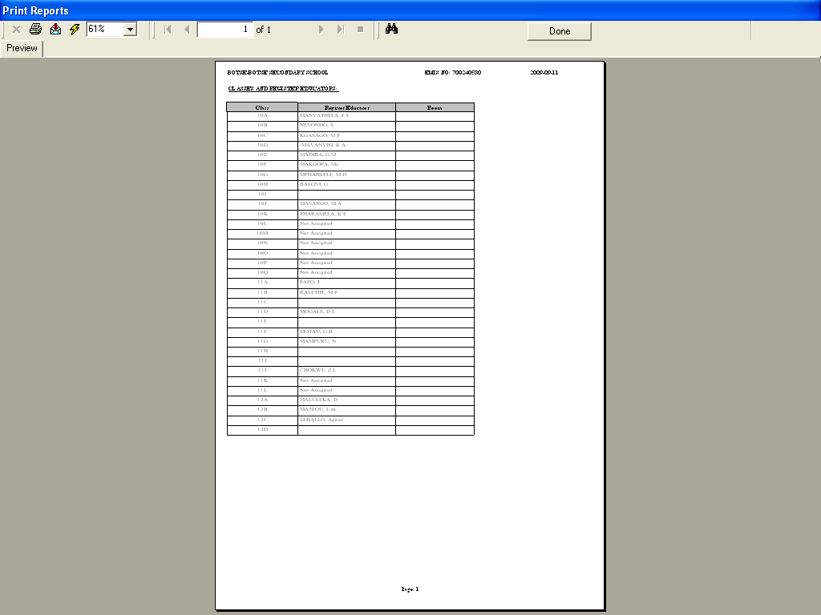
Figure 13: Classes Register print

    - Educator Contact List

- To print out or view the contact list of educators for the school, select the Educator Contact List button from the main Educator window.
- The Print Setup window will open from where you can select your printer and paper layout options.
- You can select your options or simply press OK to continue to the Print Preview window.
- The Preview window gives an indication of what the printed report will look like
- This screen can be enlarged by selecting the percentage size in the top left corner
- You can either print the report or select Done to return to the program.

  - Staff/Public Servant Information

- Click on Staff/Public Servant Information button on the HR main Menu to enter data for non –teaching staff at the school

Figure 14: HR Module

- Staff Members (Public Servants) window appears (See Figure 14 below).
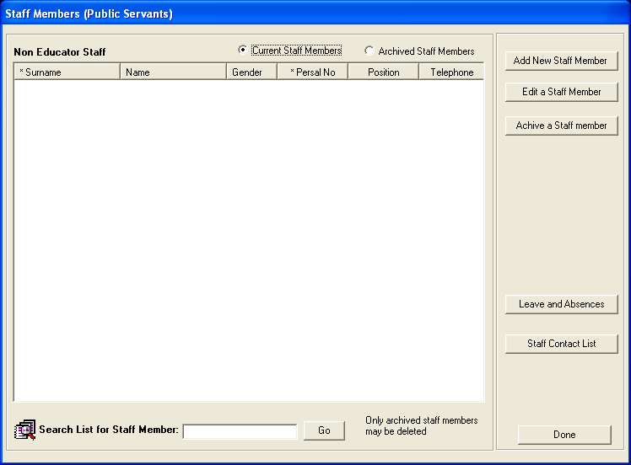
Figure 15: Staff Members

- Select the Staff/Public Servant Information button from the HR menu to add, view or edit non-teaching staff details
- The Non Educator Staff page displays the list of staff members on the system
- The user may select to view either the current staff members at the school (Current Staff Members option) or a list of other staff that have left the school (Archived Staff Members option).
- Add new staff member/update details

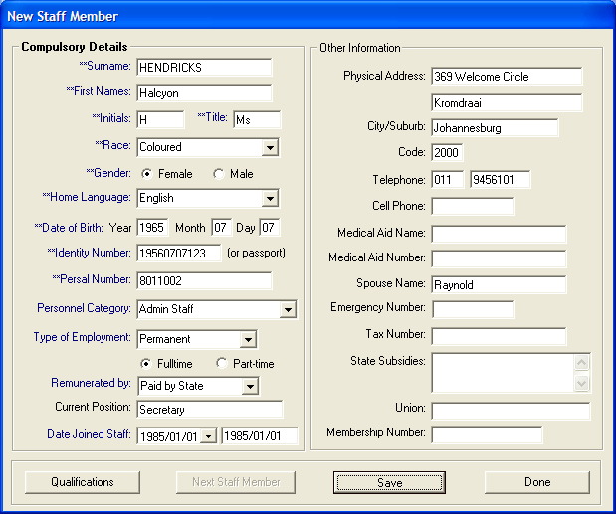
Figure 16: New staff member

- Select the Add New Staff Member button to open the page.
- Complete all the staff member details in the relevant fields and Save your data.
- All fields marked in blue are compulsory fields and must be completed before you can Save the data.
- From the Staff Member window, click on the name of a staff member that you wish to update or view.
- Updating staff information is important for the process of record keeping.
- Once you have highlighted the name of the relevant staff member, select the Edit a Staff Member button to view or update the staff member’s details.
- Remember to Save your new data if you add to or change any of the staff member’s details.
- Staff qualifications are captured by clicking on the Qualification button in the bottom left of the Staff Information Window.

Figure 17: Staff Qualifications

- Type in the staff member’s qualifications and Save the data.

    - Removing a Staff Member

- In order to remove a staff member from the current staff of a school, you have to archive the staff member. Staff members cannot be deleted from the system without first being archived.
- A staff member archive is maintained for record keeping purposes.
- From the Staff Member window, Fig 13 click on the name of the staff member that you wish to archive
- Once you have highlighted the name of the relevant staff member, click on the Archive a Staff Member button. The screen picture below will open.
- You will now be required to give reason why the staff member left the school
- Select the Archive button to archive the staff member.

    - Staff Member Contact List
- To print out or view a contact list of staff members for the school, select the Staff Member Contact List button from the main Staff Member window.
- The Printer Set-up window will open from where you can select your printer and paper layout options.
- You can select your options or simply press Ok to continue to the Print Preview window.
- The Preview window gives an indication of what the printer report will look like.
- You can either print the report or select Done to exit.

- SECTION B: DEVELOPMENT AND TRAINING DATA

This section is to capture and processes all training and development information for educators and staff. The section consists of Training categories, INSET training and DA interview records.

  - Maintain Training Categories

- Click on Maintain Training Categories button from the HR main menu to start the training categories maintenance window (See Figure 18 below)

Figure 18: HR Module

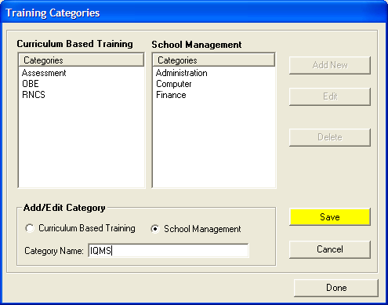
Figure 19: Training Categories

- There are 2 options under which to record training either Curriculum Based Training or School Management.
- Click on Maintain Training Categories from the HR menu.
- The Training Categories window will open.
- All categories already added will be listed.
    - Adding a New Category
- Select the Add New button
- Select either the Curriculum Based Training (Inset Training) or the School Management button
- Type in the new category in the space at the bottom of the screen and Save the data.
    - Editing/Deleting Existing Categories
- From the list of category names in the window, click on the name of the category you wish to update or delete.
- Once you have highlighted the chosen category, click on the Edit/Delete button to perform function.
- Remember to Save your new data if you add to or change any of the categories.
- Press Done to complete the task.

  - Maintain INSET Training Records

- Click on Maintain INSET Training Records button from the HR main menu to start the INSET training records maintenance window (See Figure 19 below).

Figure 20: HR Module

INSET training is a vital part of educator development. Educators attend workshops/seminars/ discussion groups given by the Education Department or by contracted Service Providers. The INSET training is aimed at developing the skills and knowledge of educators and non- educators to become effective in the classroom and within the school

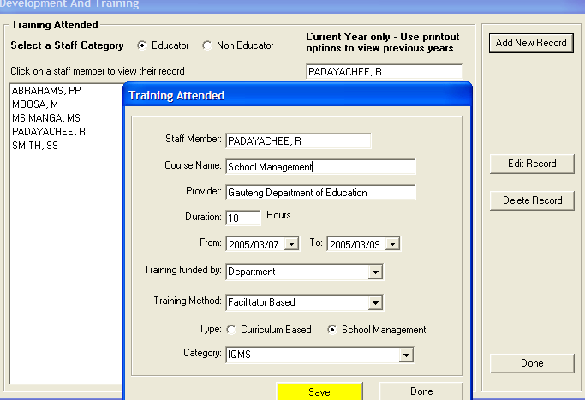
Figure 21: Development and training
    - Training Attended
- Click on Maintain INSET Training Records on the HR menu
- Select either Educator or Non-Educator to get the required staff listing
- Click on the staff member’s name
- To add records of training attended for individual educators click the Add New Record button. The Training Attended detail page will open. Fill in the details. (See Figure 20) and click Save button.
- To view or change existing training records, press the Edit Record button. Remember to Save your new data if you add to or change the existing training.
- To delete existing training records, click on the selected training you wish to delete. Press the Delete Record button.
- Press Done to complete the task.

  - Maintain Development Appraisal Interview Records

- To start the DA Interview Records Sub Module click on the Maintain DA Interview Records button from the HR Menu.

Figure 22: HR Module

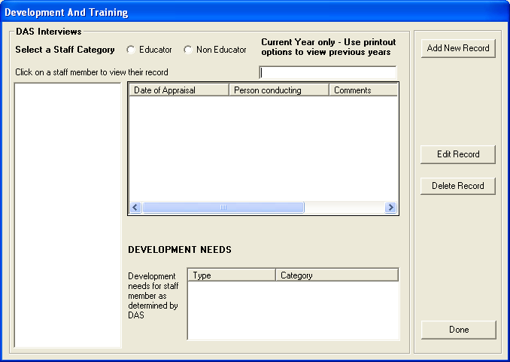
Figure 23: Development and training 2

- Click on Maintain DA Interview Records on the HR menu
- Select either Educator or Non-Educator option button to get the required listing of staff members
- Click on selected staff member’s name
- Click on Add New Record to add a record
- Complete relevant information
- To view or change existing records, press the Edit Record button. Click the yellow Save button to Save the data if you have made any changes
- To delete any records, click on the record you wish to delete. Press the Delete button to delete it. Press Done to complete the task.

    - Add Appraisal Interview Records

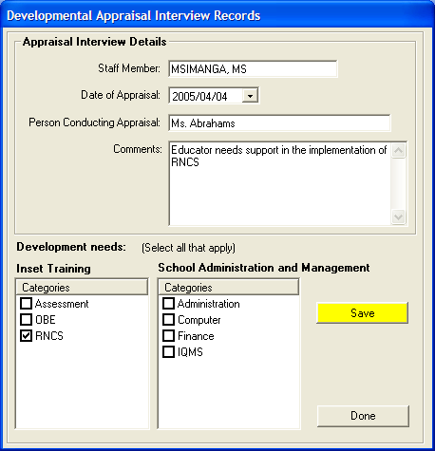
Figure 24: Development Appraisal Interview Records

    - Printout of DA Interview Records

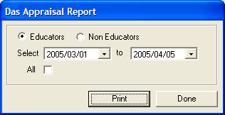
Figure 25: Das Appraisal Report

- Click on Printout of DA Interview Records on HR menu.
- Select Educators or Non Educators
- Select the dates you want for specific staff
- Tick in box if you want to select All (when All is selected dates are inactive)
- Press Print to go to Print Preview window.
- The Preview window gives an indication of what the printer report will look like.
- You can either print the report by clicking on the printer icon in the top left hand corner, or select Done to return to the program.

- SECTION C: MAINTAINING STAFF ATTENDANCE RECORDS

Figure 26: HR Menu

- This Section captures and processes attendance for educators and staff. In this section, absences, leave and reasons for leave will be captured
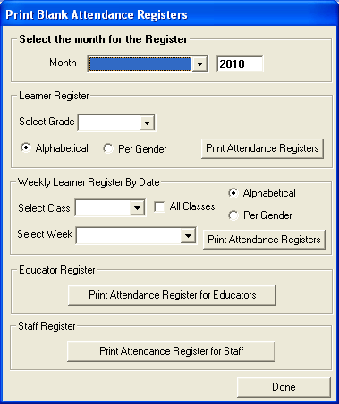
Figure 27: Print blank register

To Print a blank Attendance register for educators/ staff select Print Attendance register for educators / Print Attendance Register for Staff button(s)
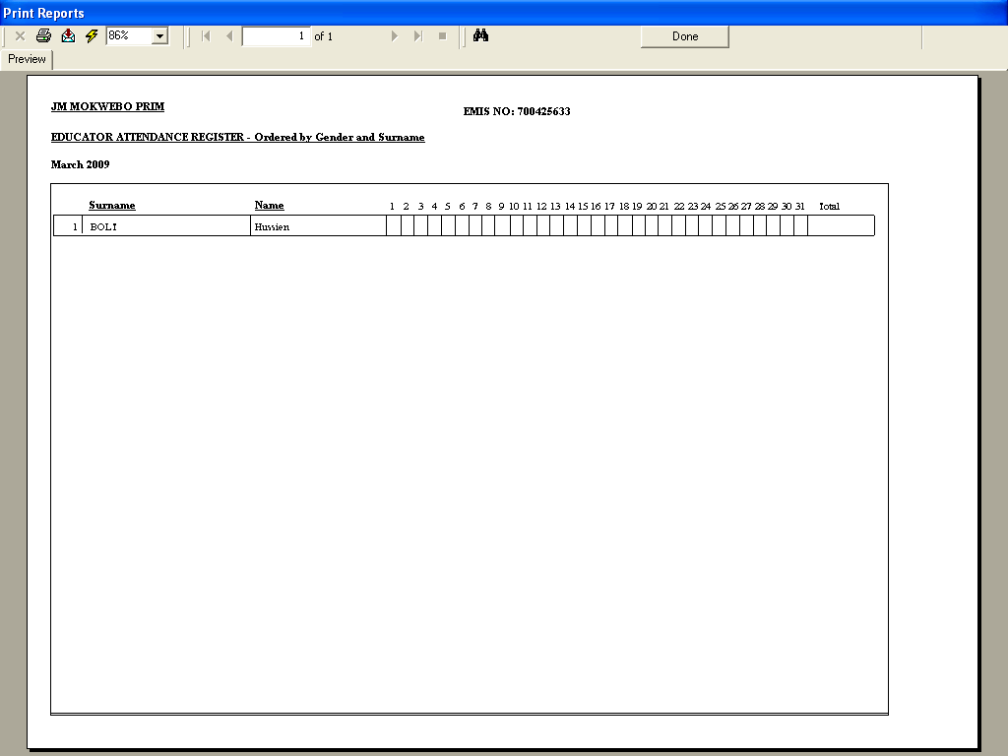
Figure 28: Blank Educator attendance register

- Click on Blank Attendance Register on the HR menu.
- This window give you the opportunity to print blank attendance register for Learners, Educators and Other Staff
- Select the month you wish to print by clicking the downward arrow until the correct month is found.
- Select the grade in the same way, by clicking the downward arrow until the correct grade is found.
- To print Educator Attendance Register or Staff Attendance Register, click on either Print Educator Attendance Register or Print Staff Attendance Register.
- Remember: when you press Print, the Printer Set up Window will open from where you can select your paper and printer layout options.
- You can select your options or simply press Ok which will take you to the Print Preview window, which shows you what your printout will look like.
- You can either print or press Done to return to the program.

  - Maintain Weekly Educator Attendance

To maintain educator weekly attendance please click on Maintain Weekly Educator Attendance button. In this section, a user can capture days when an educator was absent from work, and the reasons for absenteeism.

Figure 29: HR Menu

  - Maintain Weekly Educator Attendance

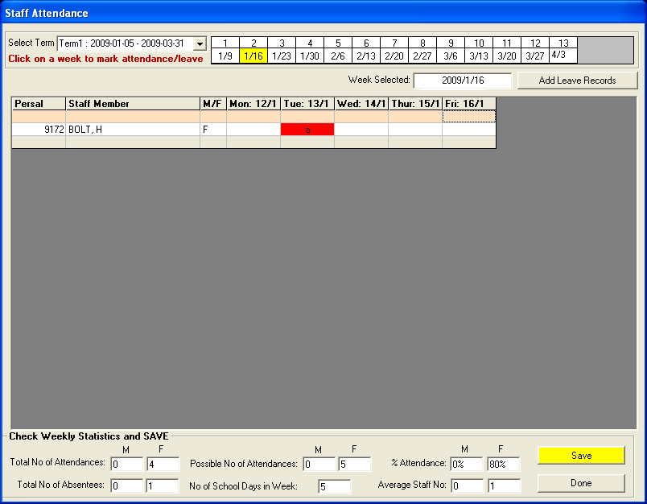
Figure 30: Staff Attendance

- To Capture attendance, select term from Select Term dropdown menu
- Select week from Click on week to mark attendance/leave
- Select days absent by clicking on the day when the educator was absent, the block will turn red with small letter A, to indicate that the educator was unsent on that day.
- Click on Add Leave Records button to add leave records and reasons for absent days.

  - Add Leave Records

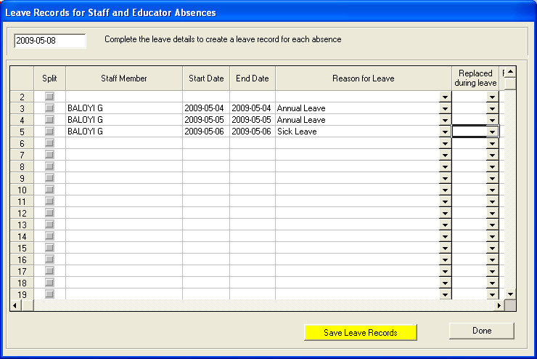
Figure 31: Leave Records for Staff and Educator Absences

- Select Reasons for Leave for the educator who was absent and click on Save Leave Records
- If an educator is absent for 3 consecutive days (2 of these days may be annual leave and 1 may be sick leave) you have to SPLIT the dates so you can assign different reasons. (see figure 30 above)
- Click on Done to exit

  - Maintain Weekly Staff Attendance

To start using the Maintain Weekly Staff Attendance click on Maintain Weekly Staff Attendance button on the HR menu.

Figure 32: HR Module

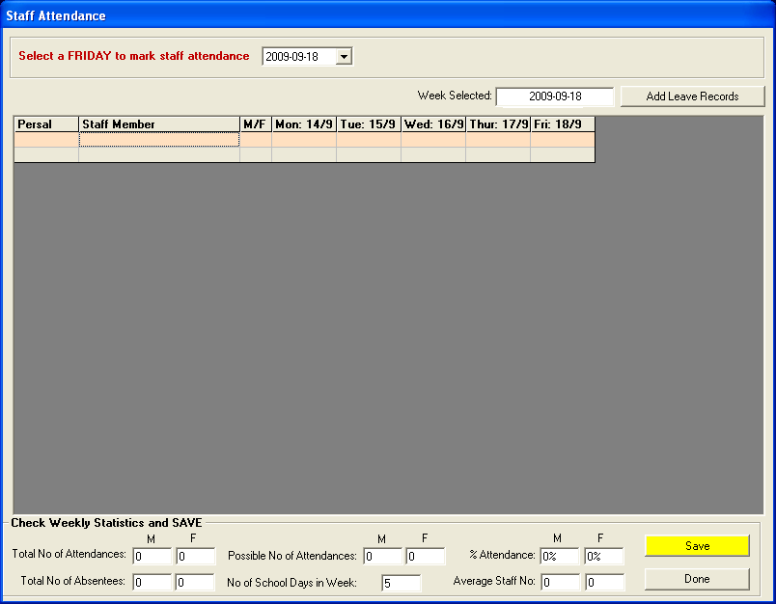
Figure 33: Maintain Weekly Staff Attendance
  - Staff Attendance
- You cannot proceed unless school terms and school days have been set-up in General School Information;
- Click Maintain Weekly Staff Attendance. The Weekly Attendance page opens;
- Click on the name of the term in which you are marking, e.g. Term 1;
- Select the Weekending Date (has to be on a Friday) from the dropdown calendar box and then click on the yellow button Mark Attendance; and
- The attendance page will open, please see below:

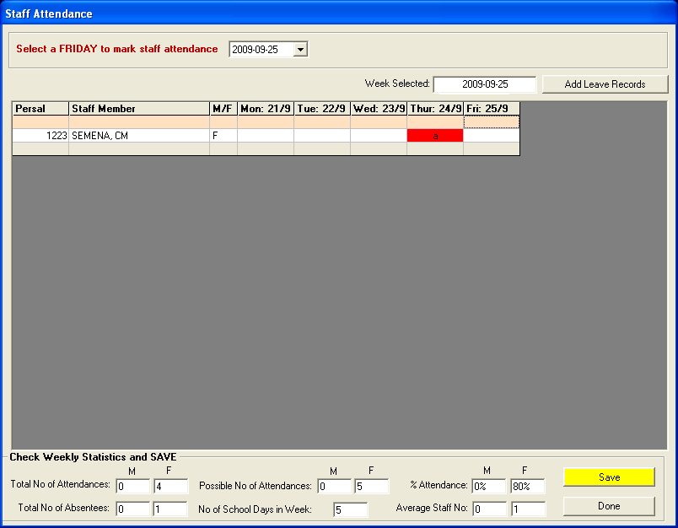
Figure 34: Staff Attendance

- To Capture attendance, select term from Select Term dropdown menu
- Select week from Click on week to mark attendance/leave
- select days absent by clicking on the day when the staff member was absent, The block will turn red with small letter a to indicate that the educator was unsent on that day
- Click on Add Leave Records button to add leave records and reasons for absent days.

  - View Individual Staff Absences

- On this section, a user can view records for individual absences for each staff member including educators. To start this module, click on View Individual Staff Absences

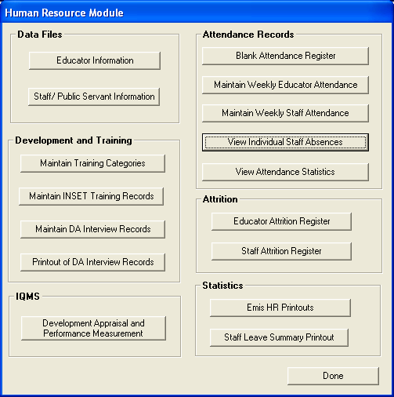
Figure 35: HR Menu
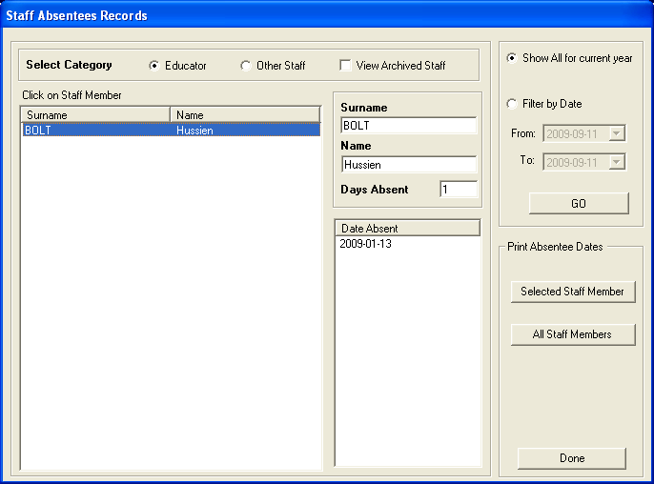
Figure 36: Staff Absentees Records

  - Staff Absentee Records

- On this section users can extract and view records for previous absences per individual educator/Staff.
- Click on View Individual Staff Absences to view individual staff absence records;
- Choose whichever staff member you wish to view;
- Click on Filter by Date to view a specific period;
- Select the From date and the To date then click on Go to view;
- For printout options, you can click on Selected Staff Member to print just one staff member; and
- Or click on All Staff Members to printout the whole staff.

  - Staff Leave Summary Printout
Staff Leave Summaries are the records of educator or staff attendance for a certain period of time. These records can be used by management to follow absentee patterns and trends of educators and are easily accessible should the Education Department ask for them.

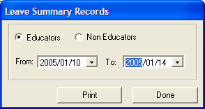
Figure 37: Staff Leave Summary Printout

- Click on Staff Leave Summary Printout under the Statistics section;
- Select either Educators or Non-Educators by clicking on the relevant button;
- Select dates to print by clicking on the downward arrows until the correct dates are found; and
- Press Print to print or Done to return to the program.

  - Attrition Register: Educator and Other Staff
Educator/Staff Attrition Registers are printouts of the aggregated data for all educators/other staff who have been archived. This data can be requested at Circuit/District or Provincial level and inform these offices of the current status of educators.

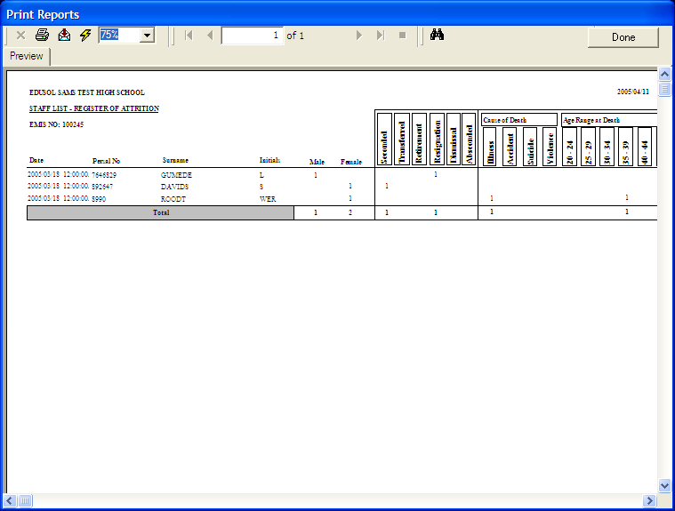
Figure 38: EMIS HR Printouts

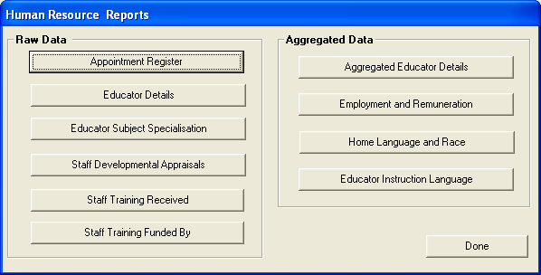
Figure 39: HR Resource Reports

  - Statistics
The EMIS HR Printouts is the data captured in the SA-SAMS programme that feeds into the Annual School Survey.

Aggregated Data at school level is easily accessible for the Education Department and can be used to influence decision-making and future planning.

Above all, these printouts can be used when completing the Annual Survey to check that data being captured is correct.

- Click on Emis HR printouts;
- There are two columns: Raw Data and Aggregated Data;
- The EMIS data is listed under each;
- To print any of these, click on the correct button, for example Appointment Register;
- The print setup screen opens. Click Ok button; and
- The print preview page opens. One can either view or print.

  - Staff Leave Summary Printout
The Staff leave Summary Printout gives the status of educator or staff absenteeism per quarter. The summary can also be between selected dates, i.e. on a monthly basis. This data can be used to track educator absenteeism patterns and inform management of direction should absenteeism be a problem at a school. These quarterly statistics are also required by the Education Department for purposes of record keeping.

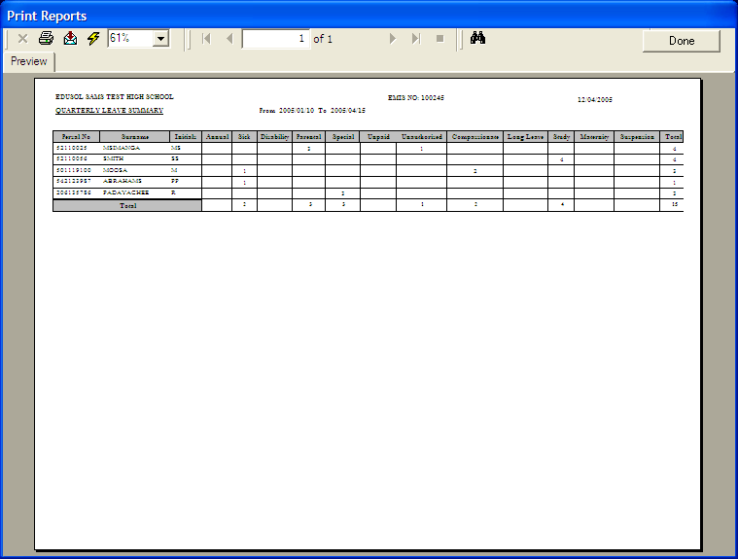
Figure 40: STAFF LEAVE SUMMARY PRINTOUT

IQMS Module

- The IQMS module is a full functional sub module that is used for educator / appraisals and performance management. IQMS is substantial module thus have a separate manual from the Human Resource manual.

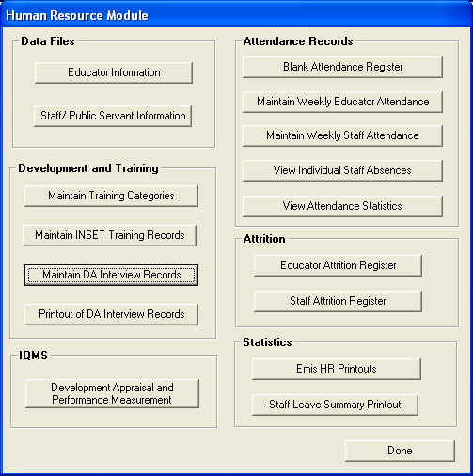
Figure 41: HR Menu (IQMS)

