Grade 10-12 NSC Exam Registrations

1. Click on the **Learner Listing** button to view the current learners.

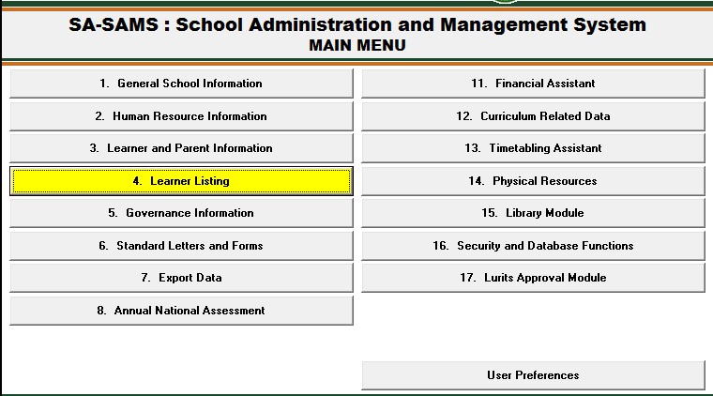

1. Filter by **grade**. Click on the learner and click on the **View/Update Learner** button to edit the learner’s NSC information.

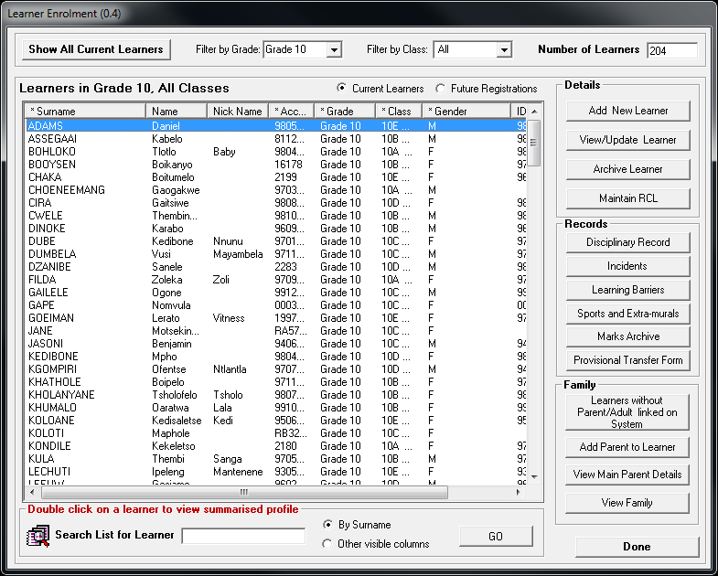

1. Click on **NSC Exam Registration** and fill in the information.

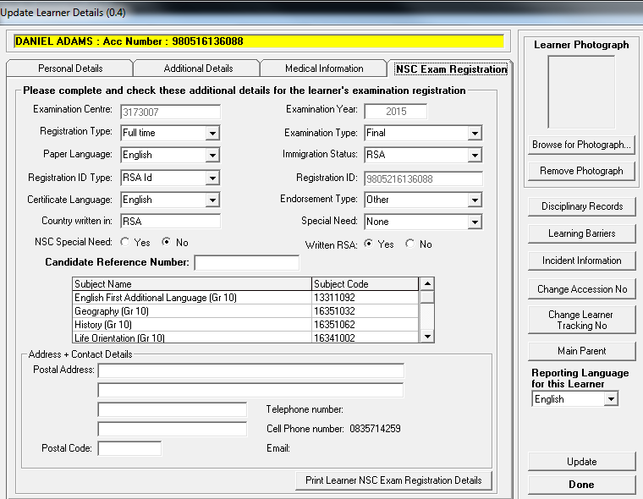

**Note: If the Examination Year is highlighted in yellow, the Update button needs to be clicked.**

1. Check the information for correctness.
   1. Click on the **Export Data** button on the Main Menu.

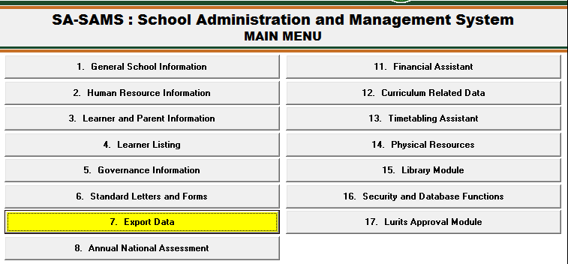

* 1. Click on the **Export NSC Exam Registration** **Data** button and click on the **Continue** button.



* 1. Select **grade** and click on the **View Export Data** button.

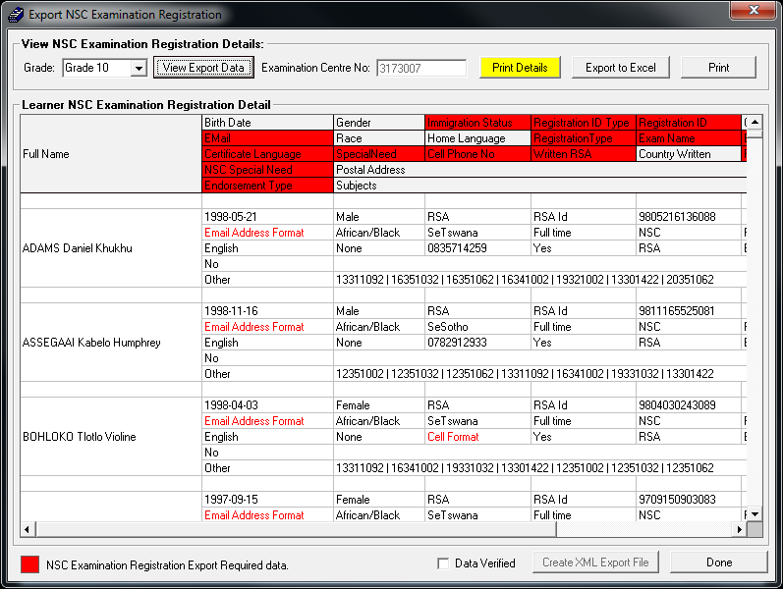

**Note: The red areas show required data that must be completed in step 3.** **(Ignore e-mail address and cell format if not applicable)**

* 1. Please make sure of the **Exam Year** as well. **Refer to Step3.**

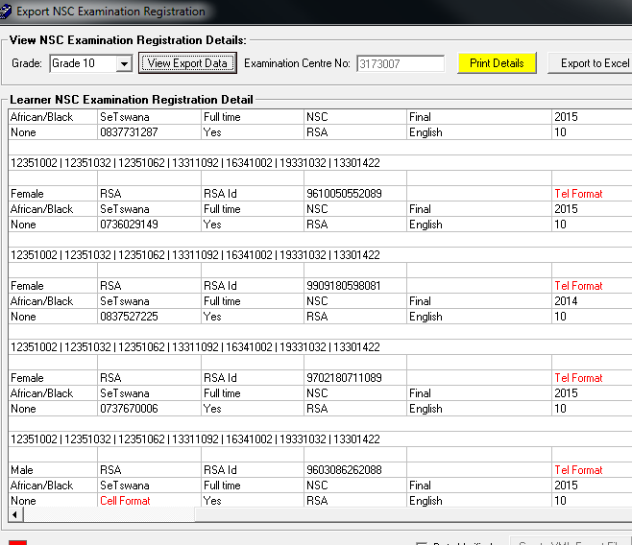

* + 1. If the Exam Year is not fixed. This error will display on the errors and omissions.

