

SA-SAMS

Guidelines for using the General School Information module

September 2009

Education Management Systems (EMS)
Department of Education
Private Bag X895
0001 PRETORIA
CONTENT

1. INTRODUCTION 3
2. GETTING STARTED 3
3. THE STRUCTURE FOR THE GOVERNANCE INFORMATION 4
4. MAINTAINING SGB MEMBERS 5
4.1 Adding SGB Members 6
4.2 Maintaining SGB Member Details 6
4.3 Add SGB Member Details 8
4.4 Add/Edit/Delete an SGB Member’s Details 8
5. MAINTAIN CURRENT SGB FUNCTIONS 9
6. MAINTAIN GOVERNANCE RECORDS 9
6.1 Maintaining Policies 10
6.2 Add New Governance Records 12
7. MAINTAIN SGB TRAINING RECORDS 13
7.1 Maintain SGB Training Categories 14
7.2 Maintain SGB Training Courses 15
7.3 Maintain Individual Training Records 16
7.4 Individual Training 17
7.5 Training Received 18
7.6 Training Required 18
8. STATISTICS 19
9. PRINTOUTS 20
10. SEXUAL HARASSMENT 20
10.1 Maintain Harassment Incidents 20
10.2 Add an Incident 21
10.3 Print Harassment Incidents 21

INTRODUCTION
Governance means the development of policy, including Financial Policy, which is in compliance with National, and Provincial Policy. The monitoring of its implementation is the responsibility of the school Principal and the SGB.

The Governance Module keeps records of all issues pertaining to the SGB. These records should be added and updated regularly so that the SGB can have current data for discussion at meetings.

GETTING STARTED
Select the GOVERNANCE INFORMATION button from the main menu to open.

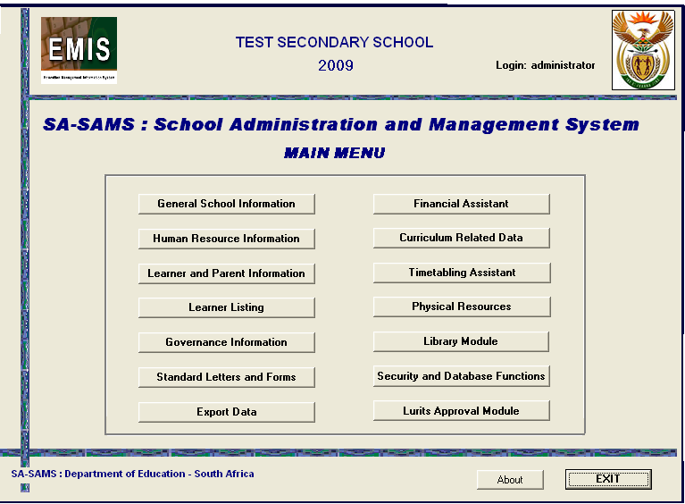
Figure 1: SA-SAMS Main Menu

THE STRUCTURE FOR THE GOVERNANCE INFORMATION
This module requires the parents, learners and the educators to maintain its members. All of this data would have been previously captured under the relevant modules and is now pulled through here. The progressive capturing of data is highlighted here where what you put in earlier is now needed down the line.

Data captured in the Governance module is also required for the completion of the ASS.
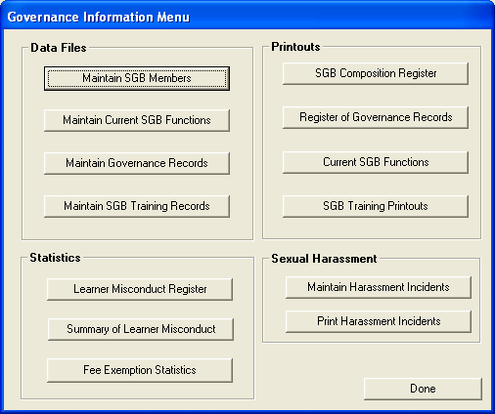
Figure 2: Governance Information Menu

MAINTAINING SGB MEMBERS
The maintain SGB members menu allows you to add new SGB members.
- In order to add, edit or delete SGB Members select the Maintain SGB Members button from the Governance Module menu.
- The SGB Members window will open;

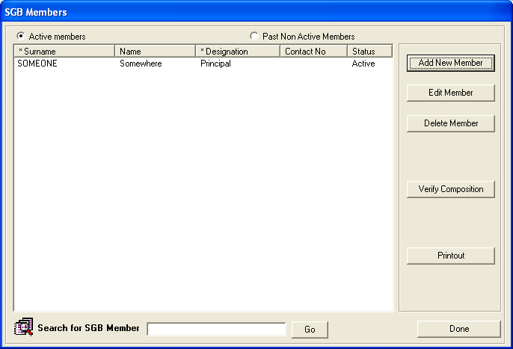
Figure 3: SBG Members

Adding SGB Members
- Select the Add New Member button to open the members’ data capture form.
- The first step to adding an SGB member is to select the type of member from the drop down list (Fig. 4)
- Once the type of member has been selected the available candidates in the relevant category will appear in the list view. (This step will be skipped for co-opted members).

Maintaining SGB Member Details
- Names of persons will appear here. Click on person to be added to SGB

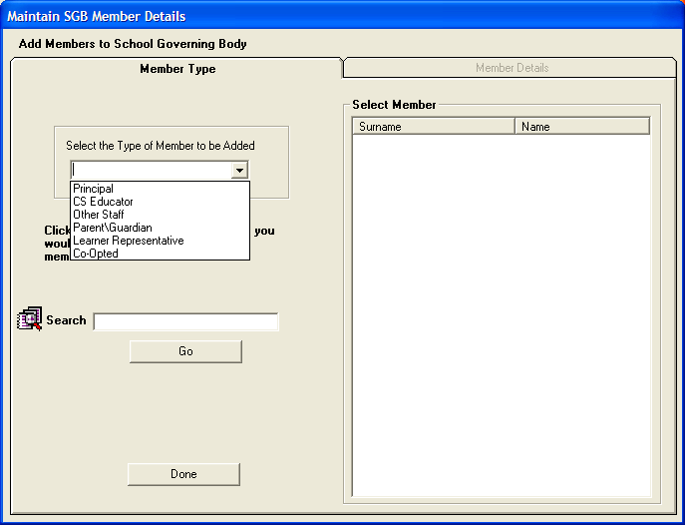
Figure 4: Maintain SBG Members

- Click on the name of the person in the listview to be added to the SGB. The member data capture form (Fig. 4) will open automatically with various member fields already completed. (No fields will be completed for co-opted members)
- Complete all the member details and Save the person to the SGB by clicking on the SAVE TO SGB button.
- Each member added will appear in the SGB listview on the SGB members form.

Add SGB Member Details
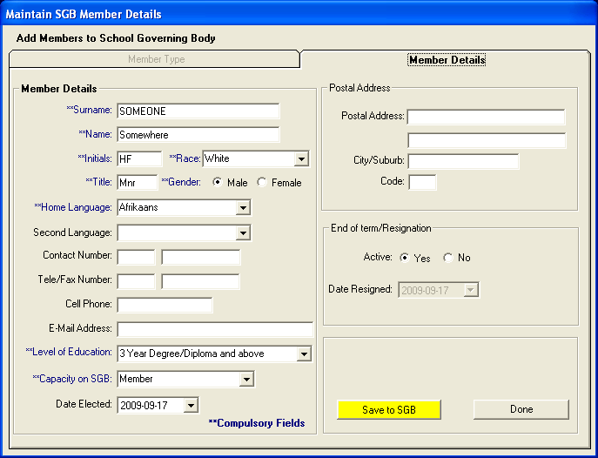 Figure 5: Maintain SBG Members Details

Add/Edit/Delete an SGB Member’s Details

- If you are adding a new member, a blank screen as in Fig 5 will open. Capture all details for this new member
- If you wish to update /edit or view a member, in the SGB Members window, click on the name of the member
- Once you have highlighted the name of the relevant member, Fig 5 above will open with member’s current details. Select the Edit Member button to view or update the member’s details
- Remember to Save your new data if you add to or change any of the details
- To delete an existing member, click on the member’s name in the SGB window then click the Delete button
- The Verify Composition button will give you a breakdown of the members according to title/position on SGB

A full list of SGB Members can be viewed or printed by selecting the PRINTOUT button from the SGB Members form.

MAINTAIN CURRENT SGB FUNCTIONS
Maintain current SGB function menu is used to enter detailed information of the SGB tasks in the school and the role that they play.

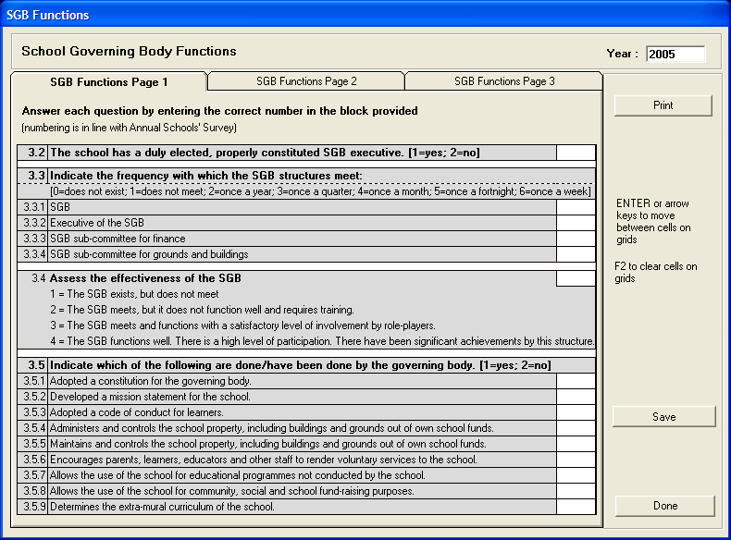
Figure 6: SBG Functions

- Click on Maintain Current SGB Functions from the Governance Menu, to fill in the School Governing Body Functions.
- You will see that each category has a code.
- Each block must be filled in according to the relevant code for your School Governing Body, as shown.
- There are three pages that must be completed.
- Remember to Save your data for each page, before continuing to the next page.

MAINTAIN GOVERNANCE RECORDS
The maintain policies menu is used to add, edit or delete school policies.
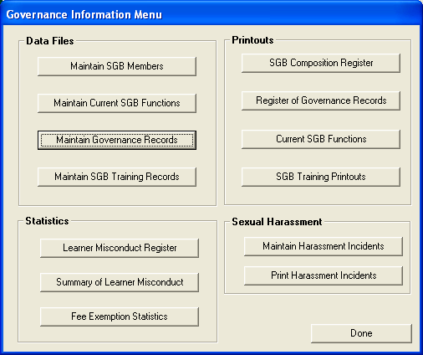
Figure 7: Governance Records

Maintaining Policies
- Click on the Maintain Governance Record menu from the Governance Information main menu and the following screen will appear;
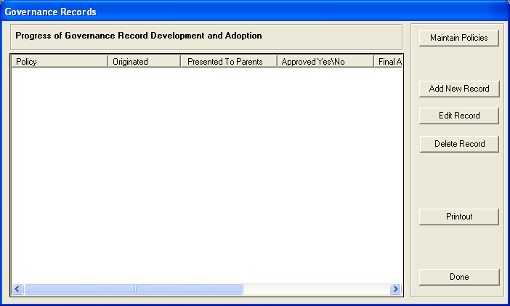
Figure 8: Maintain Policies

- Click on the Maintain Policies button and the below screen will appear
- This screen allows you to add and to edit policies.

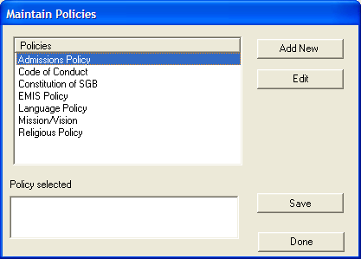
Figure 9: Edit Policies

- To maintain an existing policy, select the Maintain Policies button
- You will see that you can add new policies to the existing policies by pressing the Add New button(see figure 9)
- Then fill in all the new details in the field below
- Save your data once you have entered it
- To view or change existing policies, press the Edit button. Remember to save any changes you make.

Add New Governance Records
Figure10: Governance Records

- Click on Add New Record
- Select the policy from the dropdown menu
- Select the dates and click Save
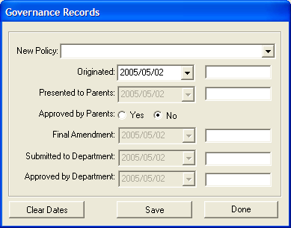
Figure 11: Governance Records

- Use the Printout button to view/print detailed information about the policies.

MAINTAIN SGB TRAINING RECORDS
Maintain SGB training record menu allows you to maintain SGB training categories, maintain SGB training course and to maintain individual training record.

- Click on the Maintain SGB Training Records to start.

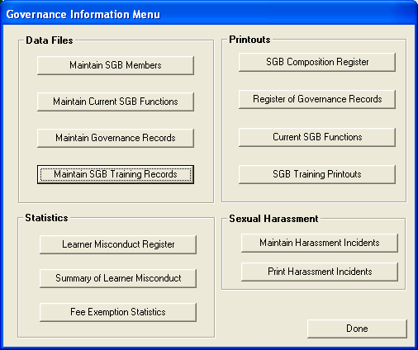
Figure 12: Governance information menu

- The following menu will appear;

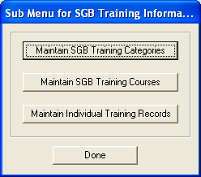
Figure 13: Sub Menu for SGB Training Information

Maintain SGB Training Categories
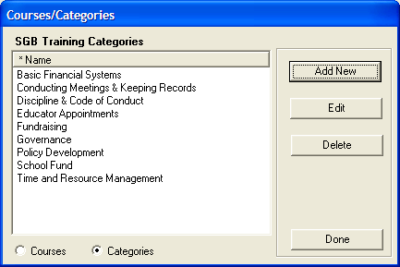
Figure 14: Courses/Categories

- You may add new categories to the existing categories by clicking the Add New button
- Fill in the relevant data. Remember to save the data you have entered
- Press Done when you have finished
- To edit existing categories click on the Edit button and remember to save your data
- To delete any existing categories, click on the category you wish to delete and press Delete
- Press Done when you have finished

Maintain SGB Training Courses
Maintain SGB Training Course menu allows you to enter courses which educators/other staff/parents on the SGB have received.

- Click on the Maintain SGB Training Course button and the following menu will open.
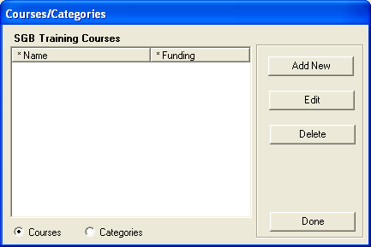
Figure 15: Add Courses/Categories

- To add a course received click on the Add New button and the following menu will open
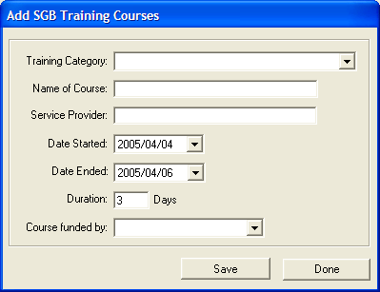
Figure 16: Add SGB Training Courses

- This option allows you to record all training courses that educators/other staff/parents on the SGB have received
- One can add new records after course training has been received by capturing all the data in the relevant fields.

Maintain Individual Training Records

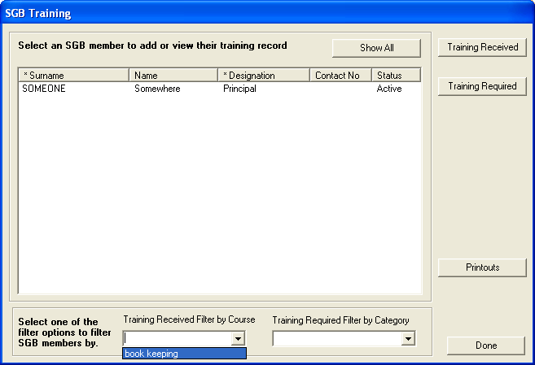
Figure 17: SGB Training

Individual Training
- In order to view the training courses any member has been on or training courses still to be attended you can use the filter options at the bottom of the screen
- Select either Training Received or Training Required to view relevant information

Training Received
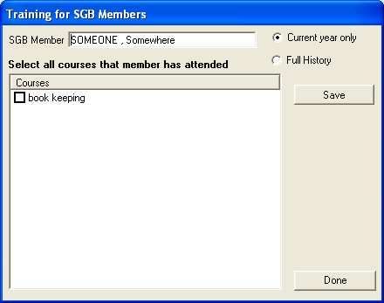
Figure 18: Training for SGB members

- Select the Training Received button
- Tick in the box next to the course/s trained on
- Click on the Save button to save your data. Press Done to complete the task

Training Required

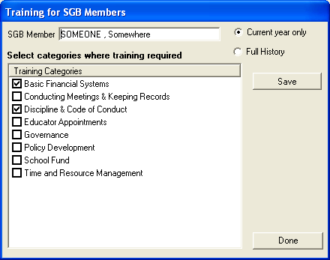
Figure 19: Training for SGB members2

- Select the Training Required button from the SGB Training Menu
- Tick in the box next to the course/s still to be trained on
- Click on the Save button to save your data. Press Done to complete the task.

STATISTICS
The information found in the three options under statistics is completed under the Learner Information module, because these are areas that require decision making by the SGB, they are stored here.

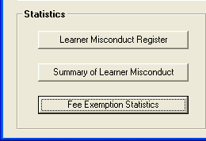
Figure 20: Stats (From Governance Main Menu)

- To print or view statistics from the Learner Misconduct Register, press the Learner Misconduct Register button on the Governance Menu
- Click on the relevant month and year from the drop down options.
- Press Print to print or Done to return to the program.
- For Summary of Learner Misconduct and Fee Exemption Statistics, do the same as above.

PRINTOUTS
- The purpose of printouts is to have current information available (in the relevant file) to access on request
- SGB meetings might require that certain topics requiring SGB decision making are to be discussed. The printouts pertaining to this can be printed beforehand to be available at the meeting.
- This option allows you to print SGB Composition Register, Register of Governance Records, Current SGB Functions and SGB Training Printouts
- To print, select the relevant button and press Print to perform the normal printing function.

SEXUAL HARASSMENT
Because of the nature of such incidents and the confidentiality involved, although the persons involved could be either learners or educators, the records are kept under Governance because decision-making will involve the SGB members.

Maintain Harassment Incidents
- To add incidents, click on the Add Incident button
- You will see that the incidents have been coded into 4 Types:
- Learner to Learner
- Learner to Educator
- Educator to Learner
- Educator to Educator

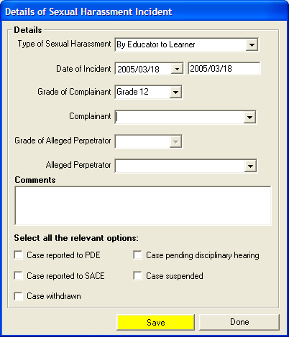
Figure 21: Details of Sexual Harassment Incident

Add an Incident
- When adding an incident select the relevant type of incident from the Type of Sexual Harassment drop down list
- Fill in the remainder of the relevant data under the details section
- Tick in the box next to the appropriate steps taken
- Press SAVE to save your data and DONE to return to the program.
- To view or change an existing incident, click on the relevant incident and click the Edit button.
- Remember to Save your data if you change anything.
- To delete an existing incident, click on the relevant incident and click Delete.
- Press Done to return to the program.

Print Harassment Incidents
- Click on the Print Harassment button Incident to get hardcopy records of the incidents
- These are Governance records and have implications for testimonials

