

SA-SAMS

Guidelines for using the General School Information module

September 2009

Education Management Systems (EMS)
Department of Education
Private Bag X895
0001 PRETORIA

CONTENT

1. INTRODUCTION 3
2. GETTING STARTED 3
3. THE STRUCTURE FOR THE GENERAL SCHOOL INFORMATION 3
3.1 School Details 3
3.2 Cycle Information 3
3.3 Class Information 3
3.4 School Subjects 3
3.4.1 Selecting School Subjects: 3
3.4.2 Editing a Subject: 3
3.4.3 Adding a Subject 3
3.5 Setup School Terms 3
3.6 Setup School Days 3
3.7 Bus Routes 3
3.8 Merit and Demerit Codes 3
3.10 School Hostels 3
3.11 Maintain Sport/House Groups 3
3.12 Feeder Schools 3
3.13 Year Planner 3
3.14 General settings 3
4. CONCLUSION 3

INTRODUCTION
The General School Information Module captures basic information that is necessary for the use of other SA-SAMS modules. For example, In order to use the Learner Information module school term dates are required for attendance and school subjects are necessary for modules such as the Timetable module and the Curriculum module.

GETTING STARTED
Data Capture process for General Information Section

Click on the General School Information menu to start.

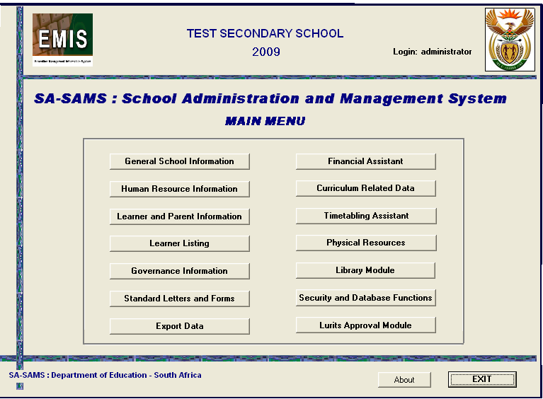
Figure 1: General School Information

THE STRUCTURE FOR THE GENERAL SCHOOL INFORMATION

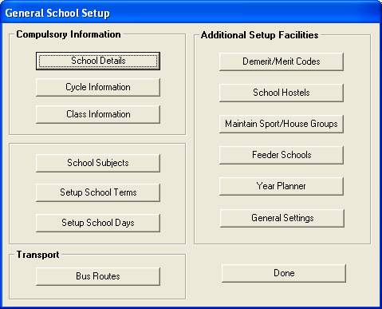
Figure 2: General School Information Setup

- This module will be able to store information about the following areas:

- Compulsory Information:

        - School Details;
        - Cycle Information;
        - Class Information;
        - School Subjects;
        - school terms
        - School days

- The data required in the General Information module is used throughout SA-SAMS for all areas of the programme.
- For example: The school terms are required in order to use the Attendance Module for learners.
- The COMPULSORY data sections must be completed before any other modules can be used in SA-SAMS. This data is usually only captured once when you first start using SA-SAMS.

- Additional Setup Facilities:
        - Demerit and Merit Codes
        - School Hostels
        - Maintain Sport/House Groups;
        - Feeder Schools
        - Year Planner; and
        - General Settings

- Transport:
        - Bus route

3.1 School Details
The school details menu is used to capture basic school formation such as the school address.

- To enter the general information about your school such as official name, address, contact information ,Click on the School Details button, See figure 3 below:

Figure 3: School Details
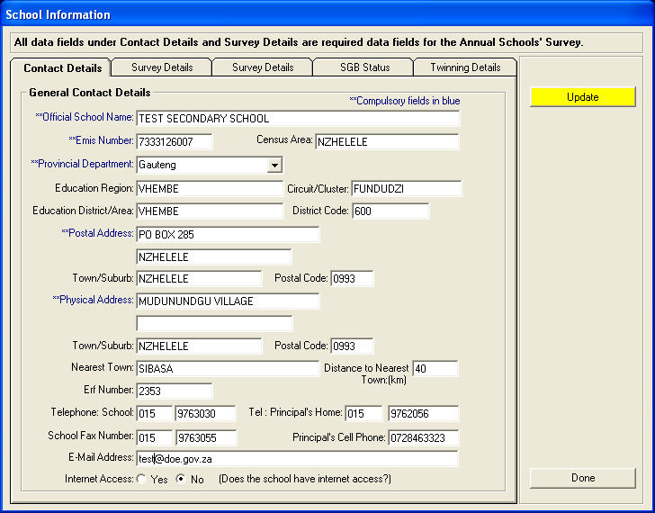
Figure 4: School Information

- The compulsory fields are marked in blue, but it is important to enter as much data as possible.
- Enter data for all five pages of this section (This school information captured in SA-SAMS, populates the Annual Survey, thus saving schools time on re-entering data):

        - Contact details;
        - Survey details 1;
        - Survey details 2;
        - SGB Status; and
        - Twinning Details.

- Once you have completed entering the data, you must click on the Save or Update button to save your data to the database.
- Once you have saved your data, you will see a confirmation message. Click on the Ok button to acknowledge this message.
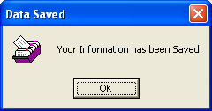
- Click on the Done button to return to the General School Setup Menu.
- To move from one cell to the next, use the tab button on your keyboard and the arrow buttons on the keyboard for drop down menus.

3.2 Cycle Information
The cycle information menu is where you setup your school framework; you can use the menu to choose if your school is an ordinary or an LSEN school. This menu is used to setup the following:

- To select school grades
- To select lowest grade in your school
- To select highest grade,
- To setup number of periods you have per day.

- To enter details about the grades and teaching hours at your school, Click on the Cycle Information button from the General School Setup menu and figure 6 will open:

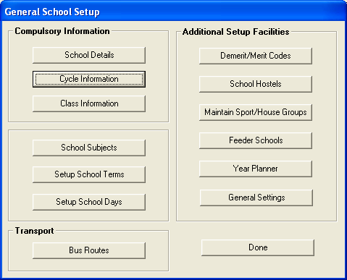
Figure 5: Cycle Information

- If you want to use separate classes for SNE or Remedial learners that are not in the mainstream, you must select these options as indicated in figure 6.
- Complete the relevant data required under teaching hours for either the GET Band or the FET Band or both depending on the grades in your school. Remember to SAVE your data before returning to the General School Setup Menu.
- If your SNE learners are absorbed into the mainstream classes then tick the No option.

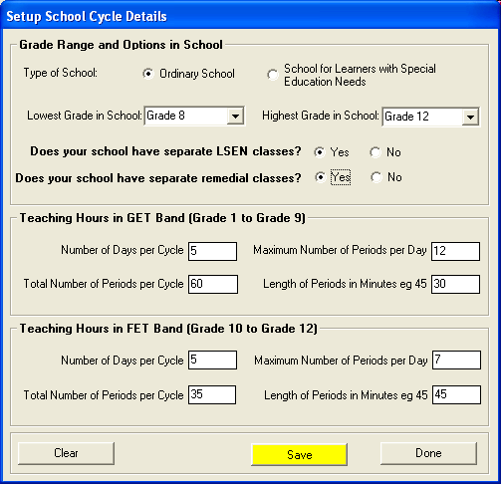
Figure 6: Setup School Cycle Information

3.3 Class Information
The class information is where you add your school classes to grades at your school.

- Select the Class Information button from the General School Setup menu to enter the class information for your school (See figure 7).

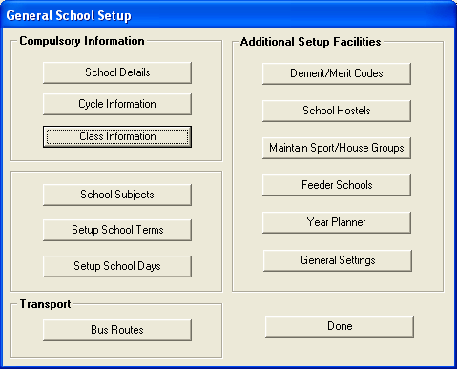
Figure 7: Class Information

- The grade range for your school was setup under Cycle Details. You will therefore only be able to add classes for the relevant grades (See figure 6).
- To add classes to each grade for the first time, click on a grade name in the tree view.
- Select either State or SGB, depending on the type of class.
- Type in the number of classes you want for the particular grade and click on the Create Classes button.
- The program will load the names of classes in the appropriate grades into the tree view.

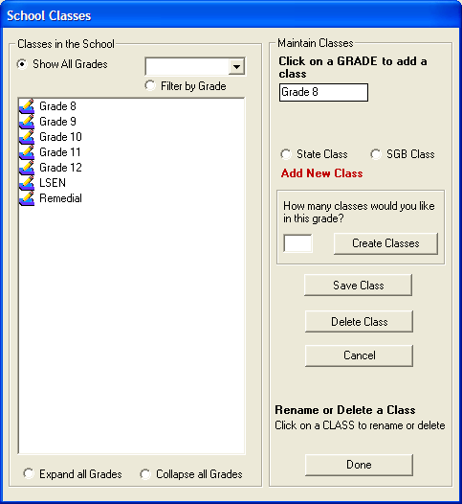
Figure 8: School Classes

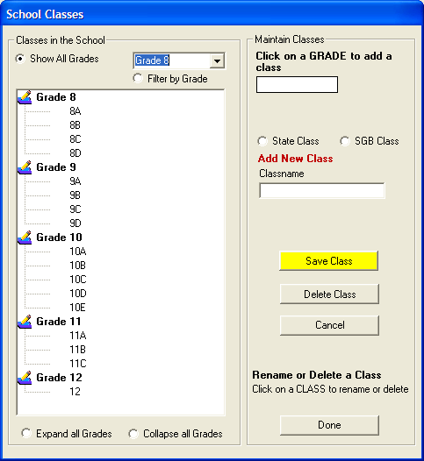h
Figure 9: School Classes

- To rename a class, click directly on the class name in the tree view. Then type in the new class name in the textbox provided and click on Save Class button to effect the change.
- To delete a class, click directly on the class name in the tree view and select the Delete Class button. A class can only be deleted if no learners have been assigned to the class.
- Should you select the incorrect class for deleting or re-naming simply click the Cancel button
- You can select to Expand all Grades to see the full list of classes in your school.
- The Collapse all Grades option collapses all classes and shows grade names only.
- To show just one grade with classes, you can select the grade in the combo box and choose the Filter by Grade option.
- Once you have completed your General School Details, Cycle Information and Class Information, you are ready to start working on any module you wish to or you may choose to continue entering data in the General Information section.
- The Done button takes you out of the screen you are working on.

3.4 School Subjects
School Subjects section is used to manage the school subjects offered by your school

- Click on SCHOOL SUBJECTS button (See figure 10).

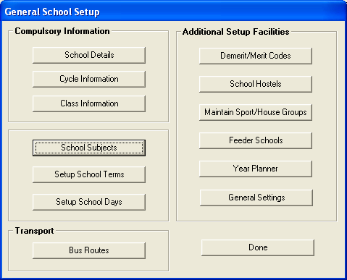
Figure 10: School subject

- The system includes a master list of subjects for your easy reference.
- Certain subjects may already have been pre-selected for your school. You can continue using these subjects or you can remove them.

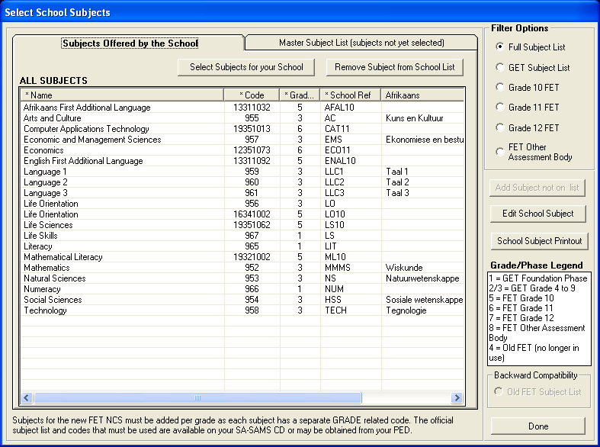
Figure 11: School Subjects

3.4.1 Selecting School Subjects:
- Click on the Master Subject List tab
- Click on the subject name to add the subject to the list of subjects offered by the school
- A pop up message will display asking if you have selected the correct subject for your school, click Yes
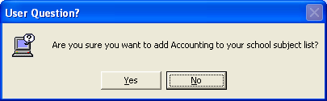
- Once you have selected your school subjects from the Master Subject List, click on the Subjects Offered by the School button.
- You now have a view of your school subjects.
- To remove a subject from your school list, click on the subject name and click the Remove Subject from School List button.
- When working with OBE subjects, please ensure that you select all the subjects required for each phase.
- You can use the Filter Options to view specific lists to check that subject selections are correct.

Editing a Subject:

You can only edit subjects that have been selected for your school. Editing includes changing the name of a subject, e.g. Human and Social Sciences to Social Sciences or adding subject names in Afrikaans.

- To Edit or enter Afrikaans names, click on the subject name in the view list for Subjects offered by the School and then click Edit School Subject button.
- The subject details will appear on the edit form. Change/update the details.
- For Afrikaans names, the English name for the subject appears in the top field.
- Type in the Afrikaans name in the relevant field.
- Select the correct phase within which the subject falls (Senior, FET).
- Click on the Save button.
- Follow this process for all subjects that require Afrikaans names.

3.4.3 Adding a Subject
If the subject that you require is not on the master subject list then you may Add it to the system
- Click on Subject Not On List button
- On the blank enter the name of the subject text field Enter The Name Of The Subject
- For the school that use Afrikaans as primary language , on the blank Afrikaans name for subject text field enter the Afrikaans Name for Subject
- On the Official subject code field, enter the official subject code provided by Provincial Department of Education
- If the subject you have selected is language, select the language type option:
        - Home /Primary language- The languages that the learner speaks at home.
        - First language- A compulsory language subject that learners are expected to undertake at that level.
        - Second language- A non-compulsory language subject that may be undertaken by learners at that level.
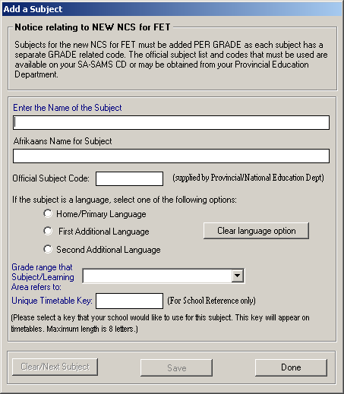
Figure 12: Add a Subject

3.5 Setup School Terms
The setup school terms menu is used to indicate the start and end date of each term.
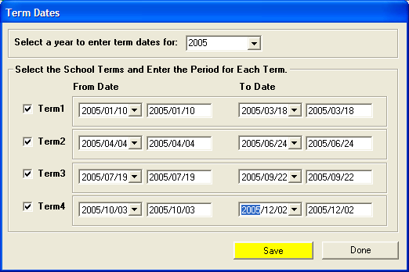
Figure 13: Terms Dates

- Click on the Setup School Terms button as shown in figure 13 in the General School Setup menu to capture school terms.
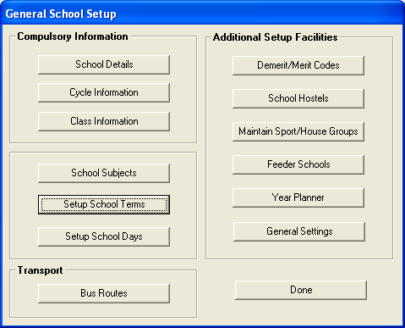
Figure 14: School Terms

Please Note: Accurate data capturing of dates for this section is important for the completion of the attendance registers for learners and educators.

- These are the dates that will reflect on the learners’ reports.
- To enter dates for the term, select a year by using the drop down box.
- The program allows you to input data for three or four terms depending on the province. If you have only three terms then leave the block to the left of Term 4 blank.
- Click in the small white box to the left of the term number.
- Select the provincial dates for start of term and end of term under the From Date and To Date columns using the drop down calendar option.
- Save once you have entered all the three or four terms data (Save, Ok and Done).

3.6 Setup School Days
Use the Setup School Days menu to setup non teaching days per term, this menu allows you to show days in which the school will not be operating.

- Click on the Setup School Days button as shown in figure 15 in the General School Setup menu to capture the non teaching days occurring in each term, e.g. Sports Day, Tour days.
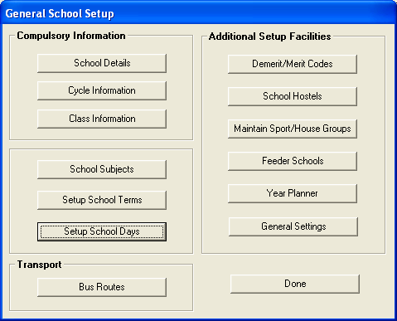
Figure 15: Setup school days

Please Note: In order to correctly reflect attendance data for learners and educators, the accurate capturing of dates for this section is necessary.

- Select the Year and click on the yellow Go button. The terms which you captured previously appear on the screen.
- Click on the term name to allocate non-teaching days falling within the term.
- Select the Month and the Day on which the non-teaching day falls from the drop down calendar.
- The date will fully appear in the Date Selected text box.
- In the next text box type in the Reason for the holiday.
- Click the Save button.
- The Clear button can be used to remove an incorrect entry before saving.
- The Delete button is used to remove unwanted days from the screen.
- The program automatically allocates holidays to the days of the month that fall outside of term time (e.g. if the term ends on a Thursday, the Friday will be highlighted as a holiday).

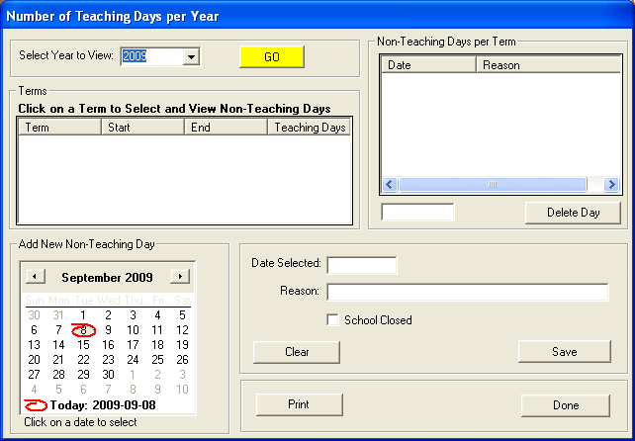
Figure 16: Teaching days per year

- The number of Teaching Days per term is indicated on the left screen. Click on the term name to see non-teaching days per term.
- To exit this form, and return to General School Setup menu, click on Done button.

3.7 Bus Routes
Use the bus route menu to add detailed information of the bus routes which are available to learners at the school. You are also able to assign an educator responsible for the route.
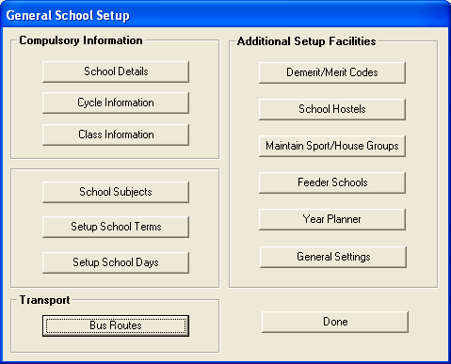
Figure 17: School bus route

- Click on the BUS ROUTES button in the General School Setup menu to capture the bus routes and the following menu will open:

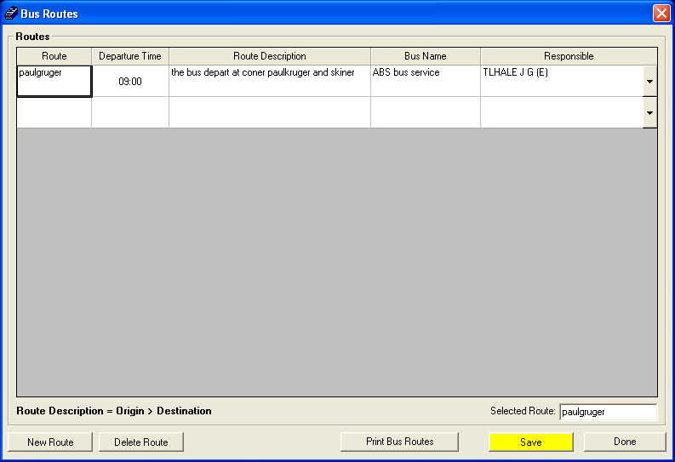
Figure 18: Bus Routes

- To enter new route , click on the New Route button
- On the blank text field enter the following:
        - Route- Describe the destination
        - Departure time- Select the departure time using the scrolls
        - Route description- Describe the pick up points and drop off
        - Bus name- Specify the name of the bus
        - Responsible- Select the responsible educator from the drop down list
- To delete a route, click on the Delete Route button.
- The bus route menu also gives you an option to make a printout of a route, to printout a bus route select a bus route you wish to print, the selected bus route will appear on the select bus route text box (see figure 18).
- Click on the Print Bus Route button.
- Once done click on the yellow Save button.

3.8 Merit and Demerit Codes
On the General School Setup menu select the Merit and Demerit Codes button as shown in figure 19.

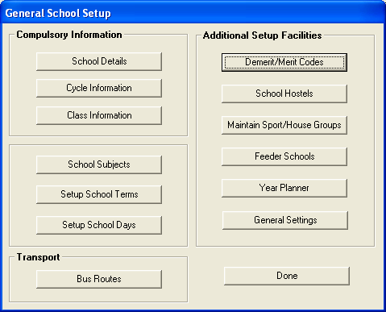
Figure 19: Demerit and Merit codes

The merit and demerit section has five levels of misconduct:
        - Level 1: Minor violation of general class discipline;
        - Level 2: Minor violation of school code of conduct or rules;
        - Level 3:Serious violation of school code or conduct of rules;
        - Level 4: Very serious violation of school code or conduct of rules;
        - Level 5: Criminal-serious violation of school code of conduct or rules but

These codes are the standard codes utilized under the learner section to record learner misconduct and the resultant disciplinary consequences. These levels of code may not be amended. Only additional descriptions may be added, edited or deleted from the levels.

- The learner actions code lists may be printed out by clicking on Print Codes button.
- Additional descriptions can be Added, Edited or Deleted by clicking on the relevant buttons.
- Click on Add New Code to add new descriptions.

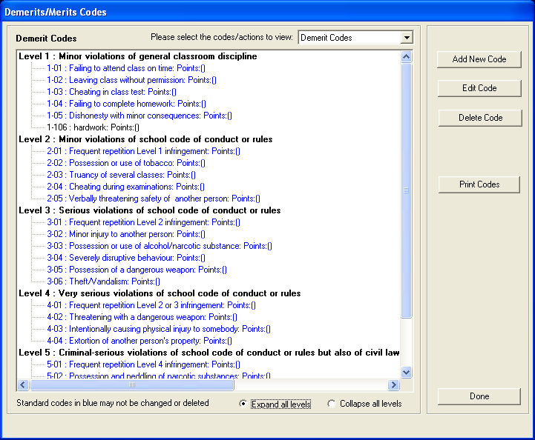
Figure 20: Merit and Demerit Codes

- From the dropdown list select the Code level.
- Enter Item Number.
- Then enter code Description and Code Points.
- Then click on the yellow Save button.

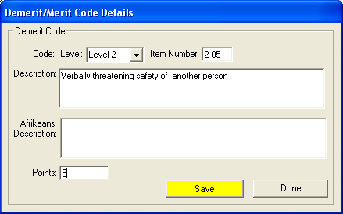
Figure 21: Code Details

- Use the Expand all levels in to view descriptions under each level and Collapse all levels to view levels only.

3.10 School Hostels
- Use the School Hostels button to enter details about your school hostels

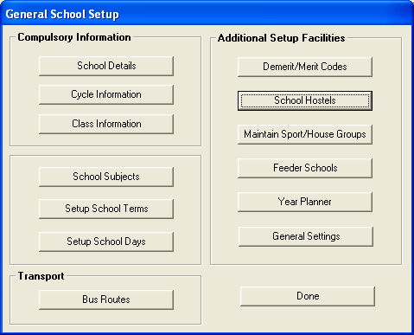
Figure 22: School Hostels

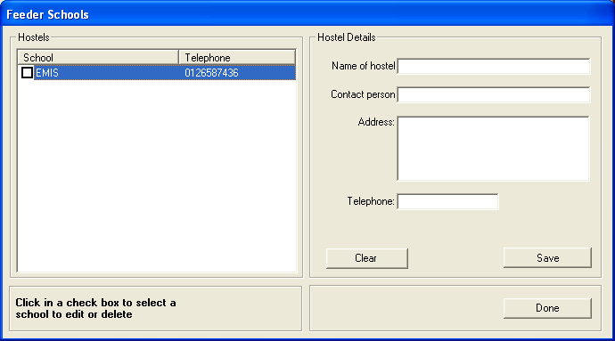
Figure 23: Feeder School

- Once you have entered the details click on the yellow Save button to save the data. The data is then shown on the left hand side of the screen in alphabetical order

- To edit a school hostels details; click in the tick box to the left of the school name. Now correct the school hostels details shown on the right of the screen. Save the amended data by clicking on the yellow Save button.

3.11 Maintain Sport/House Groups
Sport / House groups are the groupings schools use to allocate learners to compete internally in sport, cultural or academic activities. You can Add, Edit and Delete house groups. Please note: Educator data is needed in order to fully populate the required data fields.

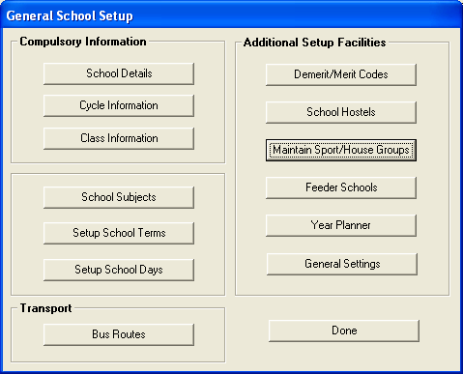
Figure 24: Maintain Sport/House Group

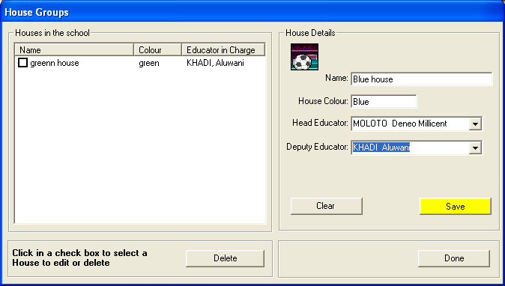
Figure 25: House Groups

- To add a new house: under House Group Details on the right hand side you can type in the new house details, then click on Save
- To edit an existing house: select the house to be edited by clicking in the check box. Change the details, then click Save.
- To delete an existing house: select the house to be deleted by clicking in the check box and click the Delete button. The User Question box will appear asking you if you are sure of the deletion. Click Yes to delete item.

3.12 Feeder Schools
Feeder school menu allows you to enter information about schools from where your school regularly gets learners.

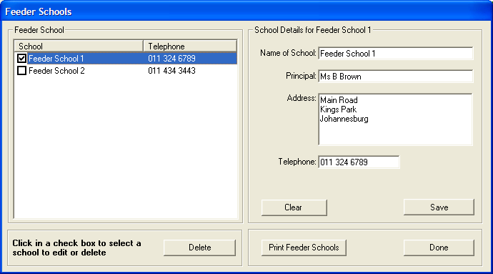
Figure 26: Feeder School

- Click on the Feeder Schools button to enter the general information about schools from where your school regularly gets learners.

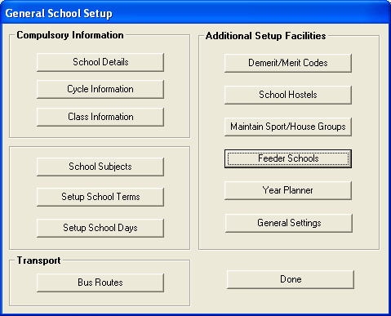
Figure 27: Feeder school

- Once you have entered the details click on the yellow Save button to save the data. The data is then shown on the left hand side of the screen in alphabetical order
- To edit a feeder school details; click in the tick box to the left of the school name. Now correct the school details shown on the right of the screen. Save the amended data by clicking on the yellow Save button.
- To delete a feeder school’s details; click in the tick box to the left of the school name and click the Delete button. A User Question box will open to clarify that the correct school is being deleted.
- To print a list of feeder schools, click on the Print Feeder Schools button.

3.13 Year Planner
The year planner is a useful tool to assist the SMT/Principal/HODs in planning the school calendar and activities for the year including the terms, functions, reporting deadlines, exam schedules and so on for both internal and external use.

- The General Planner is for external use (i.e. utilized to inform parents and learners of events, important school dates, parent meetings, etc).

- The Educator Planner is for internal usage (i.e. utilized to inform educators and staff of events, important dates, deadlines, staff meetings, etc).

- Click on the Year Planner button in the General School Setup menu to access the year planner.

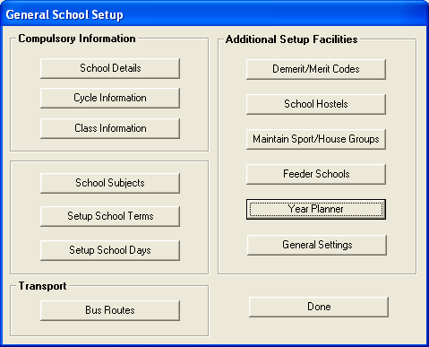
Figure 28: Year Planner

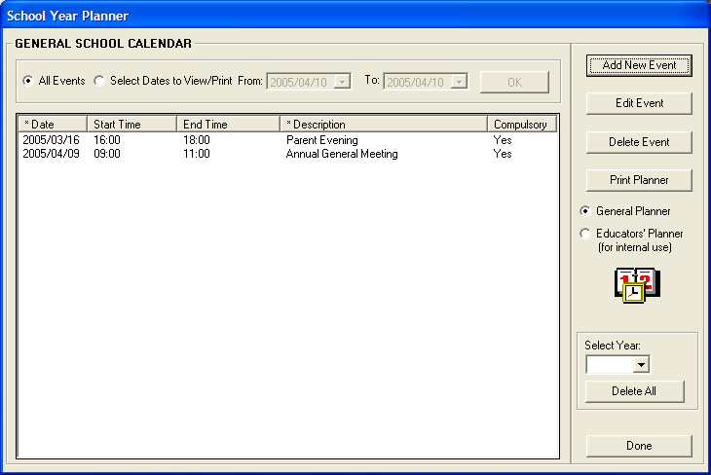
Figure 29: School Year Planner

- You can Add or Edit an event by selecting the event Date, allocating a Start and End Time (optional) and entering a Description of the Event.
- When you add or edit Figure 30 (below) will open.
- The event can then be allocated to the appropriate Planner category of either General Calendar or Educator Calendar. Or both simultaneously
- The event can then be categorized as a Compulsory Category (Yes) or not (No).
- The individual event needs to be saved by clicking on Save, Ok.
- Click on Done when all events have been added.
- The planners can be viewed or printed out for the entire year or for a specified period by clicking on either the All Events option or Selected Dates to View option and selecting the From / To dates e.g. per term.
- To print the planner, click on the Print Planner button. When printing the planner you have the option of entering your own title for the report or utilizing the default title.
- Events can be deleted from the Year Planner by clicking on the Delete Event button.

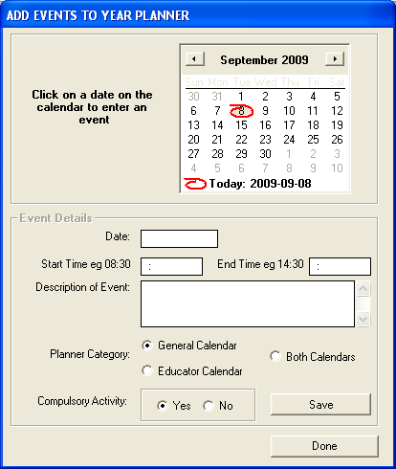
Figure 30: Add Events To Year Planner

General Settings

The General Settings section allows you to use your own school logo/emblem as the picture for the Main Menu and your school reports and school statements.

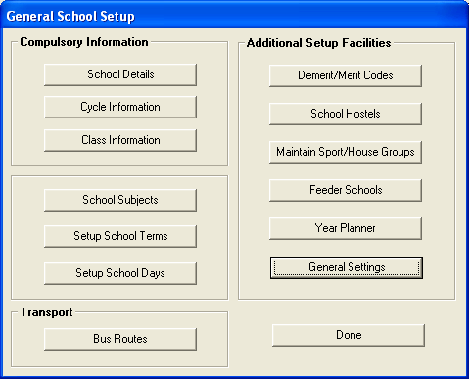
Figure 31: General Settings

- To add you own school logo, select the option “ Own Image” and then click Browse to find the image wherever you have stored it,
- Images must be in either bitmap(.bmp) or gif file format
- If you want your school logo to appear on your school reports and statements then tick on blank tick box to select Use image for progress reports and school fees statements

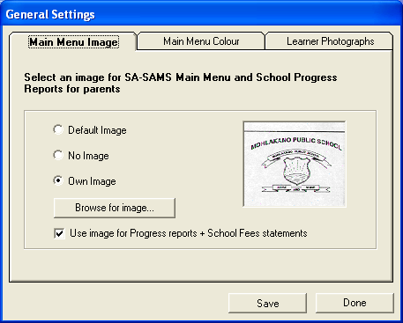
Figure 32: General Settings

- You can also choose your own color for the main menu screen as shown in Figure 33.
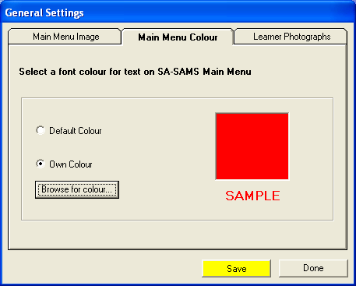
Figure 33: Setup Menu Page

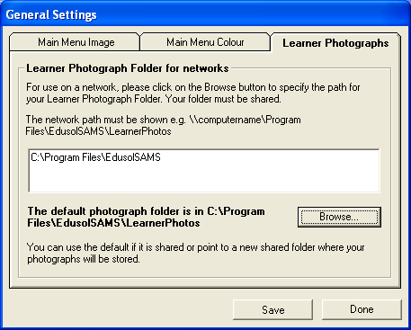
Figure 34: Setup Menu

- The leaner photographs button is used to specify or to put the path where the leaner photographs is stored
- To browse the path, click on the Browse button and the following screen will open;
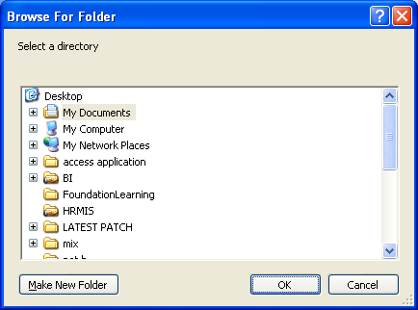
Figure 35: Setup Menu

- The default path photograph folder is in c:\programfiles\edusolSAMS\LearnerPhotos.
- For the use of network please click on the Browse button to specify path for your learner photograph folder.

CONCLUSION

Once you have done completing the General school information module you can start working on the Human resource information module because the school terms details captured on the General School Information will enable you to mark the attendance for the educator.

