

SA-SAMS

Guideline for using Export Data Module (SNE)

September 2009

Education Management Systems (EMS)
Department of Education
Private Bag X895
0001 PRETORIA

CONTENT

1. Introduction 3
2. Export Data Module for SNE 3
2.1 SNE Annual Survey 5
2.2 SNE Annual Survey Main Menu 6
2.2.1 SNE General Information 6
2.3 Export SNE Exam Registration Data 7
2.3.1 Export NSC Examination Registration 9

INTRODUCTION

The SA-SAMS Export Data module is used to export learner and educator data form for processing and reporting.

Users can export:

- Ordinary schools Snap Survey Data,
- SNE Schools Snap Survey Data,
- Ordinary School Annual Survey Data
- SNE Annual Survey Data and
- Export for NSC exam Registration Data

This data can be used for several purposes including statistics and planning for
the Provincial and National Education Department.

This manual serves to guide SA-SAMS users on how to best apply the Export
Data module in order to archive the best desired results when working on
SA-SAMS.

EXPORT DATA MODULE FOR SNE

- To start the export Data module, click on Export Data button on the SA-SAMS main Menu (Figure 2 below will appear)

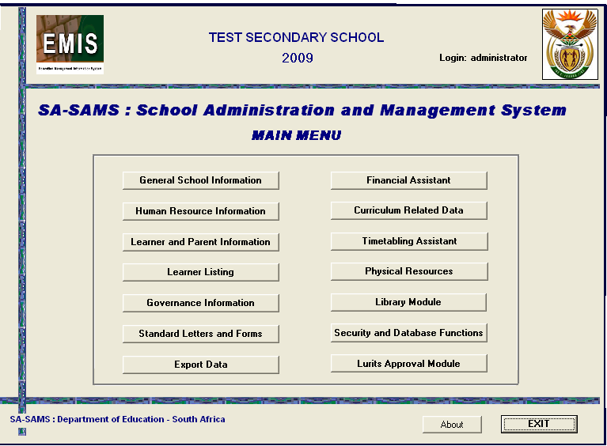
Figure 1: SA-SAMS main menu

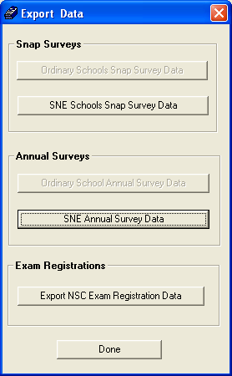
Figure 2: Export Data

- Click on SNE Annual Survey Data button to start the SNE Annual Survey Export sub module (Figure 3 below appears)
- The SNE Annual Survey Data export only applies for SNE Schools or ordinary schools which have and SNE class.

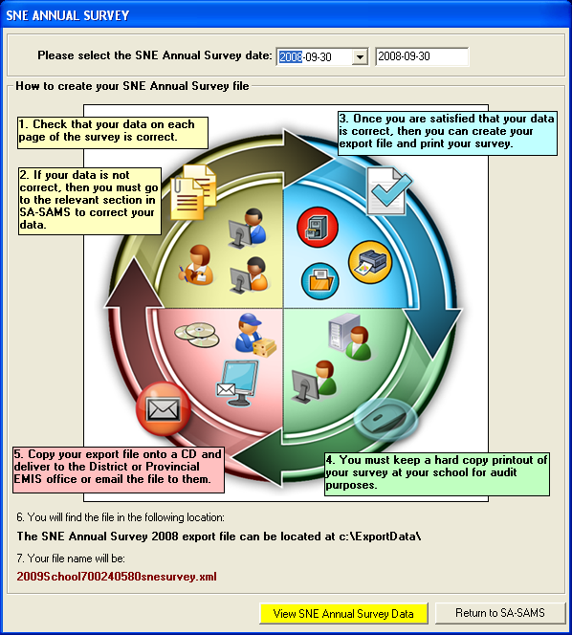
Figure 3: SNE Annual Survey

SNE Annual Survey

- Select date from the Please Select SNE annual Survey date drop menu.
- To continue, please click on the View SNE Annual Survey Data button after it turns yellow (See Figure 4 below)
- To Exit to SA-SAMS, Click on Return to SA-SAMS button.

SNE Annual Survey Main Menu

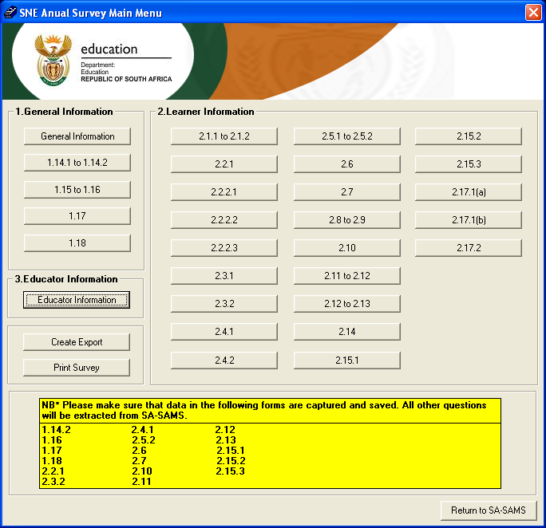
Figure 4: SNE Annual Survey main menu

- On the SNE Annual Survey main menu, click on General Information button to capture the school’s general information. (See figure 5 below)
- The yellow box at the bottom of the window indicates all the sections that must be captured before you can successfully export the SNE annual survey data.

SNE General Information

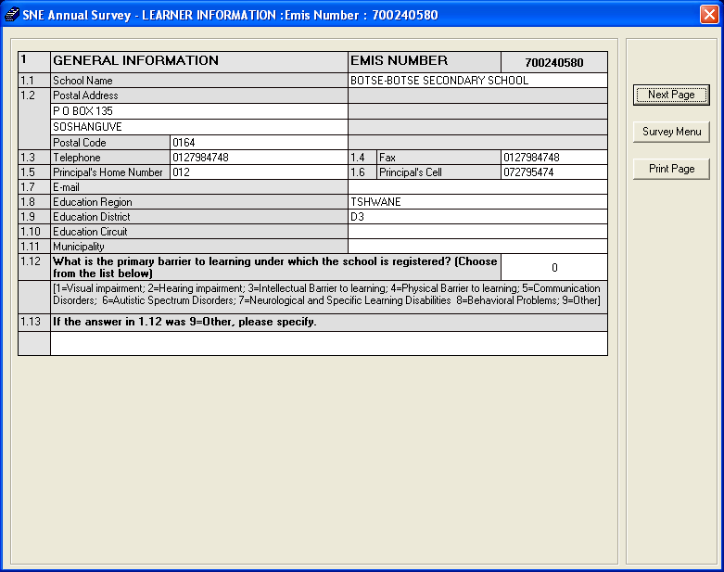
Figure 5: SNE Annual Survey: Learner Information

- To continue, Please type the information required for the SNE Survey tool for the GENERAL INFORMATION page and click on Next Page button
- To finalize the export, please capture data for all SNE pages where data is required until you get to the last page of the SNE survey tool and click on Export Data button.
- An XML file is created in the Export Data folder under the C directory

Export SNE Exam Registration Data

- To start this sub-module, click on the Export SNE exam registration Data button from the Export Data main Menu on figure 1 above. Figure 6 below appears.

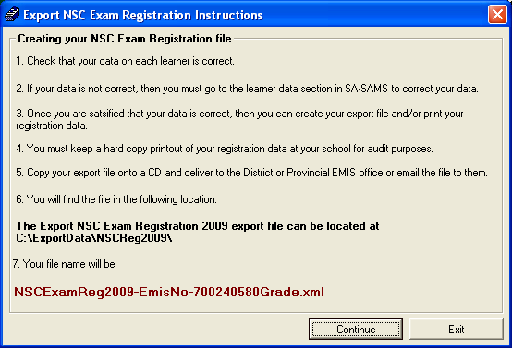
Figure 6: Export NSC Exam Registration Instructions

- To continue with the export, click on Continue button (see figure 5 below). To exit the export module, click on the Exit button.

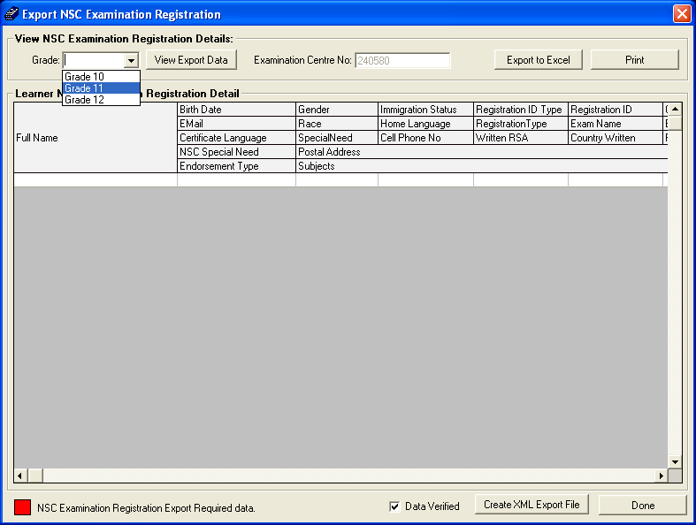
Figure 7: Export NSC Exam Registration

Export NSC Examination Registration

- To continue, select Grade from the Grade drop-down menu, and click on View Export Data button (Figure 8 below appears)

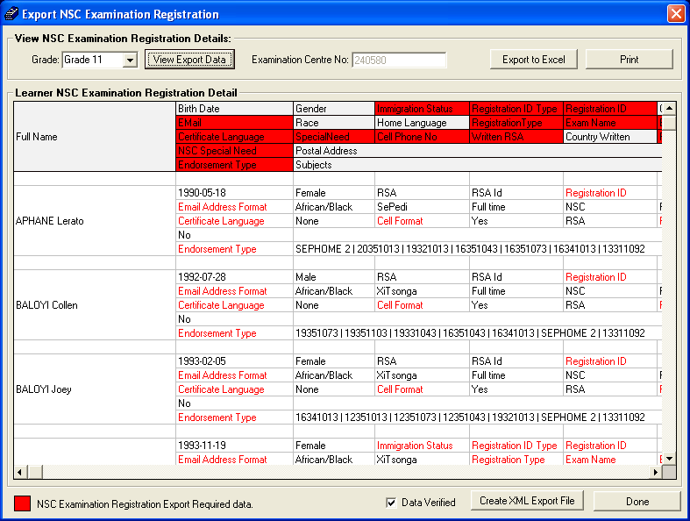
Figure 8: Export NSC Exam Registration

- Check to see that all the data is correct by scrolling down.
- When all the data is correct, click on Data Verified check box
- To continue, depending on the format of export file the user requires, Click on Create XML Export File button for an XML file or click on Export to Excel button and save the file on a specific directory to produce an excel spreadsheet export.
- To find the XML file go to C\export data\
- To exit, click on Done button.

