

SA-SAMS

Guidelines for using the Financial Assistant module

September 2009

Education Management Systems (EMS)
Department of Education
Private Bag X895
0001 PRETORIA

CONTENT

1. INTRODUCTION 5
2. GETTING STARTED 5
3. STRUCTURE OF THE FINANCIAL ASSISTANT MENU 8
3.1 System Setup 9
3.1.1 Maintain Finance System Parameters 9
3.1.1.1 Setup Financial Period 11
3.1.1.1.1 Financial Period 12
3.1.1.1.2 Period 12
3.1.1.2 Maintain Bank Accounts 12
3.1.1.2.1 Add New Bank Account 15
3.1.1.2.2 Remove Bank Account 15
3.1.1.3 Maintain Petty Cash Accounts 16
3.1.1.3.1 Petty Cash Accounts 16
3.1.1.3.2 Add Petty Cash Account 17
3.1.1.3.3 Edit Petty Cash Account 17
3.1.1.4 Maintain Voucher Numbers 18
3.1.1.4.1 Add a New Series of Petty Cash Voucher Numbers 18
3.1.1.4.2 Cancel Voucher 19
3.1.1.4.3 Cancelling Pre-Numbered voucher numbers 19
3.1.1.5 Maintain Cheque Books 20
3.1.1.5.1 Maintain Bank Accounts 20
3.1.1.6 Maintain a cheque book 21
3.1.1.6.1 Maintain Cheques Series 22
3.1.1.6.2 Cancel Unused Cheque 22
3.1.1.7 Maintain Receipt Book 23
3.1.1.7.1 Receipts Books 23
3.1.1.8 Maintain Deposit Book 25
3.1.1.8.1 Add Deposit Book 26
3.1.1.8.2 Remove Deposit Book 26
3.2 Maintain Chart of Accounts 27
3.2.1 To Add a New Account 27
3.2.2 Enter Take on Balance 29
3.2.3 General Accounts - Take on Balance 29
3.2.4 Debtors Take On Balances 30
3.2.5 Editing Accounts 30
3.3 Budget 31
3.3.1 Setting up Annual Budget/ Monthly Budget 31
3.3.2 Printouts 32
3.3.3 Annual Budgets 32
3.3.4 Monthly Budgets 32
3.4 Select a Transaction 34
3.4.1 Receipt Payment to School 36
3.4.2 Deposit Receipts 38
3.4.3 Cheque Payments 40
3.4.4 Direct Payment from Bank 42
3.4.3.1 Other Payment 43
3.4.3.2 Payment 43
3.4.5 Petty Cash Payment 44
3.4.6 SGB Salary Payment 48
3.4.6.1 Make Salary Payment (Page 1) 48
3.4.6.2 View Salary Payments (Page 2) 48
3.4.7 Journal Entry 49
3.4.7.1 View / Print Journals 51
3.4.8 Error Correction 52
3.4.8.1 Deletion of Transaction 54
3.4.8.2 Re-Process Deleted Items 55
3.4.8.3 View Audit File 56
3.4.8.4 Print Audit File 56
3.4.9 Print a receipt 57
3.5 Debtors and School Fees 57
3.5.1 Maintain School Fees 59
3.5.1.1 Assign School Fees to each grade 60
3.5.2 Debtor Take On Balance 62
3.5.3 Learner Billing 63
3.5.3.1 Process Fees for New Year 63
3.5.4 School Fees Exemptions 64
3.5.4.1 Page 1 – Adjust Individual School Fees 65
3.5.4.2 Page 2 Maintain Exemption 65
3.5.5 Debtor Age Analysis 66
3.5.6 School Fees Collection 68
3.5.7 Debtor / Learner Account Numbers 69
3.5.8 View / Print Learner Statement 69
3.5.8.1 Statements 71
3.5.9 View Account Payer 71
3.5.9.1 Account Payer Details (Page 1) 72
3.5.9.2 View Selected Account 73
3.5.9.3 Monthly Account Details 73
3.5.10 Change Account Payers 74
3.5.11 Learners with no Account Payers 75
3.5.12.1 List of Learners who have not been assigned an account payer 75
3.5.12 Archived Learners with Balance 76
3.5.13.1 Archived Learners that still have a balance on they accounts 76
3.6 Bank Reconciliation 77
3.6.1 Reconcile Bank Statement to System Transactions 77
3.6.2 View Reconciled Items and Transactions 79
3.6.3 View List of Bank Statements on System 79
3.7 Print Outstanding Cheques 80
3.8 Print Cash on Hand 81
3.9 Print Statement of Investments 81
3.10 View Cash Book 81
3.11 View Financial Statement 83
3.11.1 Actual Receipts and Payments 84
3.11.2 Monthly Income Statement 85
3.11.3 Detailed Year to Date Statement 86
3.11.4 Summarised Year to Date Statement 87
3.11.5 Total Fees Raised to Debtors Accounts 88
3.11.6 View Trial Balance 89
3.11.7 Balance Sheet to Date 89
3.11.8 Printout WCED043 (Western Cape Education Department) 90
3.12 Export to Xml File (SA DMS System) 90
3.13 View Receipts 91
3.14 View Cheque Payment 91
3.15 View Petty Cash Payment 92
3.16 View Bank + Petty Cash Deposits 93
3.17 View GL Transactions 94
3.17.1 Examples of how to find Transactions 94
3.18 View Receipts 95
3.18.1 Now Go To General Ledger Page 95
3.18.2 Other Examples 96
3.19 View Journal Entries 99
3.20 Year-End Functions 100
3.20.1 Error Fixing 106
3.20.2 Emergency Backups 106
3.20.3 Delete Archive Data 107

INTRODUCTION
NB: Please make a copy of your school data by giving the school another name, e.g. Copy School Finances or Test 1 etc and carry out the exercise at the end of the finance section to grasp the concepts of how the finance section works, before starting to capture your own school information.

You have now completed all the compulsory general school information in order to be able to proceed with the Set-up of the Financial Assistant Module.

GETTING STARTED
Select the Financial Assistant button from the SA-SAMS main menu to open.

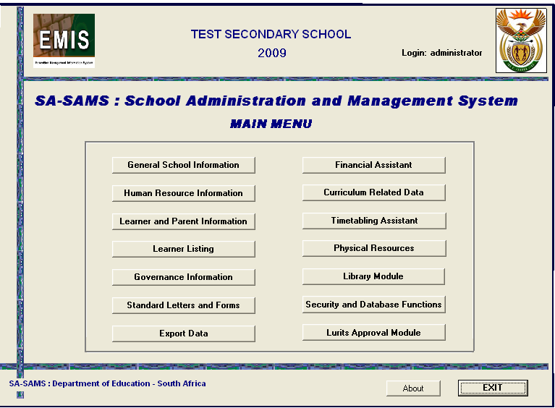
Figure 1: SA-SAMS Main Menu

- To begin using the Financial Assistant module – please click on the Financial Assistant button on the SA SAMS Main Menu
- The very first time you click on this module, a screen will pop up: Select Chart of Accounts

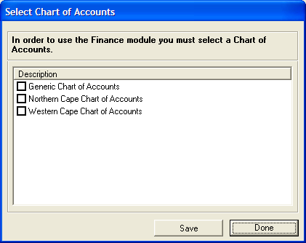
Figure 2: Select Chart Accounts

OR

You may get the screen picture below in which case you will click on Select/Change Chart of Accounts button, and the above screen will pop up. This is your last opportunity to change this setting, so ensure that it is correct before proceeding.

STRUCTURE OF THE FINANCIAL ASSISTANT MENU
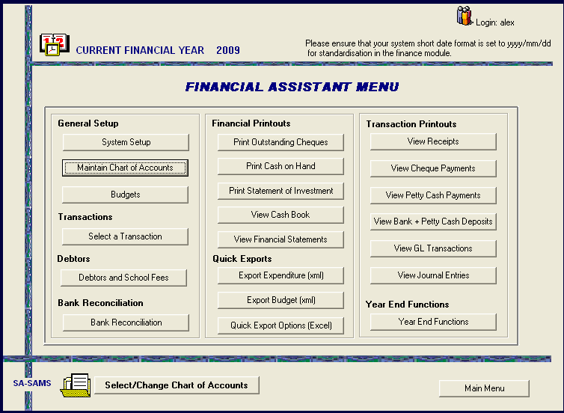
Figure 3: Financial Assistant Menu

- Your choice of Chart of Accounts will be determined by the province in which your school is
- If your province is not listed you must choose the Generic Chart of Accounts
- Tick in the relevant box
- SAVE
- OK
- Done

ALWAYS READ THE MESSAGES THAT POP UP ON THE SCREEN WHILE WORKING ON THE PROGRAMME

- The first time you are using the Financial Assistant, you will get the following warning (Fig 4.) Click on the OK button to continue.

Period Warning

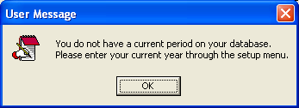
Figure 4: Period Warning

- On the first button of the main menu, select the SYSTEM SETUP button (SEE ARROW ON MAIN MENU).
- The Maintain System Parameters screen opens (Fig. 5).

System Setup
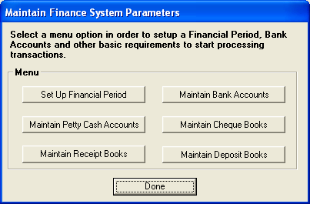
Figure 5: Maintain Finance System Parameters

Maintain Finance System Parameters

This section is the area where the following key system parameters are input:

- Set up Financial Period
  - (Allows the setting up of specific calendar years - January to December)
  - (Financial years may be added, deleted or closed)
- Maintain Petty Cash Account
  - (Multiple Petty Cash floats are accommodated and controlled)
- Maintain Receipt Books
  - (Multiple Receipt Books may be input and are controlled)
- Maintain Bank Account
  - (State schools should only have one account – multiple accounts are accommodated)
- Maintain Cheque Books
  - (A Cheque Book can only be added if the last Cheque Book is complete)
  - (Maintenance of Cheque Book)
- Maintain Deposit Books
  - (Multiple Deposit Books may be registered and are controlled)

Please Note: The Financial Assistant forces the basic financial control of not allowing any money to be receipted that is not subsequently banked. The receipting and depositing of funds are therefore reconciled.

Setup Financial Period
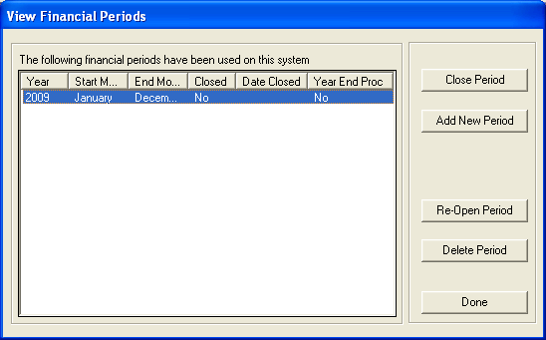
Figure 6: View Financial Periods

For first time set up as well as adding a new period at the end of each completed financial year.
- Click on Setup Financial Period button.
- The View Financial Periods screen opens (Fig 6).

Options:
- Add New Period button.
  - The Financial Periods screen opens (Fig. 6).
- Delete Period to delete an unused period once data is capture the period will not deleted
- Close Period to close financial year, for the period to close your all your amounts must balance.
- Re-open Period to open financial year, for the period to open your all amounts must balance.

Please Note: If your system date is incorrect – please exit the programme completely. Adjust system date on your desktop and then re-enter programme. Refer to Start up section for more details.

Financial Period
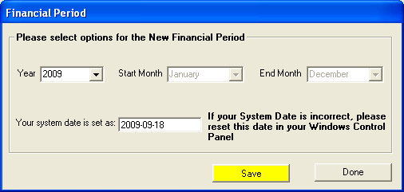
Figure 7: Maintain Finance System Parameters

Period
- Select the correct Year from the Year drop down box (e.g. 2009).
- Ensure that your system date is set correctly (today’s date – see previous page).
- Click on yellow Save button to save your input and the Done button to exit.

Maintain Bank Accounts
(Add, Edit or maintain a bank account as well as add a new Cheque series and add new Deposit books)

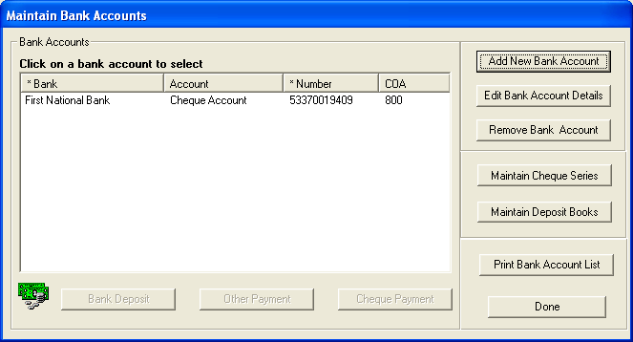
Figure 8: Maintain Bank Accounts

- Click on Maintain Bank Accounts button in the System setup section.
- The Maintain Bank Accounts screen opens (Fig. 8).
- To add a new bank account to the system, click on the Add New Bank Account button.
- Note the following screen will also open when Edit Bank Account Details is clicked
- The Add New Bank Account Details screen opens (Fig. 9
- Insert all the relevant bank account details.
  - Bank details refer to the BANK Account balance
  - Date account was opened (please note – the Date Account Opened refers to the actual date that the bank account was opened at the bank which may be 2,3 or 5 years beforehand – see fig 9)
- None of the requested details should be left out.
  - First cheque number – e.g. if your current cheque book is number from 120 – 160 and the last cheque used to date is no 136, then the first cheque number will be 137 and the last cheque 160
- Click on the yellow Save button to save your data.
- Click on Done button to exit.
- To delete a bank account click on Remove Bank Account button and a user question will open (fig. 9)
- Click on Print Bank Account List button to print a list of bank accounts
- Click on Done to return the System Setup screen
- If institution type “Other” is selected as the institution, the relevant details must be entered in the yellow area that will appear.
- If account type Other Account is selected as the account type, the relevant details must be entered in the yellow area provided
- Opening Balance Details - This section is required to run from January to December. It requires the input of the bank account balance. Accurate month, date and in or out of funds (in overdraft) information is required. Errors made here will have to be corrected using a standard Journal (See Journal section).
  - If there are outstanding/ unreconciled cheques from the previous year, then SUBTRACT these amounts from the Bank Statement balance and ADD back outstanding deposits to the Bank Statement Balance. This should then EQUAL the CASH Book balance on the 31 December pervious year. This amount should be entered as your Opening Balance Details.

Add New Bank Account
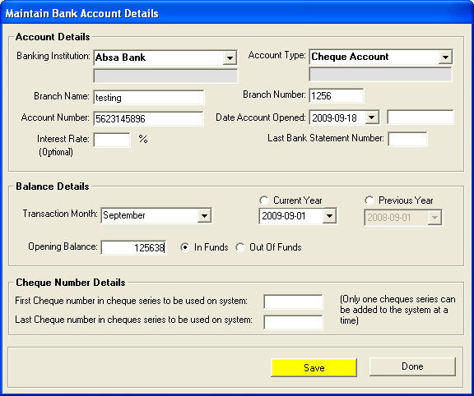
Figure 9: Maintain Bank Account Details

Remove Bank Account

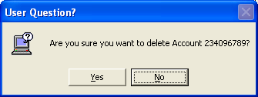
Figure 10: User Question

- Click YES to remove the bank account or NO to return to Fig.8

Maintain Petty Cash Accounts
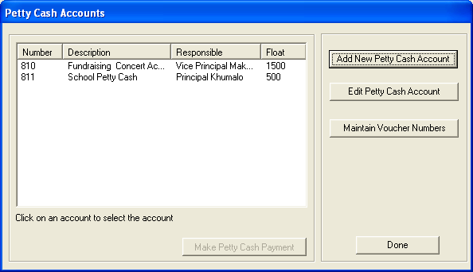
Figure 11: Petty Cash Accounts

Petty Cash Accounts
(Add or Edit Petty cash Accounts and maintain Vouchers)
- Click on Maintain Petty Cash Accounts button in the System Setup screen.
- The Petty Cash Accounts screen opens (Fig. 11)

Options:
- Add New Petty Cash Account
- Edit Petty Cash Account
- Maintain Voucher Numbers to add or edit voucher numbers

Add Petty Cash Account
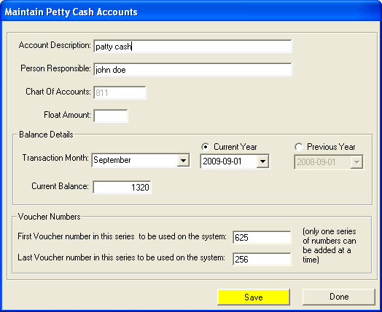
Figure 12: Maintain Petty Cash Accounts

- Insert all the relevant petty cash account details.
- None of the requested details should be left out.
- Click on the yellow Save button to save your data.
- A user question will appear concerning the importance of the accuracy of the petty cash voucher numbering details.
- Click on Done button to exit.

Edit Petty Cash Account
- Click on the relevant petty cash account to be edited and click on Edit Petty Cash Account button.
- Fig. 11 will open to make the relevant changes click on Save to save data and Done to exit
- Maintain Voucher Numbers to add or edit voucher numbers
- The Voucher Numbers screen opens (fig. 13)

PLEASE NOTE: (Refer Fig. 12)

- Balance Details - This section requires the input of the general ledger balance per the petty cash account. This is usually the reconciled closing general ledger balance from the prior year. Accurate month, date and in or out of funds information is also required. Errors made here will have to be corrected using a standard Journal (See Journal section.).

- Voucher Numbers – The voucher number details (First Voucher for this Account, Last Voucher Number Used and Last Voucher Number in Book) must be accurately input. When saving, the system will warn the user to verify the accuracy of the details. Click on YES button to continue saving or click on NO button to continue amending details. You can pre-number all voucher numbers or purchase pre-numbered voucher numbers.

Maintain Voucher Numbers
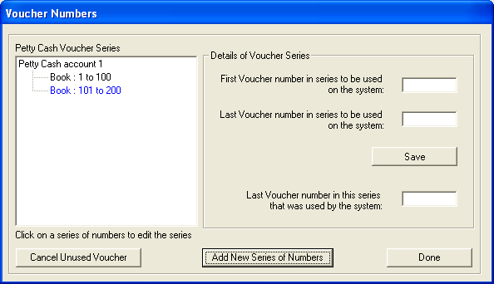
Figure 13: Voucher Numbers

Add a New Series of Petty Cash Voucher Numbers
(Cancel or add a new number series of petty cash vouchers)

- Click on Maintain Vouchers button in the System Setup screen.
- The Voucher Numbers screen opens (Fig. 13).
- Click on Add New Series Of Numbers to add another of vouchers
- Input details of new petty cash vouchers sequence in the First Voucher In Book, Voucher Most Recently Used (that will not be in this computerized cash book for the first time) and Last Voucher Number In Book input boxes.
- Click on the yellow Save button to save your data.
- To cancel an unprocessed Voucher numbers, select the book (A) and then click on Cancel Voucher
- The Cancel Voucher screen opens (Fig. 14).
- Click on the Done button to exit.

Cancel Voucher
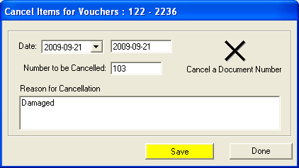
Figure 14: Voucher Numbers

Cancelling Pre-Numbered voucher numbers
- Select the cancellation date
- Enter petty cash voucher number to be cancelled in the Number to be Cancelled input box.
- Enter the reason for cancelling the petty cash voucher in the Reason for Cancellation input box.
- Click on the yellow Save button to save your data.
- Click on Done button to exit.

Maintain Cheque Books

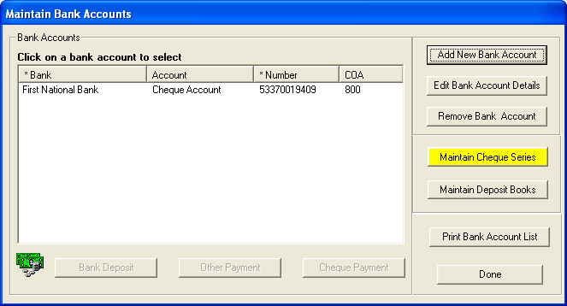
Figure 15: Maintain Cheque Books

Maintain Bank Accounts

- Click on Maintain Cheque Series button to add a cheque account (fig. 15 )
- When an Account type Cheque Account is selected, the Cheque Number Details (First Cheque in Book, Last Cheque Used and Last Cheque in Book)
- You can also edit the cheque account by clicking on Edit Bank Account Details
- And remove an account by clicking on Remove Bank Account if it has not been used
- Click on the Maintain Cheque Series button to maintain cheques, Fig. 16 will open

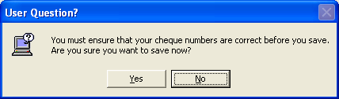
Figure 16: User Question

- A user question (Fig. 16) is displayed concerning the importance of the accuracy of the cheque numbering details.
- Click YES to continue and save or click NO to revise the cheque numbering details.

Maintain a cheque book
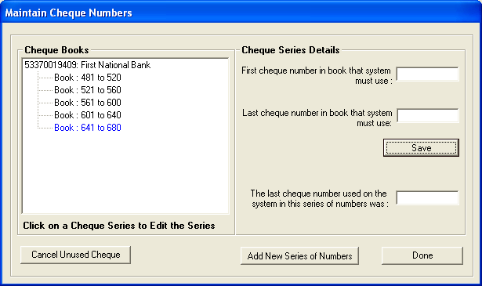
Figure 17: Maintain a cheque book

Maintain Cheques Series
(Add new series of cheques and cancel unprocessed cheques)

- To add a new series of Cheque numbers
- Select a cheque account in the Bank Accounts list.
- Click on Maintain Cheques Series button.
- The Maintain Cheque Numbers screen opens (Fig. 15).
- Click on the Add New Series of Numbers button to add a new series of chequebook numbers.
- Input details of new cheque book in the First Number In Book.
- Click on the yellow Save button to save your data.

Cancel Unused Cheque

This is ONLY where a cheque has not been processed and cannot be used, otherwise if it has been processed and still needs to be used - see under Select a Transaction / Error Correction / Delete Transactions / Cheques)

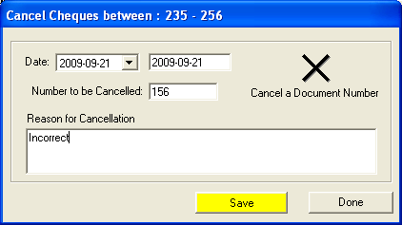
Figure 18: Cancel Cheques

- Select a chequebook in the Maintain Cheque Numbers screen and then
- Click on Cancel Unused Cheque button to cancel a cheque
- Select the cancellation date, enter the cancelled number and the reason for cancellation in the input box (fig 18)
- Click on the yellow SAVE button to save your data.
- Click on Done button to exit.

Maintain Receipt Book
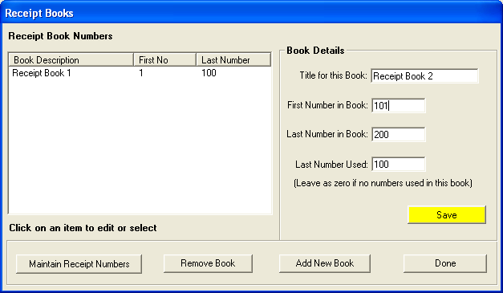
Figure 19: Receipt Books

Receipts Books
(Add or remove receipt books)
- To add a receipt book click on Maintain Receipt Books button.
- The Receipt Books screen opens (Fig. 19).
- Click on the Add New Book button.
- Input details of new receipt book in the Title For This Book, First Number In Book, Last Number Used and Last Number In Book input boxes.
- Click on the yellow Save button to save your data.
- Click on Done button to exit.
- As long as a receipt book has not been utilized and no receipts have been processed on the system, you may remove a receipt book from the system by selecting a receipt book
- Clicking on Remove Book button.
- You get a User question message” Are you sure you want to remove receipt book from the system?” – you cannot remove the Receipt Book if you have already issued receipts from it.
- Click on Yes button to remove receipt book or click on No button to abort receipt book removal.
- Click on Maintain Receipt Numbers for cancellation of items
- The Cancel item screen opens (Fig. 20). This is not to be used in order to re-issue receipt (see Select a Transaction / Error Correction /Delete Transaction / Receipts)
- Click on Done button to exit.
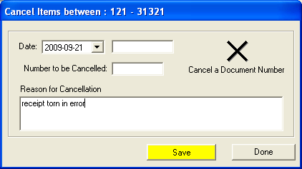
Figure 20: Cancel Items

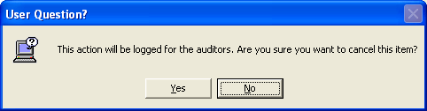
Figure 21: User Question1

Maintain Deposit Book
Deposits in a deposit book are not usually numbered from your bank. It will be up to you to label the Deposit Book e.g. Deposit Book 1 and it will be up to you to number each deposit within the book e.g. 1 – 40

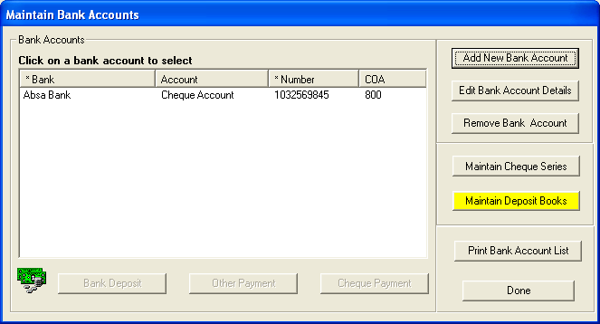
Figure 22: Receipt Books

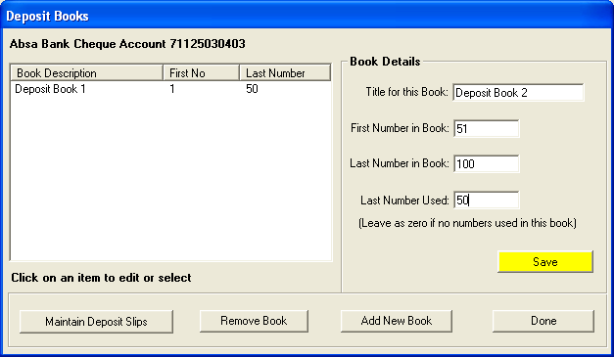 Figure 23: Deposit Books

Add Deposit Book
- Select a bank account and then
- Click on Maintain Deposit Books button to add a deposit book.
- The Deposit Books screen opens
- Click on the Add New Book button.
- Input details of new receipt book in the Title For This Book, First Number In Book, Last Number Used And Last Number In Book input boxes.
- Click on the yellow Save button to save your data.

Remove Deposit Book
- As long as a deposit book has not been utilized and no deposits have been processed on the system, you may remove a deposit book from the system by clicking on Remove Book button.
- You get a user question message” Are you sure you want to remove deposit book from the system?”
- Click on Yes button to remove deposit book or click on No button to abort deposit book removal.
- For cancellation of an item click on Maintain Deposit Slips
- The Cancellation screen will open
- Enter relevant data click the Save button and Click on Done button to exit.

Maintain Chart of Accounts

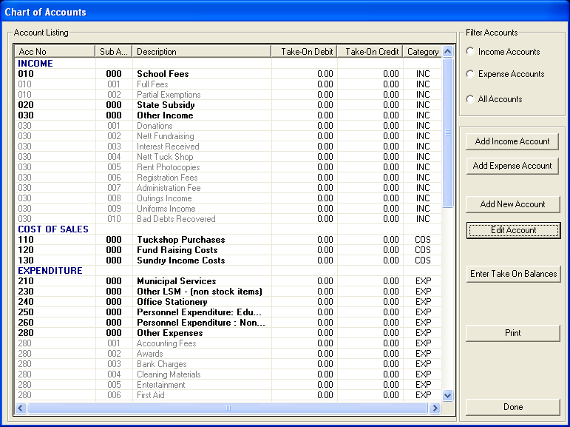
Figure 24: Chart of accounts

To Add a New Account
- Click on Maintain Chart of Accounts button to add a new account to chart of accounts.
- The Chart of Accounts screen will open.
- Put your curser onto the Income or Expense Account that you want to add to
- Click on the Add New Account button.
- The Add Account screen will open.
- It will show Account Description:
- Account number – first screen will be filled in, it is up to you to decide on sub-account number e.g. Office Stationery Printing Materials 240 050 Transaction Month: January, Opening Debit or Credit, Save, Done
Go back to Chart of Accounts and it is saved as 240 050

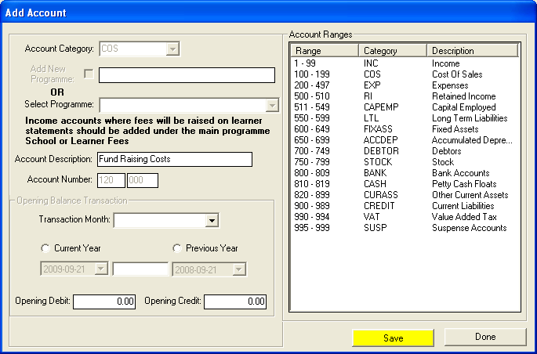
Figure 25: Add Account

- And to print click on the PRINT button on the maintain chart of account main menu

PLEASE NOTE:

- The Add Account (fig. 25) screen will open for Add Income Account, Add Expense Account and Add New Account
- When the screen opens for Add Income Account and Add Expense Account – Account Category will change to either INC (Income) or EXP (Expenses) sub-accounts and for the Add NEW Account you’ll have to select the Account Category (except for Income and Expense accounts)

Enter Take on Balance

Figure 26: Add account

FIRST TIME ONLY
When first starting up the set of books, there will be Take on Balances for many accounts Income and Expense Accounts as well as Balance Sheet Accounts.

Once the system is set up, the Year End roll-over will ensure that all Income and Expense Accounts are NIL and the Balance Sheet accounts should roll over.

General Accounts - Take on Balance
- Click on Enter Take On Balance button to open the above screen (fig. 26)
- Data will be entered in the Opening Balance Transaction section
- Select Transaction Months, Current or Prior Year, Date and Opening Credit or Opening Debit. (it will prompt in YELLOW for the usual transaction entry)
- Click on Save to save your data
- And on the Done button to exit.

Debtors Take On Balances
The way debtor opening balances work is:

When a school starts up the system (THE FIRST TIME) you will enter the total amount OUTSTANDING on your debtor accounts into account 701 on the opening balances page (fig 26).

Then you go to Debtors and School Fees Section / Debtors Take on Balance and allocate this amount bit by bit into the individual debtor accounts until it has all be assigned and equals the Debtors 701 opening balance.

Editing Accounts
- Select the account to be edited by clicking on the item in the Account Listing. The selected account will be highlighted in blue
- Click on the Edit Account button.
- The Add Account screen will open. (Fig. 26)
- Edit Account Category and Account Name details.
- You can also edit the opening balance transaction including the balance by clicking on the CHANGE OPENING BALANCE
- Click on the yellow Save button to save your edited data.
- Click on Done button to exit.

Budget
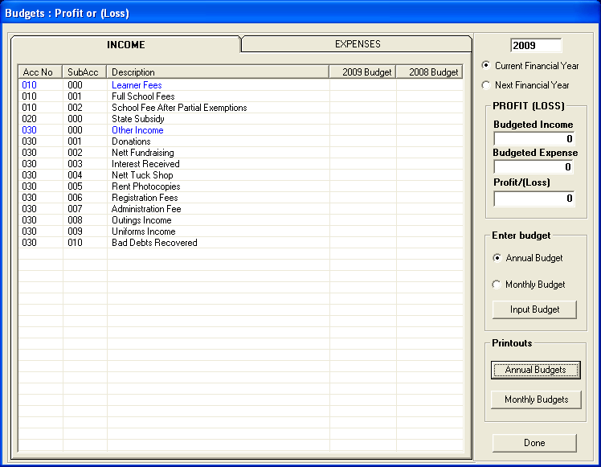
Figure 27: Budget

Setting up Annual Budget/ Monthly Budget
(Set-up, print or view current or prior year budgets)
- Click on the Budgets button in the Main Menu screen.
- The Budgets screen will open (Fig. 27).
- You can view Current and Previous year budget when the Budget screen opens.
- Select either an income or an expense account that you wish to add budget figures to by clicking on the correct account.
- Select either Annual Budget option or Monthly Budget option.
- Click on Input Budget button.

Printouts
- Annual Budgets
- Monthly Budgets
  - Annual and Monthly Budgets reports can be generated

PLEASE NOTE: (fig.28)
Annual Budget should be used where figures are not broken down per month within the budget and only a single annual figure is required.
Monthly Budget should be used where figures are broken down per month within the budget.

Annual Budgets

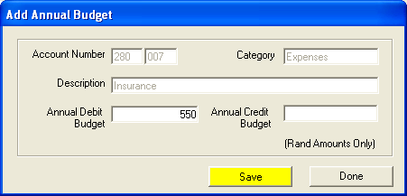
Figure 28: Add Annual Budget

- If Annual Budget is selected – the Add Annual Budget screen opens (Fig. 28).
- Input Debit or Credit balance. The correct position is highlighted in yellow.
- Click on the yellow Save button to save your data.

Click on Done button to exit.

Monthly Budgets
- If Monthly Budget selected – the Monthly Budget Amounts screen opens (Fig. 29).
- Input balances per month (January to December).
- If you wish to split a value equally over the full 12 months, enter the total budget value in any month and click on the Automate Monthly Totals button.
- A warning is given that any previous monthly totals will be lost.
- Click the Yes button to continue automation and the No button to abort the automate sequence.
- Click on the yellow Save button to save your data.
- Click on Done button to exit.

Monthly budgets equally received over full 12 months. Fig. 29
E.g. the school calculates that it should receive R60 000 over the course of the next 12 months for Full Fees.

Step 1

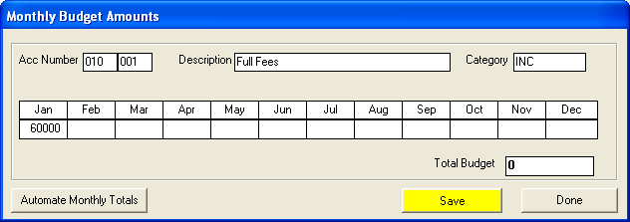
Figure 29: Monthly Budget Amounts1

Step 2
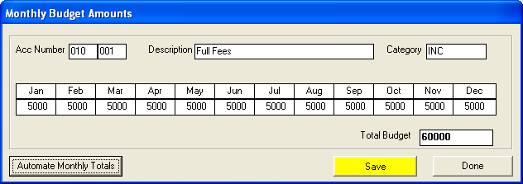
Figure 30: Monthly Budget Amounts2

If you expect to receive monies in monthly but not equally or not over full 12 month period, then use Monthly Budget but manually enter in the amounts that will be receive in each particular month. Save
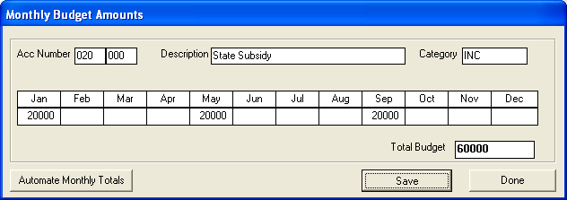
Figure 31: Monthly Budget Amounts3

Select a Transaction
This area is where most of your processing will take place, the Receipting of monies, the payment of cheques, the depositing of monies into the bank and also where you will generally correct any errors to the above.
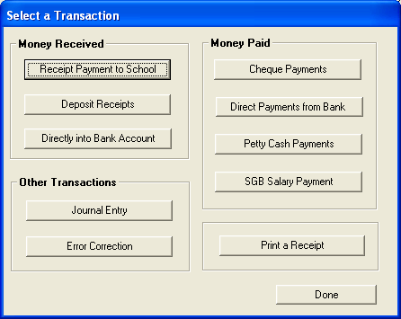
Figure 32: Select a Transaction

The following areas can be found in the Select a Transaction screen:

- Receipt Payment to School
  - (Allows entering of payments to the school)
- Deposit Receipts
  - (Allows you to select receipt that have been made out to be selected for depositing at the bank s by the school)
- Direct into Bank Account
  - (Allows entering records of deposit of interest etc)
- Journal Entry
  - (Allows entering of journal entries)
- Error Correction
  - (Allows a process of correcting errors in Cheques, Receipts, Petty Cash and Deposits)
- Cheque Payments
  - (Allows entering data for cheque payments)
- Direct Payments from Bank
  - (Entering data for direct payments made through the bank e.g. debit order on schools bank account)
- Petty Cash Payments
  - (Allows entering petty cash payments data)
- SGB Salary Payments
  - (Processing of SGB salaries)
- Print a receipt
  - (allows printing of receipt)

Receipt Payment to School

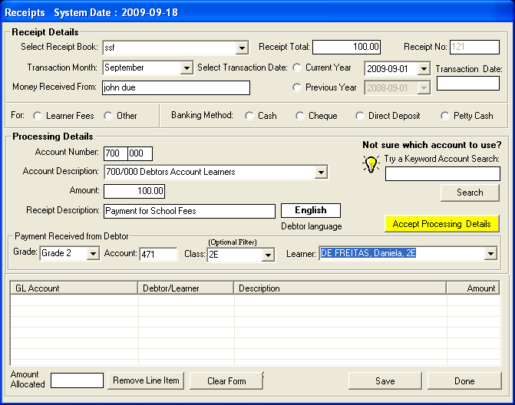
Figure 33: Receipts System Date

Receipt Payments

- Click on the Receipt Payment To School in the Select a Transaction screen
- The Receipts screen opens (fig. 33)
- Select receipt book, enter receipt total and number
- Select Month, Current Year or Previous Year option and a correct date for the current or previous year.
- Select the correct receipt date using the Receipt Date option
- Insert the amount of the receipt using the Amount option
- Select the type of receipt, either School Fees or Other
- Select the type of Payment Method being Cash, Cheque, Direct Deposit or Petty Cash
- If receipt is for School Fees, Amount, Grade and Select Learner must be completed. Description may be amended
- If receipt is for Other, Amount, Account Selected and Description must be completed. The Type in Keyword option may be utilised (refer Features below)
- Click on the Accept Processing Details button
- The receipt is now reflected in the bottom grid
- Receipts may be split into as many separate amounts as is necessary and may be split between School Fees and Other.
- The Amount Still to be allocated must equal zero before you may save.
- Clicking on it and then clicking on the Remove Line button may remove an entry.
Click on the yellow Save button.
- Click on Done button to exit.

Please note:
Keywords – the programme contains a database of commonly used terms, which are linked to general ledger accounts. An example would be, you receive a donation and put the word donation in the Type in Keyword option. The donations received general ledger account will automatically be selected.
Department – This option is currently unavailable.
Clear Form – To clear all input prior to saving, click on the Clear Form button. A Warning is given. Click on YES button to clear or on the NO button to leave as is. This option can also be used once you have saved to clear the screen and to continue processing the next receipt.

Deposit Receipts
- Click on Directly Into Bank account button to open the above screen (Fig.34).
- Select the correct deposit book using the Select Deposit Book option.
- Select the correct financial period by using the Select Transaction Month option.
- Select Current Year or Previous Year option.
- Select the correct deposit Date for the current or previous year.
- Select receipts to be deposited by clicking in the tick box to the left of the listed receipts
- Select all the receipts that relate to the single deposit slip (this should include ALL receipts listed above).
- Click on the Accept Processing Details button.
- The deposit slip totals will now be displayed at the bottom of the page (The total is split between cash and cheques).
- Click on the Save Deposit button to save the deposit entry.
- Click on the Done button to exit or click on Next / Clear Form button to continue processing.

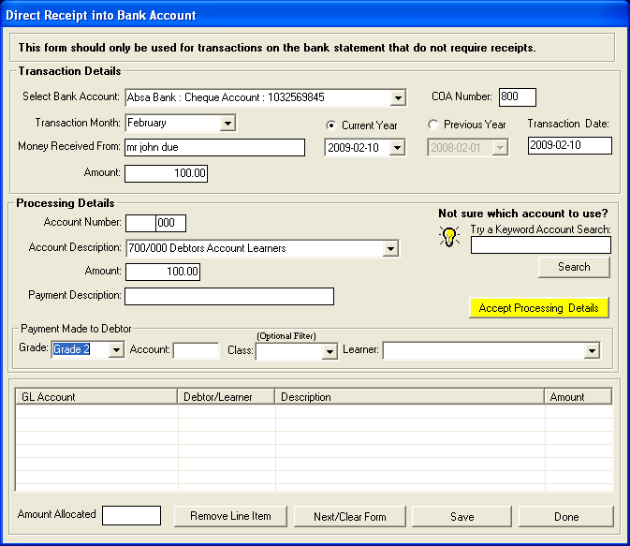
Figure 34: Direct Receipt

- Click on Directly into Bank Account button to open the above screen (Fig.34).
- Select a bank account using the Select Bank Account option.
- Select the correct financial period by using the Select Transaction Month option.
- Select Current Year or Previous Year option and the correct deposit Date for the current or previous year.
- Enter Money received from and Amount
- Enter Processing Details and
- Click on the Accept Processing Details button.
- The receipt allocation is now reflected in the bottom grid.
- To remove a line select a line you want to remove and click on Remove Line Item button
- Click on the SAVE button to save the receipt entry.
- Click on the DONE button to exit or click on Next / Clear Form button to continue processing.

You should not use this option for the electronic transfer funds by learners as it will not issue a receipt number

Cheque Payments
Example of SPLIT Cheque

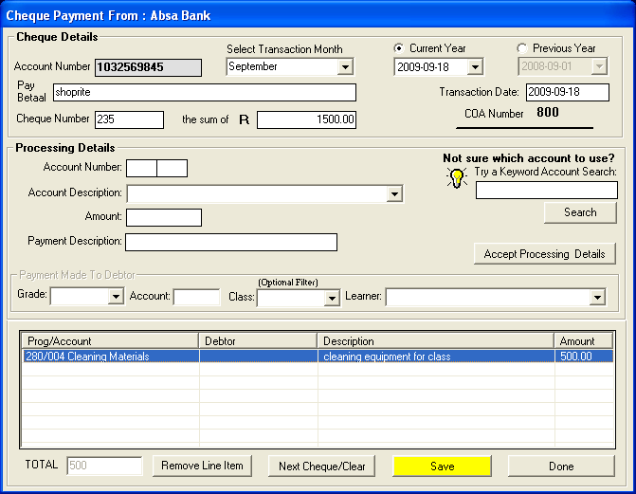
Figure 35: Add Annual Budget

- Click on the Cheque Payments button
- The Maintain Bank Accounts screen opens.
- Select the correct bank account in the Bank Accounts grid. The selected bank account will be highlighted in blue.
- Click on Cheque Payment button.
- The Cheque Payment screen opens.
- Select the correct financial period by using the Select Transaction Month option.
- Select Current Year or Previous Year option.
- Select the correct cheque Date for the current or previous year.
- Insert details of to who the cheque was made out in the Pay option.
- Insert the cheque amount in the Sum of R option.
- The Amount, Account Selected and Description must be input.
- The Keyword option may be utilized.
- Click on the Accept Processing Details button.
- The Cheque allocation is now reflected in the bottom grid.
- Cheques may be allocated to as many accounts as is necessary.

Please Note:
If Account Selected is account 700 (Debtors Accounts Parents) then the Grade and Select Learner options may be used.
- The Total in bottom left corner must equal the cheque amount before you may save.
- Clicking on it and then clicking on the Remove Line button may remove an entry.
- Click on the yellow Save button.
- Click on Done button to exit or click on Next Cheque / Clear button to continue processing.
- If a cheque has been made out to a supplier and the amount covers two or more accounts, then it is a split cheque. Make out the cheque to the supplier for the full amount, then allocate the correct number for the 1st account and then enter the amount to be allocated to that account. Accept. Then allocation the correct number for the 2nd account and then enter the amount to be allocated to that account. Accept. Save

Features

Keywords – the programme contains a database of commonly used terms, which are linked to general ledger accounts. An example would be, you buy stationery and put in the word “pencil” in the Type in Keyword option. The stationery general ledger account will automatically be selected.
Department – This option is currently unavailable.
- Click on Remove Line Item to delete an item
- Click on DONE to exit or Next Cheque/Clear to continue.

Direct Payments from Bank
This section covers payments out from your bank account e.g. debit orders, stop orders
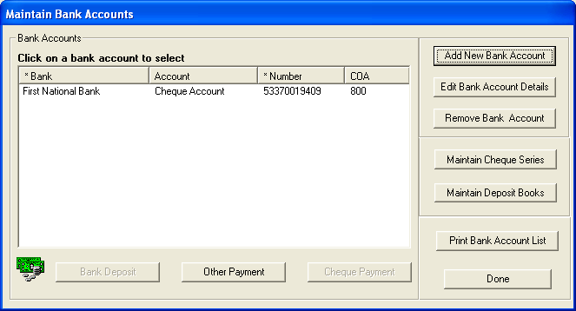
Figure 36: Maintain Accounts

Direct Payment from Bank
- Click on Direct Payments From Bank button in the Select a Transaction screen
- Click on the Bank account to select
- Click on Other Payment button in the Maintain Bank Account screen to record payment cheques
- The Other Payment screen opens (fig. 37)

Other Payment
Figure 37: Payment

Payment
- Enter and select relevant data for Transaction Details
- Select and insert relevant data for Processing Details including Payment made to Debtor where necessary
- After entering and selecting click on Accept Processing Details button
- The payment details will now appear on the grid
- Click on Save to save your data
- Click on Remove Line Item to delete an item
- Click on Done to exit or Next Payment /Clear to continue.

Petty Cash Payment
Petty Cash vouchers do not generally have voucher numbers. You will need to number the vouchers beforehand in order to keep the records.

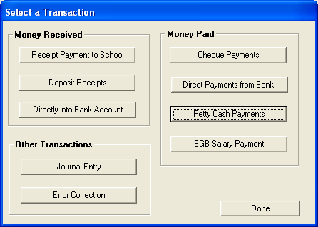
Figure 38: Select a Transaction

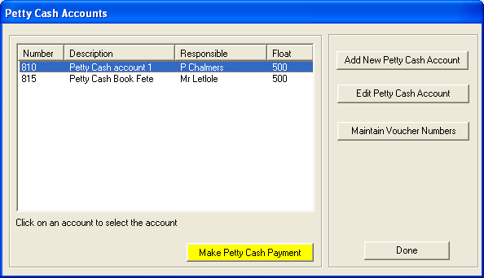
Figure 39: Petty Cash Payments

- Click on the applicable Petty Cash Account
- Click on yellow button Make a Petty Cash Payment button
- Screen will open.

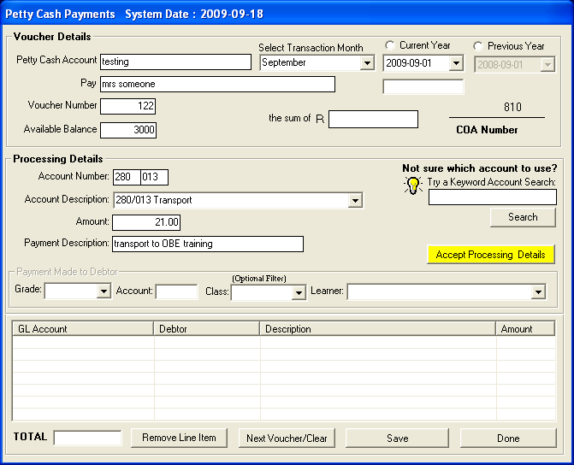
Figure 40: Petty Cash Payments System Date

- Click on The Petty Cash Payments button .
- Select the correct petty cash account in the Petty Cash Accounts grid. The selected petty cash account will be highlighted in blue.
- Click on Make Payment button.
- The Petty Cash Payment screen opens (Fig. 40).
- Select the correct financial period by using the Select Transaction Month option.
- Select Current Year or Previous Year option.
- Select the correct petty cash payment Date for the current or previous year.
- Insert details of to who the petty cash was paid to in the Pay / Betaal option.
- Insert the petty cash payment amount in The Sum Of R option.
- The available balance in the petty cash float is shown in the Available Balance option.
- The Amount, Account Selected and Description must be input.
- The Keyword option may be utilised.
- Click on the Accept Processing Details button.
- The petty cash allocation is now reflected in the bottom grid.
- Petty cash payments may be allocated to as many accounts as is necessary.
- The Total in bottom left corner must equal the petty cash payment amount before you may save.
- An entry may be removed by clicking on it and then clicking on the Remove Line button.
- Click on the yellow SAVE button.
- Click on DONE button to exit or click on Next Voucher / Clear button to continue processing.

FEATURES

Keywords – the programme contains a database of commonly used terms, which are linked to general ledger accounts. An example would be, you buy stationery and put in the word “pencil” in the Type in Keyword option. The stationery general ledger account will automatically be selected.
Department – This option is currently unavailable.

SGB Salary Payment
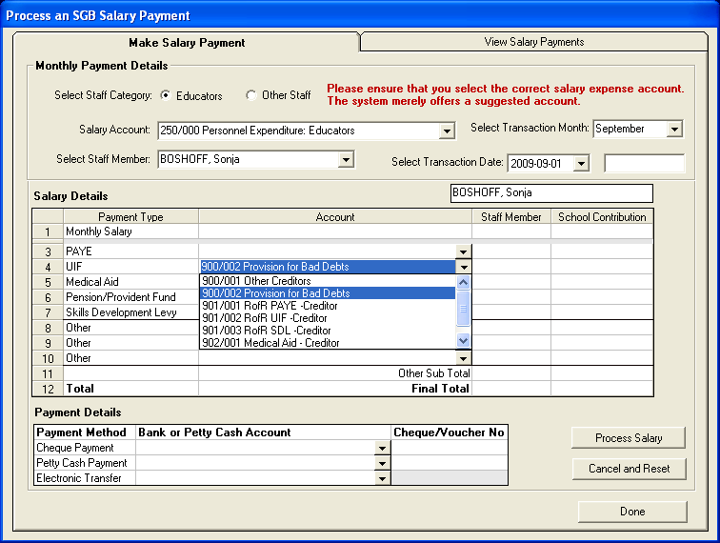
Figure 41: SGB Salary Payment

Make Salary Payment (Page 1)
- Click on SGB Salary Payment button to open this screen
- Select Staff Category, Salary Account, Transaction Month, Staff Member and Transaction Date
- Enter and select Salary Details and Payment Details
- Click on Process Salary button to process salary details
- Click on Cancel And Reset to start the process of processing a salary
- Click on Done button to exit.

View Salary Payments (Page 2)

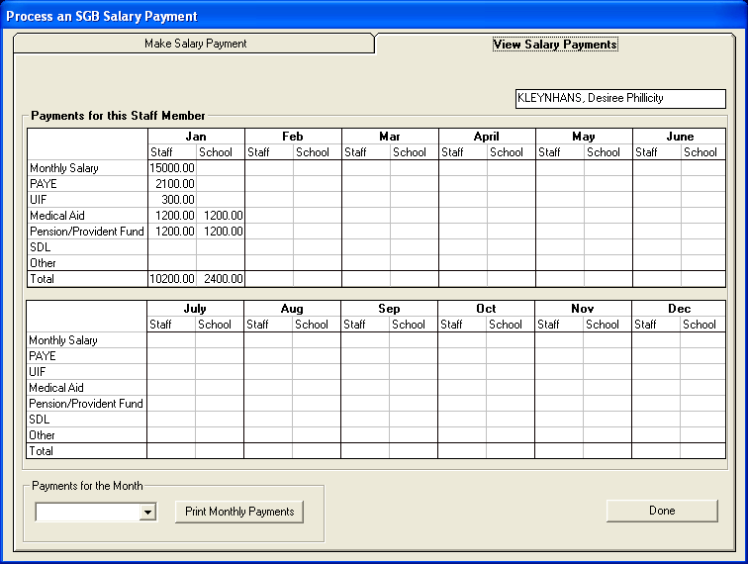
Figure 42: Process an SGB Salary Payment

- Click on the second tab of SGB Salary Payments to view or print salary payments
- To print salary payment select a month and then click on Print Monthly Payments button
- Click on Done to exit.

Journal Entry

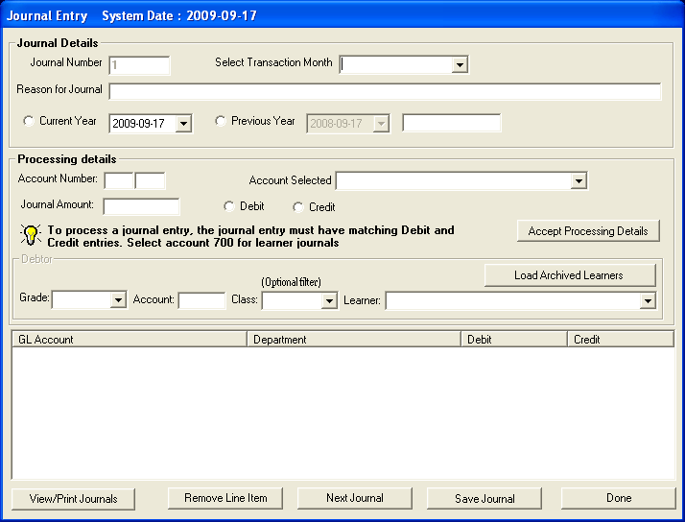
Figure 43: Journal Entry

- Click on Journal Entry button.
- The Journal Entry screen opens (Fig. 43).
- Journal Numbers are automatically generated and start at number one.
- Select the correct financial period using the Select Transaction Month option.
- Enter the reason for processing a journal in the Reason for Journal option.
- Select Current Year or Prior Year option and input the Date for the journal to be processed.
- Select the general ledger account for the first leg of the entry using the Account Selected option.
- Input the amount for this leg of the journal entry using the Journal Amount option.
- Select whether a Debit or Credit entry.
- If account 700 Debtors Accounts Learner was chosen, the Grade, Class and Select Learner options may be used.
- Click on the Accept Processing Details button.
- The first leg of the journal will now be shown, repeat procedure starting from Account Selected, etc.
- Once completed and in balance, click on Save Journal button.
- Click on the View/Print Journals button to view or print all processed journals
- Click on Next Journal button to continue processing the next journal.
- Line items may be removed by clicking on the line item, and by clicking on The Remove Line Item button.
- Click on the Done button to exit.

View / Print Journals
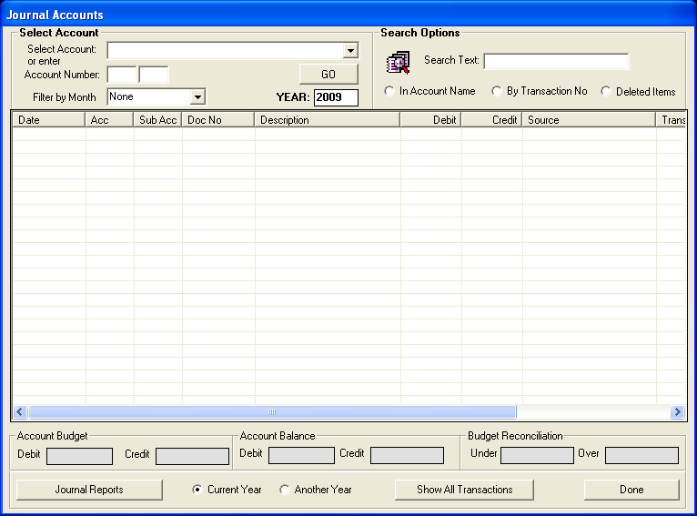
Figure 44: Journal Accounts

- Click on View/Print Journal button.
- The Journal Accounts screen opens (Fig. 44).
- Journals can be viewed per general ledger account, per journal number or all journals can be viewed.
- To view journals in a selected account – use the Select Account option.
- A Search facility is provided in which you can search for a journal / account by name, by account number or by transaction number. Input the data in the Search option and then click on the GO button.
- To view all journals, click on the Show All Transactions button.
- The selected journal data gets displayed in the detailed grid.
- Journal data may be printed by clicking on the Journal Reports button.
- Journals may be viewed for the current or previous years by selecting the Current or Another Year option.
- Journals can be filtered by month using the Filter by Month option.
- Click on the Done button to exit.

Error Correction
The following areas can be expected in the Error Correction menu:

- Delete Transactions
  - (Allows deletion of transactions)
- Re-process Deleted Items
  - (Allows processing of deleted items – cheque payments, receipts, petty cash payments, deposits)
- View Audit File
  - (Printouts of Audit Trail)
- Delete a Transaction

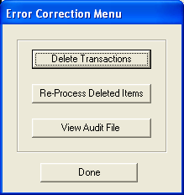
Figure 45: Error Correction Menu
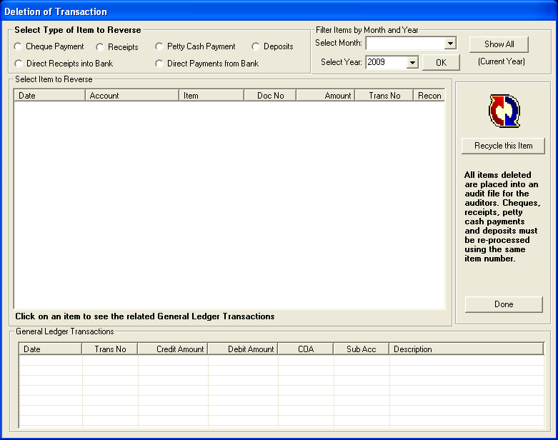
Figure 46: Deletion of Transaction

Deletion of Transaction
This action is taken when you want to re-use the already processed item when a mistake in processing has been made.

- Click on Delete A Transaction button to open this screen
- Select type of item to reverse.
- You can filter by month or show all
- Select an item and click on Recycle This Item
- A User Warning will appear (fig 47)
- You can also view an item’s General Ledger Transactions by selecting one
- Click on Done button to exit.

User Warning
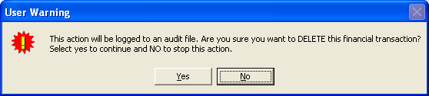
Figure 47: Warning

Re-Process Deleted Items
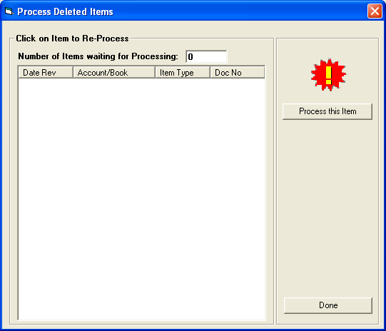
Figure 48: Process Deleted Items

Step 2 - Process Deleted Items

You are now able to re-process the incorrectly processed items.

- Click on Re-Process Delete Items button to open this screen
- Click on an item to process it correctly and then
- Click on Process This Item button.
- Click on DONE button to exit.

View Audit File

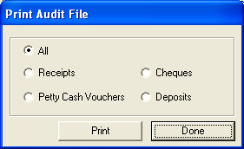
Figure 49: Print Audit File

Print Audit File
This forms the Audit Trail feature within finances

- Click on View Audit File button to open this screen
- Select any of the options and then click on Print
- Click on Done button to exit.

Print a receipt
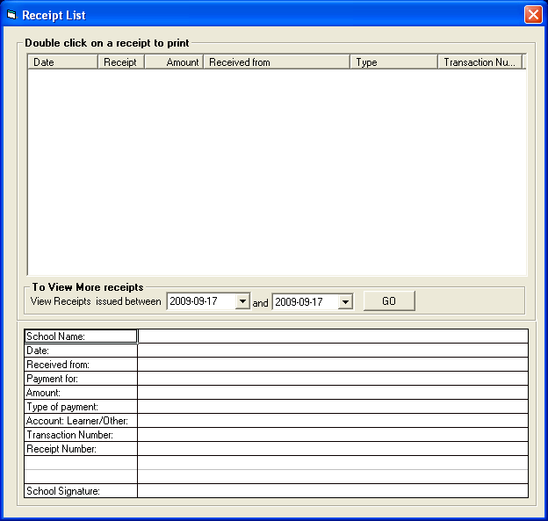
Figure 50: Print receipt

- Click on Print Receipt button to open the above screen.
- Double click on a receipt to print it.

Debtors and School Fees
The following areas are covered in Debtors and School Fees screen:

- Maintain School Fees (Step 1)
  - (Allows enter school fees amounts per grade)
- Debtor Take On Balance (Step 2)
  - (Allows entering of debtor balance for first time entering of previous years balance)
- Learner Billing (Step 3)
  - (Allows process of billing learners)
- School Fees Exemptions (Step 4)
  - (Allows entering of exemptions)
- Debtor Age Analysis
  - (Allows view of debtors monthly)
- School Fees Collections
  - (School Fees printouts)
- Learner and Account Numbers
  - (Allows for selection of learners and their account numbers)
- View/Print Learner Statement
  - (Allows viewing and printing of learner and grade statements)
- View/Print Account Payers
  - (Allows viewing of account payers and printouts of account payers)
- Learners with No Account Payer
- Archived Learners with Balances

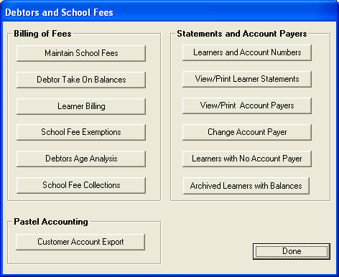
Figure 51: Debtors and School Fees

Maintain School Fees

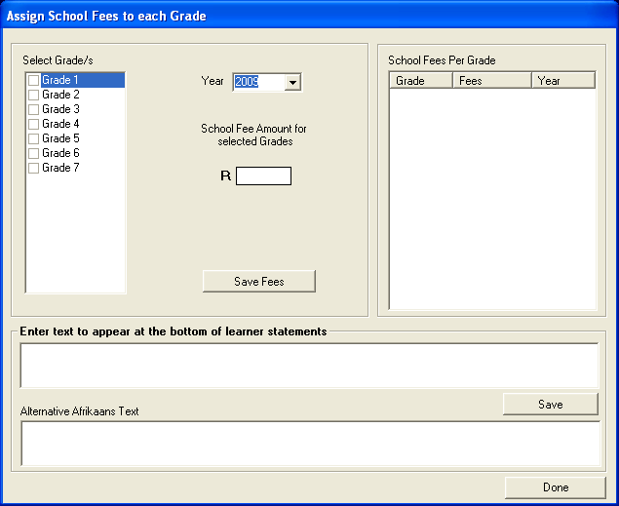
Figure 52: Assign School Fees to each Grade

Assign School Fees to each grade
- Click on Maintain School Fees button.
- The Assign School Fees To Each Grade screen opens (Fig. 52).
- Select a grade or multiple grades by clicking in the tick box (small square block) to the left of the relevant grade/s.
- Select the correct year from the Year drop down box (e.g. 2009)
- Insert the school fee amount in the School Fee Amount For Selected Grades input box. E.g. R85.
- Click the yellow Save button.
- A warning is given (Fig. 53) to the affect that if you are amending the fees, it will not affect learners who have already had school fees billed to their accounts (refer to Section – Learner Billing.)
- Click Yes button to continue.
- The fees will now be shown per grade on the right hand side of the screen (School Fees per Grade).
- Repeat above steps until all grades have school fees allocated to them.
- Click on Done button to exit.

FEATURE:
There is a Text Box if you would like to add any commentary to all the Learners statements / Afrikaans Text alternative available

Warning

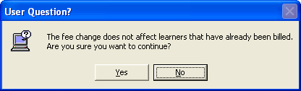
Figure 53: Warning!

This means that if you have already entered learners and fees for the current year, these fees will not be affected. It will only affect new learners that are entered from NOW on for the current year for example reduced rates for half year.

Debtor Take On Balance
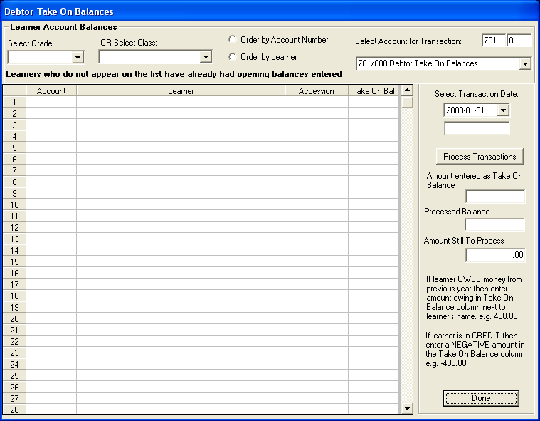
Figure 54: Debtor Take on Balance

The way debtor opening balances work is:
When a school starts up the system The First Time you will enter the total amount on your debtor accounts into account 701 on the opening balances page (Fig 54) Take on Balances.
Then you come to this section Debtor and School Fees (Debtor take on Balance) section and allocate this amount bit by bit into the Individual Debtor Accounts until it has all be assigned and equals the Debtors 701 opening balance.
Only done ONCE ever when system is started up

- Select a grade
- Select one of the two options to order by
- Select account for transaction
- Select transaction date
- Click on Process Transaction button
- Click on Done button to exit

Learner Billing

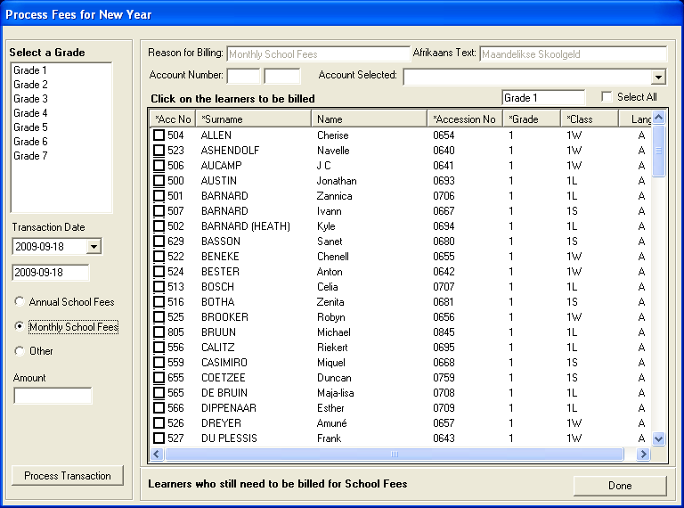
Figure 55: Process Fess for New Year

Process Fees for New Year
- Select grade
- Select transaction date
- Select one of the three options
- If you select Annual School Fees the fees will automatically appear in the Amount input box
- If you select Monthly School fees or Other you’ll have to manually enter the fee in the Amount input box
  - You can leave the Reason For Billing reason or you can put in your own information
  - Select account
- Click in the checkbox with a caption Select All or select an individual learner
- Click on Process Transaction button
- And click on Done to exit.

Carry out this process for EVERY grade in the school

School Fees Exemptions
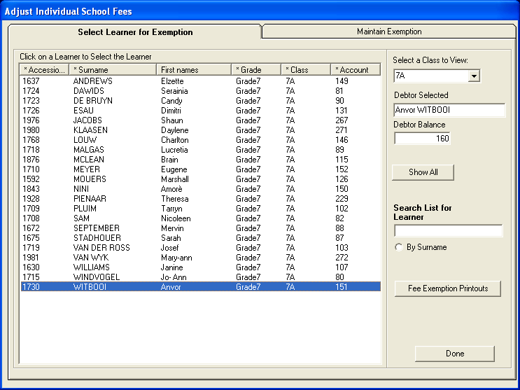
Figure 56: Adjust Individual School Fees

Page 1 – Adjust Individual School Fees
- Select a class to view or click on Show All to view all classes
- Click on a learner to view debtor balance
- You can also search on this screen
- Click on Fees Exemption Printouts to print exemption fees
- And click on Done to exit
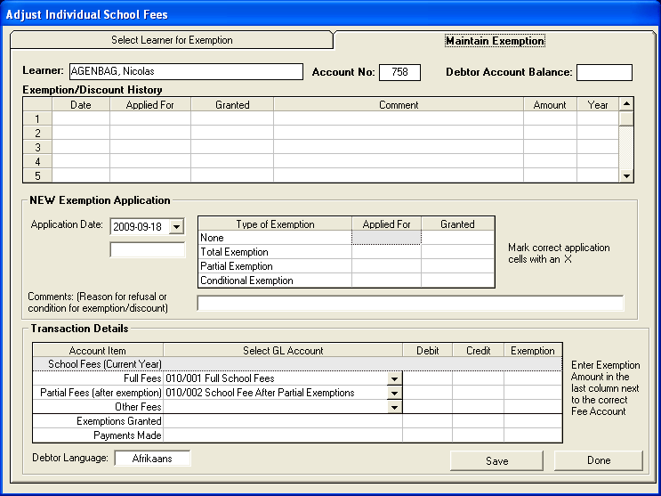
Figure 57: Adjust Individual School Fees1

Page 2 Maintain Exemption
- Click on the selected learner in the Select Learner for Exemption screen
- Click on the page Maintain Exemption to maintain exemption
- Select application date
- Mark the type of exemption applied for and if it was granted mark with an X
- Enter the Exemption amount in the Full Fees Line And Last Column and click on Save
- And click on Done to exit.

Figure 58: Adjust Individual School Fees3

Debtor Age Analysis

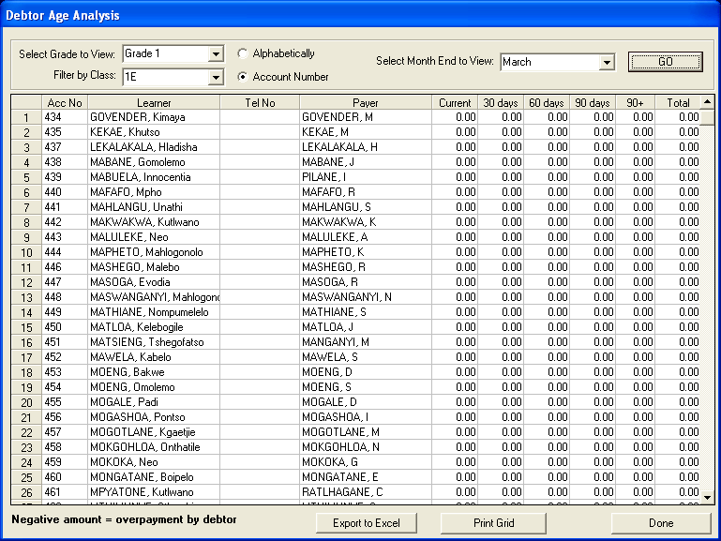
Figure 59: Debtor Age Analysis

- Click on Debtor Age Analysis
- The Debtor Age Analysis screen opens (fig. 59)
- Select grade
- Filter by selecting a class
- Select one of the two options
- Select a month and click on the yellow GO button
- Click on Print Grid to print
- Or Click on Export To Excel to open Excel with your data in it
- And click on Done to exit.

School Fees Collection
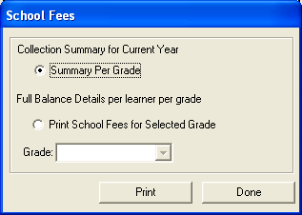
Figure 60: School Fees

Options under School Fees:
- Summary Per Grade
- Full Balance Details per learner per Grade
- School fees printouts for Selected Grade
- Print
- Done

Debtor / Learner Account Numbers
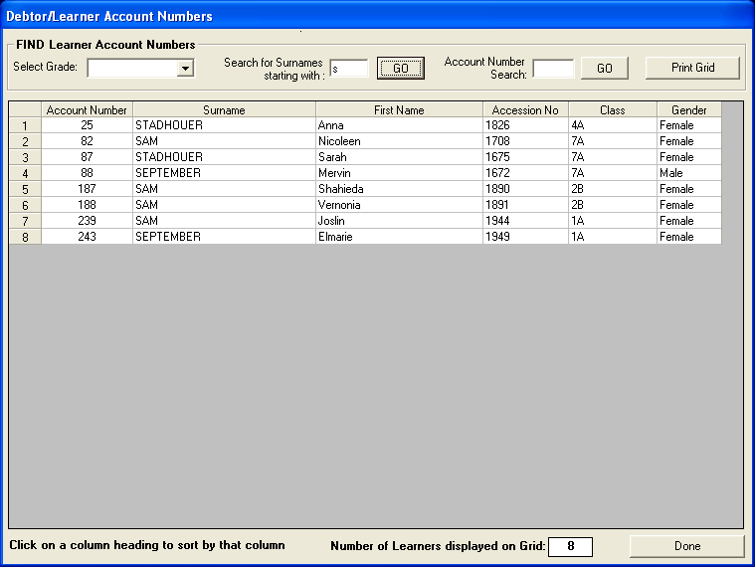
Figure 61: Debtor/Learner Account Numbers

- Either select by Grade or by Surnames
- Click GO

View / Print Learner Statement

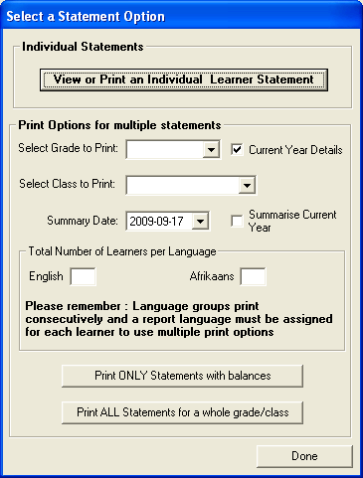
Figure 62: Select a Statement Option

- There are various options to choose from

Options:
  - View of Print an Individual Learner Statement
  - Select Grade to Print
  - Summarize Current Year
  - Total Number of Learners per Language
  - Print ONLY statements with balances
  - Print all statements for a whole grade

Statements
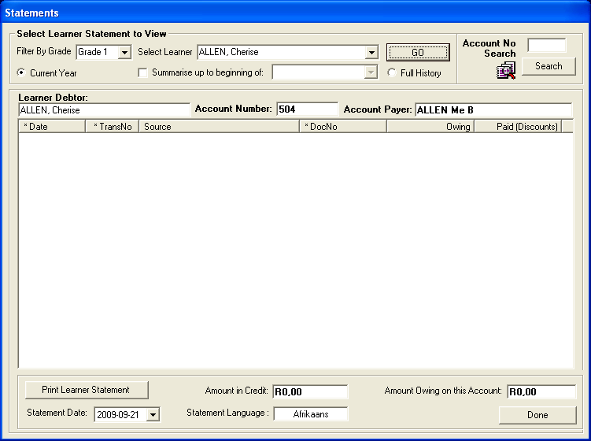
Figure 63: Statements

- Click on View / Print Learner Statement to open fig. 62
- Click on the View or print individual learner statement button
- Select grade and learner and click on the GO button to view learner
- Click on Print Learner Statement to print a statement for individual learners
- Click on Print Statement For A Whole Grade to print statements for a grade
- Click on DONE to exit.

View Account Payer

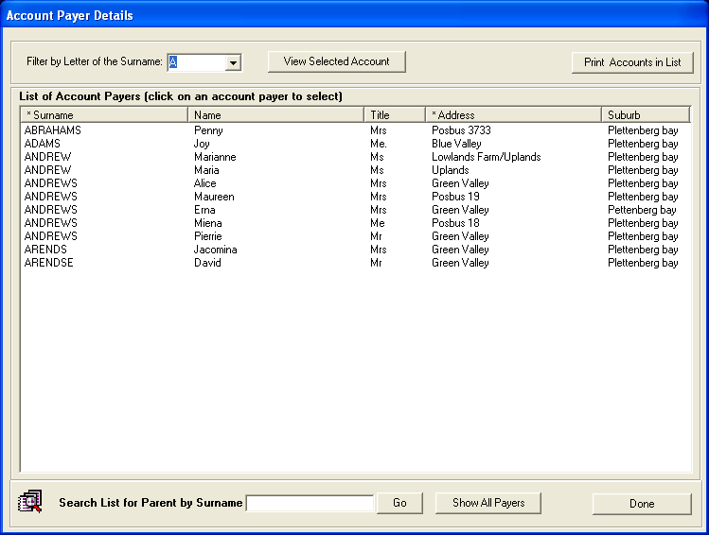
Figure 64: Account Pager Details

Account Payer Details (Page 1)
- Click on View Account payer to open
- Select a letter to filter or click on Show All Payers at the bottom of the page
- You can search parent/account payer by surname in the search panel
- You can also print by clicking on Print Accounts In List
- Select an account payer and then
- Click on the View Selected Account to look at the payer’s account balance
- The Account Details screen will open (fig. 64)
- Click Done to exit.

View Selected Account
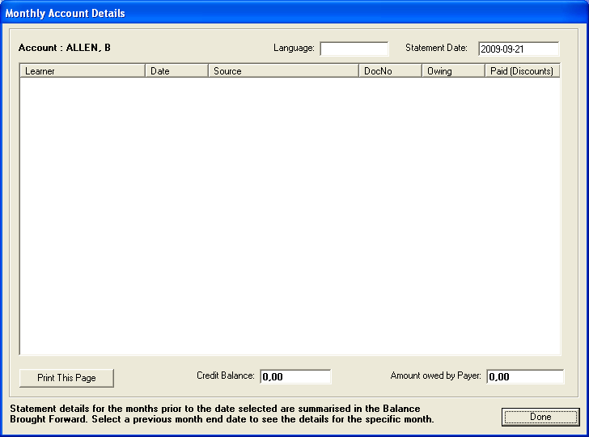
Figure 65: Monthly Account Details

Monthly Account Details
- Select a statement date and then
- Click on the View Selected Account in the Account Payer Details screen
- The Account payer screen will open (fig. 66)
- Click on Print This Page to print accounts
- Click Done to exit

Change Account Payers
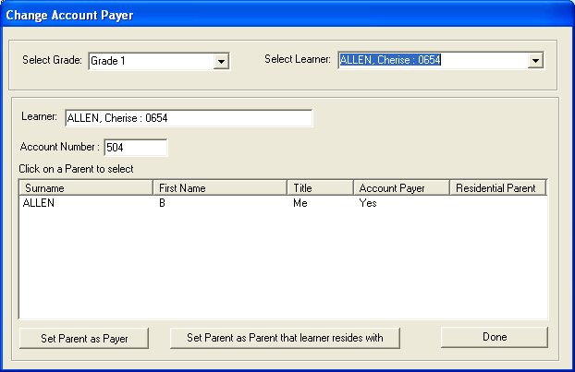
Figure 66: Change Account Prayer

- If the changed Account Payer is not at the same address, Go back to Learner and Parent Information Module,
- Click on the selected Learner
- Select – Add New Parent at bottom right hand side of screen
- Add new parents details and save
- Go back to Financial Module
- Click on the Change Account Payer in the Debtor and School Fees screen
- The Change Account Payer screen will open (fig. 66)
- Select grade, learner and then highlight parent by click on one and then click on Set Parent as Payer button
- Select grade, learner and then highlight parent by click on one and then click on Set Parent as parent that learner resides with button if the parent resides in the same address as a learner.
- Click DONE to exit.

Learners with no Account Payers
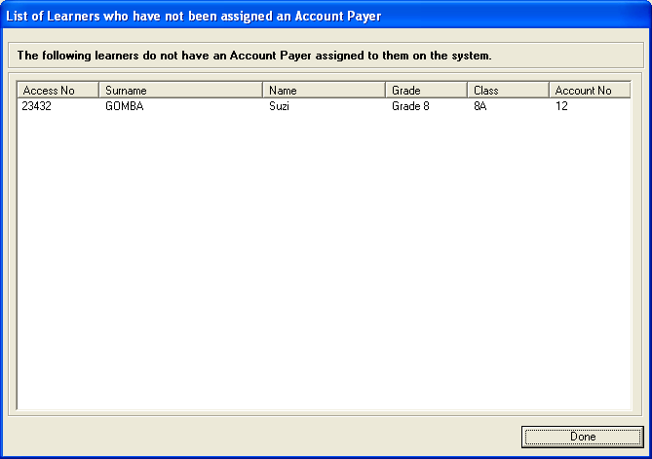
Figure 67: List of Learners

List of Learners who have not been assigned an account payer
All learners MUST be assigned an Account Payer. Even if the head of the house is an older sibling or other relative, it is then possible to grant full or partial exemption if it is merited. The system should not allow learners to be saved without an Account Payer, but if the system fails during input, it is possible to identify which learners have not been fully captured.
- View learners that do not have account payers
- Click on DONE to exit

Archived Learners with Balance
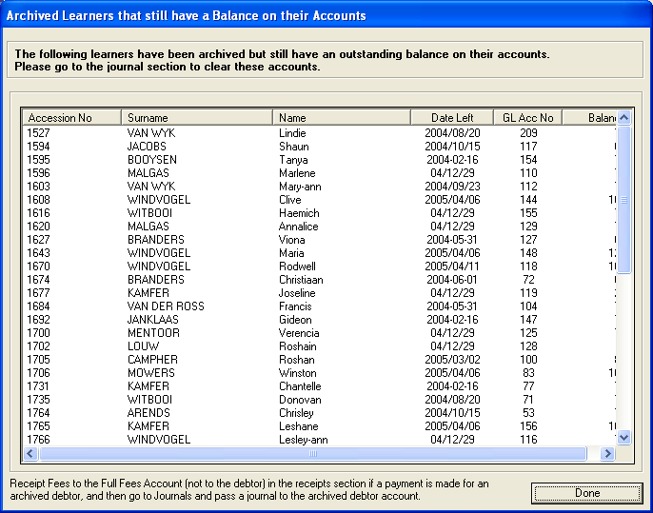
Figure 68: Archived Learners

Archived Learners that still have a balance on they accounts
- View archived learners that that still have balance on their accounts
- Click on Done to exit

When fees are received for learners who have already been archived, then Receipt Fees to the Full Fees account (not to the debtor) in the receipts section, and then go to Journals and pass a journal entry to the archived debtor account.

Bank Reconciliation

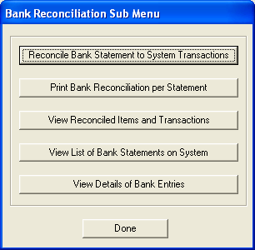
Figure 69: Bank Reconciliation sub menu

There Are Various Options:
- Reconcile Bank Statement to System Transactions
- Print Bank Reconciliation per Statement
- View Reconciled Items and Transactions
- View List of Bank Statements on System
- View details of bank Entries

Reconcile Bank Statement to System Transactions

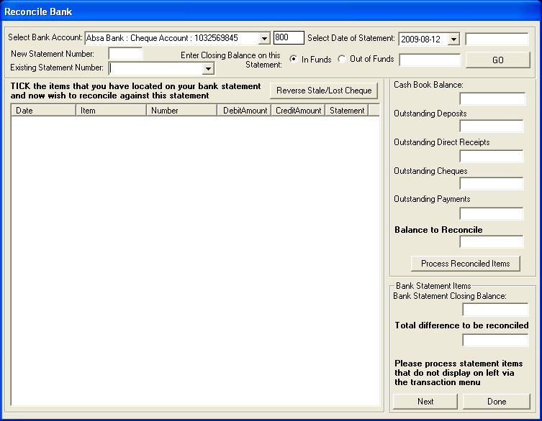
Figure 70: Reconcile Bank

- Select bank account and the last day of the month
- Enter statement number and closing balance on the statement (on the last day of the month only)
- Click on Go
- If there is a lost Cheque in the list of items, select one and click on Reverse Stale/Lost Cheque
- Select an item ONLY to reconcile it against the same item in the statement
- Do this for EVERY ITEM that appears on both your system and on the BANK STATEMENT
- And then click on Process Reconciled Items
- Click on DONE to exit

When it has been correctly done, the Balance on Statement (as at last day of month) not yet reconciled to system should state NIL

PLEASE NOTE:
Please process statement items that do not display on left screen via the Transaction Menu – direct deposits; direct payments etc.

View Reconciled Items and Transactions
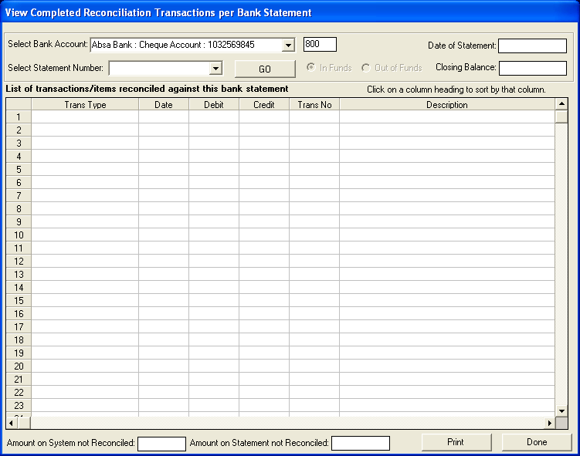
Figure 71: View completed Reconciliation

- Select the Bank Account
- Select the Statement Number
- Click on Go
- This will bring up all the items reconciled against the selected Statement Number

View List of Bank Statements on System

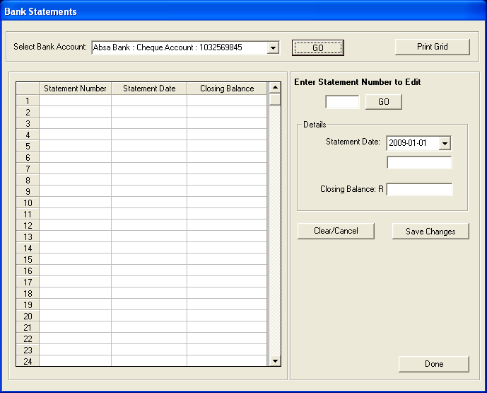
Figure 72: Bank Statements

Print Outstanding Cheques

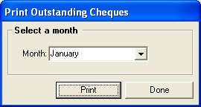
Figure 73: Print outstanding cheques

- Select the month to View / Print
- Print

Print Cash on Hand

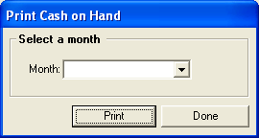
Figure 74: Print cash on hand

- Select the month to View / Print

Print Statement of Investments
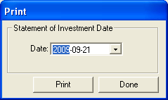
Figure 75: Print

View Cash Book

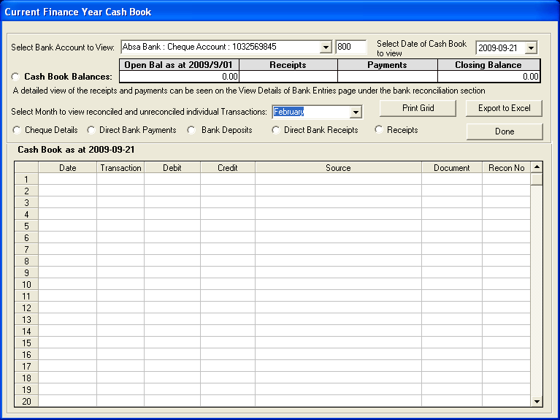 Figure 76: Current Finance Year Cash Book

- Click on the View Cashbook button
- The Cash Book screen opens (Fig. 76).
- Select the correct bank account using the Select Bank Account option.
- The cashbook can now be viewed as at the current system date.

Two options:

- Cash Book Balances – will give opening Balance, Receipts Balance, Payments Balance, Closing Balance or
- To View cash book for a specific month- click on the month required
- Choose from options:
  - Cheque Details
  - Direct Bank Payments
  - Bank Deposits
  - Direct Bank Receipts
  - Receipts.

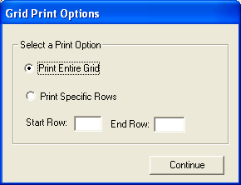
Figure 77: Grid Print Options

  - Printing Options
  - Or Export To Excel

View Financial Statement

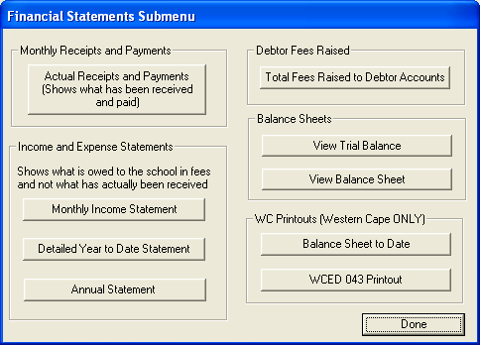
Figure 78: Financial Statement Submenu

Actual Receipts and Payments

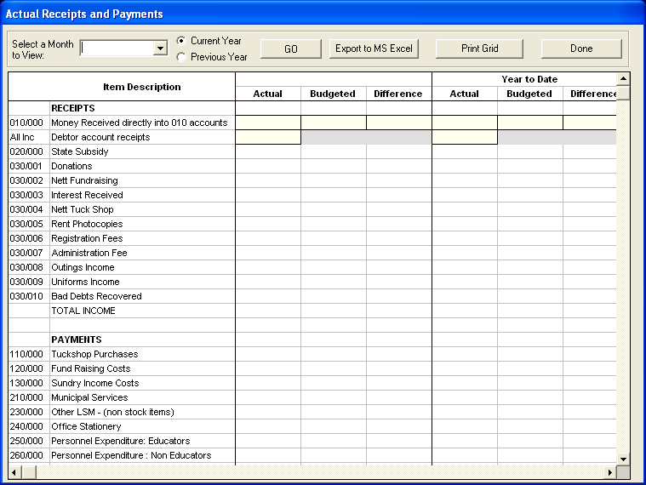
Figure 79: Actual Receipts and Payments

Monthly Income Statement

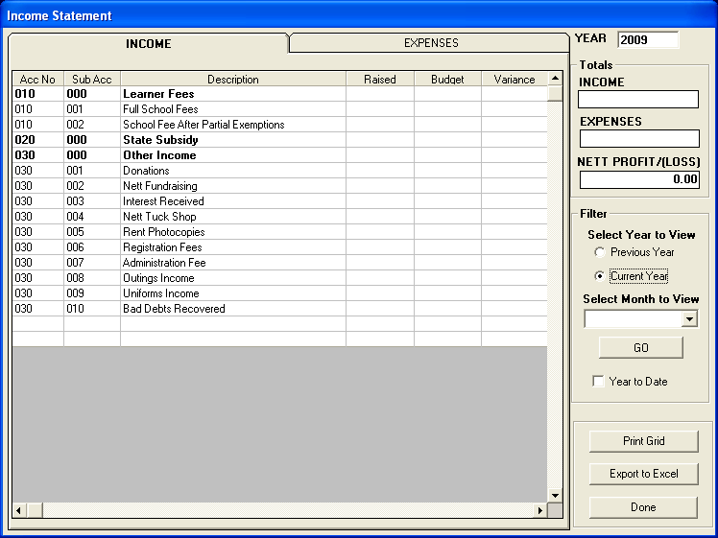
Figure 80: Income Statement

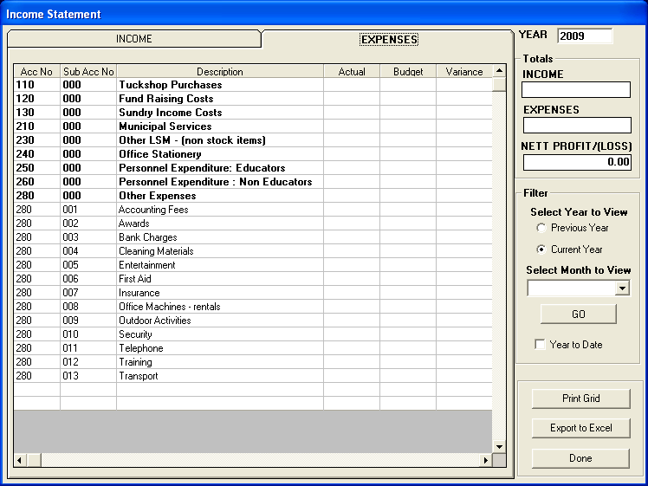
Figure 81: Income Statement2

Detailed Year to Date Statement

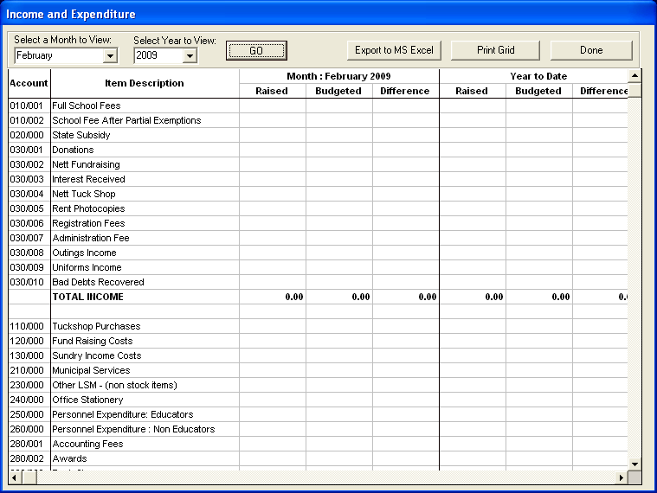
Figure 82: Income and Expenditure

Summarised Year to Date Statement

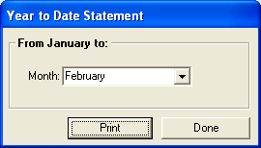
Figure 83: Year to Date Statement

- Choose month to show Actual to Budget with Variance
- Full Schedule per month

Total Fees Raised to Debtors Accounts

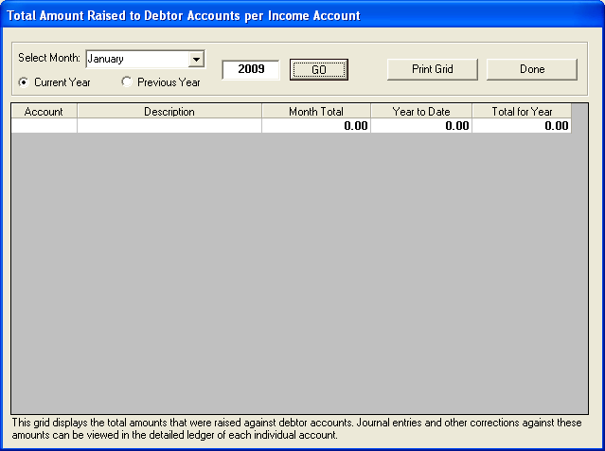
Figure 84: Total Amount Raised

View Trial Balance
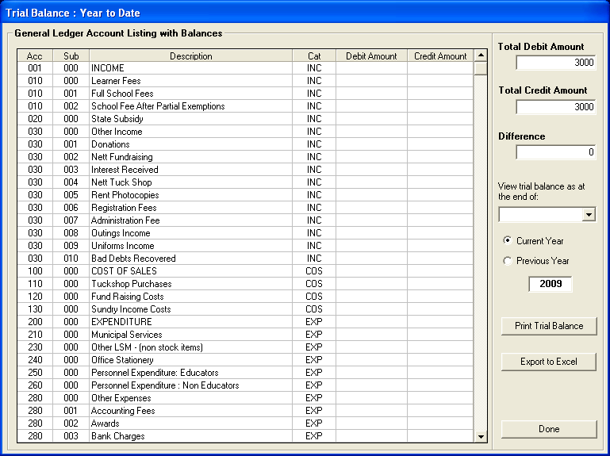
Figure 85: Trial Balance

Balance Sheet to Date

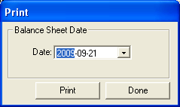
Figure 86: Print Trial Balance

Printout WCED043 (Western Cape Education Department)

This is applicable only to the Western Cape schools unless you would find this useful for your particular school
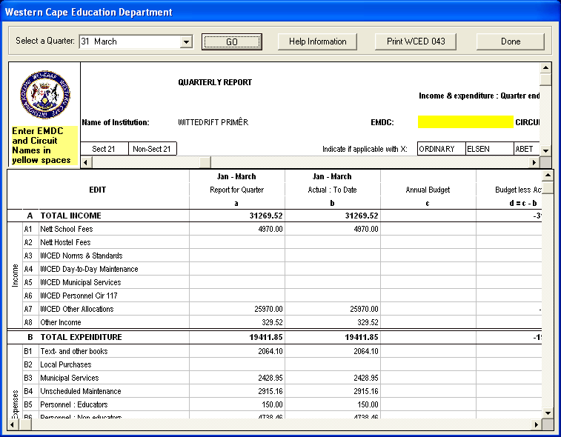
Figure 87: Western Cape Education Department

Export to Xml File (SA DMS System)
This is for exclusive use of exporting to SA DMS system if this is in place in your district or province.

Functions:
- Export Expenditure
- Export Budget

View Receipts
- Click on View Receipts button
- The View receipts screen opens
- Receipts can be viewed per receipt book by clicking on Receipt Book option.
- Select a receipt book to view using the Receipt Book to View option.
- Click on the OK button.
- Receipts can be viewed per receipt book and receipt number by clicking on Receipt Book and Number option.
- Select a receipt book to view using the Receipt Book to View option as well as inserting a slip number in the Slip Number to View option.
- Click on the OK button.
- Receipts can be viewed per month by clicking on Month option.
- Select a month using the Select Month to View option.
- You may also select only Deposited receipts or Not Deposited receipts or leave blank for all.
- Click on the OK button.
- The selected receipts data is viewed in the detailed grid.
- Receipts may be viewed for the current or previous years by selecting the Current or Previous Year option.
- To print receipts (numerous reports) click on the Receipt Reports button.
- Click on the DONE button to exit.

View Cheque Payment
- Click on View Cheque Payments button
- The Cheque Payments screen opens
- Cheques can be viewed per bank account by clicking on the Bank Account option.
- Select a bank account to view using the Bank Account to View option.
- Click on the OK button.
- Cheques can be viewed per bank account and month by clicking on the Bank Account and Month option.
- Select a bank account to view using the Bank Account to View option as well as the month by using the Select Month to View option.
- Click on the OK button.
- Cheques can be viewed per month by clicking on the Month option.
- Select a month to view using the Select Month to View option.
- Click on the OK button.
- The selected cheques data is viewed in the detailed grid.
- Cheques may be viewed for the current or previous years by selecting the Current or Previous Year option.
- A Total Cheque Payments balance is shown at the bottom of the page.
- To print cheques (numerous reports) click on the Print Reports button.
- Click on the DONE button to exit.

View Petty Cash Payment
- Click on View Petty Cash Payments button
- The View Petty Cash Payments screen opens
- Petty cash can be viewed per petty cash account by clicking on the Petty Cash Account option.
- Select a petty cash account to view using the Petty Cash Account to View option.
- Click on the OK button.
- Petty cash can be viewed per petty cash account and month by clicking on the Petty Cash Account and Month option.
- Select a petty cash account to view using the Petty Cash Account to View option as well as the month by using the Select Month to View option.
- Click on the OK button.
- Petty cash can be viewed per month by clicking on the Month option.
- Select a month to view using the Select Month to View option.
- Click on the OK button.
- The selected petty cash data is viewed in the detailed grid.
- Petty cash may be viewed for the current or previous years by selecting the Current or Previous Year option.
- A Total Petty Cash Payments balance is shown at the bottom of the page.
- To print petty cash (numerous reports) click on the Print Petty Cash Reports button.
- Click on the DONE button to exit.

View Bank + Petty Cash Deposits
- Click on View Bank Deposits button.
- The View Bank Deposits Payments screen opens
- Bank deposits can be viewed per month by clicking on the Month option.
- Select a month to view using the Select Month to View option.
- Click on the OK button.
- Bank deposits can be viewed per deposit book by clicking on the Deposit Book option.
- Select a deposit book to view using the Deposit Book to View option.
- Click on the OK button.
- Bank deposits can be viewed per deposit book and deposit slip number by clicking on the Deposit Book and Slip Number option.
- Select a deposit book to view using the Deposit Book to View option as well as the Slip Number to View option.
- Click on the OK button.
- Bank deposits can be viewed by bank account and month by clicking on the Bank Account and Month option.
- Select a bank account and month to view using the Bank Account to View option as well as the Select Month to View option.
- Click on the OK button.
- Bank deposits can be viewed by bank account by clicking on the Bank Account option.
- Select a bank account to view using the Bank Account to View option.
- Click on the OK button.
- The selected bank deposits data is viewed in the detailed grid.
- Bank deposits may be viewed for the current or previous years by selecting the Current or Previous Year option.
- A Total Deposits balance is shown at the bottom of the page.
- To print bank deposits (numerous reports) click on the Deposits Report button.
- Click on the DONE button to exit.

View GL Transactions

- Click on View GL Transactions button.
- The General Ledger Account Details screen opens
- General ledger accounts details can be viewed per general ledger account, per transaction number or all entries in the general ledger can be viewed.
- To view general ledgers entries for a selected account – use the Select Account to View option.
- A Search facility is provided in which you can search for a general ledger account by name, by account number or by transaction number. Input the data in the Search option and then click on the GO button.
- To view all general ledgers, click on the Show All Transactions button.
- The selected general ledger data gets displayed in the detailed grid.
- General ledger data may be printed by clicking on the General Ledger Reports button.
- General ledgers may be viewed for the current or previous years by selecting the Current or another Year option.
- General ledgers can be filtered by month using the Filter by Month option.
- Click on the DONE button to exit.

Examples of how to find Transactions
You can apply the following to a whole range of enquiries by finding the transaction number process to reconcile cash book receipts to individual general ledger accounts: debtors

View Receipts
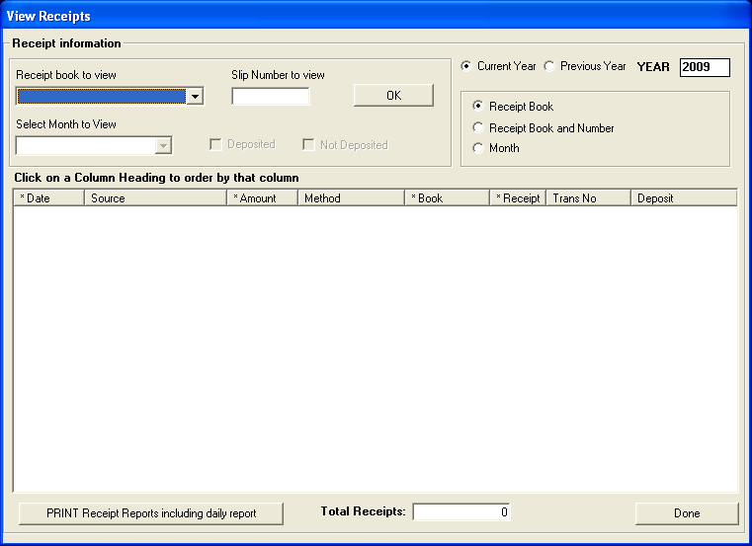
Figure 88: View Receipts

Now Go To General Ledger Page
GO TO LEARNER STATEMENTS AND SEARCH FOR 204
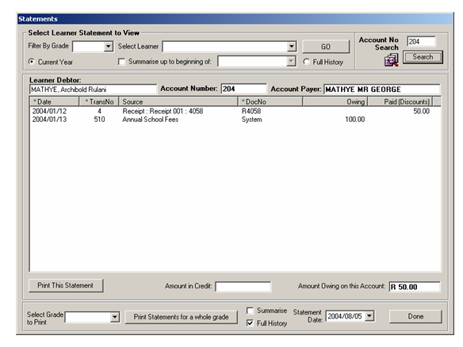

Figure 89: General Ledger Account Details Accounts Statements

This process takes approximately 15 seconds.

Other Examples
Parent comes to school advising that they have paid in January; they don’t have their account number (statement), nor their receipt.
If a parent came in without an account number then the clerk should do the following to get the account number:
- a) Go to the option called Learners and Account Numbers on the Debtors Sub Menu
- b) Do a search for the learner (by surname is the easiest) - you can search by grade, by letter of surname, by start of surname, by the full surname (whatever you type in the text field) and a reverse search to find learner if you only have account number. You can also click on column headings to sort the rows if you get more than one row by surname, account number, class etc. The possibilities are numerous.
- c) Get the account number.
OR
- a) Go straight to learner statements
- b) Select grade (I am sure parent knows which grade their child is in)
- c) Select surname from grade list and view statement

There is NO need for a complicated scenario just to get an account number. We have specially added a Whole Learner Account Number Form and search options for easy location of account numbers and or the reverse - find learners if you only have account number.

Example 1
Parent comes to school late in the year and advises that they have paid, but does not know what month / s they paid in.
- Find account number as above (go to Learners and Account numbers or straight to statements)
- There are also Parent Statements as amount might have gone to wrong learner in Same Family. (Easy search by surname on parent statements) That would be the obvious place to start. The Parent statement shows all learners in the family and you can quickly see if the wrong learner received the money
- If learner/parent shows that this family never received the credit then, you would Go To View Receipts and see if you could locate the receipt. (Order columns by amount or date etc as they would have some idea of when they paid even if they couldn't tell you the exact month)
- You Are Obviously Going To Have Problems On ANY Computer System if the parent has NO information to give you. Once you locate the receipt, you can get the transaction number and check which debtor was credited with the amount. You would then have to pass a journal to fix it if the wrong account was credited.

Example 2
Parent comes to school with a receipt they have received but it does not show on their account.

- Go to View receipts (NOT General Ledger) and type in exact receipt number and get the exact entry. (No searching through hundreds of entries necessary)
- Locate transaction number, now go to GL and type in transaction number on transaction number search and get the exact transaction details of who or which account was credited. (No searching through hundreds of entries)

OTHER EXAMPLES – GENERAL LEDGER

Error in carrying out Bank Reconciliation:

- An example when an amount from the Department is received, receipted and banked in November 2004r. The transaction number is 4353 on the computer system. It has not been reconciled at all in the given month. When the bank reconciliation is finally reconciled in March the following year, the date has been input as in March (it should have been input as of December with correct Statement number). The auditors pick up that the money has been received but it does not reflect anywhere in the bank.

Solution:

- When a transaction is processed to the bank account, it goes to the bank suspense account 800/999. When the transaction is reconciled to the bank, then it is moved to the bank account 800/000. Therefore once the bank account is fully reconciled every month, the balance on account 800/999 should be 0. If it is not 0, then there are items that are still outstanding. It is best to print out both 800/000 and 800/999 to trace all bank transactions.

The transaction you are looking for was only reconciled to the bank on 30/03/2009 - transaction number 4353.

- The easiest way to trace transactions is to enter the transaction number into the search text box on the GL page and select search by transaction number and then you will see the corresponding entry.

- Entries for the amount that you are tracing are:
- 30/11/2004 4335 800/999 3651-53 Dr
- 30/11/2004 4335 020/000 3651-53 Direct receipt (Cr)
- 30/03/2009 4353 800/999 3651-53 Cr
- 30/03/2009 4353 800/000 3651-53 Dr (Bank reconciliation)

One of the problems is that this entry was reconciled so late and the recon date was incorrectly input into the system. Even if only reconciled in March 2005, the amount should still have been reconciled against a statement date in 2004.

View Journal Entries

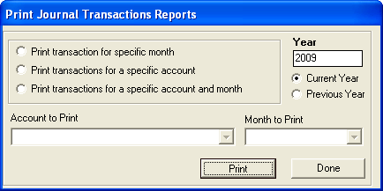
Figure 90: Print Journal Transactions Reports

- Click on View Journal Entries button and the below screen will open.

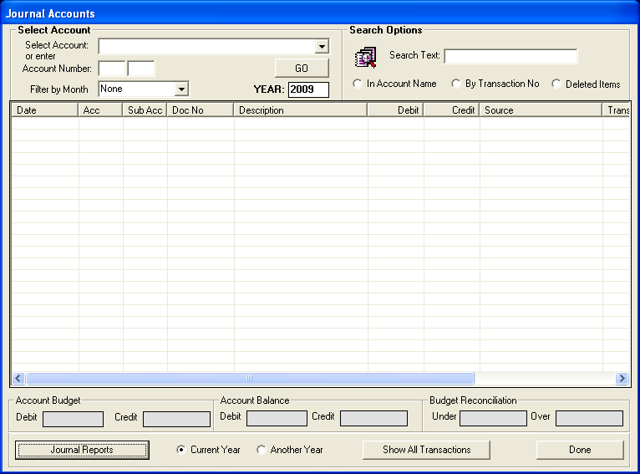
Figure 91: Print Journal Transactions Reports

- Click on Journal Report button;

Options:

- Print transaction for specific month
- Print transactions for specific account
- Print transactions for a specific account and month

Year-End Functions

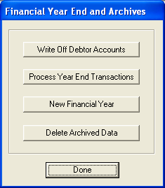
Figure 92: Financial Year End and Archives

It is vital that at the end of each year, or at the beginning of the New Year, you set about closing your existing financial period. The system will not allow you to continue and start a new financial period if you have not closed the existing financial period.

To assist you in this process, we’ve attached to the training notes the processes that you would have to follow to close a financial period.

Step 1: Check system date

- Ensure that your system date is correct and in line with the actual date (e.g January 2005)
- Correct short date format is yyyy/mm/dd e.g. 2004/01/14. Check this by going to the Control Panel and clicking on Regional and Language Options. The Regional Options page will open where you can check the date

Step 2: Backup before starting

- Ensure that you have a backup copy of your database before you start year end procedures. The system automatically creates a backup for you in the folder C:\Program Files\SASAMS\Backup if you select the COPY DATABASE option when you start the programme.
- Copy your backup to a safe place on your system

Step 3: Process entries for 2004

- Ensure that ALL entries for December 2004 have been processed (Reconciled) and any other outstanding entries for 2004 have been processed (2004 being the example year. You would select the relevant year)
- On the Finance Mein Menu, click on the button Year End Functions

Step 4: Click on button Write Off Debtor Accounts (Optional)

- This is an optional procedure. Debtor amounts can be written off if so required OTHERWISE you can leave them and they will roll over in the next year as owing to the school.
- Select the option Year End Functions from the Finance Menu. Select the option Write off Debtor Accounts.
- Select a grade and enter the amount to be written off next to each learner. Process the transaction.
- Only learners with outstanding debtor amounts will appear on the list.

Step 5: Click on Process Year End Transactions: Balance on Account 998/000

- The screen picture indicating the balance on this account will open
- The balance on Account 998/000 Opening Balances must be zero to process the year end
- You can also see the balance using the GL transactions page

ONLY IF THE BALANCE IS NOT ZERO FOLLOW THIS STEP

- Write Down the balance indicated on the screen. Press DONE
- Go to Chart of Accounts on the Finance Main Menu
- Look up the balances on Account 998/000 (Debits – Credits) and record the balance. If there are split amounts total these to see if the total is the same as the amount you wrote down
- Open a new account under the Balance Sheet section closest to the existing Suspense Account
- Click on Account 998/000 to highlight it
- Click on the button Add New Account. A page will open
- From the drop down menu Account Category select SUSP
- Put a tick in the box next to Add New Programme and type in a name for the programme, Suspense Account : Opening Balance 2004
- In the Account Number field type in 997 in the box next to /000 (997/000)
- Enter a Take on balance for this new account (the amount must be EXACTLY THE SAME as the amount of the balance on the Opening balances account 998/000 that you recorded )

E.g. If the balance in the opening balances account (998/000) is DEBIT 3565.00 then you must put in an opening DEBIT balance of 3565 into (997/000) and vice versa.

The auditors are then able to easily identify the amount and do the required Journal Entries.

Step 6:

- Go back to Year End Functions and select Process Year End Transactions
- The balance on account 998/000 should now be 0.

Step 7: Processing the Year End Transactions

- Select the year end to be processed. Ensure that 2004 is selected. Select the date for processing e.g. 2004/12/31 (last
day of the year)
- Tick each block to verify that all printouts have been made, as seen in the screen picture

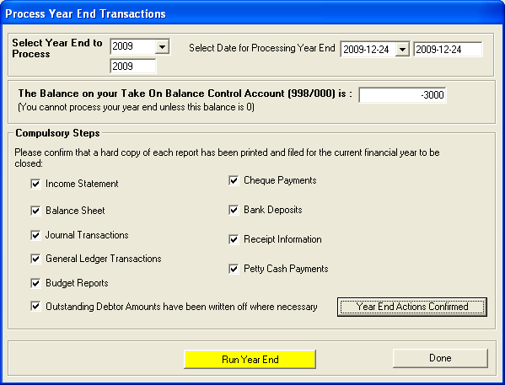
Figure 93: Process Year End Transactions

- Click on the button Year End Actions Confirmed to confirm that you are ready to process the year end transactions.
- Click on the yellow button Run Year End to start the procedure:
- The procedure will take 1 to 4 minutes depending on the size of your database.
- The procedure will first make another backup copy of your database and then ask for confirmation that you wish to proceed.
- Once you confirm that you wish to run the procedure, sit back and wait until it is FULLY completed.
- All balances will be rolled over to 2005.
- Select DONE to return to the year end sub menu.

Step 8: Open a NEW financial period on your system

- Select the option NEW Financial Period from the year end sub menu.
- The following screen picture will be displayed
- Click on the button Close Period

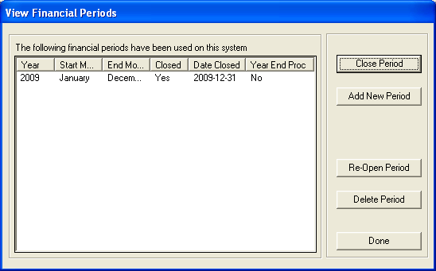
Figure 94: View Financial Periods

- You will see that the 2009 period has been closed.
- You must now open a NEW financial period for 2009.
- Click on the Add New Period button.
- The following screen will be displayed
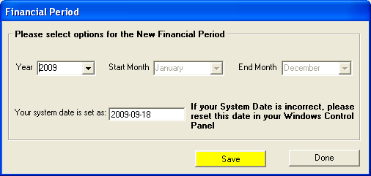 Figure 95: Financial Period

- The dates for the new period have already been entered.
- Press SAVE to open the new period

You are now ready to start processing entries for 2005.

Error Fixing
- Should you have any entries that still need to be processed for the previous year, you can still process them.
- Ensure that you select Previous Year on the relevant transaction form to process an entry for example 2004. Check that you have the correct processing date selected.
- Should you process entries for 2004; the entry will automatically be rolled over to ensure that opening balances for 2005 remain correct.
- Balances in Income and Expense accounts are carried forward as Retained Income in account 500/000.
- Balance sheet accounts (including debtor balances) are rolled over.

Emergency Backups
- You should have backup copies of your database in the following folder:
C:\Program Files\SASAMS\Backup.
- Use one of these databases if you need to start again.
- Rename the database in the DATA folder.
Copy the database from the backup folder to the DATA folder and start again.

Delete Archive Data
- Click on Year End Functions button
- The Financial Year End and Archives screen opens
- Click on Delete Archive Data button.
- The Financial Remove Financial Data screen opens
- Tick each item on Compulsory Steps to confirm that all the necessary reports have been printed.
- Select year to delete using Select Year to Delete from Current Database option.
- The program will not delete data that is less than two years old.
- Click on the Process button to confirm deletion.
- Numerous further Warnings are given.
- To use Compact The Database – refer Main Menu – Security And Database Function – Database Functions – Compact The Database.
- Click on the DONE button to exit.

