

SA-SAMS

Guideline for using Curriculum Related Data module

September 2009

Education Management Systems (EMS)
Department of Education
Private Bag X895
0001 PRETORIA

CONTENT

1. INTRODUCTION 3
1.1 The Curriculum Section Has Two Parts 3
2. GETTING STARTED 4
3. THE STRUCTURE OF THE CURRICULUM RELATED DATA MODULE 5
3.1 Setup Subject and Subject Choices 6
3.1.2 Maintain Subjects 8
3.1.2.1 Select Subject 9
3.1.2.2 Removing Subject from School List 9
3.1.2.3 Edit School Subject button allows you to: 9
3.1.2.4 Add Subject not on List 11
3.1.3 Maintain Learning Outcomes per Subject 12
3.1.3.1 Adding Learning Outcomes for each subject 12
3.1.4 Maintain Learner Report Languages 13
3.1.5 Create Subject/Learning Area Sets 15
3.1.6 Assign Subjects to Individual Learners 16
3.1.7 Create Educator Subject groups 19
3.1.8 Print Educator Mark Sheet per Group 21
3.1.9 View/Print Learner Subject Allocation 21
3.2 Continuous Assessment: Maintain School Based Assessment 23
3.2.1 School based Programme of Assessment 24
3.2.2 Enter Learner SBA Results 27
3.2.3 View Programme of Assessment Tasks 28
3.2.4 Calendar View of Assessment Task 30
3.2.5 Print Learner CASS Results 32
3.3 Common Tasks for Assessment: Setup and Maintain CTA 34
3.4 Progress Reports: Maintain Learner Progress Reports 35
3.4.1 Maintain Progress Report Cycles 36
3.4.2 Maintain National Rating Code 38
3.4.3 Maintain Promotion Decisions 39
3.4.4 Maintain Reports Comments 40
3.4.5 Maintain Report Subject Order 41
3.4.6 Enter Learner Cycle Results 43
3.4.7 Maintain Foundation Phase Results 44
3.4.8 Maintain Learner Promotion Decision + Average 45
3.4.9 Print Learner Progress Reports 46
3.5 Additional Survey Statistics: Data Required For Annual Survey 48
3.6 Printouts: Curriculum Related Printouts 49
4. CONCLUSION 51

INTRODUCTION
The Curriculum Related Data module is where the structures for recording and reporting on the progress of a learner are set up. Only the activities selected for continuous assessment, tests and exams, in each of the eight Learning Areas, are recorded here. School subjects that were captured under the General School Information Module, the learners captured under Learner Information Module, the educators captured under Human Resources Module are all linked here to populate the fields necessary to do the RECORDING of the learner’s marks/code/symbol, and the REPORTING which is the Progress Reports sent to the parents.

The Curriculum Section Has Two Parts
a) CASS + CTA marks should be entered into the system on a task-by-task basis throughout the year and not all at once. This ensures that the Principal and other School Managers can view a learner's progress on the system at any date in time.

b) The CYCLE PROGRESS REPORT is a reporting section ONLY. (No mark calculations are done in this section) It allows schools to send a progress report to parents to update them on their child's progress at regular intervals during the year, such as end of term, or on specific aspects of CASS (such as mid year exam)

The current system requires that schools have to ENTER or CHECK the progress/cycle mark or OBE symbol for each reporting cycle irrespective of whether the CASS marks are stored on the system for recording and reference purposes. The mark or symbol entered for a particular cycle should be the cumulative CASS mark of the learner at that particular point in time. (For this reason it is possible to view the CASS mark as at a specific date when completing a cycle end progress report.)

There are two main reasons why the system does not automatically just use the cumulative CASS mark at a given date and print the cycle report without the school having to ENTER or SELECT the cycle mark specifically:

Many schools do not have the resources to enter all CASS marks into the system and would not be able to print progress reports if the system generated reports automatically from CASS marks. These schools are now able to send progress reports home by entering just the cycle result and printing. They now also have a computerized record of these reports, even though their CASS marks are on paper and not in the system.

GETTING STARTED
- Click on the Curriculum Related Data button to start.

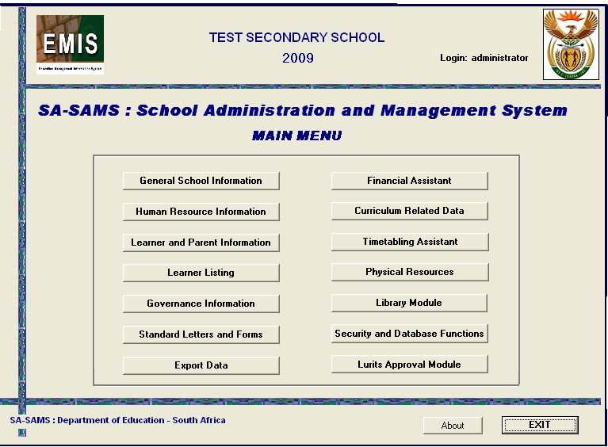
Figure 1: SA-SAMS Main menu

THE STRUCTURE OF THE CURRICULUM RELATED DATA MODULE
To begin using the curriculum Module, click on the Curriculum Related Data button on the SAMS Main Menu. The following screen will open:

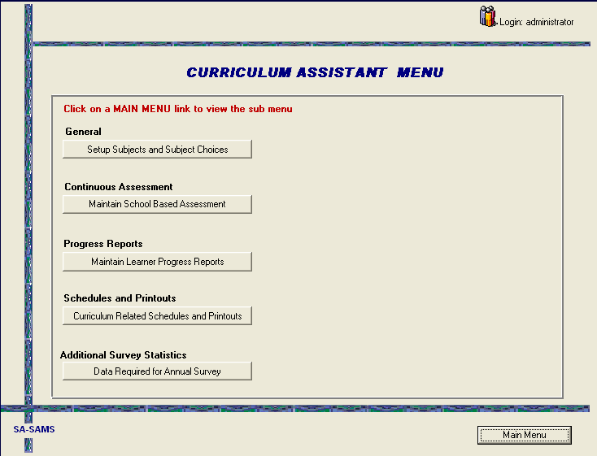
Figure 2: Curriculum Assistant Menu

Each of the main headings listed above has a link to a sub menu which opens on the left once a selection has been made.

Setup Subject and Subject Choices
Setup subject and subject choices menu is used to setup the curriculum framework, it allows the user to manage subject offered by the school and subject which will be used in the class or by learners. You can use this menu to add learning outcome.

This menu will be able to store information about the following areas:

        - Maintain Subject/Learning areas
        - Maintain learning outcome per subject
        - Maintain learner report language
        - Create subject/learning area sets
        - Assign subject to individual learners
        - Create educator subject group
        - Print educator mark assessment sheets
        - View/print learner subject allocation

- Click on Set up Subjects and Subject Choices
- A sub menu will pop up on the left indicating all the data sections that are to be captured here
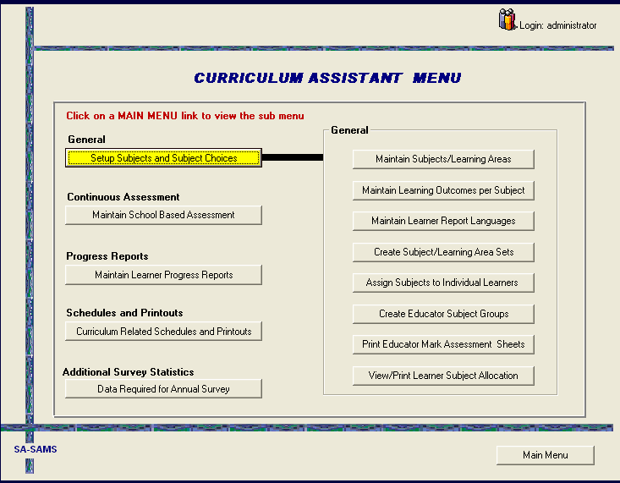
Figure 3: Curriculum Assistant Menu 2

- Click on the first button Maintain Subjects/Learning Areas
- The screen below will open.

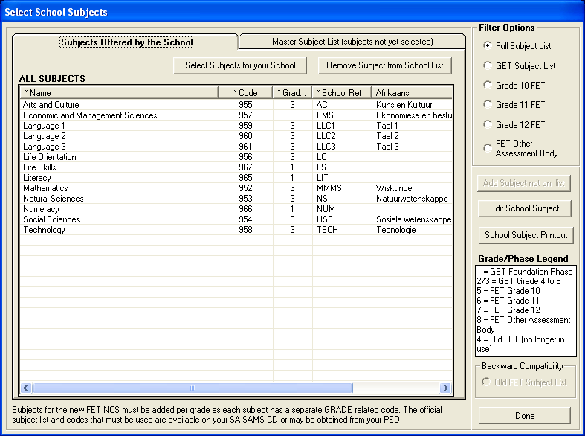
Figure 4: Select School Subject

Maintain Subjects
Maintaining Learning Area/Subjects is the first step in the process of building the framework for Continuous Assessment. This section allows you to perform the following functions:
- To select subject offered by your school
- To remove subject from school list
- To edit school subject
- To add subject not on the list
- To make printout of school subject
- To select filter options according to the following:
- Full subject list
- GET subject list
- Grade 10 FET
- Grade 11 FET
- Grade 12 FET

Select Subject
- Click on the Master Subject List tab
- Click on the subject name to add the subject to the list of subjects offered by the school
- A pop up message will display asking if you have selected the correct subject
For your school, click Yes

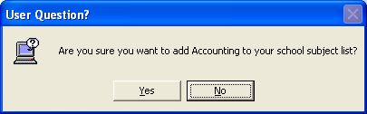

- Once you have selected your school subjects from the Master Subject List,
- Click on the Subjects Offered by the School button.
- You now have a view of your school subjects.

Removing Subject from School List
- To remove a subject from your school list, click on the subject name and click
The Remove Subject from School List button.
- When working with OBE subjects, please ensure that you select all the subjects
Required for each phase.
- You can use the Filter Options to view specific lists to check that subject
Selections are correct.

Edit School Subject button allows you to:
- The Edit School Subject button allows you to:
        - Edit subject names
        - Add the Afrikaans name for the subject

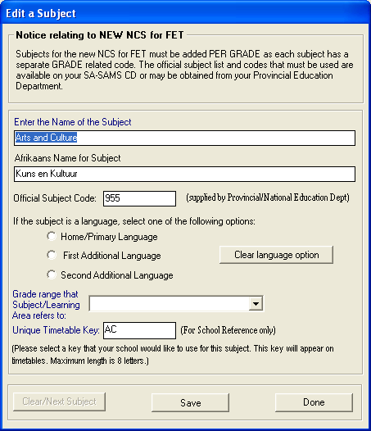
Figure 5: Edit a Subject

- Schools that give reports to learners in Afrikaans could make use of this Edit button and enter the Afrikaans names for all the subjects offered by their school so that the Afrikaans names will appear on the learner’s report.
- When you click on Select Subject for your School to add a subject not on your list, the screen below opens
- This is the Master Subject List (page two)
- It’s from this list that you select subjects not yet selected or added to your school list
- Click on a subject name to add to subjects offered by the school
- A User Question asking you to confirm your choice will pop up
- If the chosen subject is the correct one, click Yes
- The subject moves from Master List to School List

Add Subject not on List
- On this page you can add a new subject
- Should your school offer a subject that is not on the Master List, click on the Add Subject not on List button. The screen below will open;

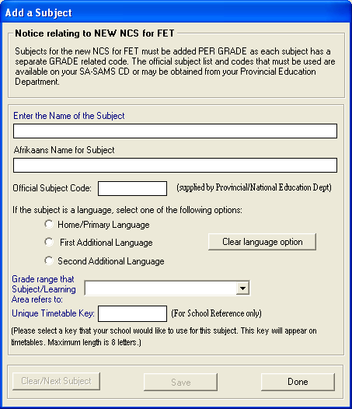
Figure 6: Add a subject

- Enter the name of the subject
- Enter the official department code, this code must be unique. The system will not accept numbers that already exist
- Select a group from the drop down menu
- Enter Unique Timetable Key that will appear on the school timetable
- You cannot edit the Unique Timetable Key

Maintain Learning Outcomes per Subject
Maintain learning outcome per subject menu allows you to setup the learning outcome which will be used when entering learners CASS marks.

Adding Learning Outcomes for each subject
- Click on the Curriculum Related Data from SA-SAMS main menu, the following
Screen will open;
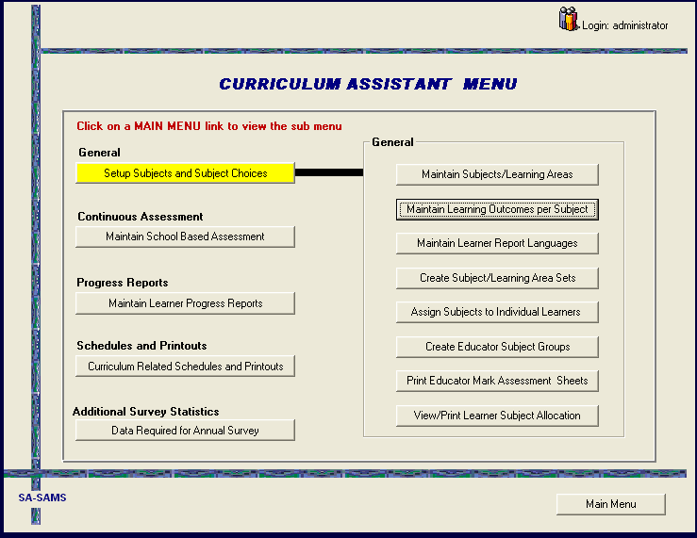
Figure 7: Add a subject

- Click on the Maintain Learning Outcome Per Subject and the following screen will appear;
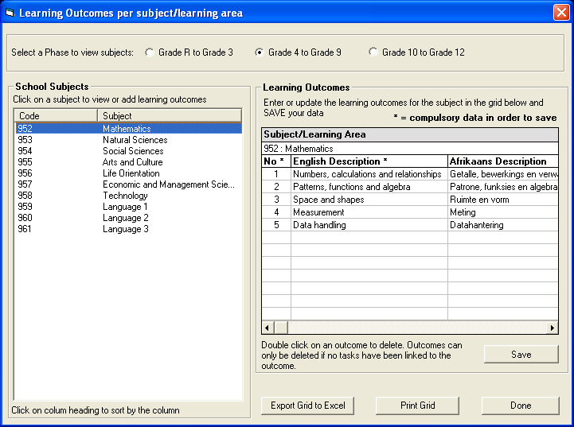
Figure 8: Learning Outcomes

- Select a phase to view subject and to enter learning outcome
- As indicated on figure 6 enter subject learning outcome per subject; then click
On the yellow Save button to save the changes you have made

Maintain Learner Report Languages
Maintain learner report languages menu allows you to setup the language which will be used when printing learners report, you can use this menu to setup the reporting language to be either English or Afrikaans

- This button has implications for printing when the print function is selected
- Learner reporting language must be selected in order for the programme to identify in which language it should print any report for a particular learner
- Financial statements can also be printed in Afrikaans if the reporting language has been selected
- Click on the Maintain Learner Report Language button and the screen below opens
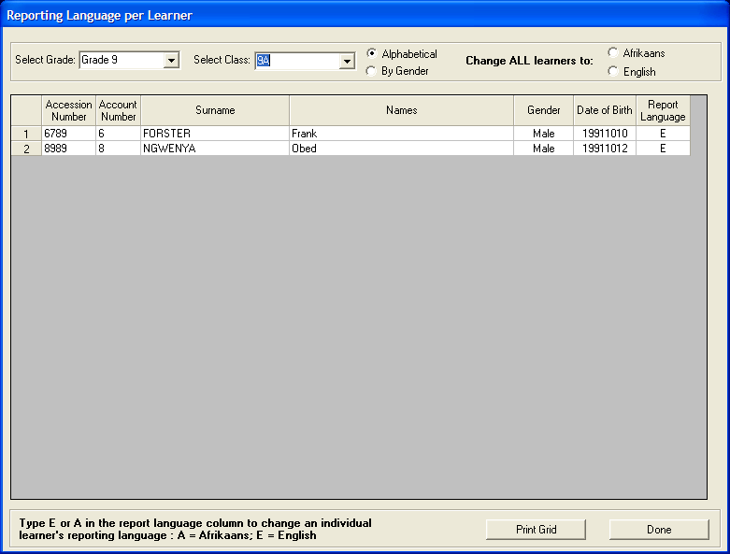
Figure 9: Reporting Language

- The message at the bottom of the screen gives instructions to select the language for reporting.
- In very small schools where classes might be dual medium, the Reporting Language for individual learners can be selected.
- Where the whole class has the same reporting language Change ALL learners to: gives the two options and all learners in the class will have their selected language appear alongside their names.
- This reporting language grid can be printed by clicking the Print Grid button.

Create Subject/Learning Area Sets
Create subject/learning area sets menu is used to put different subject under one set. A subject set can be used in a class where you have leaner that are doing different subject.

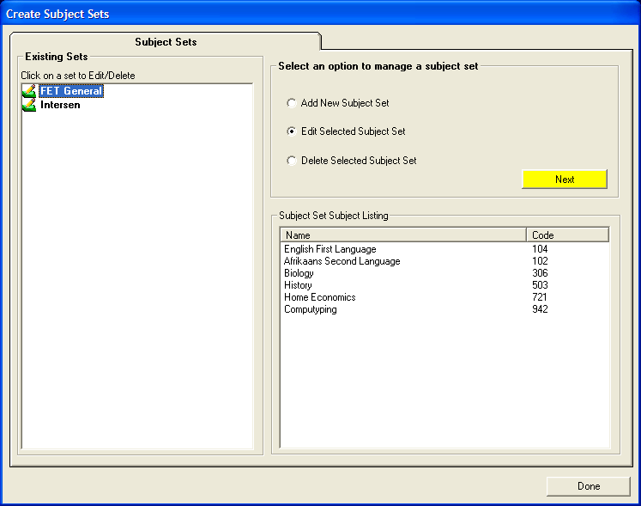
Figure 10: Create Subject Sets

- Different subject sets are created to accommodate the different choices of subjects learners make, particularly in the FET phase. Subject name lists can be printed
- At a glance, by clicking on the name of the set, one can see what subjects constitute what set
- Click on Create Subject/Learning Area Sets to open the page
- You have the options to Add, Edit or Delete a set
- To add, select Add New Set. Click on next
- The following screen will open;
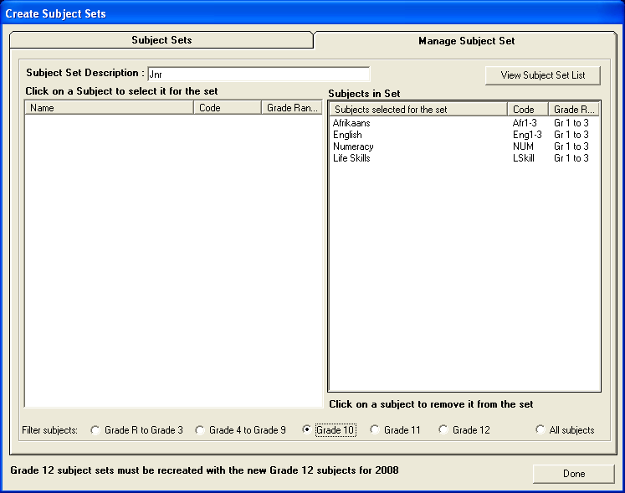
Figure 11: Create Subject Sets (Manage Subject Sets)

- Enter subject set name in Subject Set Description field
- Click on a subject in the right column to select it
- It jumps into the left column
- Click on Subject Sets (top left of screen) to go back to page one to view the list of sets created
- To edit, click on the set name. The subjects will appear in the left column
- Click next
- You can now add to or remove subjects on the subject set list by clicking on them
- To delete click on the set name, select Delete Selected Subject Set
- A User Message will ask you to confirm your decision. Click next. Click Yes and Subject set is deleted

Assign Subjects to Individual Learners
Assign subject to individual learner menu is used to assign specific subject to the learner, unlike the subject sets here you assign subject to a learner.

There are three ways in which subjects can be added to learners:
- Adding a subject set to the whole class at once
- Adding a subject set to an individual learner
- Adding individual subjects to individual learners
- There are three tabs (pages) indicated at the top of the screen:
        - Class List
        - Master Subject List
        - Subject Sets
- You will work between the three tabs
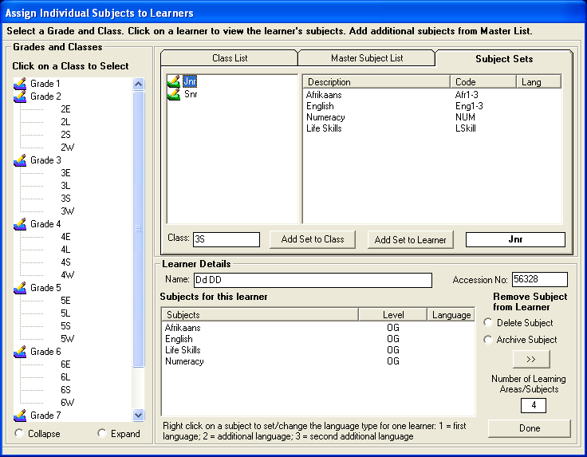
Figure 12: Assign Individual Subjects to learners

- Click on the class name. Learner list of names appears.
- Click on Subject Sets (page/tab three).
- List of sets you created appears.
- Click on the name of the set.
- The screen changes to bring in the tabs Add set to Class and Add set to Learner.
- If adding set to whole class, select the class.
- Select the subject set.
- The class name appears in the field in the middle of the screen.
- Click Add set to class.
- To add a set to a specific learner, click on the class name, from the name list. Select the specific learner.
- Learner’s name appears in field under Learner Details. Subject set name appears in field.
- Click Add set to Learner. The subject names appear under Learner Details.

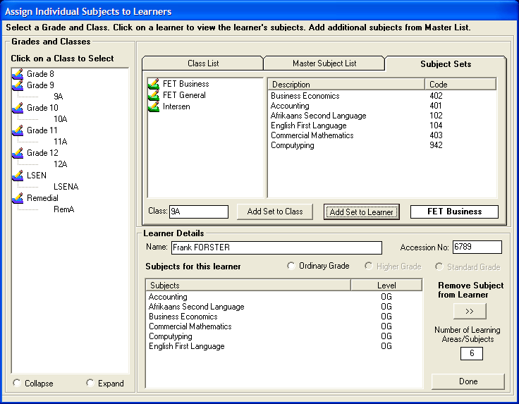
Figure 13: Assign Individual Subjects to learners (Subject Sets)

- Add additional subjects to a learner’s set by clicking on the subject in the Master Subject List listing,
- The subjects will now appear in the Subjects for this Learner list. There are three options of level to choose from
- To remove a subject from the learner list, click on the subject in the list and then click the >> button.
- Use the Collapse or Expand options to view the Grades and Classes listed in the Grades and Classes list.
- Right click on a specific subject of a learner to set it as a language option

Create Educator Subject groups
Educator subject groups are created for ease of identification of learners linked to a particular educator. An educator can print a list with the names of only the learners she/he teaches in a particular subject, instead of the whole class list and then having to filter names.

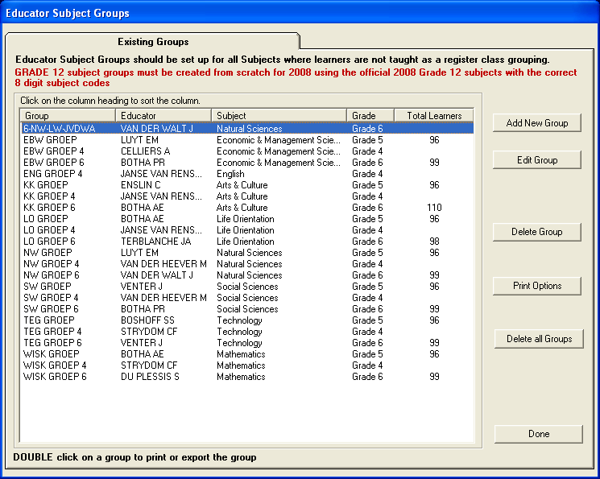
Figure 14: Educator Subject Groups

- To create an educator group click on Add new Group,
- Select grade,
- Select subject and educator,
- Enter the name of your group,
- Click on Edit to alter information,
- Click on Delete to remove the entire group.
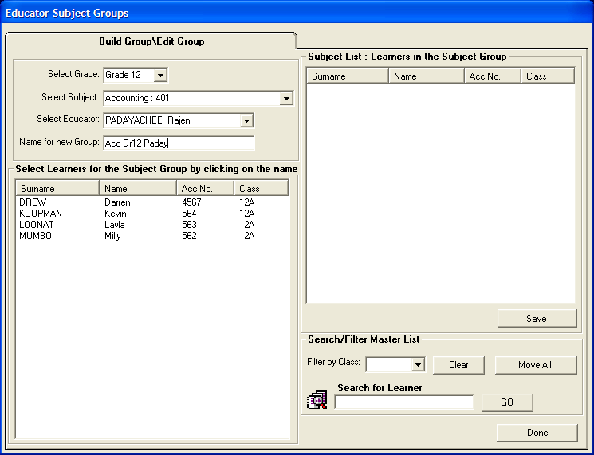
Figure 15: Educator Subject Groups (Build Groups/Edit)

- The learner list of names for the grade appears
- Use the Filter by Class option to choose a particular class or individual learners in a particular class
- Click on the identified learner s’ names
- Names jump into the left hand column as group is selected
- If the whole class is selected, click on Move All
- To remove a learner from the group click on the learner’s name
- The search option can also be used to find any particular learner by typing in either the full surname or the first letter of the surname

Print Educator Mark Sheet per Group
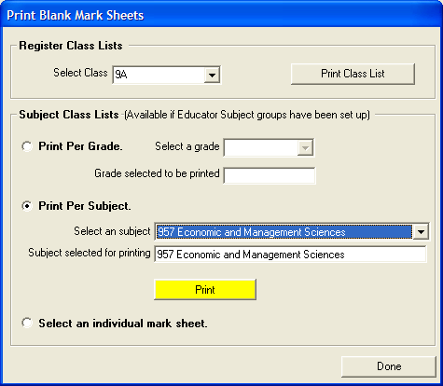
Figure 16: Print Mark Sheets

- Click on Print Educator Mark Sheet per Group
- The first print option: Register Class List, allows you to print a full class list for each class in the school
- The print options under Subject Class Lists are available if the educator groups have been set up
- Print per Grade, prints all the groups set up for the grade
- Print per Subject , prints all the groups set up in that particular subject
- Select an individual mark sheet prints only the selected subject group

View/Print Learner Subject Allocation

View/print learner subject allocation menu allows you to printout a list of learner with subject or without subject and it also allow you to view subject per class.

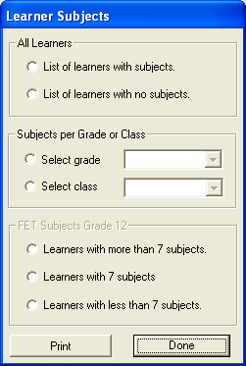
Figure 17: Learner Subjects

- Select a relevant option and then click Print button

Continuous Assessment: Maintain School Based Assessment
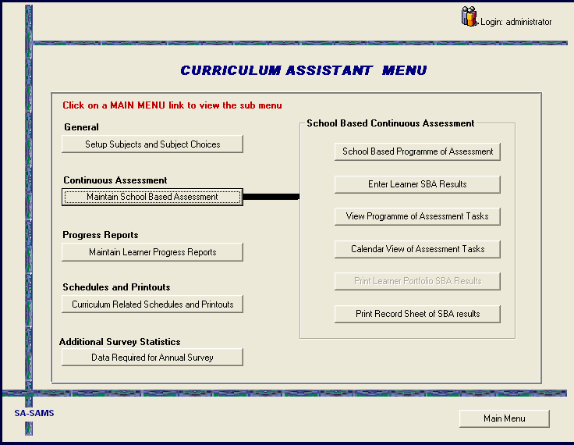
Figure 18: Curriculum Assistant Menu

The Maintain School Based Assessment menu allows you to add and to enter tasks, at a fleeting look one can be able to see the date a particular task was captured, this menu also allows you to print your task and their marks.

This menu will be able to store information about the following areas:
        - CASS programme of assessment
        - Enter learner CASS results
        - View programme of assessment
        - Calendar view of assessment
        - Print record sheet of CASS results

School based Programme of Assessment
School based programme of assessment menu allows you to view a list of all task captured in a particular grade, at a glance one can be able to view the date the task was created, you can also be able to make a printout of the task you have created.
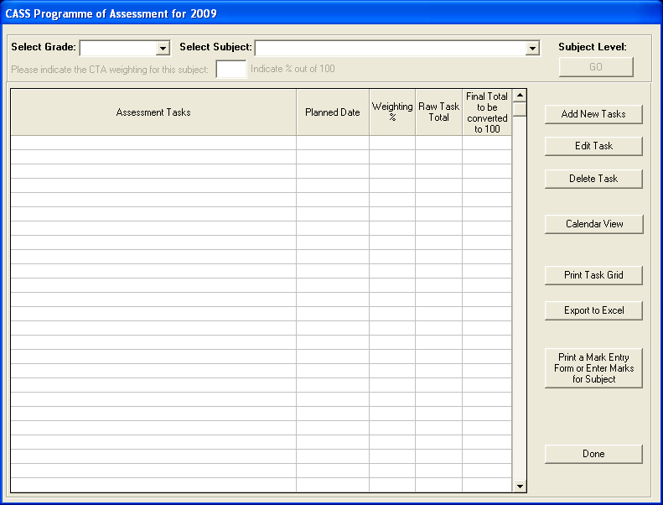
Figure 19: Set up CASS Programme of Assessment

- Select each grade and each subject and add the Assessment tasks
- Assessment tasks must be linked to Learning Outcomes for Grades 1 to 9

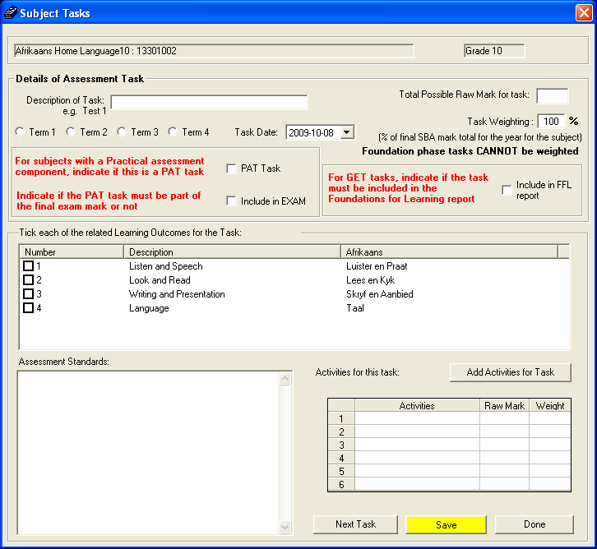
Figure 20: Subject Tasks

- Enter the description name of the task
- Complete the required information in each of the three fields
- Click on SAVE button
- Go back to description name of the task and enter the next task
- You can also be able to add activities and give marks for activities, to add an activity for a task you must save your task first and then click on the add activities for task button and the following screen will open.
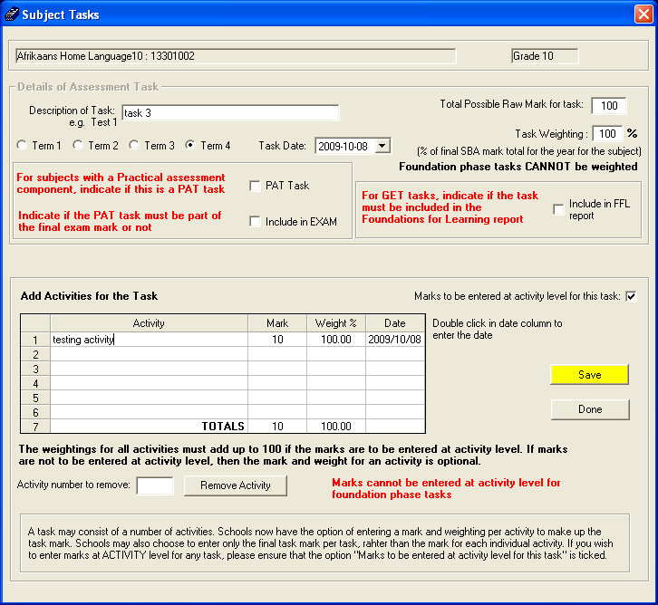
Figure 21: Add Activities

- Enter the activity name, mark, weighting percent and date the click on the yellow save button.
- Note that if you have allocated your task weighing to be 100 and decide that for that particular task you whish to have to activities both total marks for your activities must be equal to the total marks for your task.

From the main List of tasks page:
- Tasks can be Edited and Deleted by selecting the task name and clicking on the intended button
- The task grid can be printed and used for the following purposes:
        - To give to educators in the LA so that they can pace themselves with the years work
        - To give to learners so that they can get a picture of what is expected of them for the year in this LA
        - To give to parents so that they can monitor the work ethics of their children
- You can also Export to Excel. Once in Excel, remove the “Read-only” status via Protection submenu in Tools and you can then work on the grid

3.2.2 Enter Learner SBA Results

The grid is used to enter Learner Marks/OBE codes. There is also opportunity for the educator to make comments about the specific task assessed. The Filter option in the top right hand corner gives indication of the level of the subject.

- Select information from the drop down menus, i.e. grade, subject, task, class
- Click on the yellow GO button
- Learner names appear
- Enter CASS mark
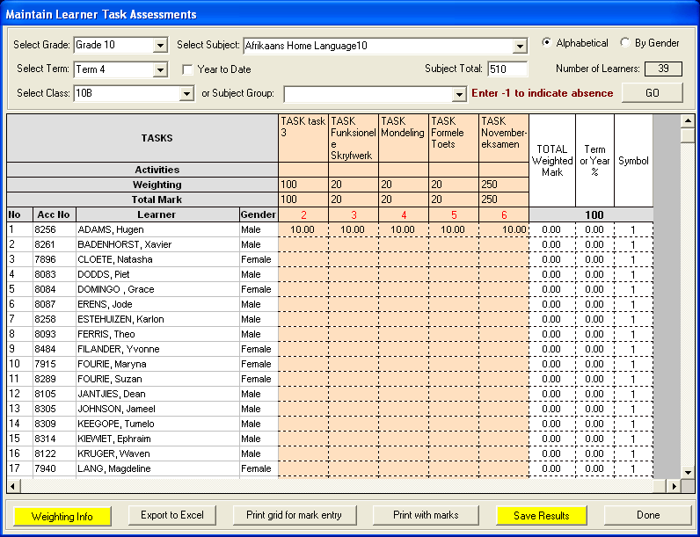
Figure 22: Maintain Learner Task Assessments

- There is also an option to Export to Excel. Once in Excel, remove the “Read- only” status via Protection submenu in Tools and you can then work on the grid
- Click on Print With Marks to print

View Programme of Assessment Tasks

View details of performance tasks menu allows you to view a list of all task captured in a particular grade, at a glance one can be able to view the date the task was created, you can also be able to make a printout of the task you have created. This menu gives you full details of the tasks created and from which subject they were created for.

- This printout is used to view task which have been captured
- Click on the view programme of assessment task button
- The following screen will open
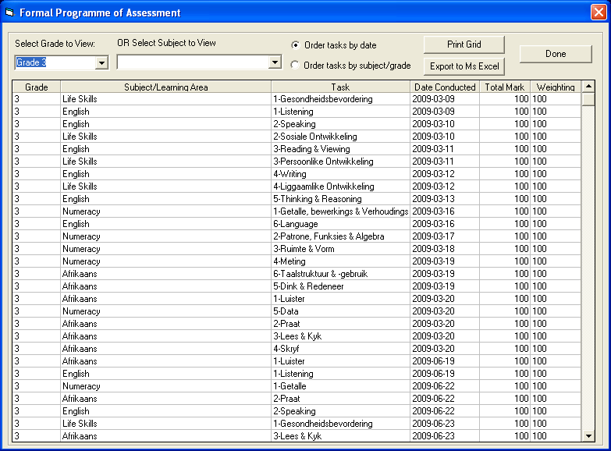
Figure 23: Continuous Assessment

- Select the required information from the drop down menus
- Click print grid button to print
- And the following screen will open giving you the full list of the tasks, dates, total mark and the activity.
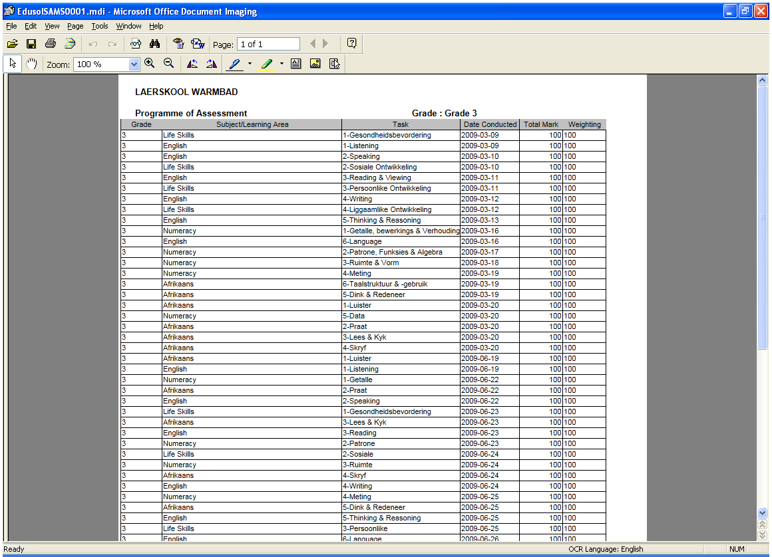
Figure 24: Print Reports

Calendar View of Assessment Task
This menu is used to show which date a task has been created, to view click on the
Calendar View of Assessment Task button.

- The following screen will appear;

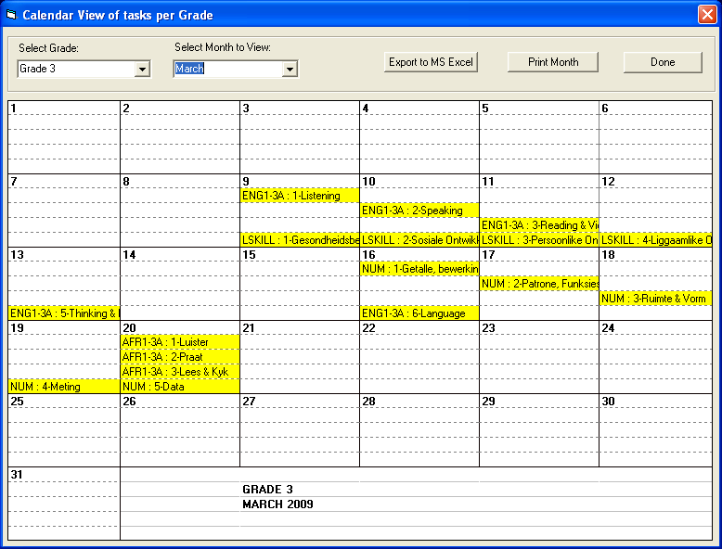
Figure 25: Print Reports

- Select the grade and a month the yellow date’s shows a task which has been created on that day
- You can also use this menu to print the task created in those particular months

Print Learner CASS Results

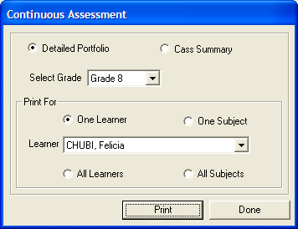
Figure 26: Continuous Assessment2

- There are two options from which to choose to print: Detailed Portfolio or CASS Summary
- The Detailed Portfolio printout gives details of each and every task mark as seen in the screen picture below
- Select the grade and then select how you wish to print the information from the options available

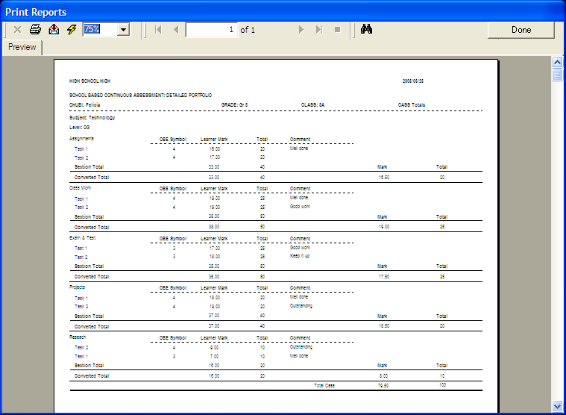
Figure 27: Reports

- The CASS Summary printout gives only the total for each Learning Area/Subject section and the total mark for the learner as seen in the screen picture below.
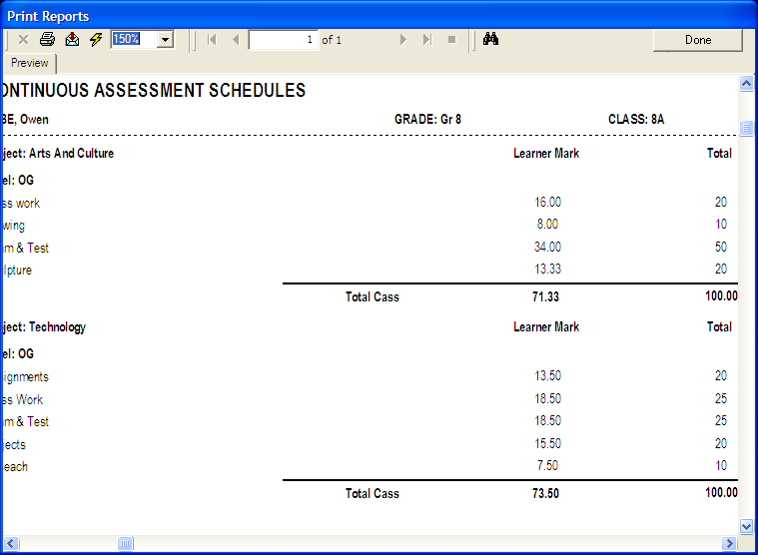
Figure 28: Reports

Common Tasks for Assessment: Setup and Maintain CTA
Tasks are entered in the same way as CASS results. This menu will be able to store information about the following areas:
        - CTA programme of assessment
        - Enter learner CTA task results
        - Calendar view of task

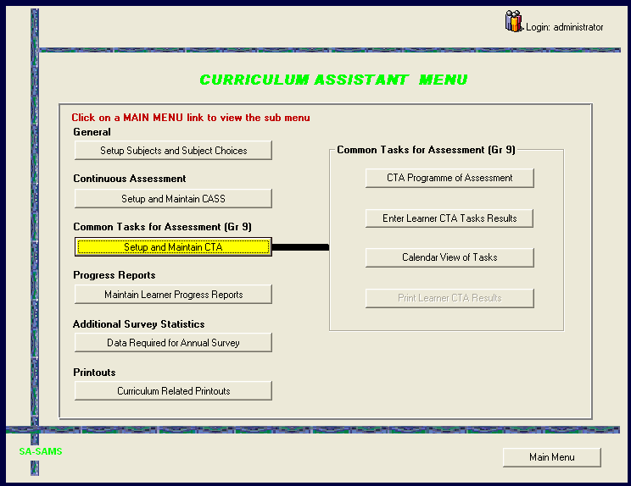
Figure 29: Curriculum Assistant Menu (CTA)

- The CTA tasks to be added would be given to you by your Provincial/District/Circuit office
- Capture these CTA’s under Add New Tasks
- The converted total for the CTA’s has been loaded onto the system already
- You enter the possible mark for each task

Progress Reports: Maintain Learner Progress Reports
Maintain learner progress reports menu allows you to setup and process learner’s promotions this is usually done at the end of term/quarter. 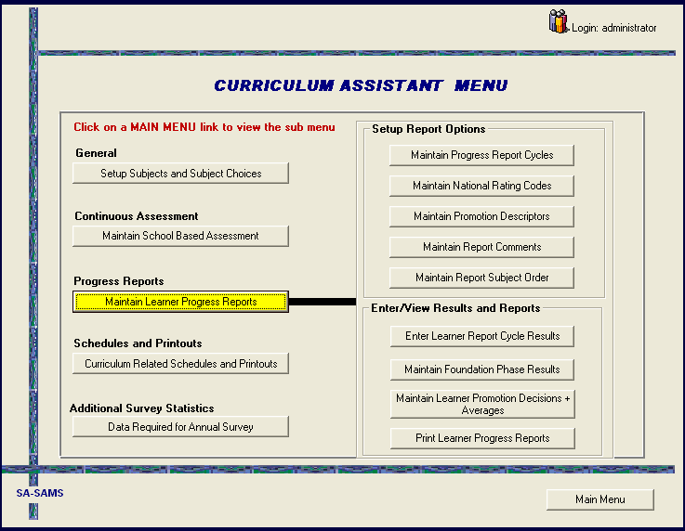
Figure 30: Curriculum Assistant Menu

Maintain Progress Report Cycles
Report Cycles are set up at the end of a period of assessment. These are normally at the end of a term/quarter.
- Click on Maintain Progress Report Cycles
- The screen picture below opens
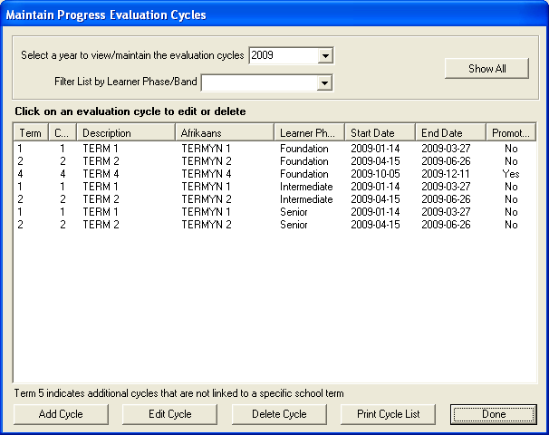
Figure 31: Maintain Evaluation Cycles

- To add an evaluation cycle click on the Add Cycle button
- The following screen opens
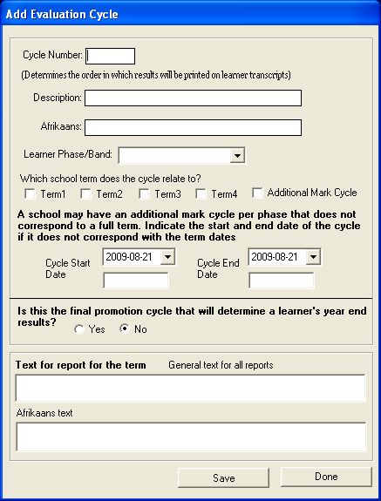
Figure 32: Add Evaluation Cycle

- Enter the required details in the various fields
- For reports that will be printed in Afrikaans, first type in the English description of the cycle in the Description field and then the Afrikaans name in the Afrikaans field
- Click on the SAVE button.
- To edit a cycle click on the Edit Cycle button
- To delete a cycle click on the Delete Cycle button.

Maintain National Rating Code

The Evaluation Keys are the OBE Codes determined by National Education Policy that reflect the level of achievement a learner has attained for each Learning Area at the end of an assessment period.
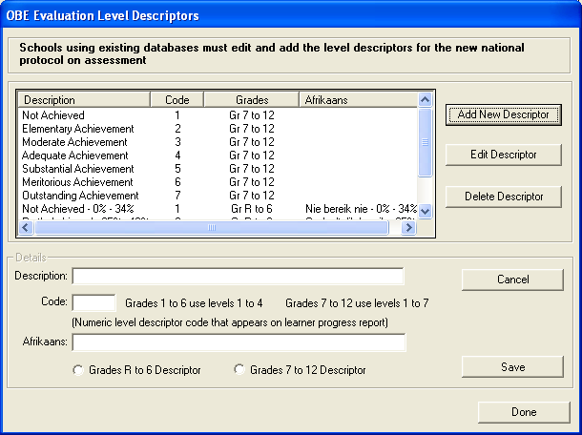
Figure 33: OBE Evaluation Level Descriptors

- Descriptors can be Added, Edited or Deleted
- For Afrikaans users, each level descriptor has to be renamed in Afrikaans
- Click on the name of the descriptor to highlight it
- Click on the Edit Descriptor button
- The English version will populate the Description field below
- Type in the Afrikaans name in the Afrikaans field
- Click on the SAVE button

Maintain Promotion Decisions
Promotional decisions are used at the end of a term, cycle or a quarter when
processing learner results.
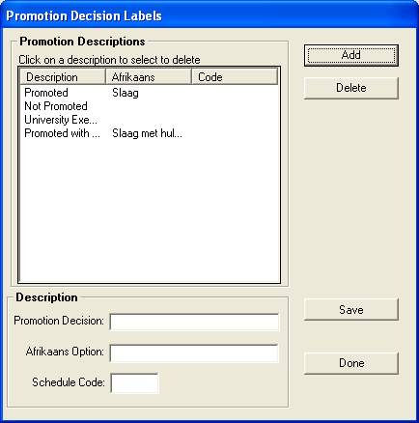
Figure 34: Promotion Decision Labels

- Click on Maintain Promotion Decisions to open this form
- To add other promotion descriptions click on Add, type in the new Promotion Decision
- For Afrikaans, first type in the English description and then the Afrikaans option
- Click on the SAVE button
- To delete click on a description and then click on Delete

Maintain Reports Comments
Report comments are captured using this menu. The comments captured here are the one which will be displayed on the bottom of a learner report.
- Click on the maintain reports comments button
- The screen below will open

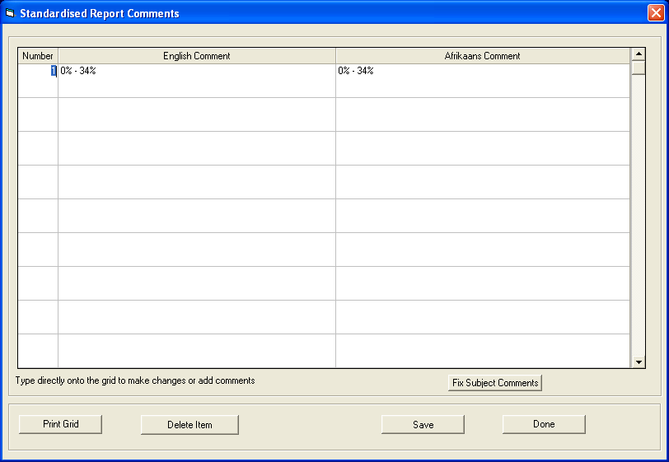
Figure 35: Promotion Decision Labels

- Enter information as shown on the above screen

Maintain Report Subject Order
Learner report subject order are setup using this menu, the subject order is used to setup the sequence in which the subject will be displayed on the report, to enter the subject order.
- Click on the Maintain Report Subject Order button, the following screen will open;

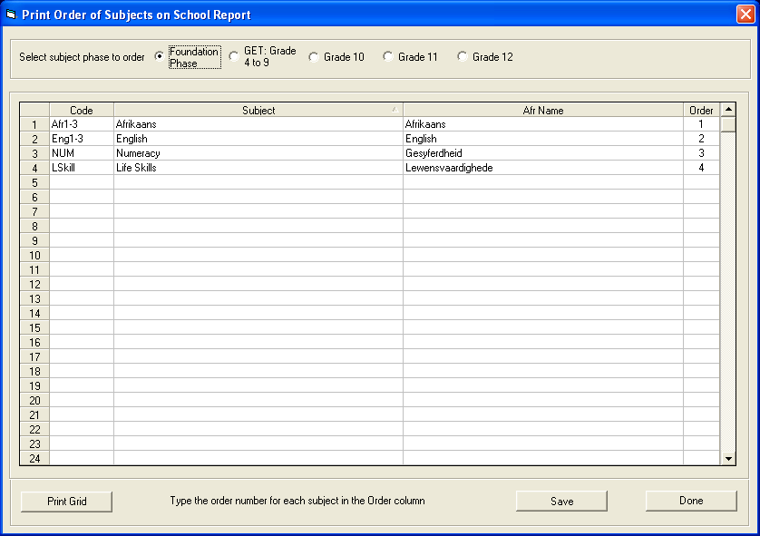
Figure 36: Promotion Decision Labels

- Put the number on the order column to determine the sequence in which learner subject will appear on the report
- Once done click on the save button

Enter Learner Cycle Results
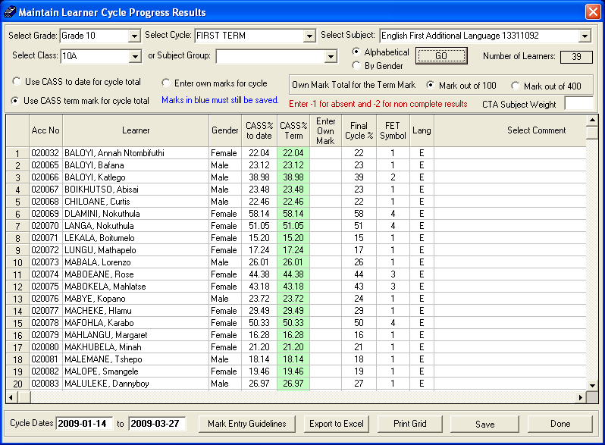
Figure 37: Maintain Learner Cycle Progress Results

- Select the grade, the cycle, the subject, the class
- Click on the yellow GO button
- List of all learners in the class appears

At this point there are two options for the entering of the cycle mark:

Option 1: Use the CASS marks
        - For users who have entered all the CASS marks for all the tasks for the selected Learning Area
        - Select either the option to Use the cumulative CASS mark to date or the CASS% for the term
        - This evaluation code is then manually entered into the Cycle Result column
        - Move screen to left and right and enter comments both on learner progress made and skills gained
        - These are the comments that will appear on the report
        - Save your results

Option 2: Cycle Result only
        - For users who have not made use of the CASS processes on the system,
But who have kept manual records of all tasks, tests and other
Assessment activities
        - Have your OBE evaluation code or your cycle total mark for the Learning
Area
        - Enter the OBE evaluation code or the cycle mark directly into the relevant
Cycle Result column
        - Enter progress comments and comments on skills gained for the learner
        - Save your results

Maintain Foundation Phase Results
Use this screen to maintain learning programme results for foundation phase learners; you can also use this menu to capture learner comments which will appear on learner’s report.

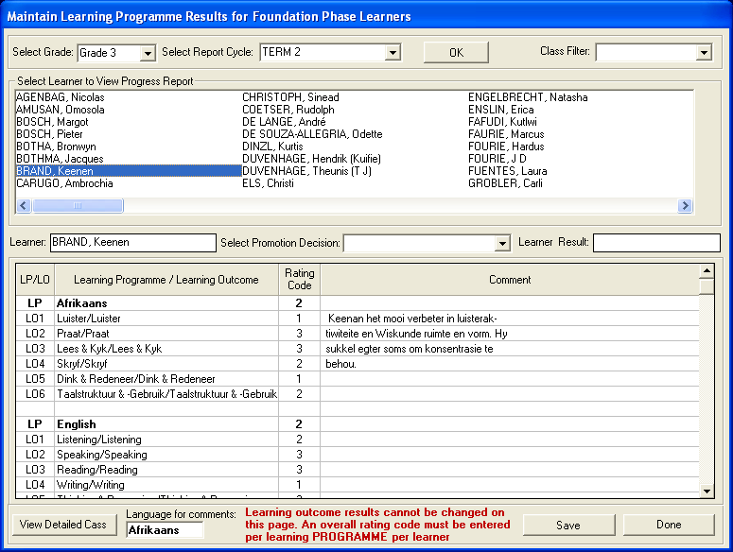
Figure 38: Promotion Decision Labels

Maintain Learner Promotion Decision + Average
After you have captured your marks you will use this window to process the learner promotion, this is where you can be able to put the comments that will appear on the leaner report.

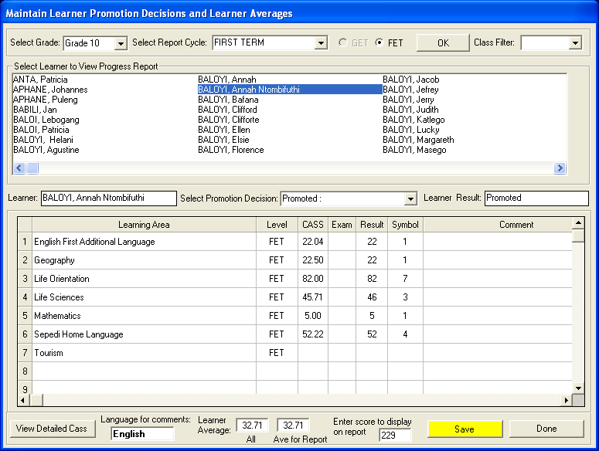
Figure 39: Promotion Decision Labels

Print Learner Progress Reports
- Click on the Print Learner Progress Report button
- The following screen picture opens
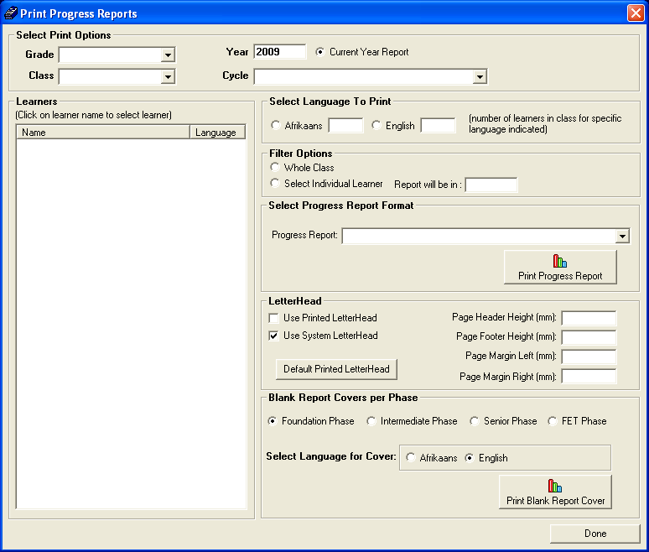
Figure 40: Print Progress Reports

- Select grade, select class, select cycle
- There are two options to select from for printing: Whole Class or Individual Learner
- When selecting Individual Learner, first click this option then click on the learner’s name
- This screen also indicates the language option in which to print
- If this option has not been captured earlier in the programme, a 0 will appear in both the language boxes and the programme will not print
- The options for the report layout will be dependent on the grades with which you are working

Blank Report Covers per Phase can also be printed by choosing your phase option, selecting the language to print in and clicking the Print Blank Report Cover button.
- Click on the DONE button to exit

Please note: Blank covers should be printed for all classes in each phase and then re-inserted into the printer so that the evaluation can be printed on the internal portion.

Additional Survey Statistics: Data Required For Annual Survey
(Curriculum data required by the Annual Survey that cannot be produced automatically)
- Click on the Data Required for Annual Survey button and the screen picture below opens.
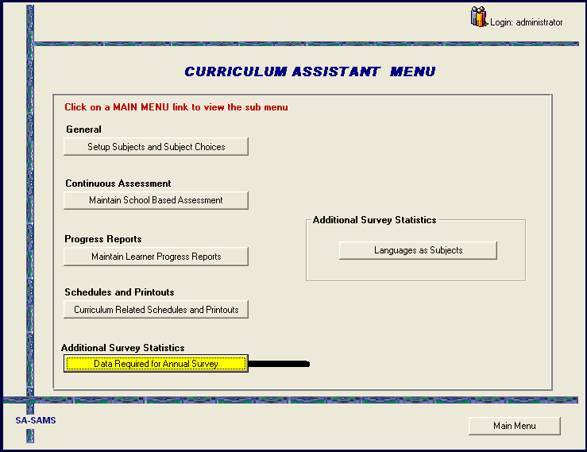
Figure 41: Curriculum Assistant Menu (Data required)

- Click on Languages as Subjects

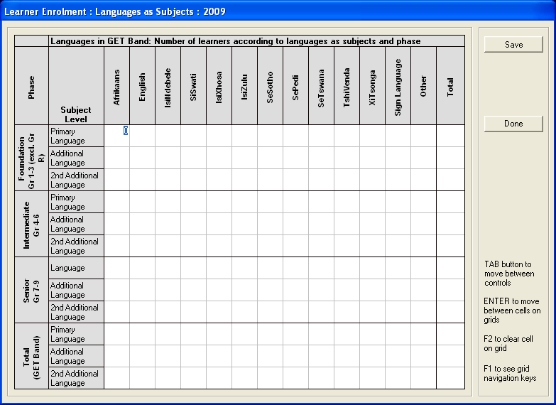
Figure 42: Learner Enrolment: Languages as Subjects: 2009

- Insert the required data in the grid and click on the SAVE button.
- Click on the Done button to exit.

Printouts: Curriculum Related Printouts
This menu will enable you to print information about the following areas:

        - Blank GET mark schedule
        - Internal mark scheduler per grade
        - Internal mark scheduler per subject
        - Internal total mark scheduler per grade
        - Department mark scheduler per grade
        - Arts and culture participation
        - Not promoted and repeating numbers
        - Learners details: repeats and drop outs
        - Enrolment: language and subject

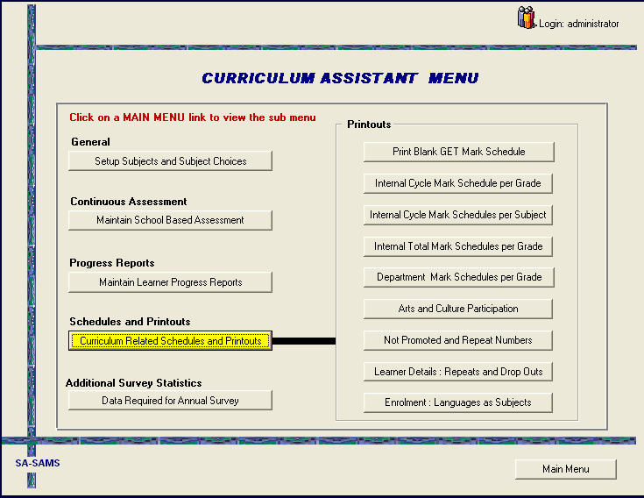 Figure 43: Curriculum Assistant Menu (Curriculum Related Printout)

- The printouts are listed on the right
- Open each one to explore the contents and the usefulness

CONCLUSION
The Curriculum Related Data menu has been designed to assist educators with the RECORDING and REPORTING functions vital to Continuous Assessment.
Once each LA/Subject performance task grid has been completed a further opportunity is then created for HOD’s to view these grids and to plan Homework timetables to ensure that homework tasks don’t clash and learners are given a fair distribution of homework tasks across the timetable.

